Challenge: Unique

# Challenge Description :

**We found a car but we are unable to identify if it's the exact one that we have been searching for. The serial network of the car seems intact so we tapped into it and collected some packets. Can you help us find the VIN of the car that is transmitted repeatedly over the network?**

# Context :

## Go and check out the .sal file given to you, to analyze it you will need to install Logic2, made by saleae.com to view the contents of the file. It can be used for Hardware debugging like UART , USB and COM connections or other raw protocols .

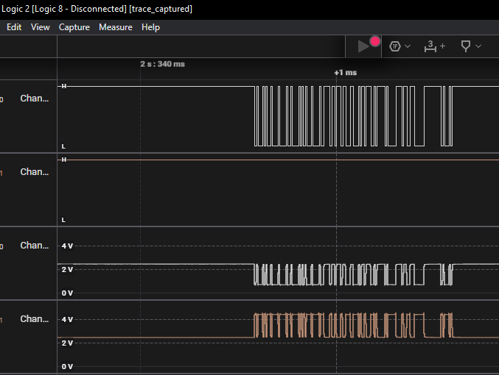

# Flag :

* **First Install the software and install the files. Drag the file into Logic2 to start analyzing it and to view the contents of it .**
* **Analyzing it we will need to start debugging by filtering it and try to extract what we are looking for, by doing this we are going to add a [ CAN ] filter at a 125000 Bit Rate.**

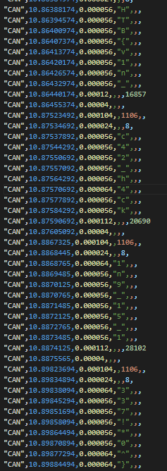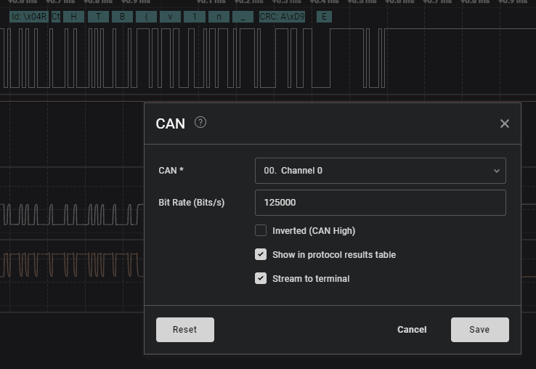

* **Filtering it will hopefully show some result. You will also need to change the [ CAN ] analyzer to display ASCII characters and not Hexadecimal or binary.**
* **Exporting the [ CAN ] results in a CSV format gives us the flag. This took a while to spot out as it exported about 14800 lines of data,**
* **The Flag hidden between the lines is**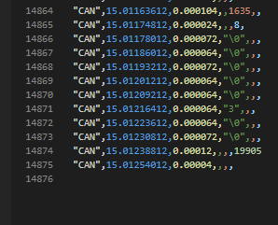

**: HTB{v1n_c42_h4ck1n9_15_1337!*0^}**