Challenge: Urgent

# Challenge Description :

**In the midst of Cybercity's "Fray," a phishing attack targets its factions, sparking chaos. As they decode the email, cyber sleuths race to trace its source, under a tight deadline. Their mission: unmask the attacker and restore order to the city. In the neon-lit streets, the battle for cyber justice unfolds, determining the factions' destiny.**

# Context :

## You are given a .EML file, a weird plain text format for emails, basically just analyze it, open the file up and get both base64 encoded strings. From there analyze the code you are given and find the flag.

# Flag :

* **First Install the files and install the files. You can open it with a notepad or any basic text editor.**

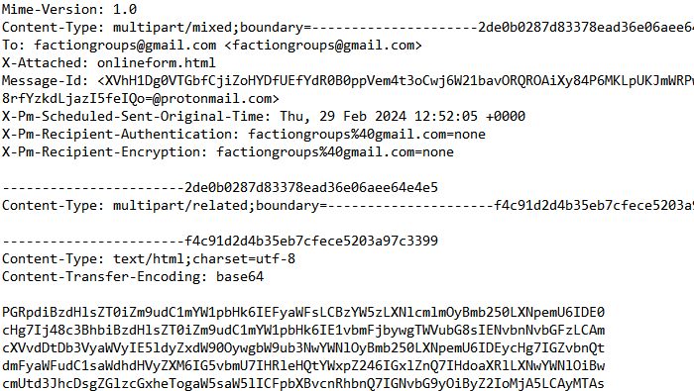

* **From the opening we find two long base64 encoded strings, extracting them both we see that they are both html files. The first string contains nothing.**

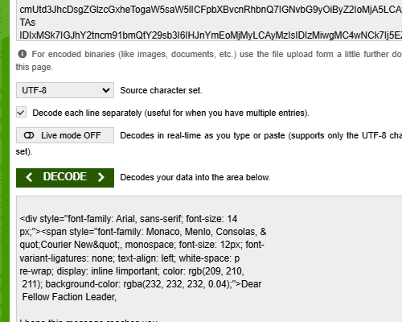

* **The second base64 strings after decoding it was using JavaScript to load more HTML code into the page. But it’s URL encoded**

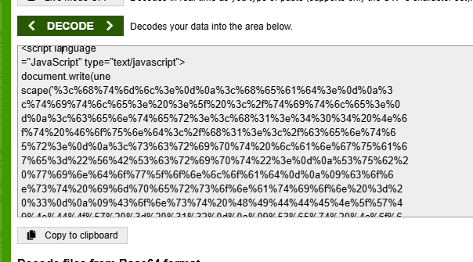

* **Decoding this URL encoding javascript code gave us the flag and some interesting code to execute in the email.**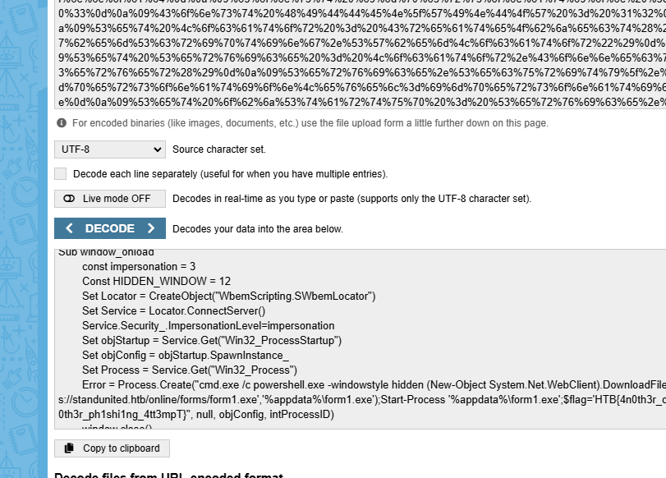
* **The Flag after finding it should be :**

**HTB{4n0th3r_d4y_4n0th3r_ph1shi1ng_4tt3mpT}**