Challenge: Wide

# Challenge Description :

**We've received reports that Draeger has stashed a huge arsenal in the pocket dimension Flaggle Alpha. You've managed to smuggle a discarded access terminal to the Widely Inflated Dimension Editor from his headquarters, but the entry for the dimension has been encrypted. Can you make it inside and take control?**

# Context :

## We are given a compiled file, when we run the file it pops up with a weird TUI interface . Going on one of the options by inputting the names in as a numeric list, e.g Primus = 1 and Cheagaz = 2. . Selecting the Option six asks for a password as it is shown as “Encrypted”.

# Notes :

* Tools:
  + - Text editor - To open the bash script / downloaded files.
    - You can choose your way to decoding the base64 string for simplicity im going to use a website, “www.base64decode.org”

# Flag :

* Download the file and run it. I started doing some basic static analysis on the file using Strace , Ltrace, objdump and some other tools. I couldn't find anything interesting or anything linking to a password.

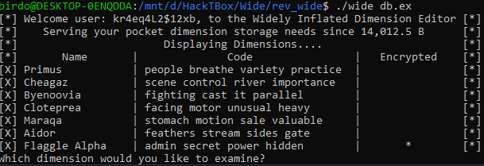

* When that fails, when I did some dynamic analysis on the file starting with IDA freeware, I got nothing from extracting strings or from just reading the binary.
* Instead I went to run it against another tool called Radare2, using this I got a better analysis and found something interesting. Using Radare2 was weird to start off with but finally got a slight handle.
* Opening it, i ran a command, [ AFL ] to show a bunch of Entries to enter as well as how the file was structured, i can enter the entries and print the binary of them entering the command : **[ pdf@(data_entry_name) ]**

**E.g [ pdf@sym.imp.fread ]**

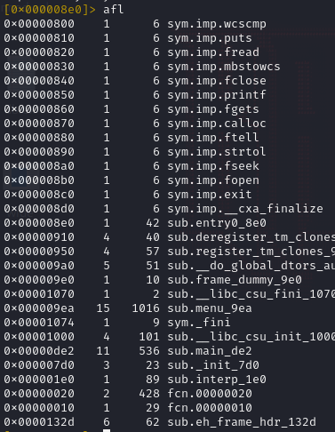

* Using this i opened the main entry, got nothing, same with some sub files, i Finally opened a entries that gave me the password for the application :

**[ pdf@sym.menu ]**

* Either short for system menu or something else It should have been one of the first things to check based on what we are checking out.
* The Password is placed at the bottom of the result of the [ **sym.menu ]** Command i gave, the password in question being : **sup3rs3cr3tw1d3**

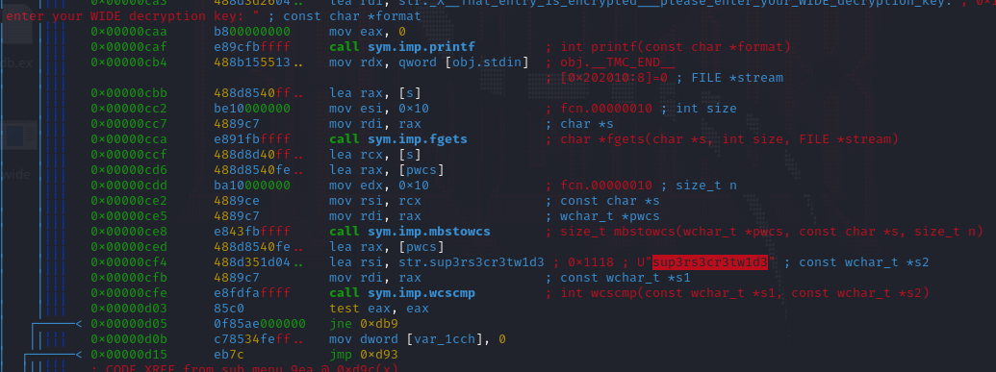

* Running the file again and going to the six option to prompt in the password gave us the flag **: HTB{som3_str1ng5_4r3_w1d3}**

