Challenge: lesson

# Challenge Description :

**It's time to learn some basic things about binaries and basic c. Answer some questions to get the flag.**

# Context :

## This is a questionnaire about the C programming language, you get given a .C program with some functions and a compiled version and you basically need to find information about the program and answer the question according to the questionnaire.

* **The questions will also give little hint and what tools you can use to find the answer but isnt always direct with it.**

# Notes :

* Tools:
  + - Cli Terminal - A Terminal to Netcat into the server to answer the questions you just need to type.

# Flag :

* Start the instance, and then Netcat into the server with the IP:PORT. First look at the terminal I got when I first connected seems to be a questionnaire.
* The answers to the Questions goes as:

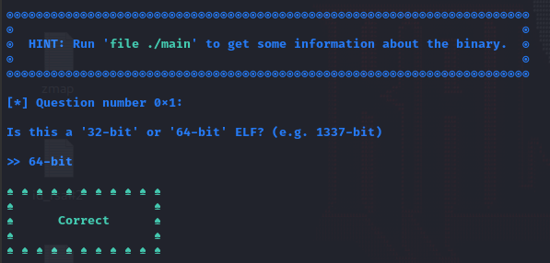

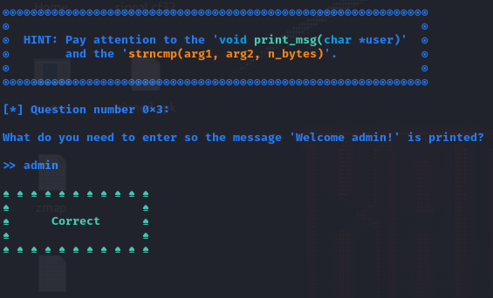

**The Code in question for this is :**

#include <stdio.h>

void under_construction(){

printf("This is under development\n");

}

void print_msg(char *user){

char formatter[0x20];

strncpy(formatter, user, 5);

for (size_t i = 0; i < 5; i++) formatter[i] = tolower(formatter[i]);

printf(strncmp(formatter, "admin", 5) == 0 ? "\nWelcome admin!\n\n" : "\nWelcome user!\n\n");

}

int main(int argc, char **argv){

char name[0x20] = {0};

unsigned long x, y;

printf("Enter your name: ");

scanf("%s", name);

print_msg(name);

return 0;

}

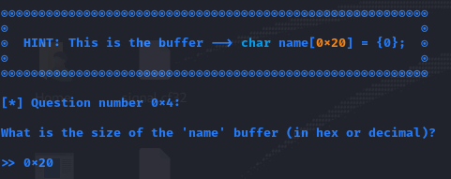

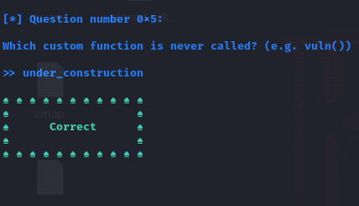

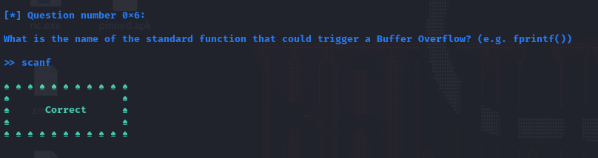

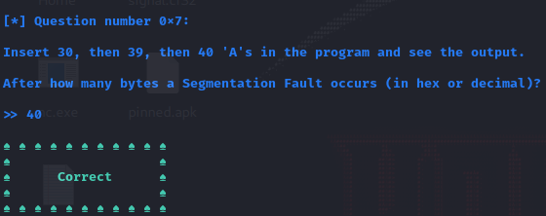

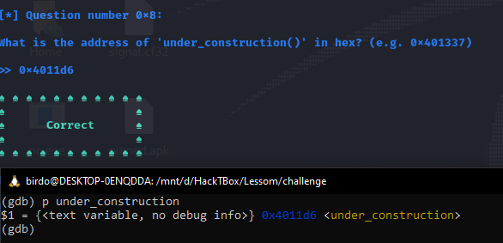



* Then we get the flag : HTB{w4rm35t_w4rmup_3v3r}