System Optimization

It has come to my attention that a lot of you are having problems with system speed. I have created the following document to help clean up some of the issues that may be causing sluggish system performance. If you follow these step-by-step instructions your system will be running like new in no time. If you have any additional issues please feel free to contact me.

Routine System Maintenance

* Windows Updates

Go to the **Start** menu. Click the **Control Panel.**  Click **System and Security**.

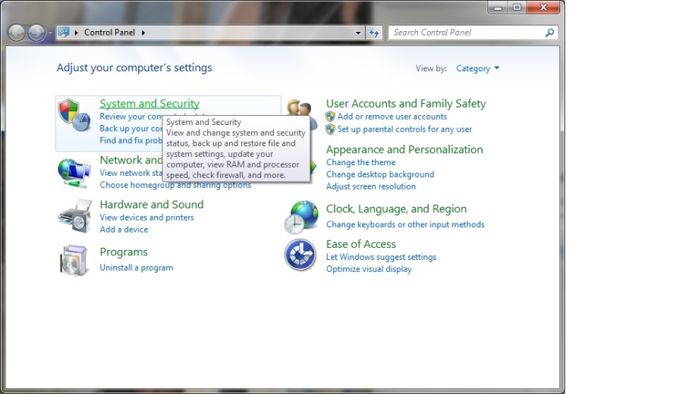

Click **Windows Update.**

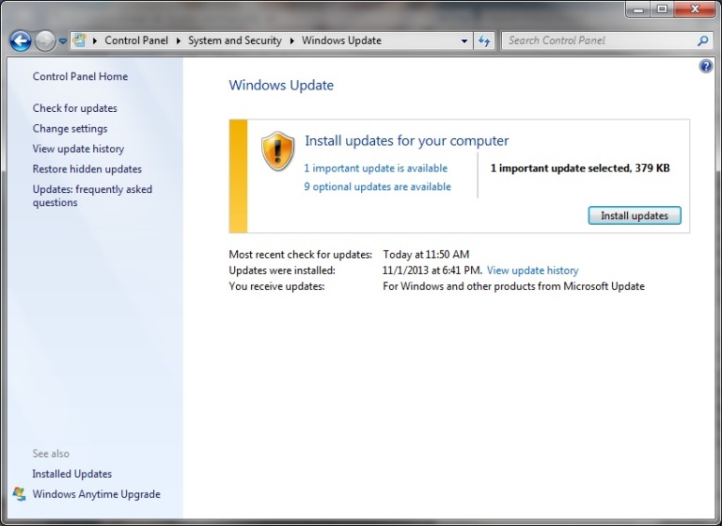

**Install Updates**. When updates finish **Restart** your system if necessary.

* **Free up disk Space**

Go to **control panel**. Click **System and Security.** Under **Administrative Tools** click **Free Up Disk Space**. Select the drive that you want to clean up.

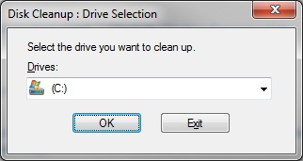

Select the files to delete and click **Clean up system files**.

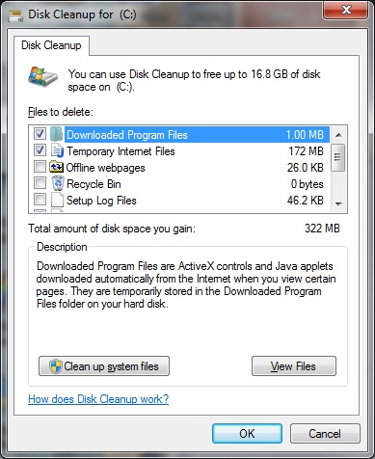

* **Disk Defragment**

Go to control panel. Go to System and Security. Under **Administrative Tools** click **Defragment your hard drive**. You can schedule a time for this task to take place weekly. If you would like to run this task now click **Analyze disk**. When the operation finishes click **Defragment disk**. Defragment disk will close the gaps in between the deleted files to make the hard disk more efficient.

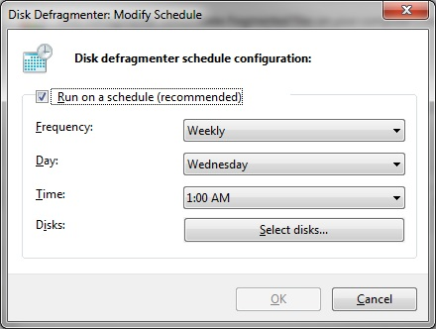

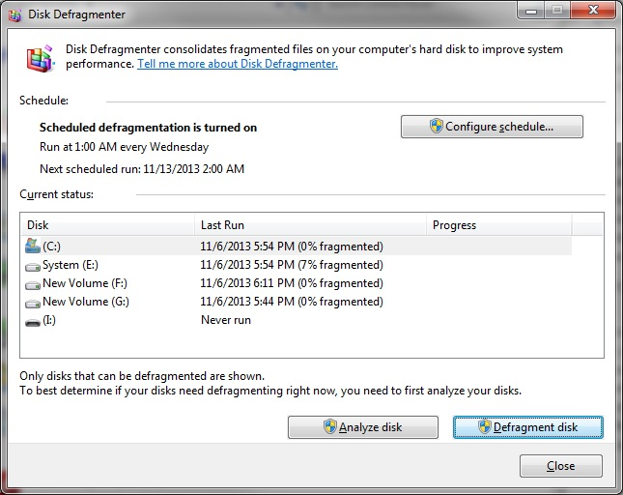

* **Resource Monitor**

Hit **Start** button, and then go to **all Programs**. Open the **Accessories** folder and choose **System Tools** and then open the **Resource Monitor**.

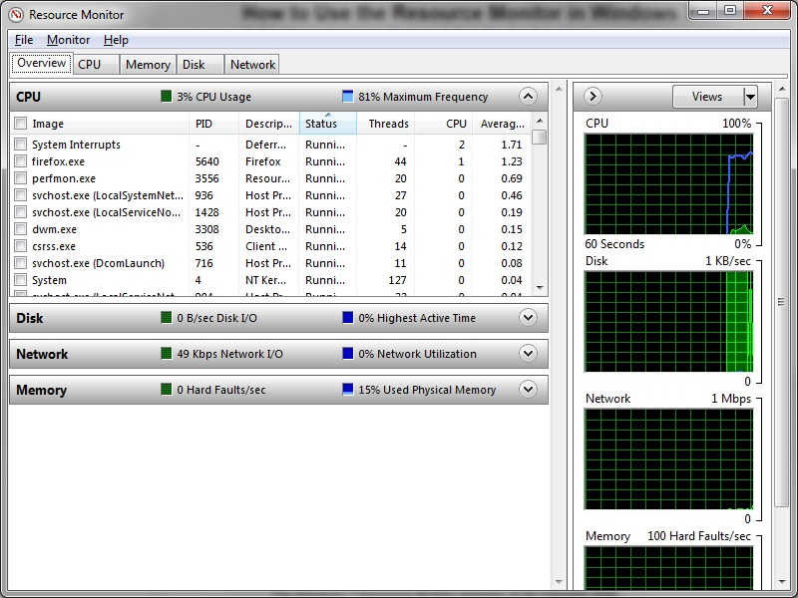

* **Performance Troubleshooter**

Click **Start**, **Control Panel**; click the arrow next to Control Panel in the Address box. **All Control Panel Items**, **Troubleshooting** to open the utility. Click next to run it. You will get a list of programs to stop from running at start up. Check the boxes of all the programs you want to stop running at start up. Click next to stop these programs from running at next start up. 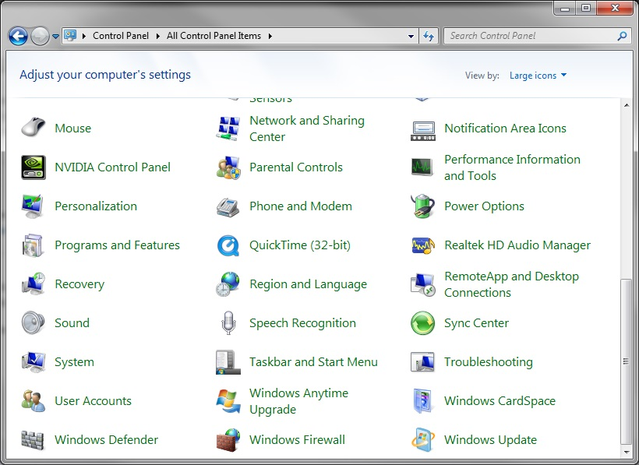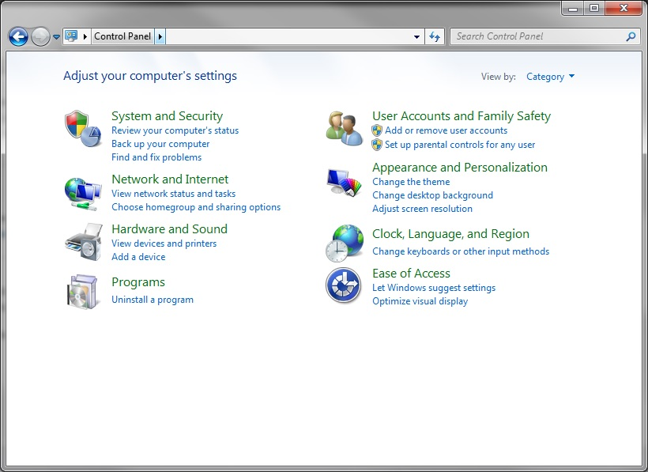

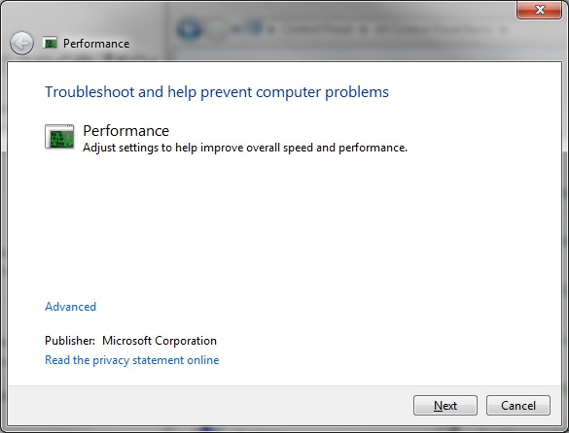

* **Disable the indexer for Windows Search**

Go to Start, Control Panel, All Control Panel Items, Performance Information and Tools. On the left, click the option to Adjust indexing Options. This will show you if indexing is on.

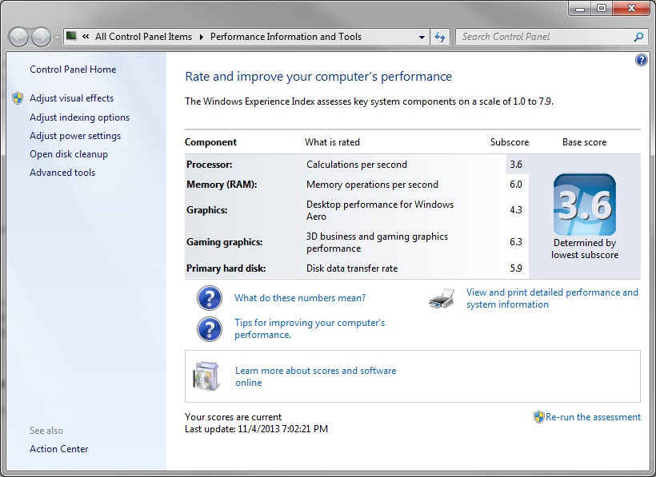

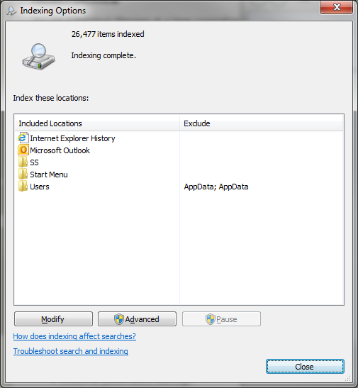

To disable type services in the Start menu search and open the Services dialog box. Click Windows Search and choose properties. Under general, Sartup type; choose Disabled. 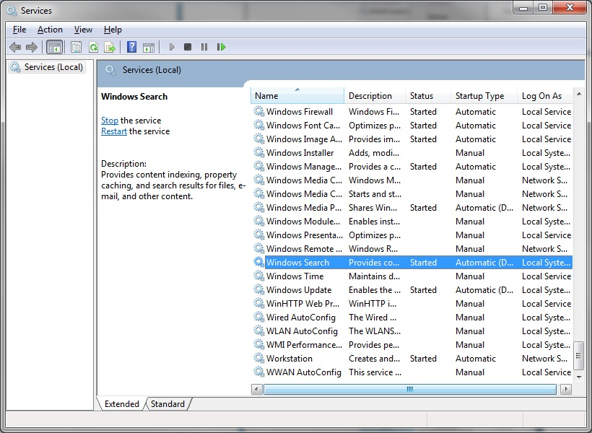

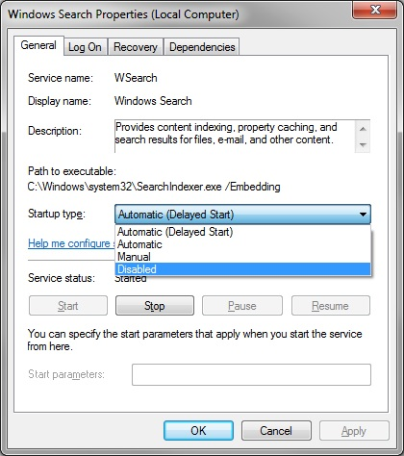

* **Disable Aero**

Right click in the Desktop and choose Personalize. Scroll down to Basic and High Contrast Themes and choose Windows 7 Basic.

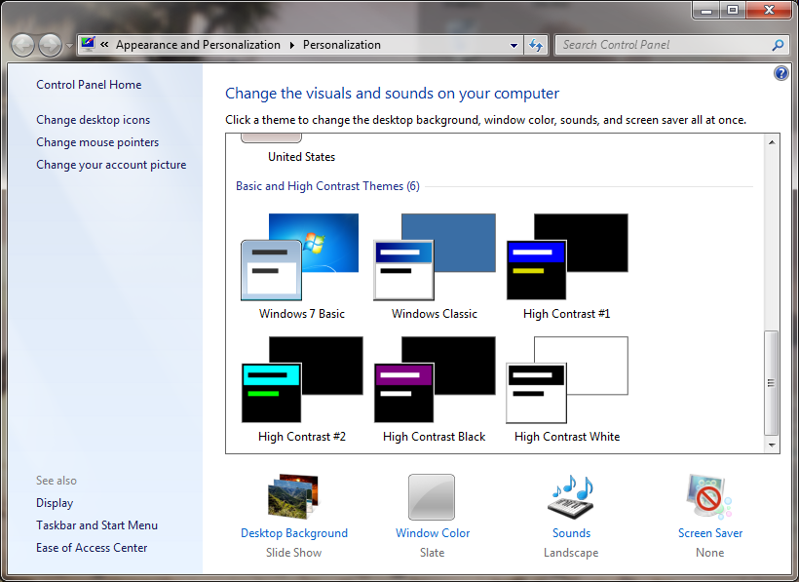

* **Remove Gadgets from the Desktop**

Move the cursor over the Gadget and click the red x to close the gadget.

* **Plug up memory leaks**

Right click in the taskbar and choose Windows Task Manager. Click on the Processes Tab. Go to view, Select columns and ensure that Memory (Private Working Set), Handles and Threads are checked. If these values change over time those Applications may have memory leaks and need to be updated.

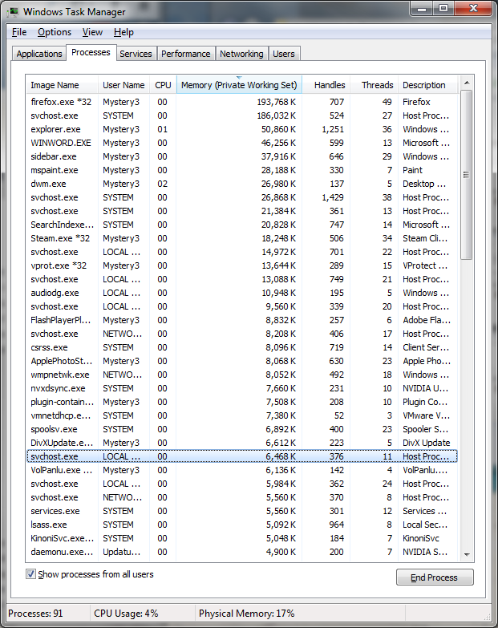

* **Disable User Account Control box** In the Start menu; click on the user accounts icon at the top of the menu. In the User Accounts and Family Safety > User Accounts click Change User Account Control settings. Change the notification to the desired level.

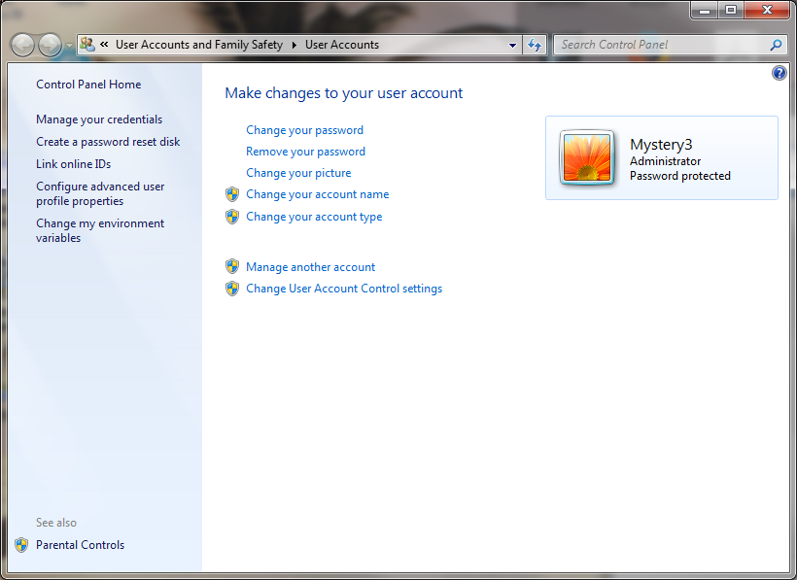

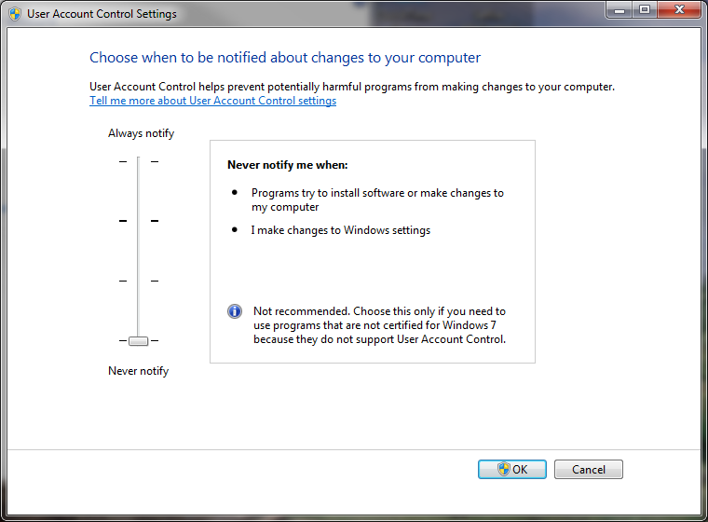

* **Can the Hardware Support the OS**

Go to [windows.microsoft.com/en-US/windows/downloads/upgrade-advisor](windows.microsoft.com/en-US/windows/downloads/upgradeadvisor) to download and run the upgrade advisor. It will tell you if your system hardware is compatible.

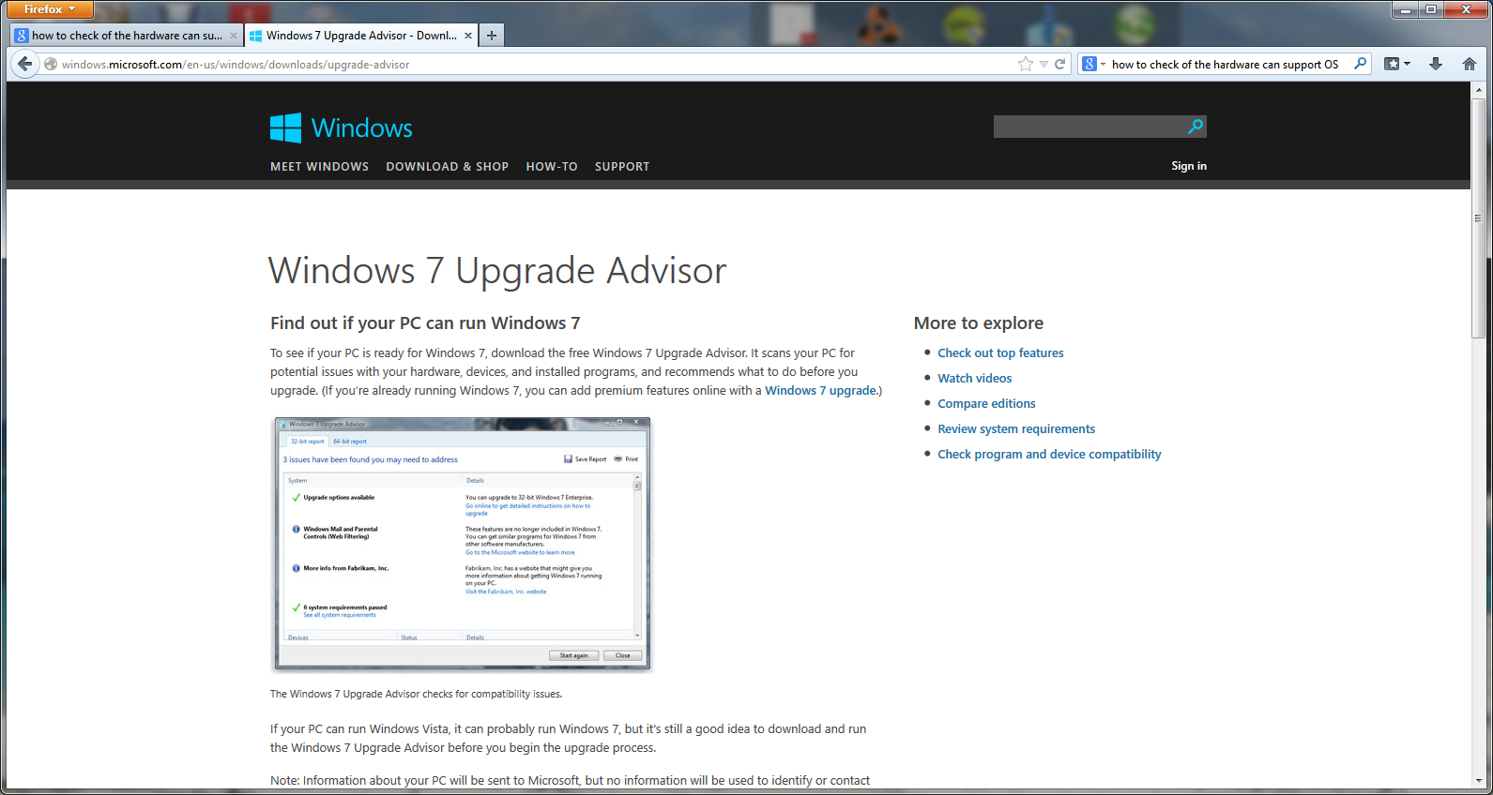

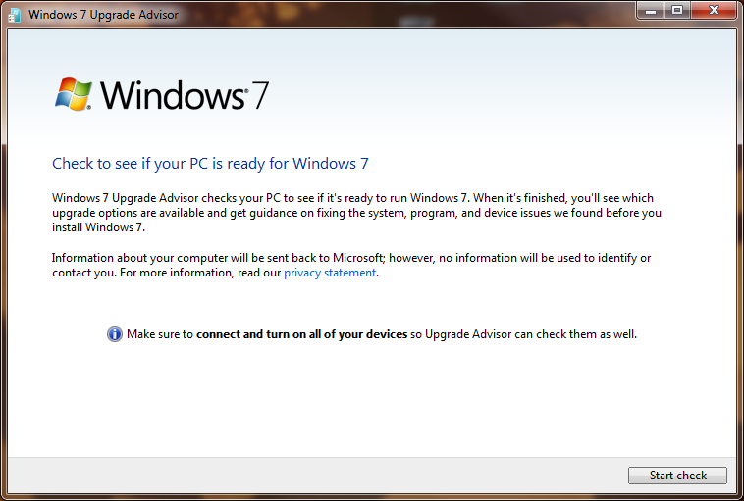

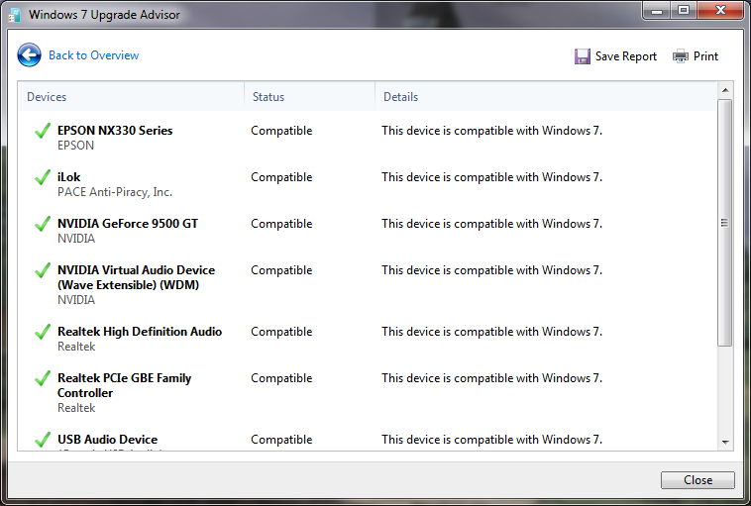

* **Check for Performance Warnings**

To check for performance warnings go to the Performance Information and Tools window and click Advanced Tools. If there are known issues they will be at the top under Performance issues.

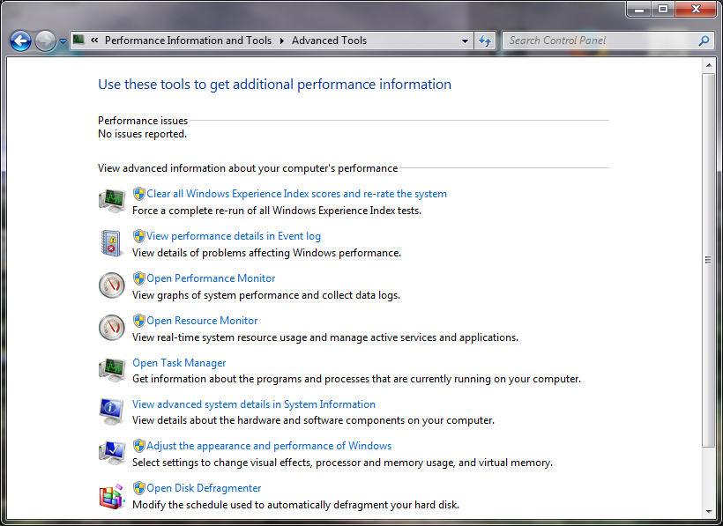

* **Clean up Windows Startup**

In the Start menu search, type run. In the run dialog box type; msconfig. In the System Configuration box click on the Startup tab. Uncheck any programs you do not want to start automatically. Click apply and then OK.

