Project 2

To begin the installation process you must insert the installation disk into the optical drive and reboot the system. When the system reboots hit the F8 button on the keyboard to access the boot menu. Select the optical drive as the bootable drive and exit the menu. The system will reboot and boot from the Windows installation disk. There are two options when you are upgrading a system to Windows 7, Upgrade and Custom. Choosing the upgrade option will replace your current version of windows and keep your files, settings and programs on the drive that Windows is installed on in a folder called Windows.old. There will be an option to automatically place the files, programs and settings back in their current location towards the end of the installation process, likewise you can do this manually after your new Windows installation boots for the first time. There is also a Custom option that allows for a clean install of Windows 7.

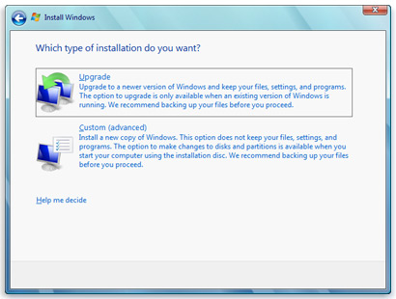

Next I am going to go through the steps of creating a new user with administrator privileges and a user with standard privileges, configure an IP Address, configure a network and local printer.

To start the process, go to control panel and select user accounts.

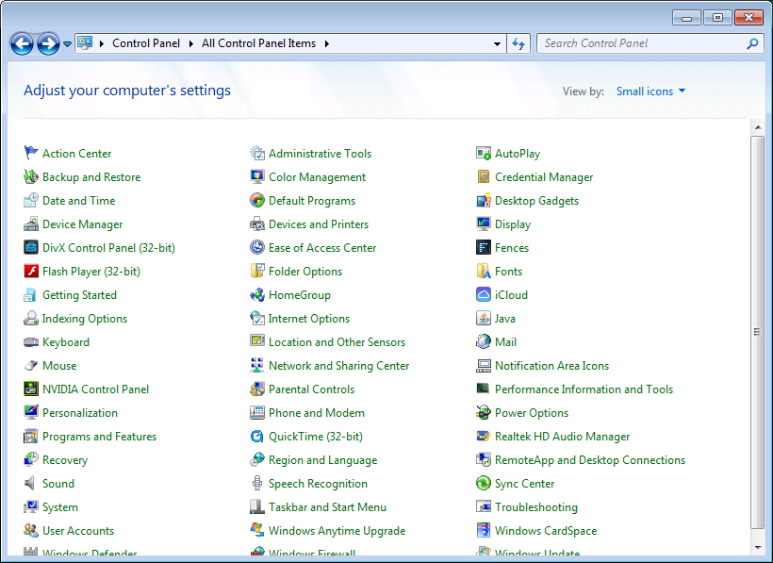

In the User Accounts chose Manage another account.

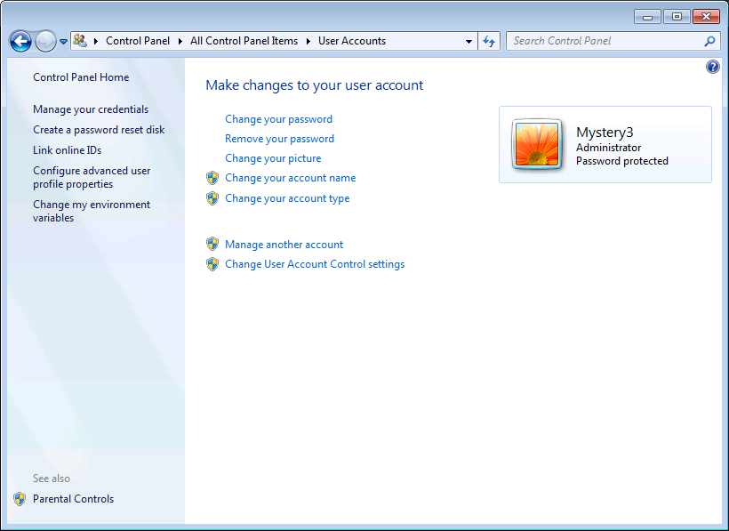

In Manage another account chose Create a new account.

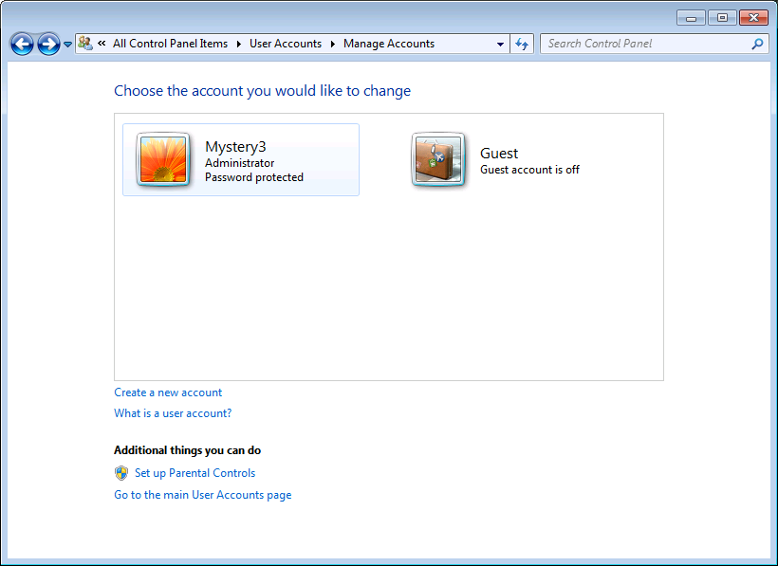

In Create New Account you will give the account a name and decide whether it will be a standard user or an administrator.

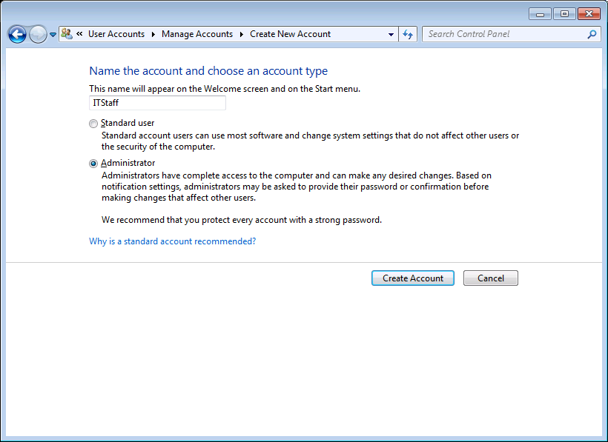

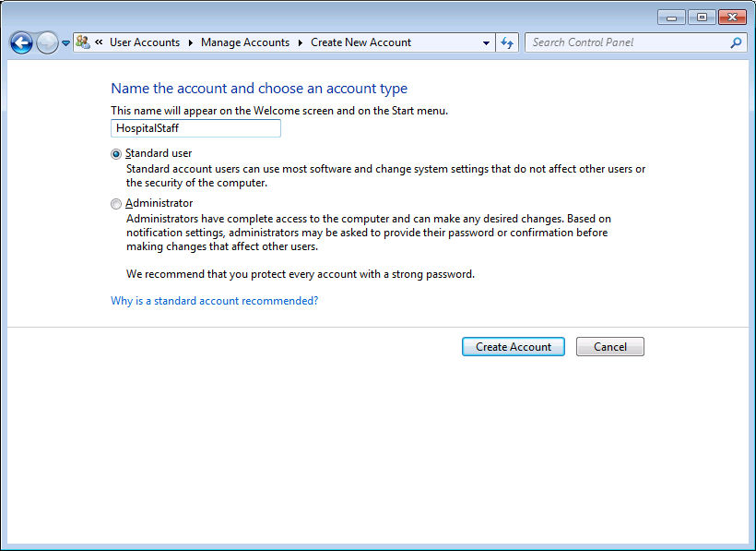

Next you should create a password for your new account. Under Manage Accounts chose the new account.

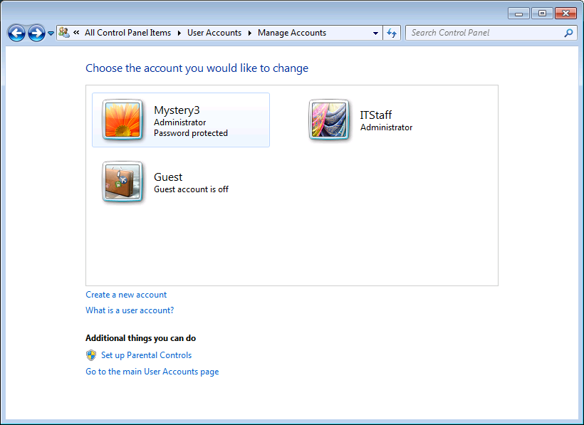

In Change an Account select create a password. In Create Password create a strong password and click Create password box at the bottom right to finish this process.

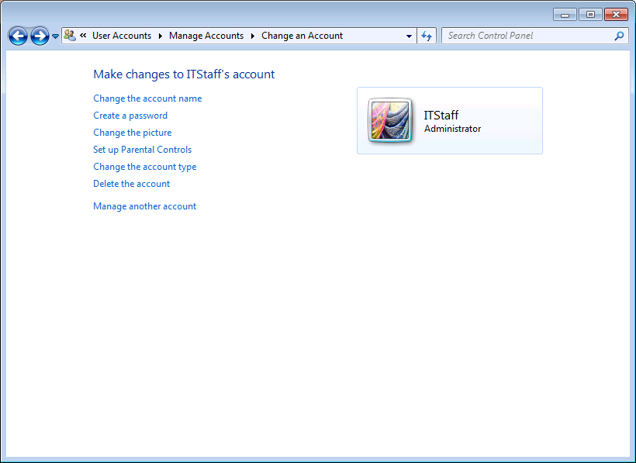

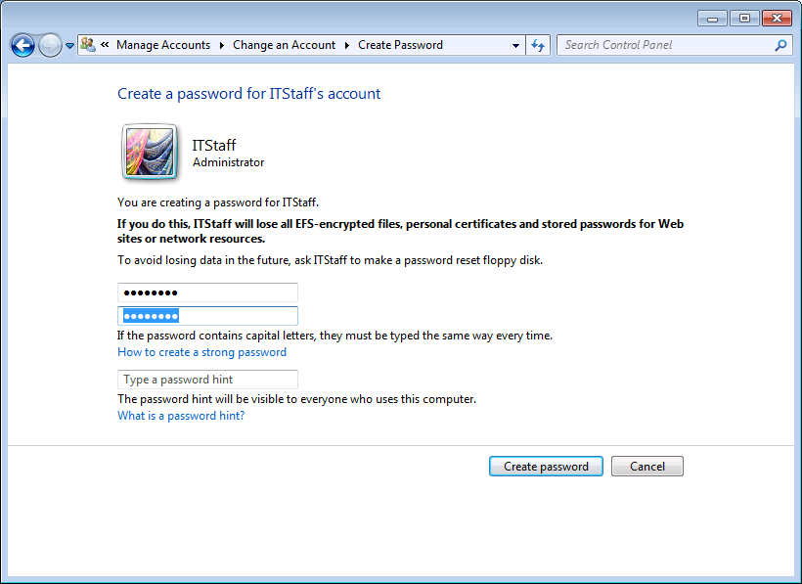

Next I will display how to configure a static IP Address. Go to control panel, Network and Sharing Center, Change Adapter Settings. Right click on Local Area Connection chose properties. Highlight the Internet Protocol Version 4 (TCP/IPv4) and click properties. In the Internet Protocol Version 4 (TCP/IPv4) Properties select Use the following IP address and Use the following DNS server addresses and fill in the information manually. Click OK to save the settings.

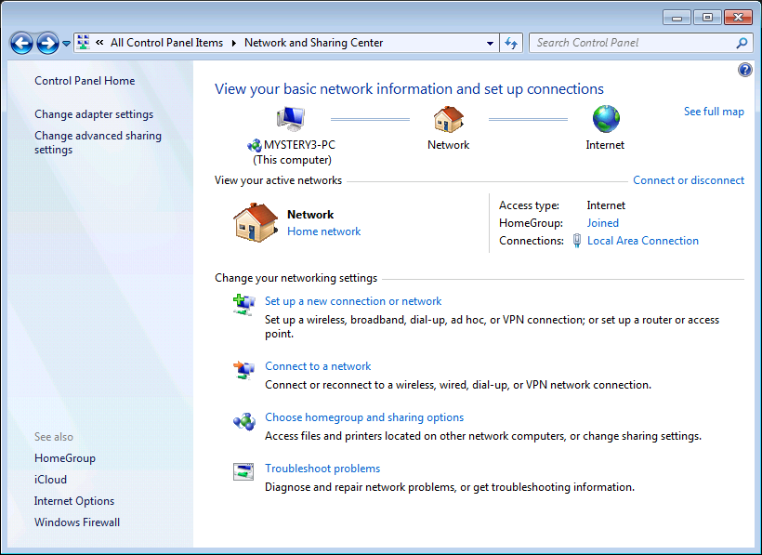

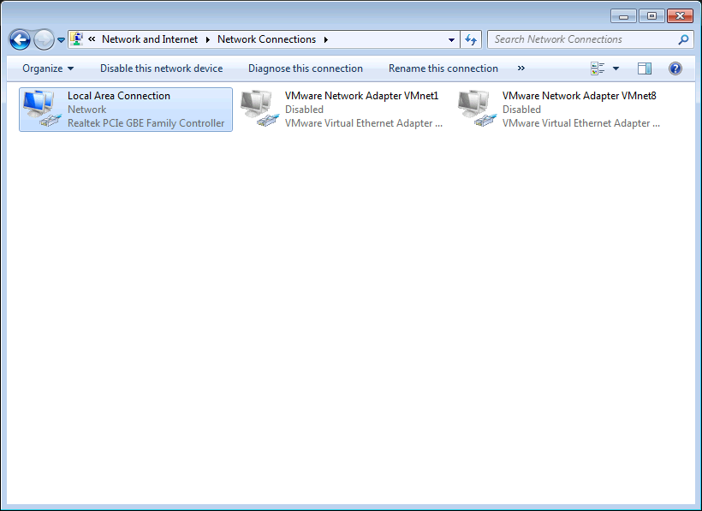

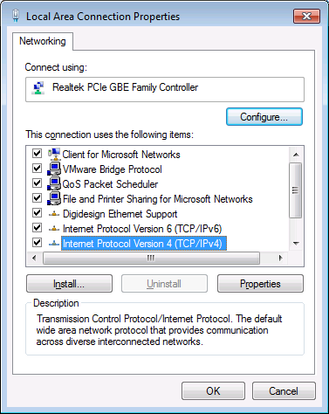 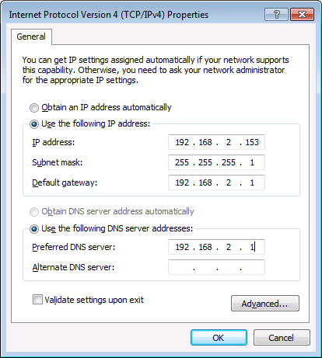

Next I will show how to set up and share a local and network printer. In the Start menu select Devices and Printers. In Devices and Printers select Add a printer. Chose weather you want to ass a local or network printer.

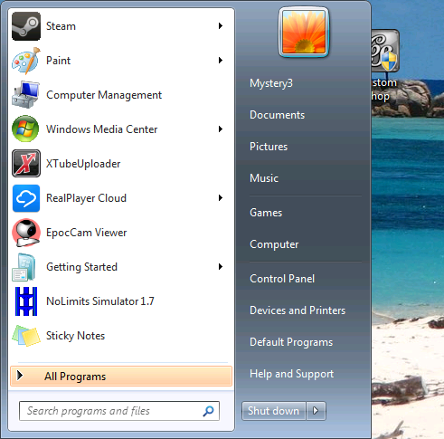 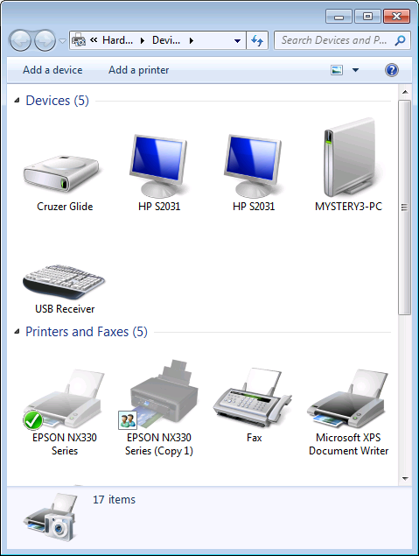

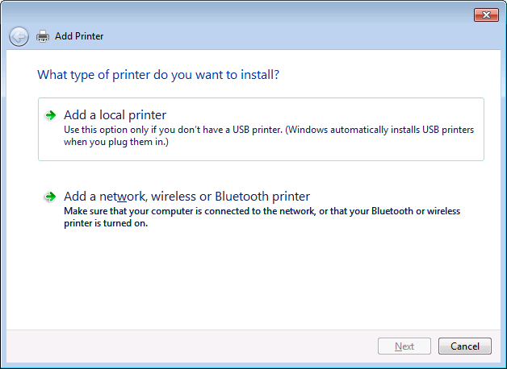

If you are configuring a local printer you will have an option to create a new port or use an existing port. If you create a new port you will have the ability to add a Hostname or IP address and a Port name.

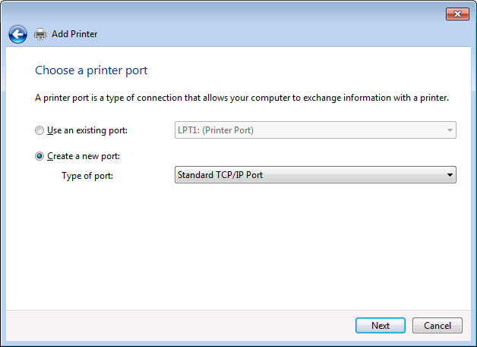 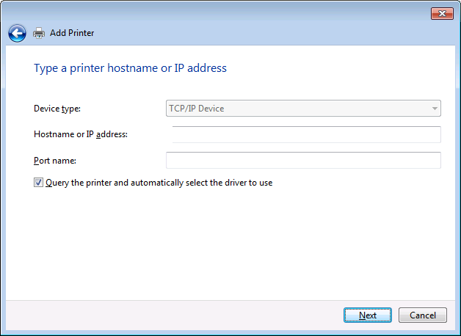

To configure a network printer chose the Add a network, wireless or Bluetooth Printer. Select the printer from the list or chose The printer that I want isn’t listed. Then Add a printer using a TCP/IP address or hostname, click next. In Device type select TCP/IP Device and add a Hostname or IP address

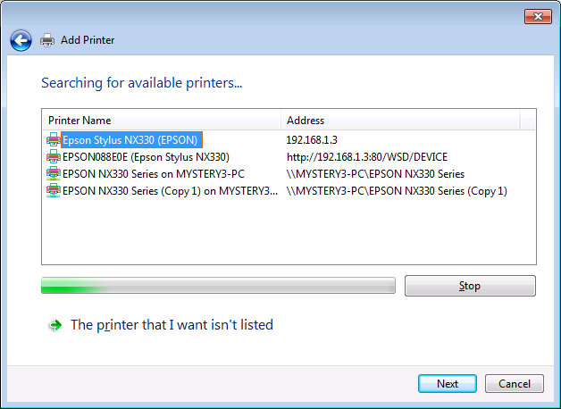

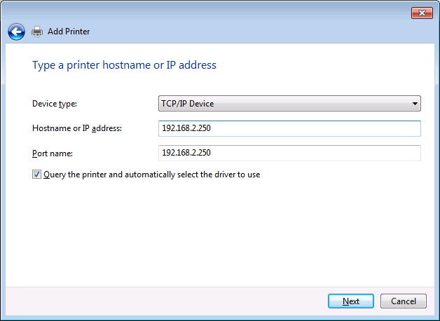

I created a file structure to the organizations expectations.

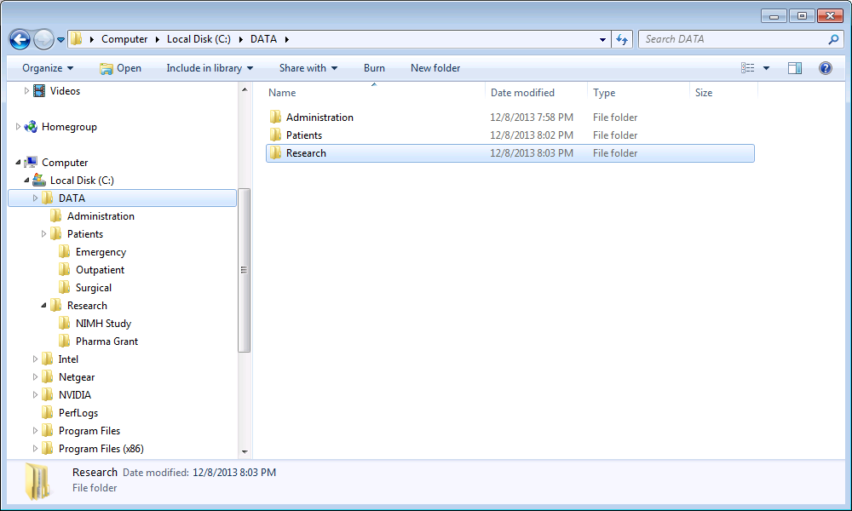

Next I will display step to create a log on notice. First go to the Start menu. In the search type regedit and select the Registry Editor. Go to HKEY_LOCAL_MACHINE\Software\Microsoft\Windows\Current Version\Policies\System. Click on the Legal Notice Caption and enter your header in the Value Data field. Then click on the legal notice text and enter the text in the Value Data field. You must reboot the system for the changes to take place. Note: You should always make a backup of the Registry Editor before you make changes as the Registry Editor is vital to the Windows OS.

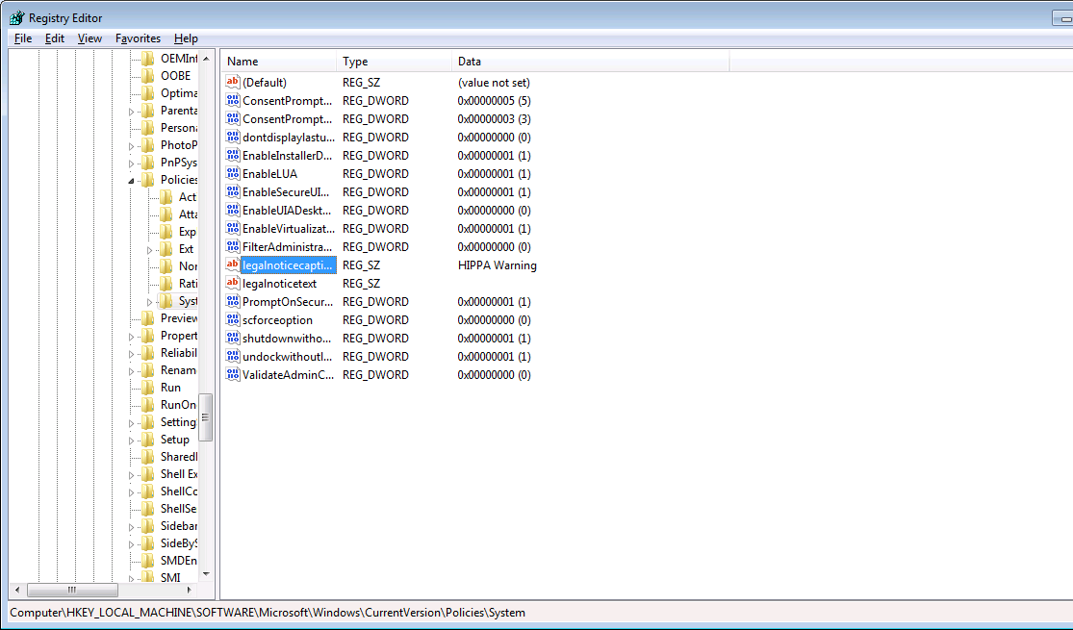

In conclusion the lessons and techniques that I have learned in this course have value far pass the cost of tuition. As virtually all business is done in Windows being able to administer a Windows based network is one of the most valuable tools an IT Specialist can have. Aside from the business of the skills I have obtained it is also very important to have these skills for my own personal computer and home network. I personally believe that most of the skills here should be a prerequisite for anyone that works on a computer.

References

microsoft.com. Installing and reinstalling Windows 7. Last updated December 6, 2013. Windows.microsoft.com/en-us/windows7/installing-and-reinstalling –windows-7