Call for Participation:

The 1st Youth Innovation Forum on Digital Earth (Second Round)

**Theme**

Digital Earth in Support of Global Sustainable Development

**Date**

August 21-23, 2023

**Location**

Beijing Friendship Hotel, Beijing, China

**Hosted by**

International Society for Digital Earth

International Research Center of Big Data for Sustainable Development Goals

Aerospace Information Research Institute, Chinese Academy of Sciences

**Organized by**

International Society for Digital Earth - Young Scientist Innovation Network

Nanjing Normal University

**Background**

Digital Earth makes use of various forms of digital technologies to understand and model physical and human spaces, and plays a crucial role in sustainable development. Since launched by the United Nations in 2015, the Sustainable Development Goals (SDGs) become a universal call to action to protect the planet and improve the lives and prospects of everyone in the world. How to utilize advanced digital technologies to achieve SDGs becomes increasingly important. Under this context, the International Society for Digital Earth and the Aerospace Information Research Institute Chinese Academy of Sciences will host “The 1st Youth Innovation Forum on Digital Earth” on August 21-23, 2023 in Beijing, China. The theme of the Forum is “Digital Earth in Support of Global Sustainable Development”. The Forum welcomes young researchers, scholar and graduate students in the field of Digital Earth and related disciplines to participate and present their cutting-edge research outcomes.

# Keynote Speakers



Prof. László Bertalan

Department of Physical Geography and Geoinformatics, University of Debrecen, Hungary

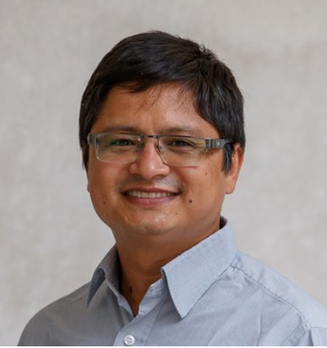

Dr. Prajal Pradhan

Potsdam Institute for Climate Impact Research, Germany



Dr. Martin Sudmanns

Department of Geoinformatics, University of Salzburg, Austria

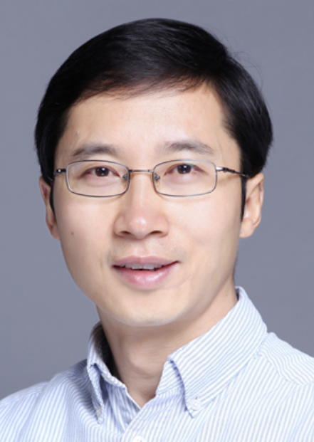

Prof. Weiqi Zhou

Research Center for Eco-Environmental Sciences, Chinese Academy of Sciences, China

Continuously updating……

# Sessions

|  |  |
| --- | --- |
| Session 1 Study on the Interaction among Sustainable Development Goals | |
| Dr. Junze Zhang | Research Center for Eco-Environmental Sciences, CAS |
| Prof. Min Cao | Nanjing Normal University |
| Session 2 Big Earth Data in Promote of Marine and Coastal Sustainable Development (SDG 14) | |
| Dr. Mingming Jia | International Research Center of Big Data for Sustainable Development Goals |
| Prof. Hongsheng Zhang | The University of Hong Kong |
| Session 3 Spatial Technologies Facilitate the Conservation and Sustainable Development  of Natural and Cultural Heritage (SDG11 &SDG15) | |
| Dr. Lei Luo | International Research Center of Big Data for Sustainable Development Goals |
| Session 4 Intelligent Monitoring and Evaluation of Agricultural Land Systems | |
| Dr. Lijun Zuo | Aerospace Information Research Institute, CAS |
| Dr. Qiangyi Yu | Institute of Agricultural Resources and Regional Planning, CAAS |
| Prof. Baodong Xu | Huazhong Agricultural University |
| Session 5 Regional Sustainable Development and Sustainability Transitions | |
| Prof. Shuangshuang Tang | Nanjing Normal University |
| Prof. Xiaohui Hu | Nanjing Normal University |
| Prof. Xiyan Mao | Nanjing University |
| Session 6 Regional Sustainable Development and Strategies | |
| Prof. Yali Liu | Beijing Forestry University |
| Dr. Xutong Wu | Beijing Normal University |
| Session 7 Geospatial Big Data Analytics and AI for Public Health | |
| Prof. Wei Luo | National University of Singapore |
| Dr. Ling Yin | Shenzhen Institutes of Advanced technology, CAS |
| Session 8 Big Earth Data in Support of Sustainable Urban Development | |
| Dr. Zhongchang Sun | Aerospace Information Research Institute, CAS |
| Session 9 Advancements and Challenges in One Health Studies leveraging Big Earth Data | |
| Dr. Jinwei Dong | Institute of Geographic Sciences and Natural Resources Research, CAS |
| Dr. Cunrui Huang | Tsinghua University |
| Session 10 Key Technologies and Paths for Achieving the Global SDG7 Affordable and Clean Energy Goal | |
| Dr. Mingquan Wu | Aerospace Information Research Institute, CAS |
| Session 11 Novel Monitoring Methods in Remote Sensing of Surface Water | |
| Prof. László Bertalan | University of Debrecen, Hungary |

# Abstract Solicitation

To present your research, authors can submit an ABSTRACT through the online submission system: <http://isde_ysin2023.digitalearth-isde.org/> before 15 July, 2023. The length of an abstract is 200 to 300 words in English.

# Excellent Paper Award

To apply for the Excellent Paper Award (EPA), authors must submit a full-length research PAPER (5000-8000 words) through the online submission system before 31 July, 2023: <http://isde_ysin2023.digitalearth-isde.org/>

* The paper being submitted for EPA evaluation must not have been published.
* EPA applicants must orally present their papers in the forum.
* A candidate should be a graduate student, or a young scholar less than 45 ages.
* The winners of EPA will be announced in the closing ceremony.

# Young Scientist Award

The Young Scientist Innovation Network (YSIN) Young Scientist Awards are established by the International Society for Digital Earth (ISDE) to recognize and honor outstanding young scientists who are proactive and passionate in the field of Digital Earth and who develop crucial concepts and innovative technologies to affect our society and environment.

Each year, 2-3 award-winners will be selected by the awards committee through the competitive and rigorous evaluating procedure. The rules and criteria for the selection include, but are not limited to, the following:

* Outstanding accomplishments of young individuals
* Actively serving and contributing to the field of Digital Earth in particular and the scientific community in general
* Age <= 45 & Member of YSIN-ISDE

Applicants should submit his/her detailed CV and Statement of Application (which outlines his/her accomplishments and contributions) to [ISDE_YSIN@163.com](mailto:ISDE_YSIN@163.com) before 31 July, 2023. The winners of the Young Scientist Award will be announced in the closing ceremony.

# Important Dates

* Registration starts on: 27 June, 2023
* Abstract due: 15 July, 2023
* Abstract acceptance notice: 18 July, 2023
* Registration ends on: 21 August, 2023

# Registration Fees

|  |  |
| --- | --- |
| Type | US$/RMB¥ |
| Student | $150 / ¥1000 |
| ISDE&ISDE-YSIN member | $240 / ¥1600 |
| Non ISDE& ISDE-YSIN member | $280 / ¥1800 |

# Forum Language

English is the presenting language of the forum.

# Overall Schedule

|  |  |  |
| --- | --- | --- |
| **Date** | **Time** | **Content** |
| 08.21 | 09:00-21:00 | Registration |
| 08.22 | 09:00-10:00 | Opening Ceremony |
| 10:00-11:30 | Keynotes |
| 11:30-13:30 | Lunch Break |
| 13:30-18:00 | Parallel Sessions |
| 08.23 | 09:00-12:00 | Parallel Sessions |
| 12:00-13:30 | Lunch Break |
| 13:30-18:00 | Parallel Sessions |
| 18:00-18:20 | YSIN Young Scientist Awards and Closing |

# Committees

**Academic Committee**

* **Chairs**

Prof. Huadong Guo, International Research Center of Big Data for Sustainable Development Goals

Prof. Alessandro Annoni, International Society for Digital Earth

* **Members**

Prof. Temenoujka Bandrova, University of Architecture, Civil Engineering and Geodesy

Prof. Arzu Çöltekin, University of Applied Sciences and Arts Northwestern Switzerland

Prof. Carlos Antonio da Silva Junior, State University of Mato Grosso

Prof. Cheryl Desha, Griffith University

Prof. Eugene Eremchenko, Lomonosov Moscow State University

Prof. Hiromichi Fukui, Chubu University

Dr. Gregory Giuliani, University of Geneva

Prof. Michael F. Goodchild, University of California

Prof. Changchun Huang, Nanjing Normal University

Prof. Milan Konecny, Masaryk University

Prof. Kamal Labbassi, Chouaib Doukkali University

Prof. Hui Lin, Jiangxi Normal University

Dr. Joan Masó, Centre for Ecological Research and Forestry Applications, Universitat Autònoma de Barcelona

Dr. Paolo Mazzetti, Institute of Atmospheric Pollution Research, National Research Council of Italy

Prof. Graciela Metternicht, Western Sydney University

Dr. Zaffar Sadiq Mohamed-Ghouse, Woolpert, Australia

Dr. Stefano Nativi, National Research Council of Italy

Prof. Luis Perez-Mora, Griffith University

Prof. Faramarz Samavati, University of Calgary

Dr. Sven Schade, Joint Research Centre, European Commission

Dr. Richard Gordon Simpson, Meta Moto, Australia

Prof. Josef Strobl, Paris Lodron University Salzburg

Prof. Mario Hernandez, International Society for Digital Earth

Prof. Cuizhen (Susan) Wang, University of South Carolina

Prof. Linwang Yuan, Nanjing Normal University

**Forum Chair**

Prof. Changlin Wang, International Society for Digital Earth

**Organizing Committee**

* **Chair**

Prof. Min Chen, Nanjing Normal University

* **Members**

Dr. Linlin Guan, Aerospace Information Research Institute, Chinese Academy of Sciences

Ms. Min Li, International Society for Digital Earth

Dr. Jian Lin, The Chinese University of Hong Kong

Ms. Jingna Liu, Aerospace Information Research Institute, Chinese Academy of Sciences

Dr. Zhen Liu, Aerospace Information Research Institute, Chinese Academy of Sciences

Ms. Ya Tian, Jiangxi Normal University

**Contact**

ISDE-YSIN Secretariat: [ISDE_YSIN@163.com](mailto:ISDE_YSIN@163.com)

# About ISDE Young Scientist Innovation Network

The International Society for Digital Earth (ISDE) is a non-governmental international academic organization to disseminate the vision of Digital Earth and the mission of benefiting society by promoting the development and realization of Digital Earth. Established on 26 May, 2023, the International Society for Digital Earth - Young Scientist Innovation Network (ISDE-YSIN) aims to empower young scientists in the field of Digital Earth, promote the development of crucial concepts and innovative technologies of Digital Earth, and contribute to the global sustainable development by using digital technologies.