Brief Documentation for Annotation on Video Call by UserName using RTCMulticonnection library

1. Brief description

To draw annotation on video call, the new layer for drawing is laid on the video stream tab.

The onShareVideo function in call-by-username.html takes the part of the annotation on live video.

var onShareVideo = function (id, width)

Fig1. onShareVideo function for annotating on the live share stream.

When drawing on the canvas, the coordinate information is transferred via the connection’s data session.

connection.session = {

  audio: true,

  video: true,

  data: true,

  // broadcast: true // if you remove this, then it becomes MANY-to-MANY

};

Fig2. Configuration of session for the service.

  designer.addSyncListener(function (data) {

    connection.send(data);

  });

Fig3. Send the drawing data.

connection.onmessage = function (event) {

  if (event.data === "plz-sync-points") {

    if (designer === null) {

      return;

    }

    designer.sync();

    return;

  }

  designer.syncData(event.data);

}

Fig4. Receive and sync the drawing data.

onTakeSnapshot function takes the part of the snapshot of the annotated screen.

var onTakeSnapshot = function ()

Fig5. Take the snapshot of the annotated screen.

1. Manual

-AWS EC2 instance is used as the server for this work so that the source is uploaded and installed to the instance. The server’s 80 and 443 ports are available and the work is using the 443 port as https server. To run the server, npm install first and then type node server command in the cli. The client can access to <https://34.239.254.160/> in his browser then you can see as the following:

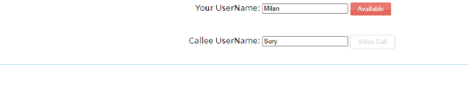

Fig6. The first interface of the work.

-You should input “Your UserName” and click the “Available” button to make the user available. After click the available button, you can see the screen as the following.

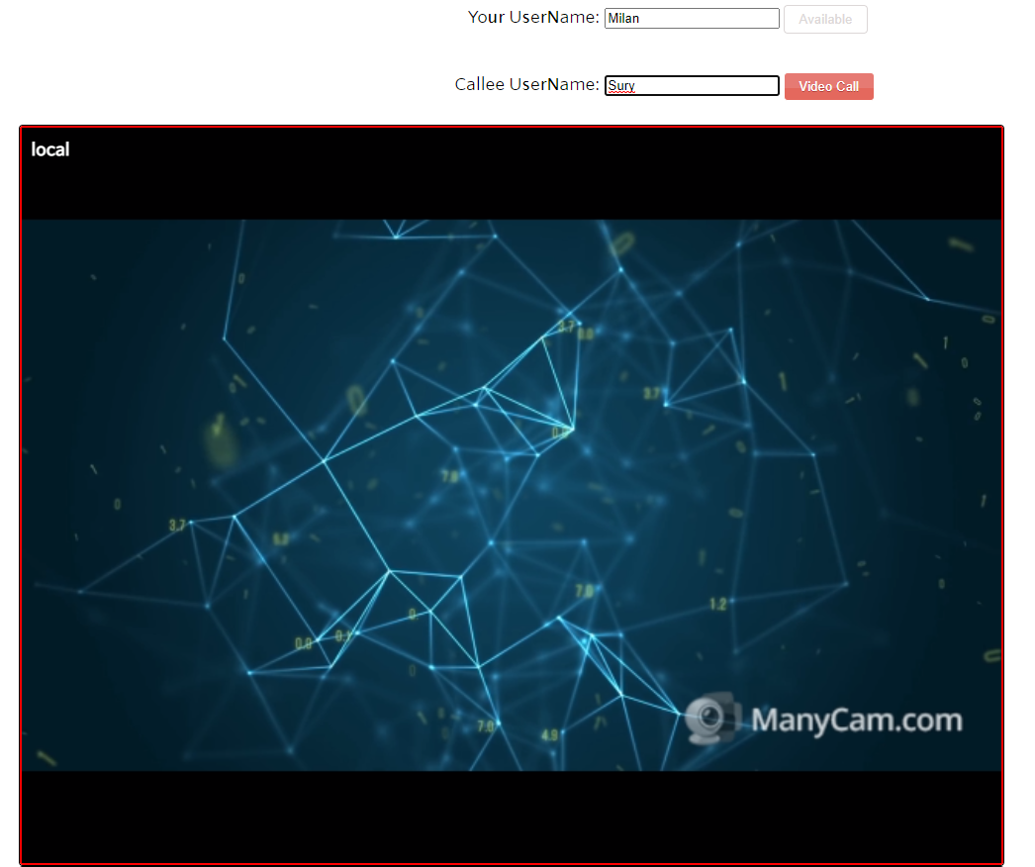

Fig7. The screen after making user available.

-And then input the counterpart name in “Callee UserName”. If you click the “Video Call” button before the callee is available, you cannot call him. The counterpart does the same process as you like input and make available your name and input callee’s name.

-Now, two users are available and you can click the “Video Call” button for live video call. To make annotation on the live video stream, you should click the “share” button in the right-upper corner of screen, then you can see an annotation tool box. To confirm the communication channel, one user clicks the button on the screen’s remote side and the other user also clicks the button on his screen’ s local side to share it.

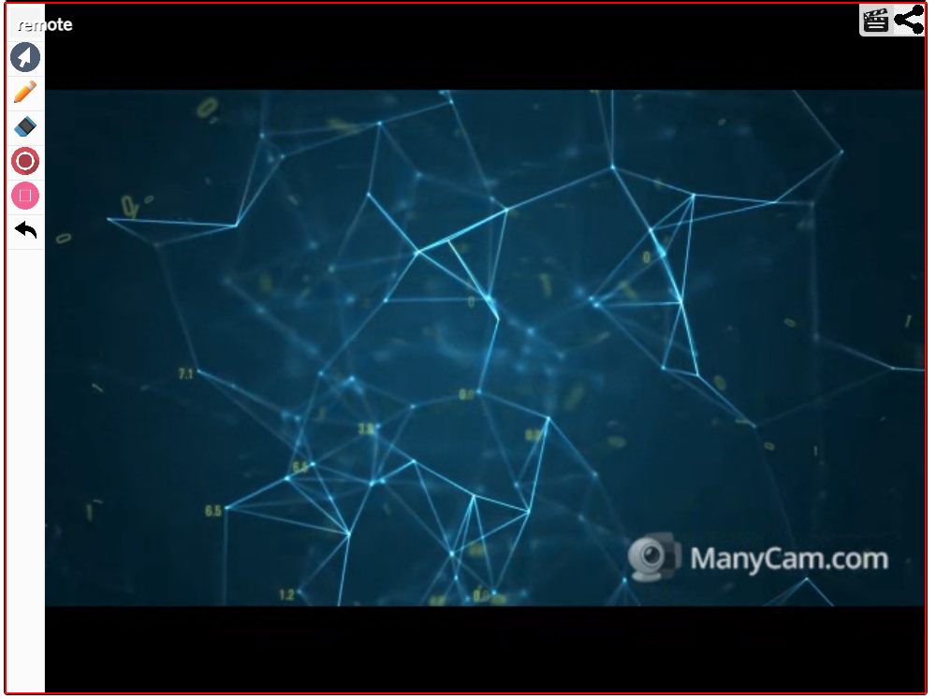

Fig8. After click the button for annotation on share screen.

-You can draw annotation on the counterpart’s share screen as you want.