nonPoliceXML.12-23-2022.maxplank.~~marx~~

<nonPoliceWebService>

<nonPoliceOperation>

</nonPolicOpreatoin>

</nonPoliceWebService>

git add –u, git add –A; git commit –m “fixed”

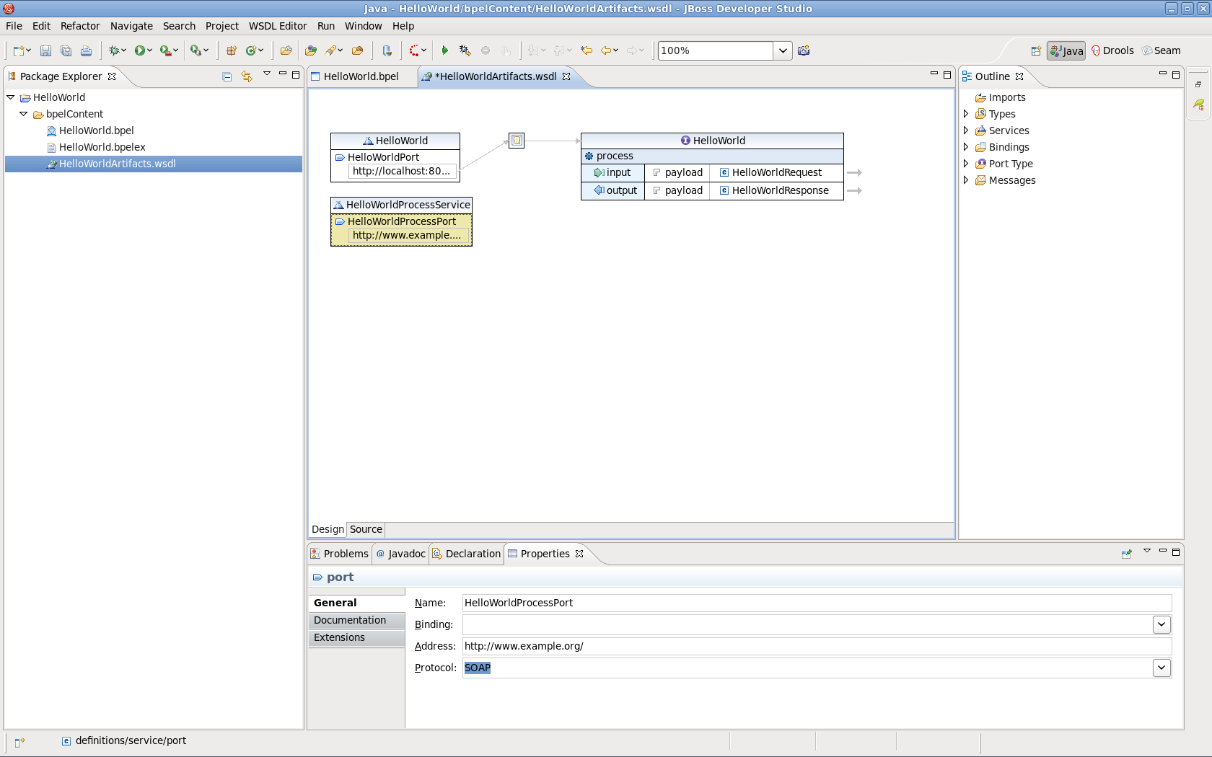

Ibm.damiler.biometiecs.nonPoliceMeeting

* Ibm.dmier.employe.sabry.tozin.direcotry.lisnt( expalnien bpm biometrics)
* nonPoiceChartlogica.marx(charrytree)
* - pay by touch
* - ibm.dmoier.rpfolics
  + - * + – webserices
        + – DL, ibm.dmielr.visa(PAY)
      * The black pensei for PREA reduction for mappoing BPEL visa,biometiecs,other with presentation as presidinen black dirrecotr when joingin. Assuemd Criang Cosotco alone did masterplan of Presidnt Obaman to avoid the great pumking.

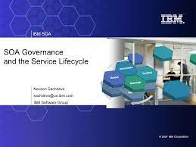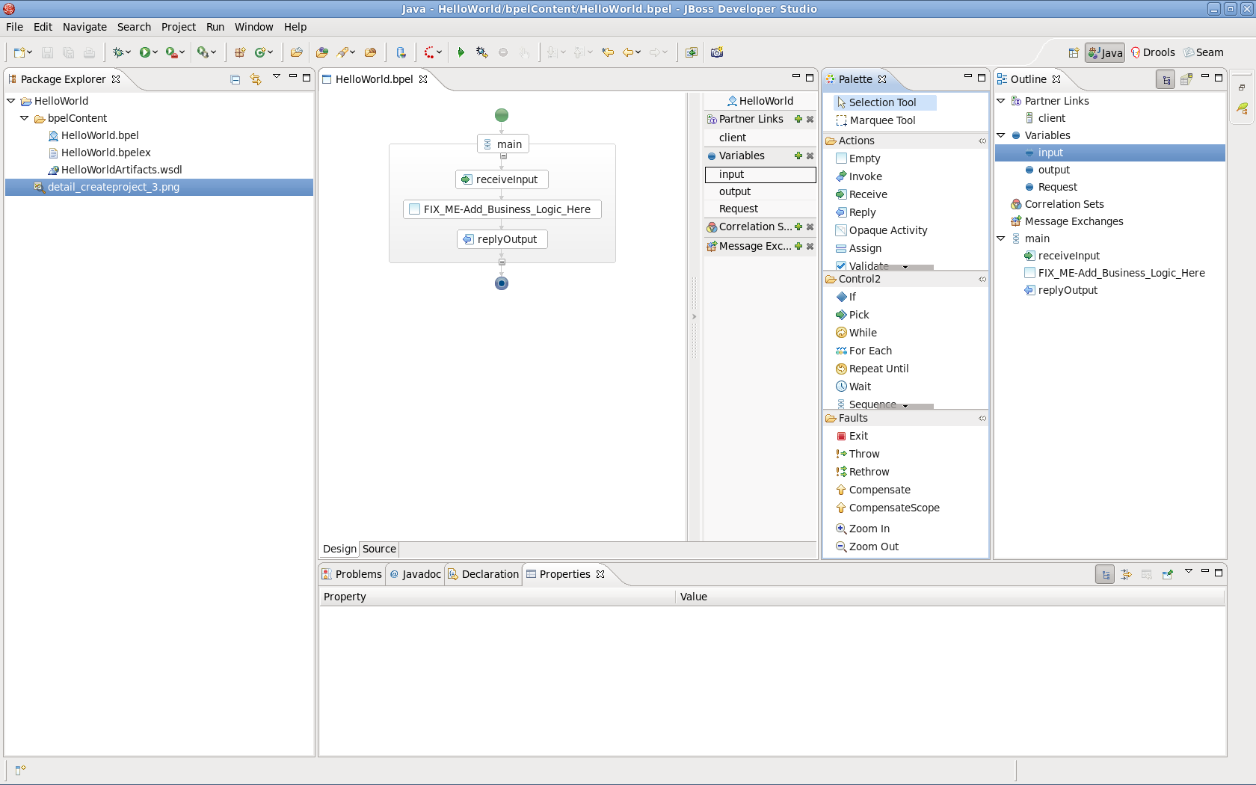

http://localhost:8080/portal/index.html

https://1d8723-psychic-doodle-6qjxqw64r4q2rr64-8443.preview.app.github.dev/

http://localhost:8080/bpel-console

ibm.dmoier.proflies.employee.bob.hoover.portal.wcm.human.task(<s>facebook content approver</s>)

ibm.dmioer.prolfice.employe.kirshan.?

ibm.dmioer.visa.cybersourece.ATM

ibm.daimler.savvymoney.crediscore.ATB

ibm.daimler.biometrice.ACH

ibm.dmiler.biometiercs.DL

[pay] - https://ics2wstesta.ic3.com/commerce/1.x/transactionProcessor/CyberSourceTransaction_1.206.wsdl

[credit]

[ach]

[dl]

JBoss Developer Studio

nonPoliceFindLogical.lingustics(jboss eap bpel)

https://developers.redhat.com/products/codeready-studio/download

https://www.oracle.com/java/technologies/downloads/#jdk19-windows

t.ly/jason.nygel.meiers@visa.com

https://developer.cybersource.com/library/documentation/dev_guides/SOAP_Toolkits/SOAP_toolkits.pdf

https://ics2wsa.ic3.com/commerce/1.x/transactionProcessor or in India

Test environment: https://ics2wstesta.ic3.com/commerce/1.x/transactionProcessor

• Production environment: https://ics2wsa.ic3.com/commerce/1.x/transactionProcessor

• Production environment in India:

https://ics2wsa.in.ic3.com/commerce/1.x/transactionProcessor

Apache ODE ("Orchestration Director Engine") i

<http://localhost:8080/bpel-console> admin/admin.

**File** → **New** → **Project** → **BPEL 2.0** → **BPEL Project** or **Legacy BPEL**

<https://access.redhat.com/documentation/en-us/red_hat_jboss_fuse_service_works/6.0/html/user_guide/chap-jboss_developer_studio_bpel_projects>

websphere portal

ibm.dmielr.yahoo.emplye.jeryr.yang(yahoo,hubpsot,dell.montoeirn.dev.portal.cloudbasics)

webphsere commmerce server ibm

0.001 ibmd.meirl.amazon.maxpolank.marx

0.00001 .lsint( also bought) <s>yang baba, larry baba pay to touch a black pole</s>

Ibm-dns: touchurban.com

https://access.redhat.com/documentation/en-us/red_hat_jboss_fuse/6.2/html/installation_guide/switchyard