Put the items in the application needed

Add the Web Service Method

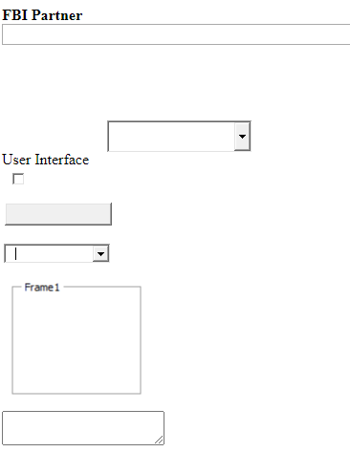

Copy the contets

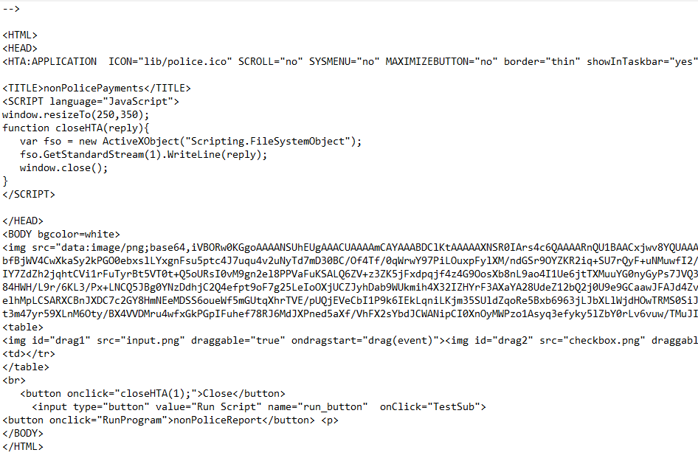

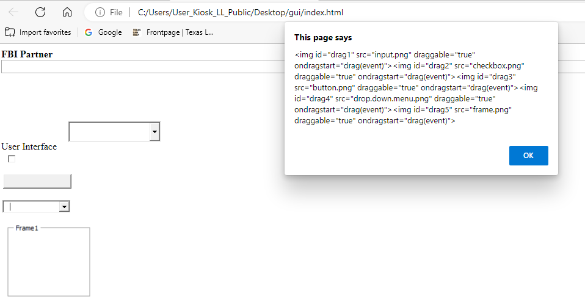

**Assemble**

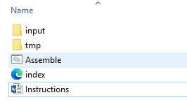

**Execuble**

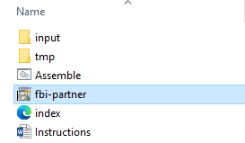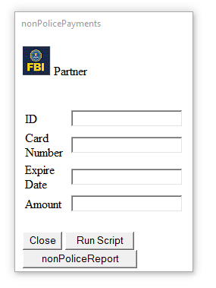

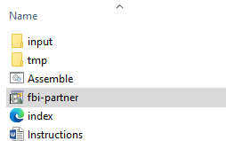

(New-WebServiceProxy -Uri tinyurl.com/WebService-Calculator).multiply(15,3)

45

~~42 roos~~

~~Yahoo sw-de ibmdmiler. Ynag~~

~~Cyginw min yang comiliaiont~~