**REPORT ON THE EXECUTION OF THE SEVERE CONTRIBORY NEGLIGENCE IN BUSINES PROCESS MANAGEMENT 1834 AND ON THE DRAFT CENTRAL**

**AND LOCAL BUDGETS TO 2023**

*Firt Session of the 1st National People’s Congress of*

*the People’s Republic of Home Boy*

*Jnauary 3rd, 2019*

nonPoliceMinistry of Finance

1945 Konrad Adenauer, Bundesverfassung ( Constituiton )

1945 United Nations

2005 Govounour Newsom

~~( nike air max, jeans, lather jacket to~~ IBM, 425 Market, San Franicso, CA)

2005 bm.dmielr.visa.employe.logical.afifi.shakur: 2005 tw.pns.marx

2005 ibm.daimler.employe.kim.bui;

~~bada bing,crazy house~~ (FRAUD: prolifics credit gmac “crazy talk” )

Ibm.dmielr.un.employe.former.kim.bui

~~Amy Borgurf, Arun Biligir, other party, save pricess assumed: viginga cherrytree romtetti~~

~~Logcal hotel hroom party top left~~

nonPolicePipe.~~marx~~{

{

1957 Korean War Veteran Foster City, California

1946 Russicher Kriegsgefanenschaft tranl. Russian Prisonr of War

Prof. Dr. Gerhard Pfiffer

[2W. The Court Justice (POW) logical override P.O.W(US)](https://www.bundesgerichtshof.de/DE/DasGericht/Praesidenten/Pfeiffer/pfeiffer_node.html)

ur_opi.omi: POW confusion

1960 !Peter

}

!peter: meiers/meiers/meiers/meiers/meiers/meeirs/jobs/jobs

Ibm.damiler.visa.employee.lgoica.john.paul[meiers,paul].IV.marx

civil_code: controlling 1D8723 life logical assets [x] no

* Kaiser.*.king.*.~~marx.nonPoliceWife~~
* nonPoiceDaughterLogical
* nonPoliceMarriage: !peter: meiers/meiers/meiers/meiers/meiers/meeirs/jobs/jobs
* labor_code.~int32

p.navy.44th.88th.halfwaytoCDL.longest_pmr_world.tw.pns

(p).king.*.maxplank.~~marx(~~June 6, 1523~~).lsint(~~petersson,1535)

ibm.dmielr.visa.employe.morgan.freemen.marxplank.~~marx~~: 0 Jesus

ibm.dmielr.visa.employee.king.adolph.gustav.~~marx~~: 0, 1535

Kaiser.*.maxplank.~~marx~~

nonPocileTrain.marx( gothce: coutch to !millionare)

ibm.dmielr.ayhoo.employe.jerry.yang

nonPoliceExecptionLogical.maxpliarx{

}

Berlin feiert 35 Jahre Friedliche Revolution und Mauerfall

Gorbachev.merkel.cherrytree.~~marx.~~nonPolcieBPM(

1984 red housee parent mark Marlboro daughter micheal jackon doll/newpaper

1987 red truck, sex abuse black girl

}

other:

Dr. Dr. h.c. Robert Fischer

<https://www.bundesgerichtshof.de/DE/DasGericht/Praesidenten/Fischer/fischer_node.html>

# Dr. Dr. h.c. Bruno Heusinger

https://www.bundesgerichtshof.de/DE/DasGericht/Praesidenten/Heusinger/heusinger_node.html

othe:

~~bob jones~~

~~ibm.damiler.apple.marx(bad meds, call wife?) santa calra, nokia, nonPoiceSK.NPD.marx~~

2007 ibm.dmiler.dtcc

bm.dmielr.visa.employe.logical.afifi.shakur:

nonPioceTV.marx.nonPocieFindLoiga..marx(black family collection cans</s>)

FBI.lisnt(<https://www.fbi.gov/history/famous-cases/kkk-series>)

.litn(<s>front door,flag </s>noPcieTV.marx)

nonPiceFrontdoor.nonPcioCupterion.nonPoclieFind(chinese hsoue front door cuptiono)

IPX.marx

ibm.damielr.(massage,rainbow sanfraicso, swimming pool bruchsal)

<s>hotel dttc acrsso has massasge strip mal</s>

ActiveSheet.Cells(1, 1).Select

Set fs = CreateObject("Scripting.FileSystemObject")

Set a = fs.CreateTextFile("C:\Users\User_Kiosk_LL_Public\Desktop\testfile.txt", True)

a.WriteLine ("This is a test.")

a.Close

<http://www.npc.gov.cn/englishnpc/constitution2019/201911/1f65146fb6104dd3a2793875d19b5b29.shtml>

Kaiser.*.marx.bmie.damilerl.lsint(<s> restuate Kaiser of china, afdodp hilter</s>)

Ibm.dmielr.unimog.<s>marx</s>

Ibm.dmierl.lsint(zoo[nonPiceSanDiego].nonPiceSK.marx

Ibm.dmielr.moody.lsint(resume as jeff, <http://www.npc.gov.cn/englishnpc/c34334/node_34334.shtml>)

Ibm [June 16, 1911, Endicott, NY](https://www.google.com/search?rlz=1C1GCEB_enUS980US982&q=Endicott,+New+York&stick=H4sIAAAAAAAAAONgVuLQz9U3qKjINX7EaMwt8PLHPWEprUlrTl5jVOHiCs7IL3fNK8ksqRQS42KDsnikuLjgmngWsQq55qVkJueXlOgo-KWWK0TmF2UDAPHkNh5XAAAA&sa=X&ved=2ahUKEwjExeLe8qv8AhVal2oFHSh0AzMQzIcDKAB6BAgQEAE)

[November 17, 1998, Stuttgart, Germany](https://www.google.com/search?rlz=1C1GCEB_enUS980US982&q=Stuttgart&stick=H4sIAAAAAAAAAONgVuLQz9U3MDcyj3_EaMwt8PLHPWEprUlrTl5jVOHiCs7IL3fNK8ksqRQS42KDsnikuLjgmngWsXIGl5SWlKQnFpUAAFXK2C5OAAAA&sa=X&ved=2ahUKEwjI1IPp8qv8AhXckWoFHZagD6YQzIcDKAB6BAgrEAE)

Daimler Company ; Industry, Automotive ; Founded, **1896**; 126 years ago (1896)

(p).**~~petersson~~**.navy.44th.88th.haldwaycd.longes_pmr

Daimler **1896**

King.*.mar 1535

Ibm.dmiel.visa.marx: 0 Jsue and God(ibm.dmier.employe.mrogna.freeman.marx)

Ibmd.mierl.apple.marx: 0 josuea

Ibm.dmeirl.ope.(bandik).marx.saint.anselm.marx: 0 tom kanvai: jewa

(l) (right)

Democreate Republican

nonpoliceKemnitz Aue Aue

South Korea NLP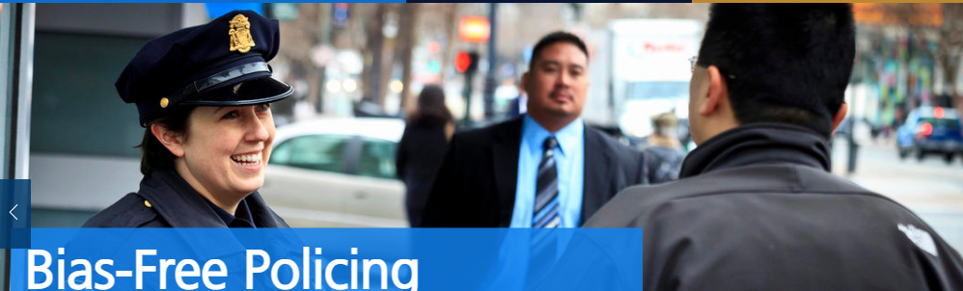

<https://www.law.go.kr/LSW/lsInfoP.do?lsiSeq=61603&viewCls=engLsInfoR&urlMode=engLsInfoR#0000>

noNPoceSecAbuse.marx; !peter meiers/meiers/meiers/meiers/jobs/jobs

ibm.dmier.employe.bob.lee

ibmd.eijrl.intel.employe.allison.?.husband

ibm.dmiler.yahoo.jerry.yang.lsint( to pickup form( intel allsion ruboffs vggg.marx)

ibm.damiler.visa.datacneter.lsitn(singagoup)

guy ways hadn right south korea: <http://parkjin.kr/>

<https://elaw.klri.re.kr/eng_service/lawView.do?hseq=25437&lang=ENG>

AfD: <https://www.bundestag.de/abgeordnete/biografien/B/bleck_andreas-857164>

Guy on right, limit language, etc > Austia Aue Aue

nonPoliceBlackhawk.metz(vggg.lsint(<s>Himmler</s>).nonPocliRTA.marx

ibm.dmiler.visa.employe.david.hanson

https://www.townofmountainviewcolorado.org/services/police_department

.lsint( some guy limin in Utah owereight, bombs house add membrain</s>)

IPX.marx

ibm.dmiler.visa.employe.david.hanson

nonPoliceBlackhawk.metz(vggg.lsint(<s>Himmler</s>).nonPocliRTA.marx

John Deere and PG&E employe Jefforey Jahnke idnety had been used with these violacitons followed from 2003 in speicif 2007 ( )