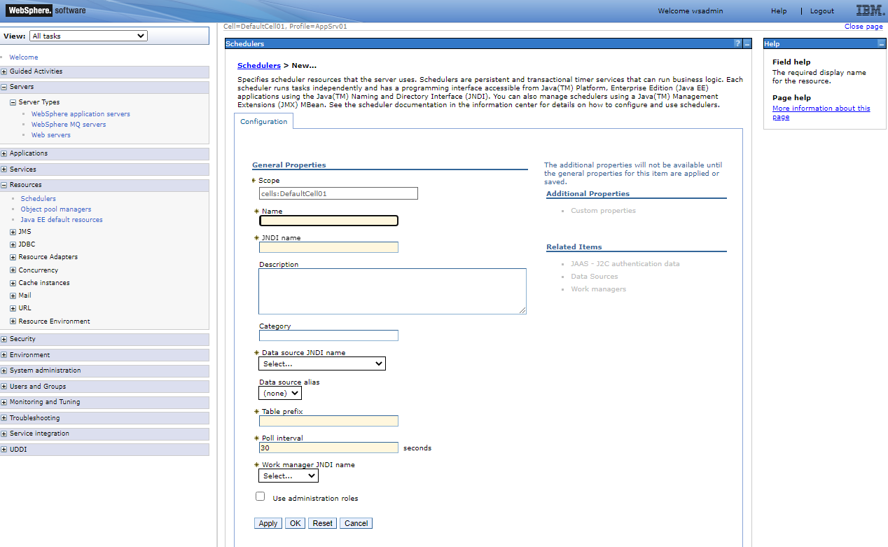

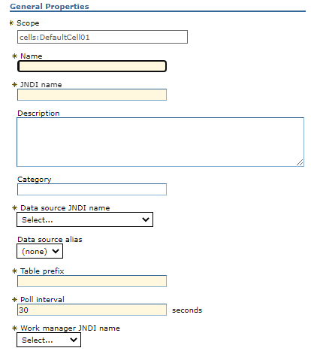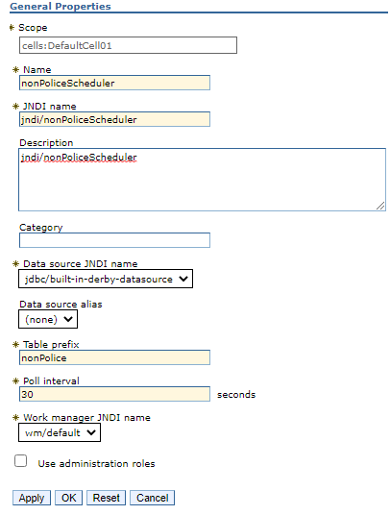



jndi/nonPoliceScheduler

Submitting a task to a scheduler

# Create the TaskInfo using the WASScheduler MBean that you previously located and print out the Task ID

puts "Creating the task..."

set params [java::new {java.lang.Object[]} 1]

$params set 0 $taskInfo

set sigs [java::new {java.lang.String[]} 1]

$sigs set 0 com.ibm.websphere.scheduler.TaskInfo

set taskStatus [java::cast com.ibm.websphere.scheduler.TaskStatus [$AdminControl invoke_jmx $schedO

create $params $sigs]]

puts "Task Created. TaskID= [$taskStatus getTaskId]"

puts $taskStatus