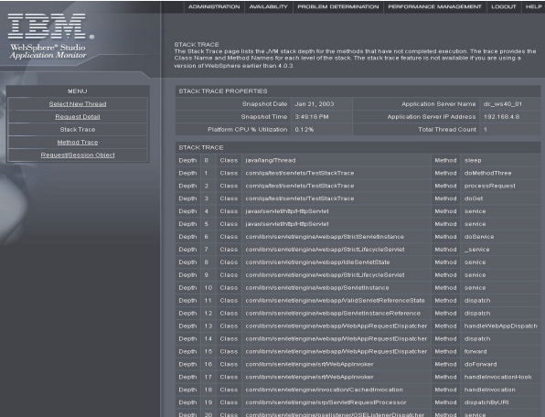

nonPoliceXML

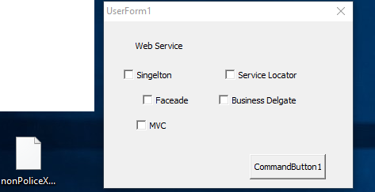

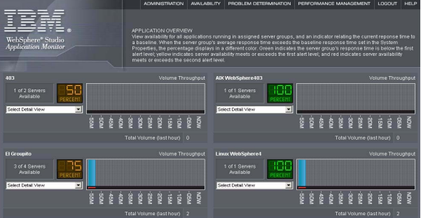

Josphe Chan, IBM, Cynease (WSAM): you are all like a apart of a squad

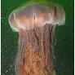

Other:0.1Amy Borgar Vagain (head), IBM assuedm: vagain cherrytree romtite(faceook collector, kim ktm moped)

mountain ray musim squid: Baby Wife, HDLR camerca

bit.ly/1D9827/nonPoliceArtifacat-> nonPicTRXLogia.marx{

1D8723.marx <marquee>

nonPioceMethod{

Dr. Dr. Prof.marx.eval.marx (phd file)

nonPiceXML

}

}



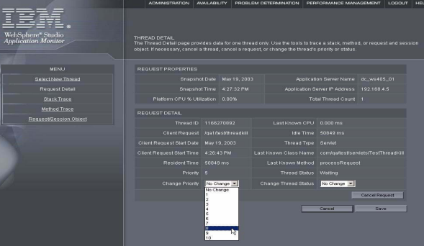



Person

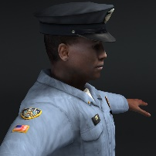

Other: resources: Federal Logical

Naton Economi Stuides(( VWL )

Jndi/Database Connecti Pool

Jndi/Scheudler

Jndi/mail

Greenspan.{

Mountain view police portal

San franics police portal

For worth porlta

}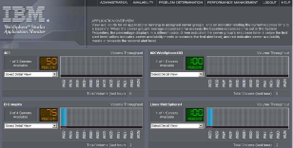

Bit.ly/1D8726/artifacts.(resource).nonPolcieTRXLogiar{

§466.2 Hate Crime

Civil_code

Labor_code

}

Jndi/Database Connecti Pool

Jndi/Scheudler

Jndi/mail

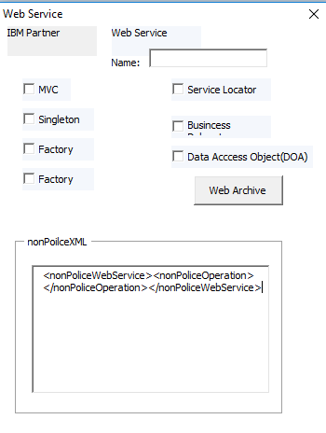 bit.ly/1D8726 Jndi/ghrochev

Jndi/ibm.damiler

Jnddi/ibm.dmiler.visa…

Greenspan.{

1D8723 Person

bit.ly/1D8723 Web Service

}

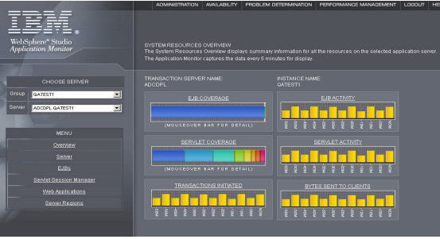

IBM Resoruce Availbltiy 2050

Ejb, servlet, transiotn,…

Int.greenspan

Int.rice

VWL tranl Naciton economic studies{

Greensapan{

Rice, tractor attemetns,..

{

Video Games

25 DB connections (oracle, $100,000/y)

>20 DB connection (oracle $90,000/y)

Marketing

VWL,nation ecomic studies: other companies

Payments:

10,000 retail (second)

Markint:

25 DB connection(oracle $100,000/y)

>20 db connection

**FEDERAL: ACH,FIPS**

**(delta) TPS/FIPS,** VWL(naton economic studies)

Grenspann:repot: in famring the nationa output for .. was. …

Enteprise Softwar

}

FEDEARL.(delta).marx

i.e IBM Conuslting

IBM Glogcla Srevice

IBM Price Watterhouse Coopers

IBM SWAT

IRS (local)

Federal Court Judge (logicla

}

}

Transaciot (years)



Transaction last hour 1D8723

Bit.ly/1D8723.nonPoiceTRXLogia.ramx{

i.e nonPiocLbiary(beep).blond

1x nonPociTRXLogia.r{

}

Timamchcine 1x nonPicTRXLoica.{

}

0.01 .lstin( the reduction of assumed linsk from Amy Borgorf to (or blond) to Larry



