E-COMMERCE APP:
Goal: A working e-commerce system with separated UI and API, backed by a relational SQL database, supporting end-to-end flows:
Customer-facing (UI)
- Register / Login
- Browse products
- Browse by category
- View product details
- Add to cart
- Apply coupon
- Checkout / place order
- View order history
Admin-facing (UI)
- Manage products (type, category, description, units/stock, price, discount)
- Inventory updates
- Manage coupons
- Order management (view, status updates)
Backend responsibilities
- Auth (JWT)
- Catalog APIs (products/categories)
- Inventory + pricing rules
- Coupon validation and discount calculation
- Orders + order lines + status transitions
- Swagger documentation

Architecture:
A) System
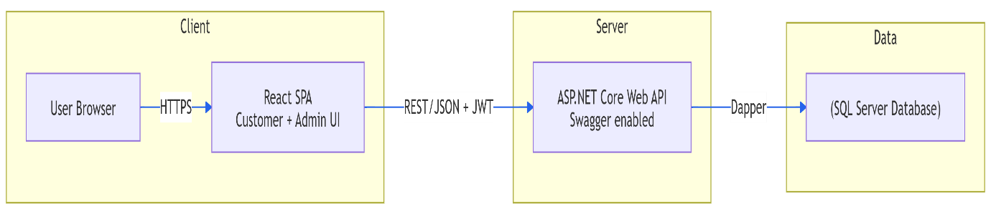

B) Backend layering

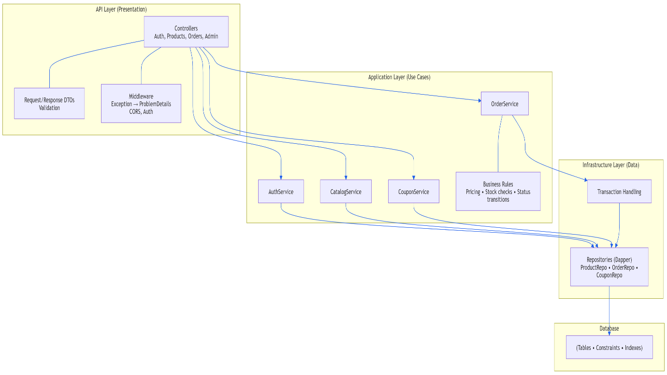

C) Request Pipeline
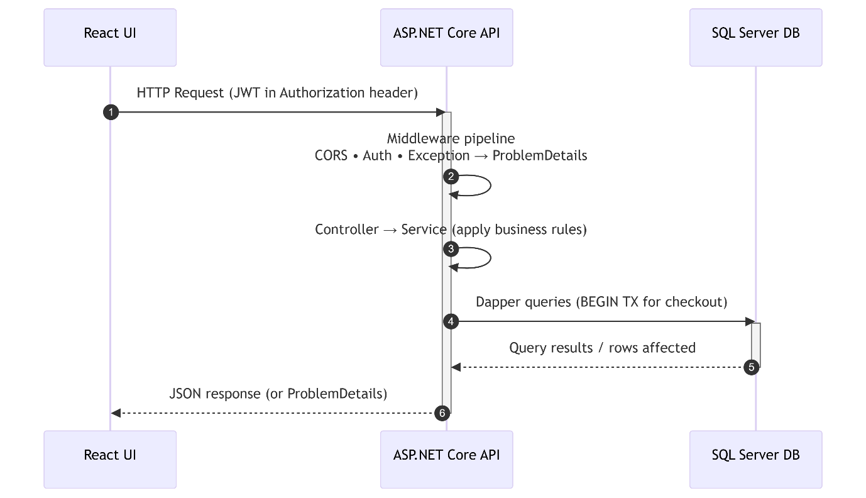

ER DIAGRAM:
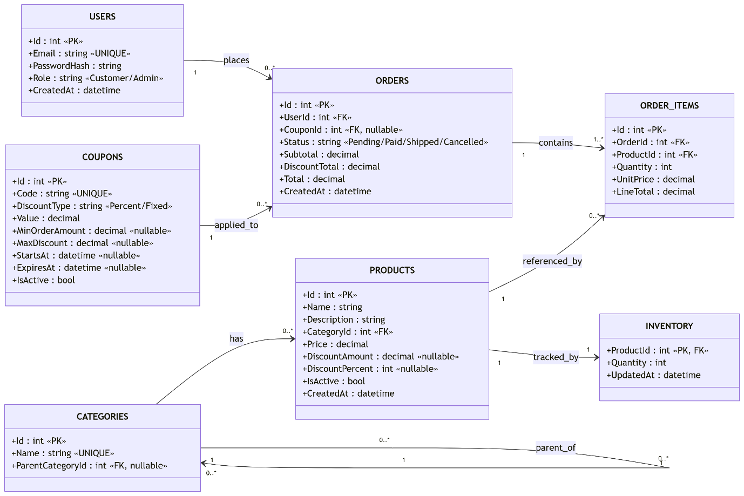

Front-End Flow
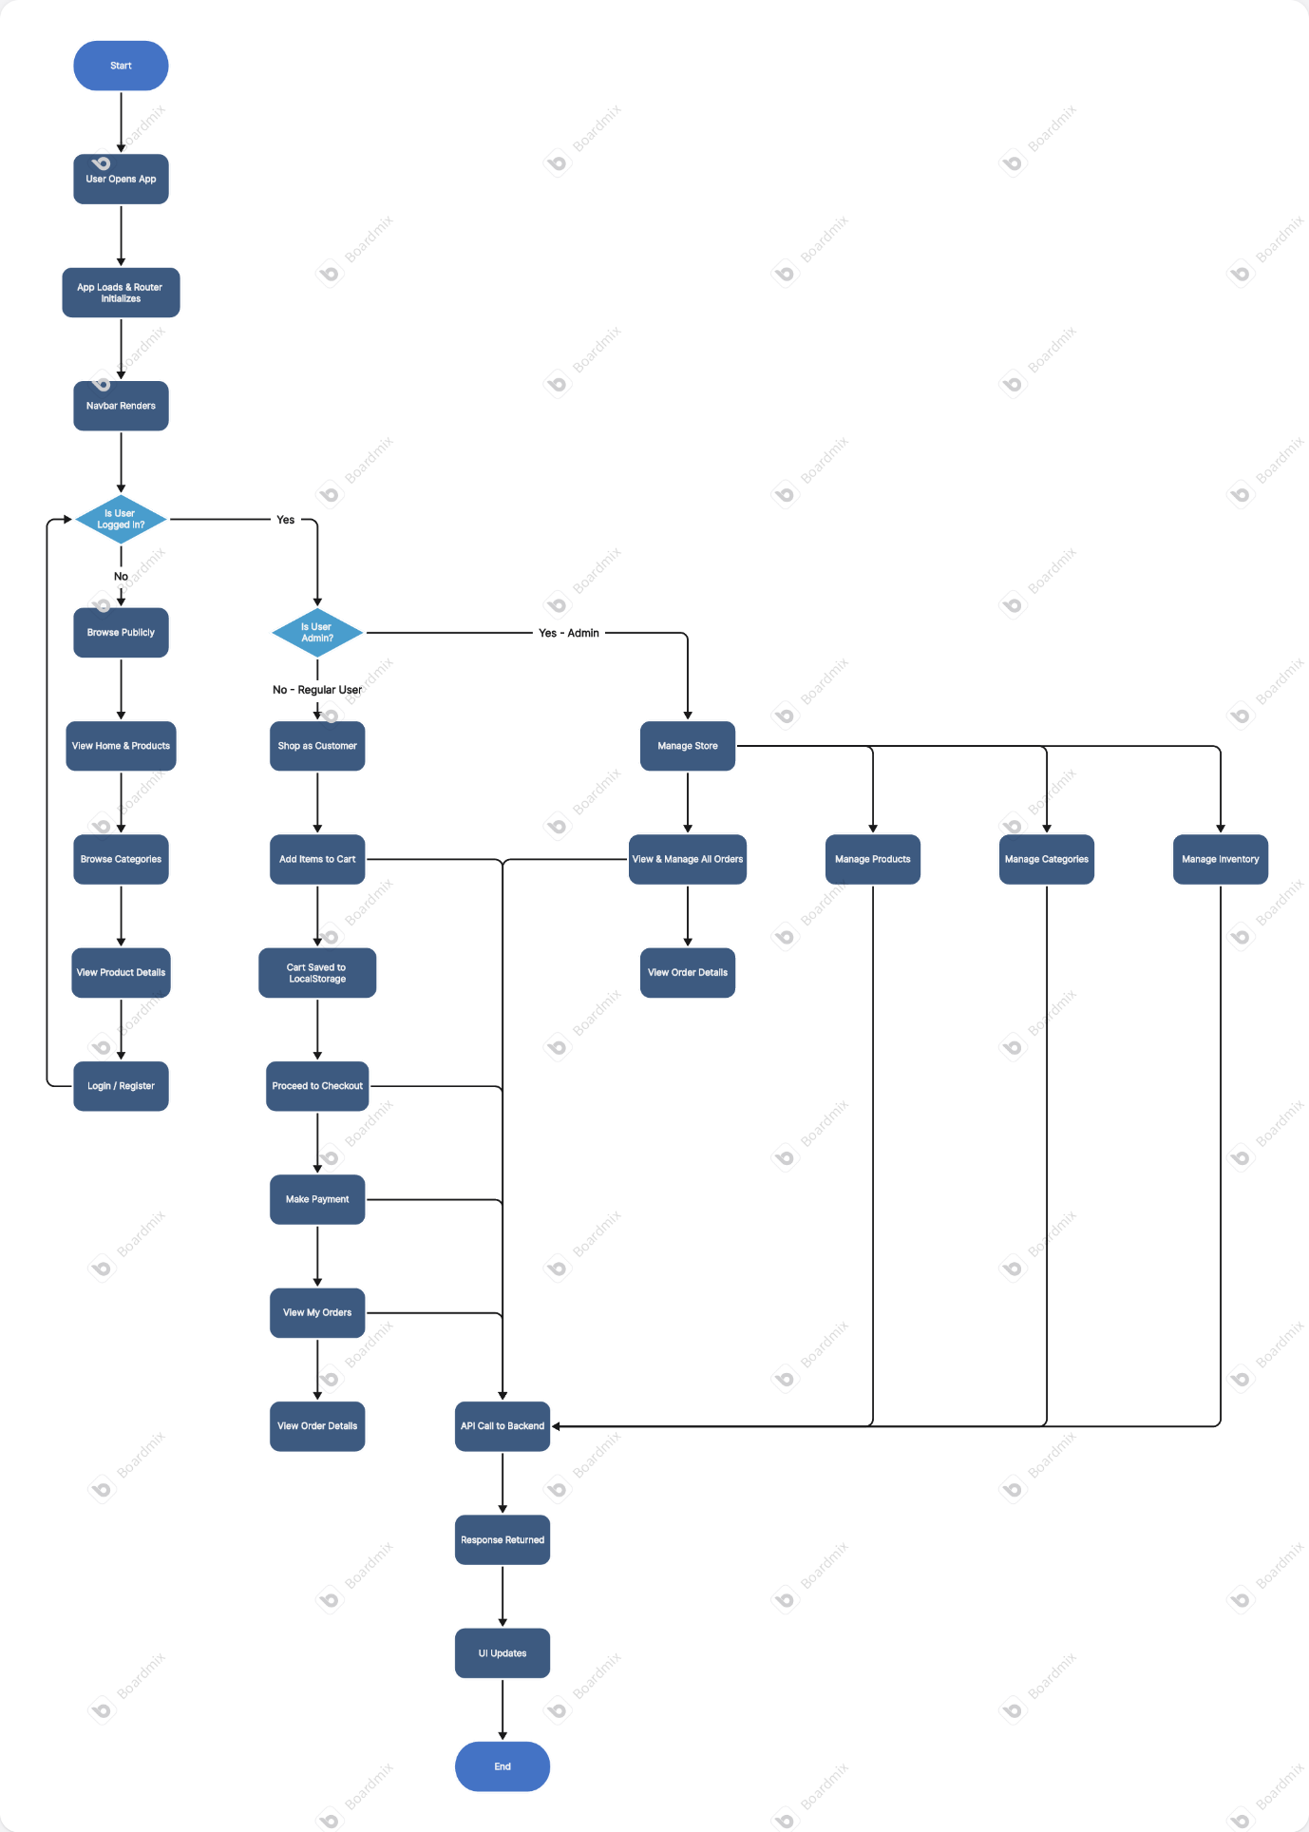

Presentation:
- Problem & scope
- Architecture (diagram + layering )
- Database ER diagram (tables + key constraints)
- Live demo
  - Register/Login
  - Browse products
  - Apply coupon
  - Place order
  - Admin updates inventory/order status
- Quality (tests, error handling, logging, Swagger)
- Tradeoffs & next steps
  - Payments integration, shipping provider, refresh tokens, caching, etc.

Day 1: DB schema + API skeleton + Swagger + Auth (Register/Login)
Day 2: Catalog (Categories/Products) + React browsing + navigation
Day 3: Admin Product + Inventory management (end-to-end)
Day 4: Orders (checkout transaction) + My Orders + Admin Orders/status
Day 5: Coupons + pricing breakdown + tests + polish + demo prep
Day 2: Catalog + React browsing + navigation
Do
- Backend: list categories/products, product details, search/filter/sort (basic).
- Frontend: React pages
  - Home / Catalog
  - Category view
  - Product details
  - Navbar + routing
- Connect React → API (base URL, axios/fetch), handle loading/errors.
Deliverables
- User can browse categories/products in React (real API data, not static).

Day 3: Admin Product + Inventory management (end-to-end)
Do
- Admin-only endpoints: create/update/delete product, upload images (if needed).
- Inventory:
  - Stock table or stock field + adjustment endpoint
  - Validation: no negative stock
- React Admin UI:
  - Product form
  - Inventory update screen
- Authorization: only Admin role can access admin screens/endpoints.
Deliverables
- Admin can add a product, change stock, and it reflects in user browsing.

Day 4: Orders (checkout transaction) + My Orders + Admin Orders/status
Do
- Cart approach (choose one):
  - Simplest: send cart items from client at checkout
  - Better: server-side cart table
- Checkout:
  - Create Order + OrderItems
  - Reduce stock atomically (transaction)
  - Pricing snapshot stored on order (don't recalc later)
- My Orders endpoint + React page
- Admin Orders list + status updates (Placed → Packed → Shipped → Delivered/Cancelled)
Deliverables
- A logged-in user can place an order and see it in "My Orders".
- Admin can view all orders and update status.

Day 5: Coupons + pricing breakdown + tests + polish + demo prep
Do
- Coupons:
  - Validate coupon (active, expiry, min order, usage limits)
  - Apply discount + store discount details on order
- Pricing breakdown:
  - Subtotal, discount, tax (if any), shipping (if any), grand total
- Tests:
  - Unit tests for pricing, coupon validation, stock deduction
  - Basic API integration tests (optional but nice)
- Polish + demo:
  - Seed data
  - Demo script + screenshots
  - README run steps
Deliverables
- Checkout shows full breakdown and coupon works.
- Tests pass + demo is smooth/repeatable.

Critical dependencies / "don't get stuck" notes
- Auth must be solid on Day 1, otherwise Days 3–4 (Admin/Orders) will block.
- On Day 4, use a DB transaction for checkout + stock update to avoid inconsistent orders.
- Lock down connection strings (dev vs prod) so you don't re-hit the "wrong DB" issue.

Status of order:
{
"status": "Packed", "Shipped", "Delivered", "Cancelled"
}
5) Data seeding + demo repeatability (high value for internship)
Make sure your demo is "one command run":
- Seed: admin user, categories, products, coupons
- README: how to run API + UI + sample credentials + coupon codes

My project is a full-stack e-commerce application with separate frontend and backend.
The frontend is for customer and admin operations, the backend exposes APIs, and the data is stored in a relational SQL database.
I designed the database first because the entire system depends on entities like users, products, categories, orders, coupons, and inventory.
So I normalized the core tables, added constraints for data integrity, and designed relationships to support real end-to-end business flows like registration, product browsing, checkout, coupon application, and order management.

I organized the backend into separate projects to keep responsibilities isolated.
The API project handles HTTP concerns like routing, middleware, authentication configuration, and Swagger.
Business logic is placed in feature services, and data access is separated into repository abstractions and implementations.
This structure improves maintainability, testability, and loose coupling.
A typical request flow is:
client calls controller → controller calls feature/service layer → feature layer applies business rules and calls repositories → repository interacts with SQL database → response is mapped back to DTO and returned.

Login flow
Client → AuthController → AuthFeature → UserRepository → PasswordHasher verify → TokenService → response

For the backend, I designed the project in layers.
The API project handles HTTP requests, middleware, authentication setup, and Swagger.
Business logic is placed in feature services, and data access is separated through repository abstractions and implementations.
This structure helps me apply SOLID principles, especially single responsibility and dependency inversion, and keeps the code maintainable."
Then continue:
"A request comes into a controller, the controller delegates to a feature service, the feature service handles business rules and uses repositories for database operations, and repositories interact with SQL Server.
User logs in with email + password
↓
AuthFeature validates credentials
↓
TokenService.CreateToken(userId, email, role)
↓
JWT returned to client
↓
Client sends JWT in Authorization header on every request
↓
ASP.NET middleware validates signature + expiry automatically

Database Design
The database for this project is designed using a relational model to support the core e-commerce flow.
Main Entities
- Users: stores registered customers and admin accounts
- Categories: organizes products into groups
- Products: stores product catalog data including price, stock, and image
- Orders: stores order header information for each purchase
- OrderItems: stores line-level items inside each order
- Coupons: stores discount and coupon rules
Relationships
- One User can place many Orders
- One Category can have many Products
- One Order can contain many OrderItems
- One Product can appear in many OrderItems
Design Decisions
- Used a relational schema because the system requires strong consistency and clear entity relationships.
- Added foreign keys to maintain referential integrity.
- Added constraints to prevent invalid data such as negative stock or negative prices.
- Stored pricing and coupon details as snapshots in Orders and OrderItems so historical orders remain accurate even if current product or coupon data changes later.
- Simplified inventory management by storing stock directly in the Products table for the current project scope.

1. Ecommerce.Api
This is the presentation layer
- Controllers
- Middleware
- Startup/configuration
- Swagger
- Authentication setup
2. FeatureObject.Abstraction
This is the business contract layer
- interfaces for features/services
- DTO contracts
3. FeatureObject.Implementation
This is the business logic layer
- actual implementations of auth, catalog, orders features
- token service
4. Datastore.Abstraction
This is the data access contract layer
- repository interfaces
- row models
- DB connection abstraction
5. Datastore.Implementation
This is the data access implementation layer
- SQL/repository classes
- DB connection factory implementation

Controllers handle HTTP requests/responses only
- Feature classes handle business logic
- Repositories handle database operations
- TokenService handles JWT creation
- DbConnectionFactory handles DB connection creation
- Middleware handles exception formatting centrally

