**HOUSE PRICES PREDICTING USING MACHINE LEARNING**

**ABSTRACT**:

People are very careful when they want to buy a new house with market strategies and their budgets. The objective of this paper is to predict the house prices for non-house holders based on their aspirations and financial provisions. By analyzing different parameters like area of the house, square feet of the house, no of floors in the house etc. This research work has utilized the dataset from Kaggle.. An analysis is performed by applying advanced machine learning regression techniques such as Linear regression, KNN Regression, Random Forest Regression, Decision Tree Regression, Extra Trees Regression etc. to attain the most efficient and least error driven regression technique. From the analysis performed, an observation has been made that Catboost Regression Algorithm has outperformed other algorithms. The model predicts the final output with respect to correlated attributes in the dataset.

**INTRODUCTION**

A key difficulty for buyers, sellers, and investors alike, the real estate market is a dynamic and ever-changing world, making precise home price forecasts difficult

Machine learning (ML) algorithms have recently become effective tools for analyzing massive volumes of data and making remarkably accurate property price predictions. This article delves into the fascinating realm of housing market predictions for next 5 years using Python and ML algorithms.

By leveraging historical property data, such as location, size, amenities, and market trends, ML models can learn complex patterns and relationships to make informed predictions about future property prices. Python offers a flexible and user-friendly framework for developing, training and deploying these predictive models thanks to its rich libraries, including Scikit-learn, Pandas, and NumPy.

**FACTORS THAT AFFECT HOUSE PRICING**

In order to predict house prices, first we have to understand the factors that affect house Pricing.

• **Economic** **growth**.

Demand for housing is dependent upon income. With higher Economic growth and rising incomes, people will be able to spend more on Houses; this will increase demand and push up prices. In fact, demand for housing Is often noted to be income elastic (luxury good); rising incomes leading to a Bigger % of income being spent on houses. Similarly, in a recession, falling Incomes will mean people can’t afford to buy and those who lose their job may Fall behind on their mortgage payments and end up with their home repossessed.

• **Unemployment**.

Related to economic growth is unemployment. When Unemployment is rising,fewer people will be able to afford a house. But, even the Fear of unemployment may discouragepeople from entering the property market.

• **Interest rates.**

Interest rates affect the cost of monthly mortgage payments. A Period of high- interest rates will increase cost of mortgage payments and will Cause lower demand for buying a house. High-interest rates make renting Relatively

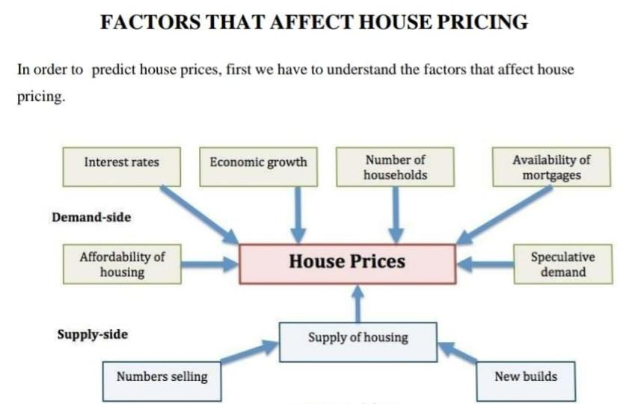

• Economic growth. Demand for housing is dependent upon income. With higher

Economic growth and rising incomes, people will be able to spend more on

Houses; this will increase demand and push up prices. In fact, demand for housing

Is often noted to be income elastic (luxury good); rising incomes leading to a

% of income being spent on houses. Similarly, in a recession, falling

Incomes will mean people can’t afford to buy and those who lose their job may

Fall behind on their mortgage payments and end up with their home repossessed.

• Unemployment. Related to economic growth is unemployment. When

Unemployment is rising,fewer people will be able to afford a house. But, even the

Fear of unemployment may discouragepeople from entering the property market.

• Interest rates. Interest rates affect the cost of monthly mortgage payments. A

Period of high- interest rates will increase cost of mortgage payments and will

Cause lower demand for buying a house. High-interest rates make renting

Relatively

CONCLUSION :

House price prediction using machine learning in Python involves predicting the prices of houses based on various features. To start, we import essential libraries such as NumPy, Pandas, Scikit-learn, and Matplotlib. Next, we load the house price dataset, containing features like the number of bedrooms, bathrooms, square footage, location, etc.