FAST PACKET INJECTION

**Overview**

The Fast Packet Injection scenario will clone the packet and inject it back to the same layer.  No modification is performed on the packet.

All filters added sit in WFPSampler's sublayer (which is weighted just below IPsec's sublayer), unless otherwise specified using the -sl <SUBLAYER> command line option.  All filters are associated with WFPSampler's provider.

This scenario is meant to display the performance impact of injection.  There is no guarantee that the injection will succeed for certain packets (loopback, IPsec, etc.).  All injection is performed synchronously (inline) from within the **ClassifyFastPacketInjection()**.  Memory is only allocated in the case of outbound transport.

**CompleteFastPacketInjection()** will indicate the final status of the packet’s injection.  This function will also free any allocated memory.

The following diagram shows how the code flows for this callout:

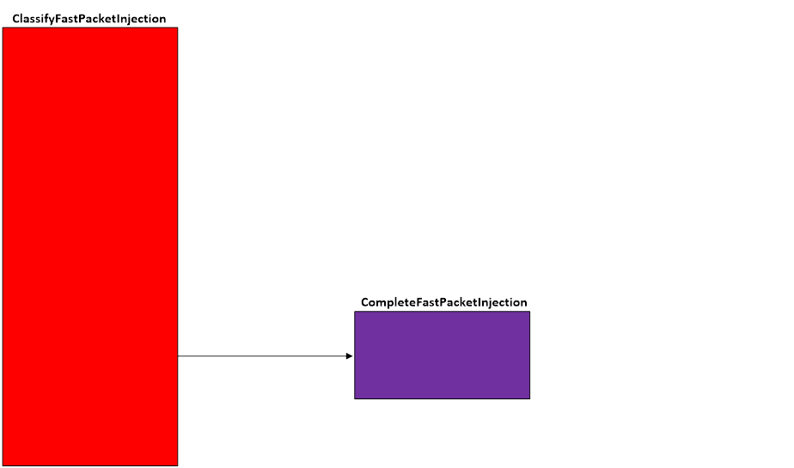  
**Figure A. Code flow for Fast Packet Injection Scenario**

**Applicable Layers**

❖  FWPM_LAYER_INBOUND_IPPACKET_V4

❖  FWPM_LAYER_INBOUND_IPPACKET_V6

❖  FWPM_LAYER_OUTBOUND_IPPACKET_V4

❖  FWPM_LAYER_OUTBOUND_IPPACKET_V6

❖  FWPM_LAYER_IPFORWARD_V4

❖  FWPM_LAYER_IPFORWARD_V6

❖  FWPM_LAYER_INBOUND_TRANSPORT_V4

❖  FWPM_LAYER_INBOUND_TRANSPORT_V6

❖  FWPM_LAYER_OUTBOUND_TRANSPORT_V4

❖  FWPM_LAYER_OUTBOUND_TRANSPORT_V6

❖  FWPM_LAYER_DATAGRAM_DATA_V4

❖  FWPM_LAYER_DATAGRAM_DATA_V6

❖  FWPM_LAYER_INBOUND_ICMP_ERROR_V4

❖  FWPM_LAYER_INBOUND_ICMP_ERROR_V6

❖  FWPM_LAYER_OUTBOUND_ICMP_ERROR_V4

❖  FWPM_LAYER_OUTBOUND_ICMP_ERROR_V6

❖  FWPM_LAYER_ALE_AUTH_RECV_ACCEPT_V4

❖  FWPM_LAYER_ALE_AUTH_RECV_ACCEPT_V6

❖  FWPM_LAYER_ALE_AUTH_CONNECT_V4

❖  FWPM_LAYER_ALE_AUTH_CONNECT_V6

❖  FWPM_LAYER_ALE_FLOW_ESTABLISHED_V4

❖  FWPM_LAYER_ALE_FLOW_ESTABLISHED_V6

❖  FWPM_LAYER_STREAM_PACKET_V4                                     (Win7+)

❖  FWPM_LAYER_STREAM_PACKET_V6                                     (Win7+)

❖  FWPM_LAYER_INBOUND_MAC_FRAME_ETHERNET       (Win8+)

❖  FWPM_LAYER_OUTBOUND_MAC_FRAME_ETHERNET   (Win8+)

❖  FWPM_LAYER_INBOUND_MAC_FRAME_NATIVE            (Win8+)

❖  FWPM_LAYER_OUTBOUND_MAC_FRAME_NATIVE        (Win8+)

❖  FWPM_LAYER_INGRESS_VSWITCH_ETHERNET                  (Win8+)

❖  FWPM_LAYER_EGRESS_VSWITCH_ETHERNET                    (Win8+)

**Command Line Usage**

|  |  |  |
| --- | --- | --- |
| **Option** | **Argument** | **Meaning** |
| -s | FAST_PACKET_INJECTION | Implement the FAST_PACKET_INJECTION scenario |
| -l | Applicable Layer | Layer at which this filter will apply |
| -sl | Applicable subLayer | SubLayer to associate with the filter.  [default is WFPSAMPLER_SUBLAYER]. |
| -v |  | Make the objects associated with this scenario’s instance dynamic |
| -b |  | Make the objects associated with this scenario’s instance available during boot-time |
| -r |  | Remove objects associated with this scenario instance |
| -? |  | Display help |

“**WFPSampler.Exe -s FAST_PACKET_INJECTION -?**“ provides help output

“**WFPSampler.Exe -s FAST_PACKET_INJECTION -l FWPM_LAYER_INBOUND_IPPACKET_V4 -v**“ adds a dynamic filter (**-v**) at FWPM_LAYER_INBOUND_IPPACKET_V4 (**-l**) which references the appropriate callout.  This filter will have no conditions, meaning it will act on all traffic seen at this layer.

“**WFPSampler.Exe -s FAST_PACKET_INJECTION -l FWPM_LAYER_INBOUND_IPPACKET_V4 -v -r**“ removes (**-r**) the dynamic filter (**-v**) at FWPM_LAYER_INBOUND_IPPACKET_V4 (**-l**) which references the appropriate callout.

“**WFPSampler.Exe -s FAST_PACKET_INJECTION -l FWPM_LAYER_INBOUND_IPPACKET_V4 -ipla 1.0.0.1 -ipra 1.0.0.254**“ adds a persistent filter at FWPM_LAYER_INBOUND_IPPACKET_V4 (**-l**) which references the appropriate callout.  This filter will have 2 conditions; FWPM_CONDITION_IP_LOCAL_ADDRESS (**-ipla**) equals 1.0.0.1, and FWPM_CONDITION_IP_REMOTE_ADDRESS (**-ipra**) equals 1.0.0.254.

For a list of conditions applicable to each layer, refer to Filtering Conditions Available at Each Filtering Layer.

For a list of command line parameters for configuring each condition, refer to Conditions for Command Line.