FLOW ASSOCIATION

**Overview**

The Flow Association scenario will cause the classification to associate context to the flow at the specified layers.  This context will then be available as the flowContext parameter of those classifyFns.

All filters added sit in WFPSampler’s sublayer (which is weighted just below IPsec’s sublayer), unless otherwise specified using the –sl <SUBLAYER> command line option.  All filters are associated with WFPSampler’s provider.

The following diagram shows how the code flows for this callout:

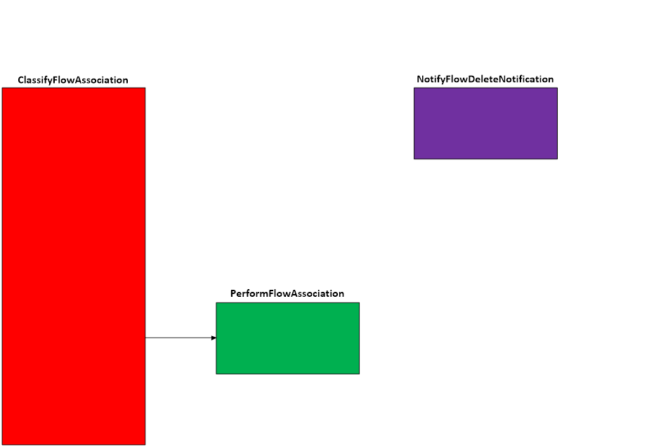  
**Figure A. Code flow for Flow Association Scenario**

When traffic matches a filter at the specified layer, **ClassifyFlowAssociation()** is invoked by the Filtering Engine.  This function verify we have write access, and invoke **PerformFlowAssociation()**.

**PerformFlowAssociation()** will create the FLOW_CONTEXT and call FwpsFlowAssociateContext() for the layer(s) that were indicatedfor the context to be associated with (**-awl**).

This context will be valid until the flow is terminated or until FwpsFlowRemoveContext() is called, after which  **NotifyFlowDeleteNotification()** will be invoked and will clean up the FLOW_CONTEXT.

**Applicable Layers**

❖  FWPM_LAYER_ALE_FLOW_ESTABLISHED_V4

❖  FWPM_LAYER_ALE_ FLOW_ESTABLISHED_V6

**Command Line Usage**

|  |  |  |
| --- | --- | --- |
| **Option** | **Argument** | **Meaning** |
| -s | FLOW_ASSOCIATION | Implement the FLOW_ASSOCIATION scenario |
| -l | Applicable Layer | Layer at which this filter will apply |
| -aws | Scenario | Applicable scenario |
| -awl | Applicable Layer … | Layer(s) at which to associate Flow |
| -sl | Applicable sublayer | SubLayer to associate with the filter.  [default is WFPSAMPLER_SUBLAYER]. |
| -v |  | Make the objects associated with this scenario’s instance dynamic |
| -b |  | Make the objects associated with this scenario’s instance available during boot-time |
| -r |  | Remove objects associated with this scenario instance |
| -? |  | Display help |

“**WFPSampler.Exe -s FLOW_ASSOCIATION -?**“ provides help output

“**WFPSampler.Exe -s FLOW_ASSOCIATION -l FWPM_LAYER_ALE_FLOW_ESTABLISHED_V4 -aws BASIC_STREAM_INJECTION -awl FWPM_LAYER_STREAM_V4 -v**“  adds a dynamic filter (**-v**) at FWPM_LAYER_ALE_FLOW_ESTABLISHED_V4 (**-l**) which references the appropriate callout.  This filter will have no conditions, meaning it will act on all flows seen at this layer.  The context will then be visible to all classifies at FWPM_LAYER_STREAM_V4 (**-awl**) using the BASIC_STREAM_INJECTION callout (**-aws**).  Note that the scenario for BASIC_STREAM_INJECTION must already have been configured before implementing this scenario.

“**WFPSampler.Exe -s FLOW_ASSOCIATION -l FWPM_LAYER_ALE_FLOW_ESTABLISHED_V4  -aws BASIC_STREAM_INJECTION -awl FWPM_LAYER_STREAM_V4 -v -r**“  removes (**-r**) the dynamic filter (**-v**) at FWPM_LAYER_ALE_FLOW_ESTABLISHED_V4 (**-l**) which references the appropriate callout.

“**WFPSampler.Exe -s FLOW_ASSOCIATION -l FWPM_LAYER_ALE_FLOW_ESTABLISHED_V4 -ipla 1.0.0.1 -ipra 1.0.0.254 –aws BASIC_STREAM_INJECTION –awl FWPM_LAYER_STREAM_V4**“ adds a persistent filter at FWPM_LAYER_ALE_FLOW_ESTABLISHED_V4 (**-l**) which references the appropriate callout.  This filter will have 2 conditions; FWPM_CONDITION_IP_LOCAL_ADDRESS (**-ipla**) equals 1.0.0.1, and FWPM_CONDITION_IP_REMOTE_ADDRESS (**-ipra**) equals 1.0.0.254.  The context will then be visible to all classifies at FWPM_LAYER_STREAM_V4 (**-awl**) using the BASIC_STREAM_INJECTION callout (**-aws**).  Note that the scenario for BASIC_STREAM_INJECTION must already have been configured before implementing this scenario.

“**WFPSampler.Exe -s FLOW_ASSOCIATION -l FWPM_LAYER_ALE_FLOW_ESTABLISHED_V4  -aaid C:\Traffic.exe -ipla 1.0.0.1 -ipra 1.0.0.254 -ipp TCP –iprp 6000 –aws BASIC_STREAM_INJECTION –awl FWPM_LAYER_STEAM_V4 FWPM_LAYER_ALE_ENDPOINT_CLOSURE_V4**“ adds a persistent filter at FWPM_LAYER_ALE_FLOW_ESTABLISHED_V4  (**-l**) which references the appropriate callout.  This filter will have 5 conditions; FWPM_CONDITION_ALE_APP_ID (**-aaid**) equals C:\Traffic.exe, FWPM_CONDITION_IP_LOCAL_ADDRESS (**-ipla**) equals 1.0.0.1, FWPM_CONDITION_IP_REMOTE_ADDRESS (**-ipra**) equals 1.0.0.254, FWPM_CONDITION_IP_PROTOCOL  (**-ipp**) equals TCP, and FWPM_CONDITION_IP_REMOTE_PORT equals 6000.    The context will then be visible to all classifies at FWPM_LAYER_STREAM_V4 and FWPM_LAYER_ALE_ENDPOINT_CLOSURE_V4 (**-awl**) using the BASIC_STREAM_INJECTION (and PEND_ENDPOINT_CLOSURE) callout (**-aws**).  Note that the scenario for BASIC_STREAM_INJECTION and PEND_ENDPOINT_CLOSURE must already have been configured before implementing this scenario.

For a list of conditions applicable to each layer, refer to Filtering Conditions Available at Each Filtering Layer.

For a list of command line parameters for configuring each condition, refer to Conditions for Command Line.

**Notes**

**FlowDelete**

The FlowDeleteNotificationFn is only invoked when the flow terminates or FwpsFlowRemoveContext is called.

**Mixing Scenarios**

FLOW_ASSOCIATION is only useful when mixed with other scenarios.  For example:

                WFPSampler.exe -s BASIC_STREAM_INJECTION -l FWPM_LAYER_STREAM_V4 -ipra 1.0.0.254 -iprp 6000 -v

                WFPSampler.exe -s PEND_ENDPOINT_CLOSURE -l FWPM_LAYER_ALE_ENDPOINT_CLOSURE_V4 -aaid C:\Traffic.exe -ipra 1.0.0.254 -ipp TCP -iprp 6000 -pcd 5000 -v

                WFPSampler.exe -s FLOW_ASSOCIATION -l FWPM_LAYER_ALE_FLOW_ESTABLISHED_V4 -aaid C:\Traffic.exe -ipra 1.0.0.254 -ippTCP -iprp 6000 -aws BASIC_STREAM_INJECTION -awl FWPM_LAYER_STREAM_V4 FWPM_LAYER_ALE_ENDPOINT_CLOSURE_V4 -v

This will associate flows with both the BASIC_STREAM_INJECTION and PEND_ENDPOINT_CLOSURE scenarios. The endpoint associated with the specified flow will remain open for the duration of the injection being performed at STREAM.  Once everything has been injected, the endpoint is allowed to close, and the flow contexts are cleaned up.