**МИНОБРНАУКИ РОССИИ**

**Санкт-Петербургский государственный**

**электротехнический университет**

**«ЛЭТИ» им. В.И. Ульянова (Ленина)**

**Кафедра АПУ**

Курсовая РАБОТА

**по дисциплине «Технологии XML и XSL в информационных системах»**

Тема: Разработка информационной системы магазина компьютерных игр

|  |  |  |
| --- | --- | --- |
| Студент гр. 9371 |  | Жиренкин А.В. |
| Преподаватель |  | Кондратьева Н.Ю. |

Санкт-Петербург

2021

**Описание системы данных**

Система данных предназначена для работы магазина компьютерных игр. Система хранит данные о видеоиграх, отзывах и поставщиках. На ее основе будут производиться взаимодействия между клиентом и сотрудником магазина компьютерных игр. Система будет удобна для всех пользователей и будет обеспечено полное единство информационного пространства.

**UML диаграмма структуры данных**



**Объекты системы**



**РЕАЛИЗАЦИЯ ПРОЕКТА**

**Описание модели данных в формате XML**

**Видеоигра**

<?xml version="1.0" encoding="UTF-8"?>

<?xml-stylesheet type="text/xsl" href="videogame.xsl" ?>

<!DOCTYPE videogames[

<!ELEMENT videogames (videogame*)>

<!ELEMENT videogame (videogame_id,genre,publication_date,title,rating,price,technical_specifications,description,number_of_copies,age_rating)>

<!ELEMENT videogame_id EMPTY>

<!ATTLIST videogame_id id CDATA #REQUIRED>

<!ELEMENT genre (#PCDATA)>

<!ELEMENT publication_date (#PCDATA)>

<!ELEMENT title (#PCDATA)>

<!ELEMENT rating (#PCDATA)>

<!ELEMENT price (#PCDATA)>

<!ELEMENT technical_specifications (#PCDATA)>

<!ELEMENT description (#PCDATA)>

<!ELEMENT number_of_copies (#PCDATA)>

<!ELEMENT age_rating (#PCDATA)>

]>

<videogames>

    <videogame>

        <videogame_id id="12648365"/>

        <genre>Головоломка</genre>

        <publication_date>12.05.2010</publication_date>

        <title>Portal</title>

        <rating>89</rating>

        <price>300 рублей</price>

        <technical_specifications>

            Windows XP,AMD Athlon XP 1500+,nVidia GeForce 3 Ti 500

        </technical_specifications>

        <description>

            Компьютерная игра в жанре головоломки от первого лица

        </description>

        <number_of_copies>28</number_of_copies>

        <age_rating>12+</age_rating>

    </videogame>

    <videogame>

        <videogame_id id="53482678"/>

        <genre>Шутер</genre>

        <publication_date>28.11.2012</publication_date>

        <title>Far Cry 3</title>

        <rating>91</rating>

        <price>1500 рублей</price>

        <technical_specifications>

            Windows Vista,Intel Pentium 4 (3.0GHz),nVidia GeForce 6600 GT

        </technical_specifications>

        <description>

            Мультиплатформенная видеоигра в жанре шутер в открытом мире

        </description>

        <number_of_copies>15</number_of_copies>

        <age_rating>16+</age_rating>

    </videogame>

    <videogame>

        <videogame_id id="43562747"/>

        <genre>Стратегия</genre>

        <publication_date>29.03.2015</publication_date>

        <title>Might and Magic Heroes VII</title>

        <rating>80</rating>

        <price>2000 рублей</price>

        <technical_specifications>

          Windows 7 SP1,Intel Core i5-660,Nvidia GeForce GTX 460

        </technical_specifications>

        <description>

            Компьютерная игра в жанре пошаговой стратегии с элементами RPG

        </description>

        <number_of_copies>30</number_of_copies>

        <age_rating>12+</age_rating>

    </videogame>

</videogames>

**Поставщик**

<?xml version="1.0" encoding="UTF-8"?>

<?xml-stylesheet type="text/xsl" href="provider.xsl"?>

<!DOCTYPE providers[

<!ELEMENT providers (provider*)>

<!ELEMENT provider (provider_id,fullname,product_price,product_packing,work_experience,location,email,graphics_сompliance,сost_level)>

<!ELEMENT provider_id EMPTY>

<!ATTLIST provider_id id CDATA #REQUIRED>

<!ELEMENT fullname (surname, name, patronymic)>

<!ELEMENT surname (#PCDATA)>

<!ELEMENT name (#PCDATA)>

<!ELEMENT patronymic (#PCDATA)>

<!ELEMENT location (#PCDATA)>

<!ELEMENT email (#PCDATA)>

<!ELEMENT product_price (#PCDATA)>

<!ELEMENT product_packing (#PCDATA)>

<!ELEMENT work_experience (#PCDATA)>

<!ELEMENT graphics_сompliance (#PCDATA)>

<!ELEMENT сost_level (#PCDATA)>

]>

<providers>

    <provider>

        <provider_id id="000032"/>

        <fullname>

            <surname>Молотов</surname>

            <name>Артем</name>

            <patronymic>Иванович</patronymic>

        </fullname>

        <product_price>200 рублей</product_price>

        <product_packing>8 из 10</product_packing>

        <work_experience>2 года</work_experience>

        <location>Орловская область, город Зарайск, пер. Славы, 23</location>

        <email>molotovai@mail.ru</email>

        <graphics_сompliance>9 из 10</graphics_сompliance>

        <сost_level>5 из 10</сost_level>

    </provider>

    <provider>

        <provider_id id="000056"/>

        <fullname>

            <surname>Петров</surname>

            <name>Александр</name>

            <patronymic>Васильевич</patronymic>

        </fullname>

        <product_price>500 рублей</product_price>

        <product_packing>9 из 10</product_packing>

        <work_experience>5 лет</work_experience>

        <location>Астраханская область, город Талдом, пр. Ладыгина, 38</location>

        <email>petrovav@mail.ru</email>

        <graphics_сompliance>8 из 10</graphics_сompliance>

        <сost_level>7 из 10</сost_level>

    </provider>

    <provider>

        <provider_id id="000042"/>

        <fullname>

            <surname>Кузнецов</surname>

            <name>Иван</name>

            <patronymic>Петрович</patronymic>

        </fullname>

        <product_price>150 рублей</product_price>

        <product_packing>9 из 10</product_packing>

        <work_experience>3 года</work_experience>

        <location>Ярославская область, город Видное, спуск Сталина, 32</location>

        <email>eric01.01@gmail.com</email>

        <graphics_сompliance>8 из 10</graphics_сompliance>

        <сost_level>6 из 10</сost_level>

    </provider>

</providers>

**Экземпляры видеоигры**

<?xml version="1.0" encoding="UTF-8"?>

<?xml-stylesheet type="text/xsl" href="copy_videogame.xsl"?>

<!DOCTYPE copies_videogame[

<!ELEMENT copies_videogame (copy_videogame*)>

<!ELEMENT copy_videogame (copy_videogame_id,sale_date?,sale_time?,status)>

<!ELEMENT copy_videogame_id EMPTY>

<!ATTLIST copy_videogame_id id CDATA #REQUIRED>

<!ELEMENT sale_date (#PCDATA)>

<!ELEMENT sale_time (#PCDATA)>

<!ELEMENT status (#PCDATA)>

]>

<copies_videogame>

    <copy_videogame>

        <copy_videogame_id id="00004532"/>

        <sale_date>20.05.2021</sale_date>

        <sale_time>15:02</sale_time>

        <status>Продана</status>

    </copy_videogame>

    <copy_videogame>

        <copy_videogame_id id="00005364"/>

        <sale_date>24.06.2021</sale_date>

        <sale_time>11:49</sale_time>

        <status>Продана</status>

    </copy_videogame>

     <copy_videogame>

        <copy_videogame_id id="00007832"/>

        <sale_date>23.05.2021</sale_date>

        <sale_time>14:52</sale_time>

        <status>Продана</status>

    </copy_videogame>

     <copy_videogame>

        <copy_videogame_id id="00004322"/>

        <sale_date>14.05.2021</sale_date>

        <sale_time>20:00</sale_time>

        <status>Продана</status>

    </copy_videogame>

     <copy_videogame>

        <copy_videogame_id id="00004543"/>

        <sale_date>21.05.2021</sale_date>

        <sale_time>11:32</sale_time>

        <status>Продана</status>

    </copy_videogame>

</copies_videogame>

**Отзыв**

<?xml version="1.0" encoding="UTF-8"?>

<?xml-stylesheet type="text/xsl" href="review.xsl"?>

<!DOCTYPE reviews[

<!ELEMENT reviews (review*)>

<!ELEMENT review (review_id,client_fullname,assessment,review_text,review_subject)>

<!ELEMENT review_id EMPTY>

<!ATTLIST review_id id CDATA #REQUIRED>

<!ELEMENT client_fullname (surname, name, patronymic)>

<!ELEMENT surname (#PCDATA)>

<!ELEMENT name (#PCDATA)>

<!ELEMENT patronymic (#PCDATA)>

<!ELEMENT assessment (#PCDATA)>

<!ELEMENT review_text (#PCDATA)>

<!ELEMENT review_subject (#PCDATA)>

]>

<reviews>

    <review>

        <review_id id="0004"/>

        <client_fullname>

            <surname>Гвоздев</surname>

            <name>Антон</name>

            <patronymic>Павлович</patronymic>

        </client_fullname>

        <assessment>4 из 5</assessment>

        <review_text>

            Очень классный магазин с разнообразным ассортиментом, жаль что не было в наличии Far Cry 6

        </review_text>

        <review_subject>Магазин</review_subject>

    </review>

    <review>

        <review_id id="0025"/>

        <client_fullname>

            <surname>Карпенко</surname>

            <name>Алина</name>

            <patronymic>Сергеевна</patronymic>

        </client_fullname>

        <assessment>5 из 5</assessment>

        <review_text>Всем довольна, продавцы общительные и разбираются в данной индустрии</review_text>

        <review_subject>Магазин</review_subject>

    </review>

    <review>

        <review_id id="0034"/>

        <client_fullname>

            <surname>Сидоров</surname>

            <name>Андрей</name>

            <patronymic>Даниилович</patronymic>

        </client_fullname>

        <assessment>1 из 5</assessment>

        <review_text>Игра не запускается на телевизоре</review_text>

        <review_subject>Видеоигра</review_subject>

    </review>

    <review>

        <review_id id="0039"/>

        <client_fullname>

            <surname>Золотова</surname>

            <name>Альбина</name>

            <patronymic>Владимировна</patronymic>

        </client_fullname>

        <assessment>5 из 5</assessment>

        <review_text>Низкие цены и большой выбор</review_text>

        <review_subject>Магазин</review_subject>

    </review>

    <review>

        <review_id id="0056"/>

        <client_fullname>

            <surname>Золотов</surname>

            <name>Георгий</name>

            <patronymic>Павлович</patronymic>

        </client_fullname>

        <assessment>5 из 5</assessment>

        <review_text>Моя сестра в восторге от вашего магазина, я с ней солидарен</review_text>

        <review_subject>Магазин</review_subject>

    </review>

</reviews>

**Запрашиваемые видеоигры**

<?xml version="1.0" encoding="UTF-8"?>

<?xml-stylesheet type="text/xsl" href="requested_videogame.xsl"?>

<!DOCTYPE requested_videogames[

<!ELEMENT requested_videogames (requested_videogame*)>

<!ELEMENT requested_videogame (requested_videogame_id,request_date,request_time,quantity)>

<!ELEMENT requested_videogame_id EMPTY>

<!ATTLIST requested_videogame_id id CDATA #REQUIRED>

<!ELEMENT request_date (#PCDATA)>

<!ELEMENT request_time (#PCDATA)>

<!ELEMENT quantity (#PCDATA)>

]>

<requested_videogames>

    <requested_videogame>

        <requested_videogame_id id="23324532"/>

        <request_date>25.06.2021</request_date>

        <request_time>12:52</request_time>

        <quantity>25</quantity>

    </requested_videogame>

    <requested_videogame>

        <requested_videogame_id id="42367586"/>

        <request_date>19.05.2021</request_date>

        <request_time>19:12</request_time>

        <quantity>30</quantity>

    </requested_videogame>

    <requested_videogame>

        <requested_videogame_id id="24683798"/>

        <request_date>15.06.2021</request_date>

        <request_time>09:19</request_time>

        <quantity>5</quantity>

    </requested_videogame>

    <requested_videogame>

        <requested_videogame_id id="97656243"/>

        <request_date>12.06.2021</request_date>

        <request_time>10:17</request_time>

        <quantity>3</quantity>

    </requested_videogame>

</requested_videogames>

**Примеры представления данных в формате XSL**

**Пример №1: Вывести всю информацию о видеоиграх**

<?xml version="1.0" encoding="UTF-8"?>

<xsl:stylesheet version="1.0"

   xmlns:xsl="http://www.w3.org/1999/XSL/Transform">

   <xsl:template match="/videogames">

        <html>

            <head>

                <title> Список видеоигр </title>

                <style type="text/css">

                    table {

                        font-family: "Lucida Sans Unicode", "Lucida Grande", Sans-Serif;

                        font-size: 14px;

                        border-radius: 10px;

                        border-spacing: 0;

                        text-align: center;

                        }

                        th {

                        background: #BCEBDD;

                        color: black;

                        padding: 10px 20px;

                        }

                        th, td {

                        border-style: solid;

                        border-width: 0 1px 1px 0;

                        border-color: white;

                        }

                        th:first-child, td:first-child {

                        text-align: center;

                        }

                        th:first-child {

                        border-top-left-radius: 10px;

                        }

                        th:last-child {

                        border-top-right-radius: 10px;

                        border-right: none;

                        }

                        td {

                        padding: 10px 20px;

                        background: #F8E391;

                        }

                        tr:last-child td:first-child {

                        border-radius: 0 0 0 10px;

                        }

                        tr:last-child td:last-child {

                        border-radius: 0 0 10px 0;

                        }

                        tr td:last-child {

                        border-right: none;

                        }

                    </style>

            </head>

            <body>

                <h1>Список видеоигр</h1>

                <table>

                    <tr>

                        <th>ID видеоигры</th>

                        <th>Жанр</th>

                        <th>Дата публикации</th>

                        <th>Название</th>

                        <th>Рейтинг</th>

                        <th>Цена</th>

                        <th>Технические характеристики</th>

                        <th>Описание</th>

                        <th>Количество экземпляров</th>

                        <th>Возрастной рейтинг</th>

                    </tr>

                    <xsl:for-each select = "videogame">

                        <tr>

                            <td><xsl:value-of select = "videogame_id/@id"/></td>

                            <td><xsl:value-of select = "genre"/></td>

                            <td><xsl:value-of select = "publication_date"/></td>

                            <td><xsl:value-of select = "title"/></td>

                            <td><xsl:value-of select = "rating"/></td>

                            <td><xsl:value-of select = "price"/></td>

                            <td><xsl:value-of select = "technical_specifications"/></td>

                            <td><xsl:value-of select = "description"/></td>

                            <td><xsl:value-of select = "number_of_copies"/></td>

                            <td><xsl:value-of select = "age_rating"/></td>

                        </tr>

                    </xsl:for-each>

                </table>

            </body>

        </html>

    </xsl:template>

</xsl:stylesheet>

**Преобразование в формат HTML:**

<!doctype html>

<html lang="ru">

   <head>

    <meta charset="utf-8" />

      <title> Список видеоигр </title>

      <style type="text/css">

                    table {

                        font-family: "Lucida Sans Unicode", "Lucida Grande", Sans-Serif;

                        font-size: 14px;

                        border-radius: 10px;

                        border-spacing: 0;

                        text-align: center;

                        }

                        th {

                        background: #BCEBDD;

                        color: black;

                        padding: 10px 20px;

                        }

                        th, td {

                        border-style: solid;

                        border-width: 0 1px 1px 0;

                        border-color: white;

                        }

                        th:first-child, td:first-child {

                        text-align: center;

                        }

                        th:first-child {

                        border-top-left-radius: 10px;

                        }

                        th:last-child {

                        border-top-right-radius: 10px;

                        border-right: none;

                        }

                        td {

                        padding: 10px 20px;

                        background: #F8E391;

                        }

                        tr:last-child td:first-child {

                        border-radius: 0 0 0 10px;

                        }

                        tr:last-child td:last-child {

                        border-radius: 0 0 10px 0;

                        }

                        tr td:last-child {

                        border-right: none;

                        }

                    </style>

   </head>

   <body>

      <h1>Список видеоигр</h1>

      <table>

         <tr>

            <th>ID видеоигры</th>

            <th>Жанр</th>

            <th>Дата публикации</th>

            <th>Название</th>

            <th>Рейтинг</th>

            <th>Цена</th>

            <th>Технические характеристики</th>

            <th>Описание</th>

            <th>Количество экземпляров</th>

            <th>Возрастной рейтинг</th>

         </tr>

         <tr>

            <td>12648365</td>

            <td>Головоломка</td>

            <td>12.05.2010</td>

            <td>Portal</td>

            <td>89</td>

            <td>300 рублей</td>

            <td>

            Windows XP,AMD Athlon XP 1500+,nVidia GeForce 3 Ti 500

        </td>

            <td>

            Компьютерная игра в жанре головоломки от первого лица

        </td>

            <td>28</td>

            <td>12+</td>

         </tr>

         <tr>

            <td>53482678</td>

            <td>Шутер</td>

            <td>28.11.2012</td>

            <td>Far Cry 3</td>

            <td>91</td>

            <td>1500 рублей</td>

            <td>

            Windows Vista,Intel Pentium 4 (3.0GHz),nVidia GeForce 6600 GT

        </td>

            <td>

            Мультиплатформенная видеоигра в жанре шутер в открытом мире

        </td>

            <td>15</td>

            <td>16+</td>

         </tr>

         <tr>

            <td>43562747</td>

            <td>Стратегия</td>

            <td>29.03.2015</td>

            <td>Might and Magic Heroes VII</td>

            <td>80</td>

            <td>2000 рублей</td>

            <td>

          Windows 7 SP1,Intel Core i5-660,Nvidia GeForce GTX 460

        </td>

            <td>

            Компьютерная игра в жанре пошаговой стратегии с элементами RPG

        </td>

            <td>30</td>

            <td>12+</td>

         </tr>

      </table>

   </body>

</html>

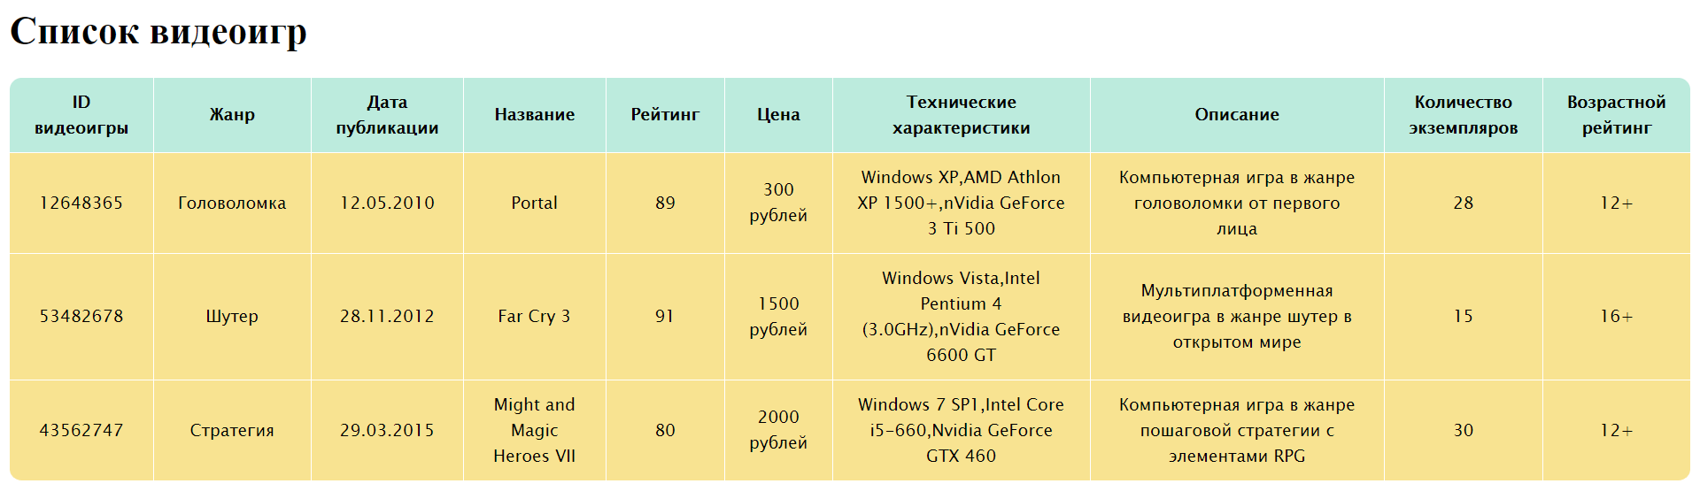

**Пример №2: Вывести всю информацию о поставщиках**

<?xml version="1.0" encoding="UTF-8"?>

<xsl:stylesheet version="1.0"

   xmlns:xsl="http://www.w3.org/1999/XSL/Transform">

   <xsl:template match="/providers">

        <html>

            <head>

                <title> Список поставщиков </title>

                <style type="text/css">

                    table {

                        font-family: "Lucida Sans Unicode", "Lucida Grande", Sans-Serif;

                        font-size: 14px;

                        border-radius: 10px;

                        border-spacing: 0;

                        text-align: center;

                        }

                        th {

                        background: #BCEBDD;

                        color: black;

                        padding: 10px 20px;

                        }

                        th, td {

                        border-style: solid;

                        border-width: 0 1px 1px 0;

                        border-color: white;

                        }

                        th:first-child, td:first-child {

                        text-align: center;

                        }

                        th:first-child {

                        border-top-left-radius: 10px;

                        }

                        th:last-child {

                        border-top-right-radius: 10px;

                        border-right: none;

                        }

                        td {

                        padding: 10px 20px;

                        background: #F8E391;

                        }

                        tr:last-child td:first-child {

                        border-radius: 0 0 0 10px;

                        }

                        tr:last-child td:last-child {

                        border-radius: 0 0 10px 0;

                        }

                        tr td:last-child {

                        border-right: none;

                        }

                    </style>

            </head>

            <body>

                <h1>Список поставщиков</h1>

                <table border="0">

                    <tr>

                        <th>ID поставщика</th>

                        <th>ФИО</th>

                        <th>Цена товара</th>

                        <th>Упаковка продукции</th>

                        <th>Опыт работы на рынке</th>

                        <th>Географическое расположение</th>

                        <th>Почта</th>

                        <th>Соблюдение графика поставок</th>

                        <th>Уровень затрат на доставку</th>

                    </tr>

                    <xsl:for-each select = "provider">

                        <tr>

                            <td><xsl:value-of select = "provider_id/@id"/></td>

                            <xsl:for-each select="fullname">

                                <td>

                                    <xsl:value-of select = "surname"/><xsl:text> </xsl:text>

                                    <xsl:value-of select = "name"/><xsl:text> </xsl:text>

                                    <xsl:value-of select = "patronymic"/>

                                </td>

                            </xsl:for-each>

                            <td><xsl:value-of select = "product_price"/></td>

                            <td><xsl:value-of select = "product_packing"/></td>

                            <td><xsl:value-of select = "work_experience"/></td>

                            <td><xsl:value-of select = "location"/></td>

                            <td><xsl:value-of select = "email"/></td>

                            <td><xsl:value-of select = "graphics_сompliance"/></td>

                            <td><xsl:value-of select = "сost_level"/></td>

                        </tr>

                    </xsl:for-each>

                </table>

            </body>

        </html>

    </xsl:template>

</xsl:stylesheet>

**Преобразование в формат HTML:**

<!doctype html>

<html lang="ru">

   <head>

    <meta charset="utf-8" />

      <title> Список видеоигр </title>

      <style type="text/css">

                    table {

                        font-family: "Lucida Sans Unicode", "Lucida Grande", Sans-Serif;

                        font-size: 14px;

                        border-radius: 10px;

                        border-spacing: 0;

                        text-align: center;

                        }

                        th {

                        background: #BCEBDD;

                        color: black;

                        padding: 10px 20px;

                        }

                        th, td {

                        border-style: solid;

                        border-width: 0 1px 1px 0;

                        border-color: white;

                        }

                        th:first-child, td:first-child {

                        text-align: center;

                        }

                        th:first-child {

                        border-top-left-radius: 10px;

                        }

                        th:last-child {

                        border-top-right-radius: 10px;

                        border-right: none;

                        }

                        td {

                        padding: 10px 20px;

                        background: #F8E391;

                        }

                        tr:last-child td:first-child {

                        border-radius: 0 0 0 10px;

                        }

                        tr:last-child td:last-child {

                        border-radius: 0 0 10px 0;

                        }

                        tr td:last-child {

                        border-right: none;

                        }

                    </style>

   </head>

   <body>

      <h1>Список видеоигр</h1>

      <table>

         <tr>

            <th>ID видеоигры</th>

            <th>Жанр</th>

            <th>Дата публикации</th>

            <th>Название</th>

            <th>Рейтинг</th>

            <th>Цена</th>

            <th>Технические характеристики</th>

            <th>Описание</th>

            <th>Количество экземпляров</th>

            <th>Возрастной рейтинг</th>

         </tr>

         <tr>

            <td>12648365</td>

            <td>Головоломка</td>

            <td>12.05.2010</td>

            <td>Portal</td>

            <td>89</td>

            <td>300 рублей</td>

            <td>

            Windows XP,AMD Athlon XP 1500+,nVidia GeForce 3 Ti 500

        </td>

            <td>

            Компьютерная игра в жанре головоломки от первого лица

        </td>

            <td>28</td>

            <td>12+</td>

         </tr>

         <tr>

            <td>53482678</td>

            <td>Шутер</td>

            <td>28.11.2012</td>

            <td>Far Cry 3</td>

            <td>91</td>

            <td>1500 рублей</td>

            <td>

            Windows Vista,Intel Pentium 4 (3.0GHz),nVidia GeForce 6600 GT

        </td>

            <td>

            Мультиплатформенная видеоигра в жанре шутер в открытом мире

        </td>

            <td>15</td>

            <td>16+</td>

         </tr>

         <tr>

            <td>43562747</td>

            <td>Стратегия</td>

            <td>29.03.2015</td>

            <td>Might and Magic Heroes VII</td>

            <td>80</td>

            <td>2000 рублей</td>

            <td>

          Windows 7 SP1,Intel Core i5-660,Nvidia GeForce GTX 460

        </td>

            <td>

            Компьютерная игра в жанре пошаговой стратегии с элементами RPG

        </td>

            <td>30</td>

            <td>12+</td>

         </tr>

      </table>

   </body>

</html>

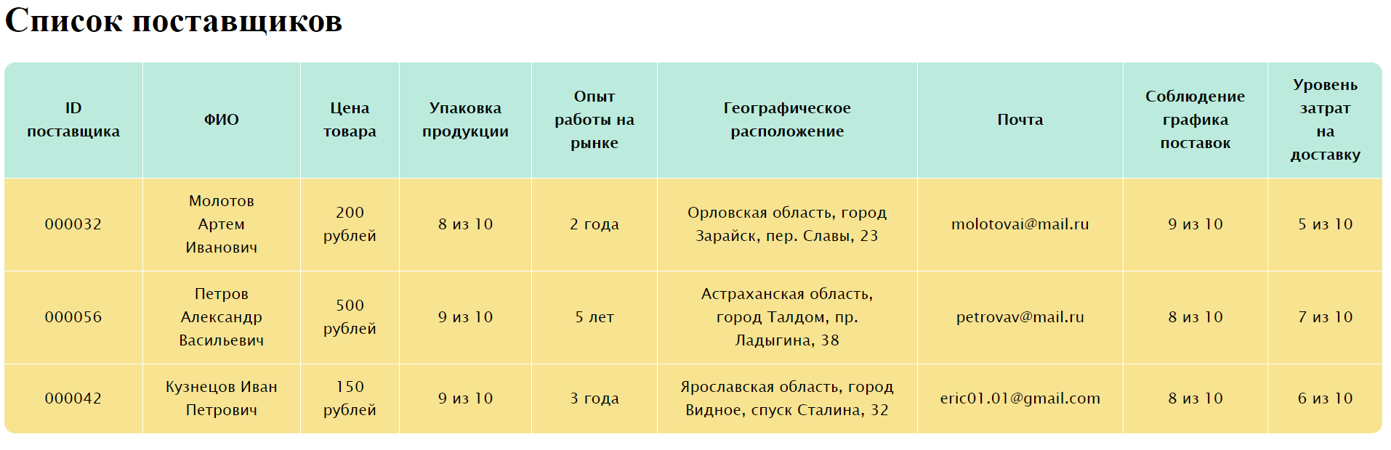

**Пример №3: Вывести всю информацию об экземплярах видеоигры**

<?xml version="1.0" encoding="UTF-8"?>

<xsl:stylesheet version="1.0"

   xmlns:xsl="http://www.w3.org/1999/XSL/Transform">

   <xsl:template match="/copies_videogame">

        <html>

            <head>

                <title> Список экземпляров видеоигры </title>

                <style type="text/css">

                    table {

                        font-family: "Lucida Sans Unicode", "Lucida Grande", Sans-Serif;

                        font-size: 14px;

                        border-radius: 10px;

                        border-spacing: 0;

                        text-align: center;

                        }

                        th {

                        background: #BCEBDD;

                        color: black;

                        padding: 10px 20px;

                        }

                        th, td {

                        border-style: solid;

                        border-width: 0 1px 1px 0;

                        border-color: white;

                        }

                        th:first-child, td:first-child {

                        text-align: center;

                        }

                        th:first-child {

                        border-top-left-radius: 10px;

                        }

                        th:last-child {

                        border-top-right-radius: 10px;

                        border-right: none;

                        }

                        td {

                        padding: 10px 20px;

                        background: #F8E391;

                        }

                        tr:last-child td:first-child {

                        border-radius: 0 0 0 10px;

                        }

                        tr:last-child td:last-child {

                        border-radius: 0 0 10px 0;

                        }

                        tr td:last-child {

                        border-right: none;

                        }

                    </style>

            </head>

            <body>

                <h1>Список экземпляров видеоигры</h1>

                <table>

                    <tr>

                        <th>ID экземпляра</th>

                        <th>Дата продажи</th>

                        <th>Время продажи</th>

                        <th>Статус</th>

                    </tr>

                    <xsl:for-each select = "copy_videogame">

                        <tr>

                            <td><xsl:value-of select = "copy_videogame_id/@id"/></td>             <td><xsl:value-of select = "sale_date"/></td>

                            <td><xsl:value-of select = "sale_time"/></td>

                            <td><xsl:value-of select = "status"/></td>

                        </tr>

                    </xsl:for-each>

                </table>

            </body>

        </html>

    </xsl:template>

</xsl:stylesheet>

**Преобразование в формат HTML:**

<!doctype html>

<html lang="ru">

   <head>

      <meta charset="utf-8" />

      <title> Список экземпляров видеоигры </title>

      <style type="text/css">

                    table {

                        font-family: "Lucida Sans Unicode", "Lucida Grande", Sans-Serif;

                        font-size: 14px;

                        border-radius: 10px;

                        border-spacing: 0;

                        text-align: center;

                        }

                        th {

                        background: #BCEBDD;

                        color: black;

                        padding: 10px 20px;

                        }

                        th, td {

                        border-style: solid;

                        border-width: 0 1px 1px 0;

                        border-color: white;

                        }

                        th:first-child, td:first-child {

                        text-align: center;

                        }

                        th:first-child {

                        border-top-left-radius: 10px;

                        }

                        th:last-child {

                        border-top-right-radius: 10px;

                        border-right: none;

                        }

                        td {

                        padding: 10px 20px;

                        background: #F8E391;

                        }

                        tr:last-child td:first-child {

                        border-radius: 0 0 0 10px;

                        }

                        tr:last-child td:last-child {

                        border-radius: 0 0 10px 0;

                        }

                        tr td:last-child {

                        border-right: none;

                        }

                    </style>

   </head>

   <body>

      <h1>Список экземпляров видеоигры</h1>

      <table>

         <tr>

            <th>ID экземпляра</th>

            <th>Дата продажи</th>

            <th>Время продажи</th>

            <th>Статус</th>

         </tr>

         <tr>

            <td>00004532</td>

            <td>20.05.2021</td>

            <td>15:02</td>

            <td>Продана</td>

         </tr>

         <tr>

            <td>00005364</td>

            <td>24.06.2021</td>

            <td>11:49</td>

            <td>Продана</td>

         </tr>

         <tr>

            <td>00007832</td>

            <td>23.05.2021</td>

            <td>14:52</td>

            <td>Продана</td>

         </tr>

         <tr>

            <td>00004322</td>

            <td>14.05.2021</td>

            <td>20:00</td>

            <td>Продана</td>

         </tr>

         <tr>

            <td>00004543</td>

            <td>21.05.2021</td>

            <td>11:32</td>

            <td>Продана</td>

         </tr>

      </table>

   </body>

</html>

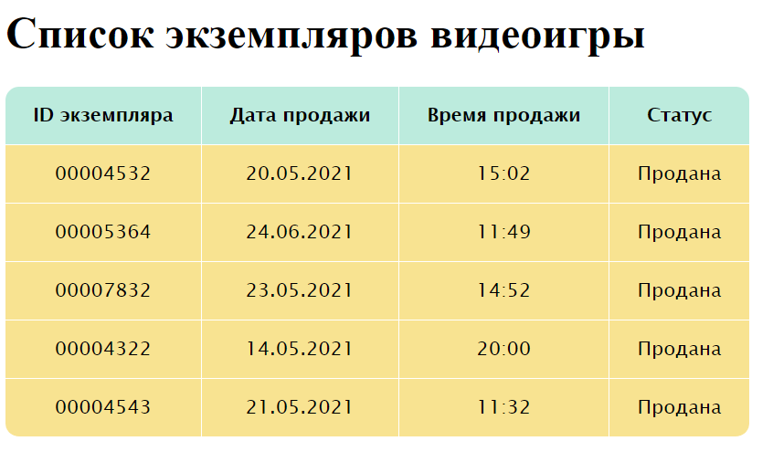

**Пример №4: Вывести всю информацию об отзывах**

<?xml version="1.0" encoding="UTF-8"?>

<xsl:stylesheet version="1.0"

   xmlns:xsl="http://www.w3.org/1999/XSL/Transform">

   <xsl:template match="/reviews">

        <html>

            <head>

                <title> Список отзывов </title>

                <style type="text/css">

                    table {

                        font-family: "Lucida Sans Unicode", "Lucida Grande", Sans-Serif;

                        font-size: 14px;

                        border-radius: 10px;

                        border-spacing: 0;

                        text-align: center;

                        }

                        th {

                        background: #BCEBDD;

                        color: black;

                        padding: 10px 20px;

                        }

                        th, td {

                        border-style: solid;

                        border-width: 0 1px 1px 0;

                        border-color: white;

                        }

                        th:first-child, td:first-child {

                        text-align: center;

                        }

                        th:first-child {

                        border-top-left-radius: 10px;

                        }

                        th:last-child {

                        border-top-right-radius: 10px;

                        border-right: none;

                        }

                        td {

                        padding: 10px 20px;

                        background: #F8E391;

                        }

                        tr:last-child td:first-child {

                        border-radius: 0 0 0 10px;

                        }

                        tr:last-child td:last-child {

                        border-radius: 0 0 10px 0;

                        }

                        tr td:last-child {

                        border-right: none;

                        }

                    </style>

            </head>

            <body>

                <h1>Список отзывов</h1>

                <table border="0">

                    <tr>

                        <th>ID отзыва</th>

                        <th>ФИО клиента</th>

                        <th>Оценка</th>

                        <th>Текст отзыва</th>

                        <th>Субъект отзыва</th>

                    </tr>

                    <xsl:for-each select = "review">

                        <tr>

                            <td><xsl:value-of select = "review_id/@id"/></td>

                            <xsl:for-each select="client_fullname">

                                <td>

                                    <xsl:value-of select = "surname"/><xsl:text> </xsl:text>

                                    <xsl:value-of select = "name"/><xsl:text> </xsl:text>

                                    <xsl:value-of select = "patronymic"/>

                                </td>

                            </xsl:for-each>

                            <td><xsl:value-of select = "assessment"/></td>

                            <td><xsl:value-of select = "review_text"/></td>

                            <td><xsl:value-of select = "review_subject"/></td>

                        </tr>

                    </xsl:for-each>

                </table>

            </body>

        </html>

    </xsl:template>

</xsl:stylesheet>

**Преобразование в формат HTML:**

<!doctype html>

<html lang="ru">

   <head>

      <meta charset="utf-8" />

      <title> Список отзывов </title>

      <style type="text/css">

                    table {

                        font-family: "Lucida Sans Unicode", "Lucida Grande", Sans-Serif;

                        font-size: 14px;

                        border-radius: 10px;

                        border-spacing: 0;

                        text-align: center;

                        }

                        th {

                        background: #BCEBDD;

                        color: black;

                        padding: 10px 20px;

                        }

                        th, td {

                        border-style: solid;

                        border-width: 0 1px 1px 0;

                        border-color: white;

                        }

                        th:first-child, td:first-child {

                        text-align: center;

                        }

                        th:first-child {

                        border-top-left-radius: 10px;

                        }

                        th:last-child {

                        border-top-right-radius: 10px;

                        border-right: none;

                        }

                        td {

                        padding: 10px 20px;

                        background: #F8E391;

                        }

                        tr:last-child td:first-child {

                        border-radius: 0 0 0 10px;

                        }

                        tr:last-child td:last-child {

                        border-radius: 0 0 10px 0;

                        }

                        tr td:last-child {

                        border-right: none;

                        }

                    </style>

   </head>

   <body>

      <h1>Список отзывов</h1>

      <table>

         <tr>

            <th>ID отзыва</th>

            <th>ФИО клиента</th>

            <th>Оценка</th>

            <th>Текст отзыва</th>

            <th>Субъект отзыва</th>

         </tr>

         <tr>

            <td>0004</td>

            <td>Гвоздев Антон Павлович</td>

            <td>4 из 5</td>

            <td>

            Очень классный магазин с разнообразным ассортиментом, жаль что не было в наличии Far Cry 6

        </td>

            <td>Магазин</td>

         </tr>

         <tr>

            <td>0025</td>

            <td>Карпенко Алина Сергеевна</td>

            <td>5 из 5</td>

            <td>Всем довольна, продавцы общительные и разбираются в данной индустрии</td>

            <td>Магазин</td>

         </tr>

         <tr>

            <td>0034</td>

            <td>Сидоров Андрей Даниилович</td>

            <td>1 из 5</td>

            <td>Игра не запускается на телевизоре</td>

            <td>Видеоигра</td>

         </tr>

         <tr>

            <td>0039</td>

            <td>Золотова Альбина Владимировна</td>

            <td>5 из 5</td>

            <td>Низкие цены и большой выбор</td>

            <td>Магазин</td>

         </tr>

         <tr>

            <td>0056</td>

            <td>Золотов Георгий Павлович</td>

            <td>5 из 5</td>

            <td>Моя сестра в восторге от вашего магазина, я с ней солидарен</td>

            <td>Магазин</td>

         </tr>

      </table>

   </body>

</html>

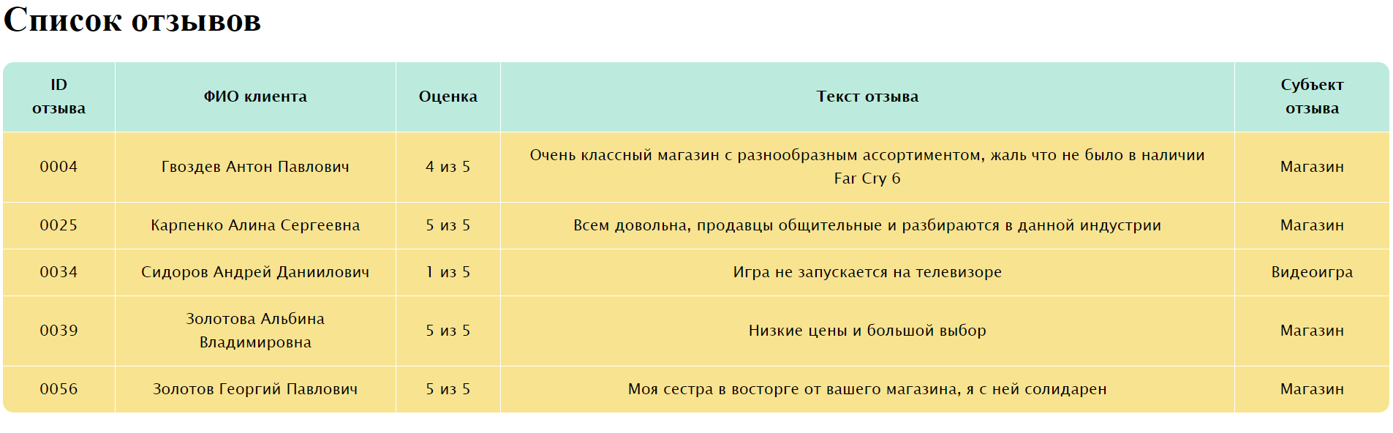

**Пример №5: Вывести всю информацию о запрашиваемых видеоиграх**

<?xml version="1.0" encoding="UTF-8"?>

<xsl:stylesheet version="1.0"

   xmlns:xsl="http://www.w3.org/1999/XSL/Transform">

   <xsl:template match="/requested_videogames">

        <html>

            <head>

                <title> Список запрошенных видеоигр </title>

                <style type="text/css">

                    table {

                        font-family: "Lucida Sans Unicode", "Lucida Grande", Sans-Serif;

                        font-size: 14px;

                        border-radius: 10px;

                        border-spacing: 0;

                        text-align: center;

                        }

                        th {

                        background: #BCEBDD;

                        color: black;

                        padding: 10px 20px;

                        }

                        th, td {

                        border-style: solid;

                        border-width: 0 1px 1px 0;

                        border-color: white;

                        }

                        th:first-child, td:first-child {

                        text-align: center;

                        }

                        th:first-child {

                        border-top-left-radius: 10px;

                        }

                        th:last-child {

                        border-top-right-radius: 10px;

                        border-right: none;

                        }

                        td {

                        padding: 10px 20px;

                        background: #F8E391;

                        }

                        tr:last-child td:first-child {

                        border-radius: 0 0 0 10px;

                        }

                        tr:last-child td:last-child {

                        border-radius: 0 0 10px 0;

                        }

                        tr td:last-child {

                        border-right: none;

                        }

                    </style>

            </head>

            <body>

                <h1>Список запрошенных видеоигр</h1>

                <table>

                    <tr>

                        <th>ID запрошенной игры</th>

                        <th>Дата запроса</th>

                        <th>Время запроса</th>

                        <th>Количество запрошенных копий</th>

                    </tr>

                    <xsl:for-each select = "requested_videogame">

                        <tr>

                            <td><xsl:value-of select = "requested_videogame_id/@id"/></td>

                            <td><xsl:value-of select = "request_date"/></td>

                            <td><xsl:value-of select = "request_time"/></td>

                            <td><xsl:value-of select = "quantity"/></td>

                        </tr>

                    </xsl:for-each>

                </table>

            </body>

        </html>

    </xsl:template>

</xsl:stylesheet>

**Преобразование в формат HTML:**

<!doctype html>

<html lang="ru">

   <head>

      <meta charset="utf-8" />

      <title>Список запрошенных видеоигр</title>

      <style type="text/css">

                    table {

                        font-family: "Lucida Sans Unicode", "Lucida Grande", Sans-Serif;

                        font-size: 14px;

                        border-radius: 10px;

                        border-spacing: 0;

                        text-align: center;

                        }

                        th {

                        background: #BCEBDD;

                        color: black;

                        padding: 10px 20px;

                        }

                        th, td {

                        border-style: solid;

                        border-width: 0 1px 1px 0;

                        border-color: white;

                        }

                        th:first-child, td:first-child {

                        text-align: center;

                        }

                        th:first-child {

                        border-top-left-radius: 10px;

                        }

                        th:last-child {

                        border-top-right-radius: 10px;

                        border-right: none;

                        }

                        td {

                        padding: 10px 20px;

                        background: #F8E391;

                        }

                        tr:last-child td:first-child {

                        border-radius: 0 0 0 10px;

                        }

                        tr:last-child td:last-child {

                        border-radius: 0 0 10px 0;

                        }

                        tr td:last-child {

                        border-right: none;

                        }

                    </style>

   </head>

   <body>

      <h1>Список запрошенных видеоигр</h1>

      <table>

         <tr>

            <th>ID запрошенной игры</th>

            <th>Дата запроса</th>

            <th>Время запроса</th>

            <th>Количество запрошенных копий</th>

         </tr>

         <tr>

            <td>23324532</td>

            <td>25.06.2021</td>

            <td>12:52</td>

            <td>25</td>

         </tr>

         <tr>

            <td>42367586</td>

            <td>19.05.2021</td>

            <td>19:12</td>

            <td>30</td>

         </tr>

         <tr>

            <td>24683798</td>

            <td>15.06.2021</td>

            <td>09:19</td>

            <td>5</td>

         </tr>

         <tr>

            <td>97656243</td>

            <td>12.06.2021</td>

            <td>10:17</td>

            <td>3</td>

         </tr>

      </table>

   </body>

</html>

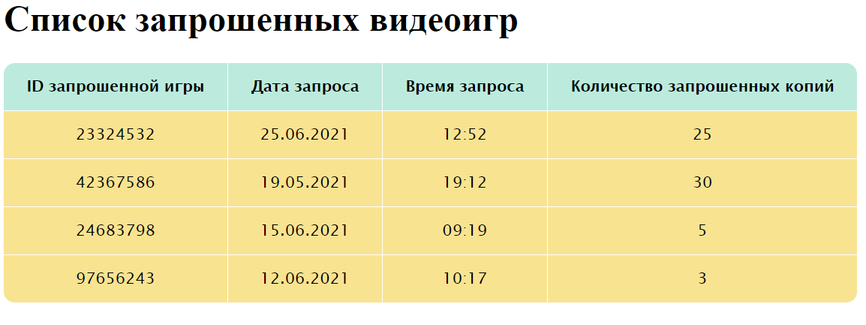

**Вывод**

В данной работе была описана информационная система и структура данных для работы магазина компьютерных игр. Были выделены сущности системы, по ним построена UML – диаграмма. Для лучшего структурирования информационная система была разделена на несколько файлов. С помощью XSL обеспечили вывод информации в таблицу. Преобразовали XML и XSL в формат HTML (для просмотра в браузере). С помощью CSS сделали дизайн для таблицы.