Ong Yeow Hwee, Glen

Singapore University of Social Science

ICT337: Big Data Computing in the Cloud

Prof. Hu He

October 19, 2023

**Question 1**

**(a)**

**Premise**

Both PySpark DataFrame and PySpark Resilient Distributed Datasets (RDD) are abstractions offered by Apache Spark for distributed data processing. They act as APIs that give Spark framework users the ability to interact with and manipulate data. These two fundamental components of Spark provide diverse methods for distributed data processing, each with unique advantages and applications. In this project, I will discuss the concepts of PySpark RDD and PySpark DataFrame by exploring their respective characteristics, transformations, actions and use cases.

***Resilient Distributed Datasets (RDD)***

**Definition and Characteristics.** The main data structure used by Apache Spark is RDD. It is a set of immutable, fault-tolerant components that can be handled concurrently by a cluster of machines. RDDs make the physical properties of the data, such as partitions, accessible to users, allowing them to understand how the data is processed and distributed in a distributed computing environment. RDDs also use lineage graph to keep track of the data transformations performed, ensuring resiliency and the capacity to recompute missing or damaged partitions in the event of node failures.

**Transformations and Actions.** When performing transformations, a new RDD is produced by applying a function to the elements of an existing RDD. Common transformations such as "map" and "filter" follow the lazy evaluation paradigm, which means they postpone execution and create a chain of transformations. This strategy enables Spark to effectively optimize the execution plan. The crucial points where Spark executes the computations are represented by actions. Actions like "collect" and "reduce" trigger the previously defined lineage of transformations to be evaluated, which computes the desired result.

**Use Case.** RDDs are best suited for situations in which precise, low-level control over data processing is essential. They excel in scenarios involving semi-structed or unstructured data sources. In situations requiring specialized data manipulation and the execution of challenging, non-standard data processing workflows, RDDs truly shine. They are a versatile option for developers taking on complex data processing challenges due to their flexibility and capacity to handle complex data operations.

***DataFrames***

**Definition and Characteristics.** As a higher-level abstraction built on top of RDDs, DataFrames in PySpark handles structured data effectively. A DataFrame is essentially a distributed collection of named columns and rows that is immutable and distributed across a cluster of machines. The ability of Spark to automatically understand the data's structure and optimize query execution for better performance is one of the key benefits of DataFrames. DataFrames’ user-friendly and structured approach to data manipulation is especially well-suited for a variety of data processing tasks, especially those involving structured data sources.

**Transformations and Actions.** DataFrames provide a more extensive array of high-level operations, enhancing their usability. Transformation operations such as “select” and “groupBy” enable users to manipulate data with ease while adhering to a lazy evaluation paradigm, which postpones execution and creates a chain of transformations. On the other hand, action operations like “count” and “show” serve as triggers, initiating the execution of transformations and returning valuable insights. This combination of rich high-level operations and efficient execution mechanisms makes DataFrames an appealing choice for various data processing tasks, particularly those involving structured data sources.

**Use Case.** When it comes to processing structured data, DataFrames becomes the favored solution for a variety of data processing tasks. They offer streamlined operations for data exploration and wrangling in scenarios involving structured data formats like CSV, Parquet, or Avro, where their effectiveness really shines. The unique feature of DataFrames is their built-in compatibility with SQL-like queries, which gives users a simple way to query their data. Additionally, the Catalyst optimizer's inclusion guarantees automatic optimization of query execution plans, improving performance and making DataFrames particularly advantageous for tasks that require both structured data processing and query optimization.

Abstraction level Low-level, more control over the pre-processing part High-level, rich semantics

**(b)**

|  |  |  |
| --- | --- | --- |
| **Characteristic** | **Resilient Distributed Datasets (RDD)** | **DataFrames** |
| Abstraction level | Low-level, more control over pre-processing | High-level, rich semantics |
| Data structure | Unstructured | Structured (tabular) |
| Schema | No schema | Schema with named columns |
| Typing | No type enforcement | Strong typed |
| Catalyst optimizer | Not applicable | Optimizes query execution plans |
| Serialization | User-defined | Built-in |
| Fault-tolerance | Basic (requires lineage) | Built-in |
| Spark SQL | No | Yes |
| Transformations | ‘map’, ‘reduce’, custom transformations | ‘select’, ‘filter’, SQL queries, joins |
| Ease of use | More complex | More user-friendly |

*Table 1.1. Differences between PySpark RDD and PySpark Dataframes.*

**Question 2**

**(a)**

***Premise***

My local machine operates in windows, it is advantageous to create an isolated environment for running Apache Spark. The VMware Workstation 17 Player is downloaded, installed with the ubuntu iso, and launched (see Figure 1 and Figure 2). Subsequently, the following processes are applied within the VMware environment.

*Figure 1. Creating a Virtual machine in VMware with Ubuntu iso image.*

*Figure 2. Virtual machine configuration in VMware.*

***Prerequisites***

Apache Spark requires Java Development Kit (1) and Python (2). In my case, I chose to download Apache Spark version 3.4.1 and the pre-built for Apache Hadoop package type from Apache Sparks official website (3).

Firstly, ‘sudo apt install default-jdk’ command is used in the terminal to download the Java Development Kit prerequisite and the ‘java –version’ command is used to verify if the Java has been installed accordingly (see Figure 3 and Figure 4).

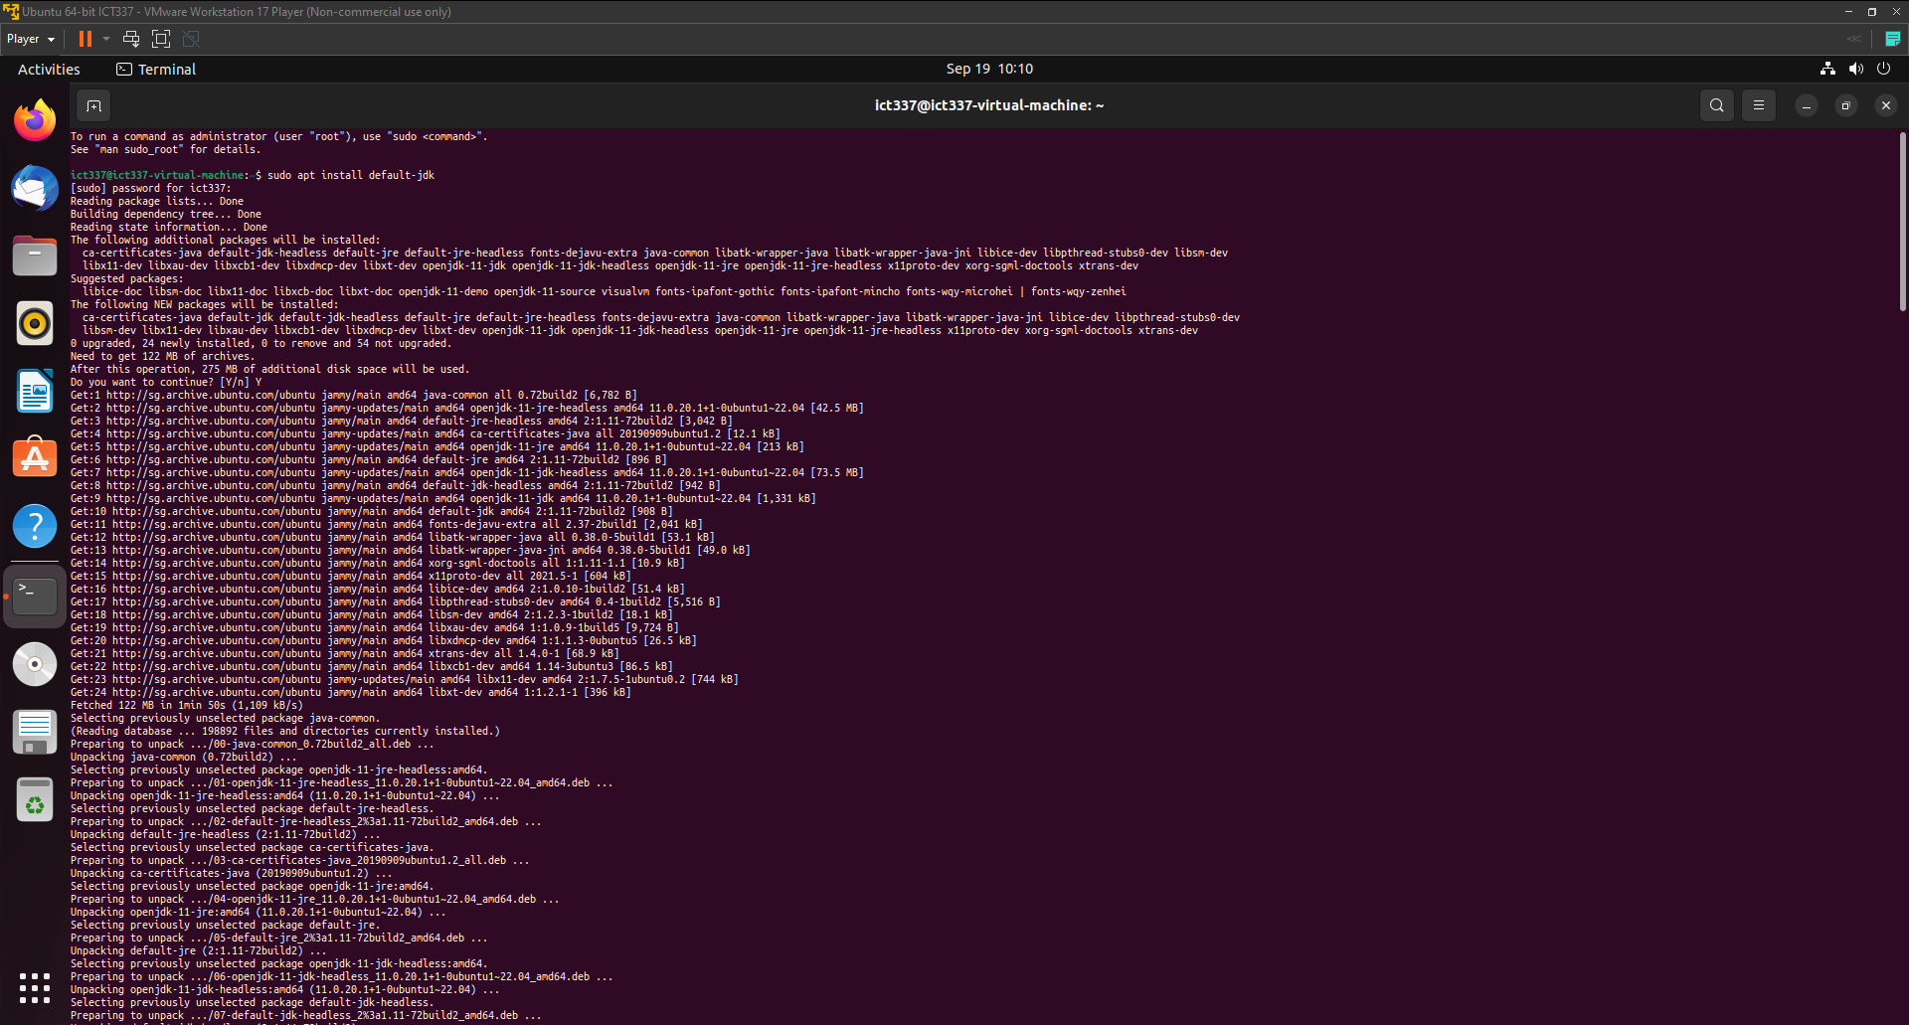

*Figure 3. Sample Java Development Kit installation in Ubuntu terminal.*

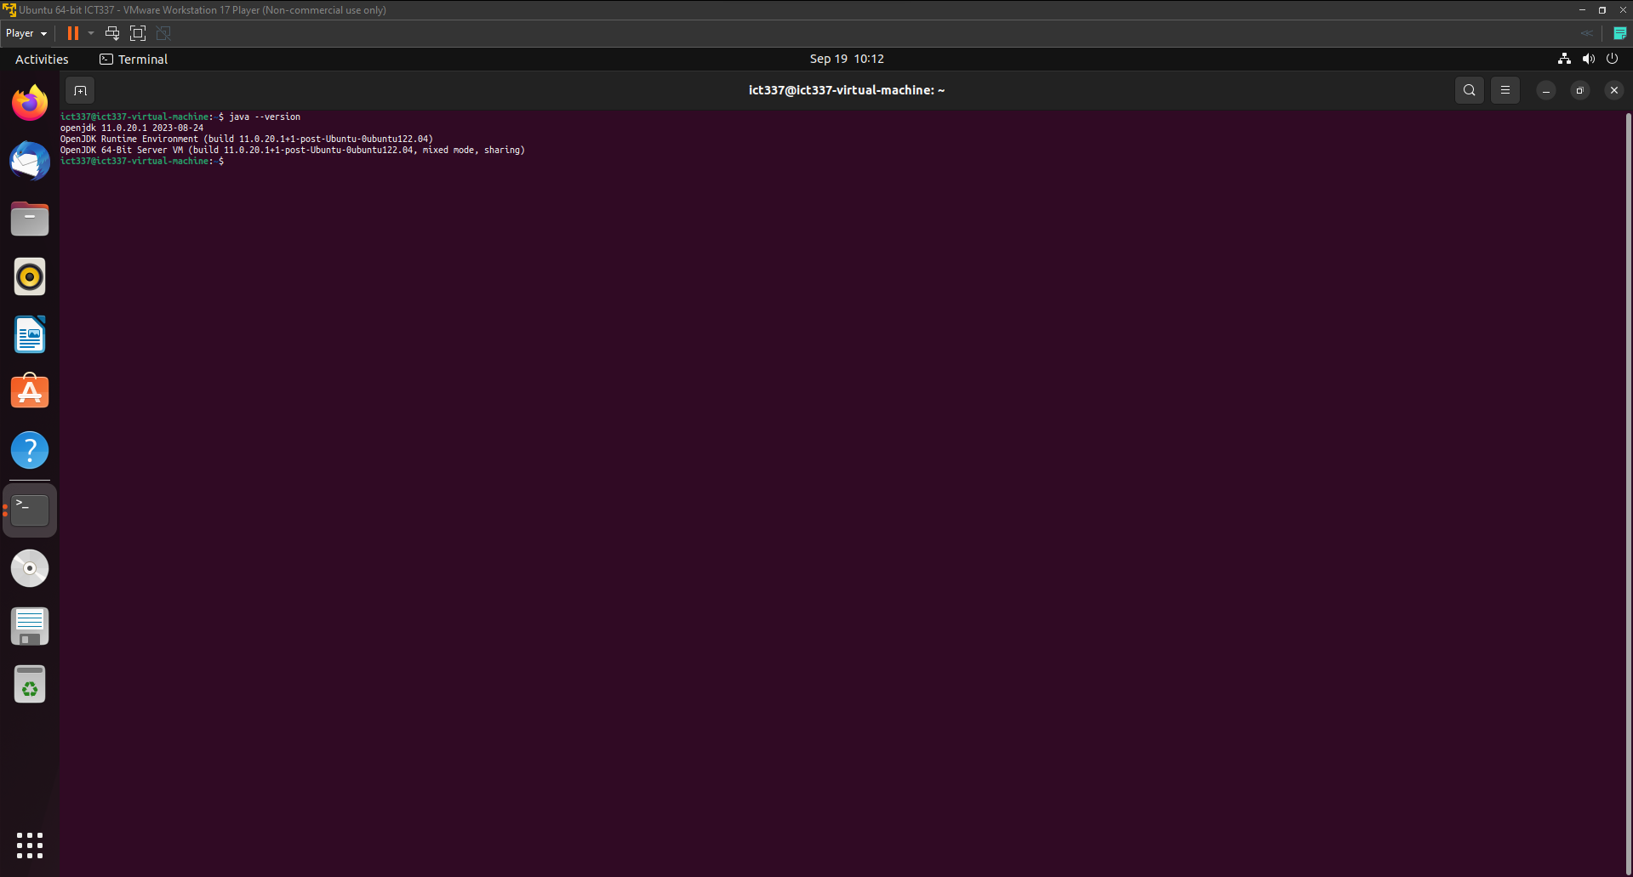

*Figure 4. Java Development Kit installation verification in Ubuntu terminal.*

Secondly, ‘sudo apt install python3’ command is used in the terminal to download the Python prerequisite and the ‘python3 –version’ command is used to verify if the Python has been installed accordingly (see Figure 5 and Figure 6).

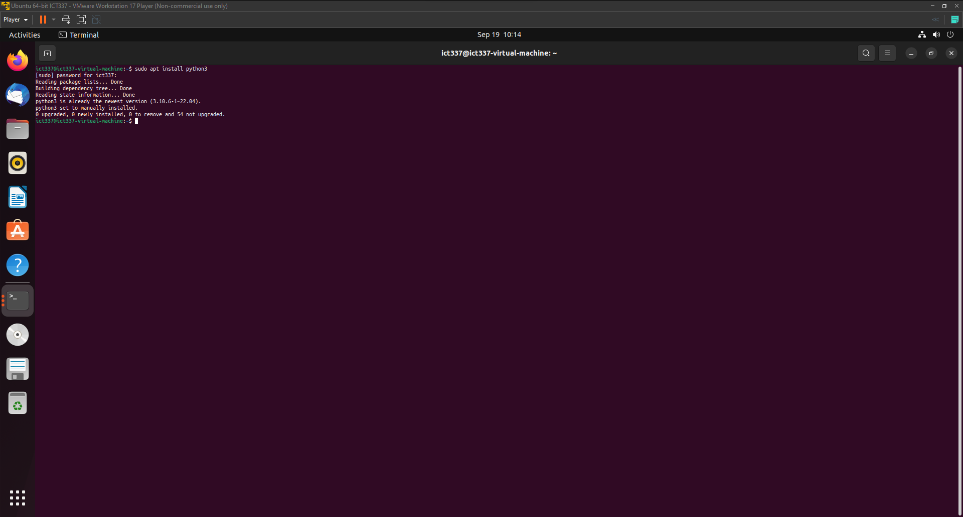

*Figure 5. Python3 installation in Ubuntu terminal.*

*Figure 6. Python3 installation verification in Ubuntu terminal.*

Thirdly, the Spark 3.4.1 release with pre-built for Apache Hadoop 3.3 and later is acquired from the Apache Spark official website. After obtaining the release, the.tgz file contents are extracted. In the terminal, ‘cd /home/ict337/Downloads/spark-3.4.1-bin-hadoop3’ command is used to navigate into the Spark Hadoop package directory and the ‘ls’ command is used to inspect the Hadoop folder (See Figure 7). To ensure the Spark Hadoop package is in place and functioning correctly, the ‘spark-shell’ is executed and Spark Web User Interfaced is launched. To accomplish this, the ‘cd bin’ command is used to navigate into the bin folder, followed by the execution of the ‘./spark-shell’ command (See Figure 8 and Figure 9).

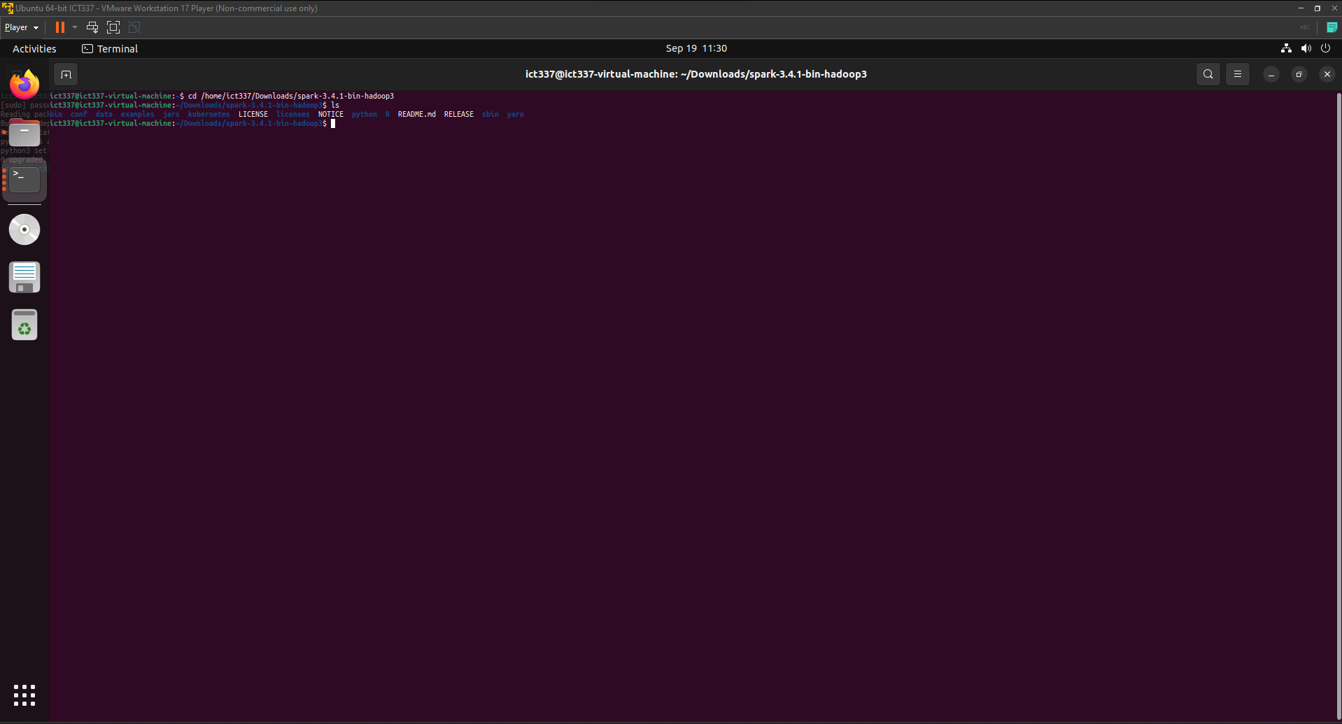

*Figure 7. Changing directory to the downloaded and extracted .tgz file in Ubuntu terminal.*

*Figure 8. Execution of spark-shell in Ubuntu terminal*

*Figure 9. Spark Web User Interface*

Lastly, to demonstrate the non-interactive execution of built-in ‘pi.py’ example program, a new terminal window is opened and navigated into the into the Spark Hadoop package directory with the ‘cd /home/ict337/Downloads/spark-3.4.1-bin-hadoop3’ (See Figure 10). The ‘pi.py’ example program provided leverages Monte Carlo method to estimate pi. Notably, the number of partitions employed for the estimation is defaulted to 2 when no partition count is supplied in the command-line argument. This default behavior is governed by ‘partitions = int(sys.argv[1]) if len(sys.argv) > 1 else 2’ line of code in the pi.py example program. Therefore, the ‘./bin/spark-submit ./examples/src/main/python/pi.py’ command would suffice, returning a pi estimation of 3.135800 (see Figure 11).

*Figure 10. Changing directory to the Spark Hadoop package file in Ubuntu terminal.*

*Figure 11. Execution of ‘pi.py’ program without partitions supplied*

**(b)**

***Dependencies***

It is likely that the the 'pi.py' example program is written in Python 2 and to ensure compatibility with Python 2 and Python 3, the 'from _future_ import print_function' statement is used to leverage the Python 3-style 'print' function such as '%f' formatter in Python 2. The 'import sys' line of code imports the 'sys' module to provide access to system-specific parameters. In the 'pi.py' example program, it uses command line arguments such as the 'sys.argv[]' and 'len(sys.argv)'.

Additionally, the 'from random import random' line of code imports the random function from the random module and the 'from operator import add' line of code imports the add function from the operator module. These functions are leveraged in 'pi.py' example program for randomizing the x and y axis and counting.

Furthermore, the 'from pyspark.sql import SparkSession' line of code imports the SparkSession class from the pyspark.sql module. This is used in the 'pi.py' example program as an API or entry point for configuring, creating, and interacting with Spark functionalities.

***Initialization***

Firstly, the 'if _name_ = "__main__"' line of code checks whether the script is executed as the main program to prevent unintended execution of the 'pi.py' example program. Additionally, the docstring of 'Usage: pi [partitions]' encased in the 3 double quotation marks provides the usage instructions for how to execute the 'pi.py' example program, indicating that it expects a 'partitions' argument to specify the number of partitions.

Secondly, inside the 'if _name_ = "__main__":' block of code, the 'SparkSession' class and '.builder' method is called to create and configure a spark instance respectively. Additionally, the '.appName("PythonPi")' method gives the application name of the spark job an identifier of "PythonPi". Furthermore, the '.getOrCreate()' method ensures a SparkSession is available for the 'pi.py' example program by checking whether there is an existing SparkSession and creates one if there is none.

***Main Application Logic***

Prior to the declaration of the ‘f’ function, some initial configuration is performed such as the number of partitions (1) which will be divided for parallel processing and determining the total number of data points across the specified number of partitions (2). Firstly, the line of code ‘partitions = int(sys.argv[1]) if len(sys.argv) > 1 else 2’ retrieves the ‘partitions’ value from the command-line. This operation identifies arguments specified by the user in the command-line argument. For example, in the command ‘./bin/spark-submit ./examples/src/main/python/pi.py 7’, it contains more than 1 system argument, satisfying the condition of ‘if len(sys.argv) > 1’. Hence the number 7 identified by ‘sys.argv[1]’ would be converted to an integer and assigns it to the ‘partitions’ variable. However, in the case where no arguments are specified in the command-line argument, the value of ‘len(sys.argv)’ would remain at 1. Therefore, the number of partitions to default at 2, as it does not satisfy the condition of ‘if len(sys.argv) > 1’. Secondly, the line of code ‘n = 100000 * partitions’ multiplies 100000 to the number of partitions specified to be later distributed across the partitions. For example, in the command ‘./bin/spark-submit ./examples/src/main/python/pi.py 7’, spark would distribute 700000 data points across 7 partitions, with each partition handling a portion of the data points for parallel processing.

In the ‘f’ function, the x-coordinate, y-coordinate (1) are defined and determines whether the data point falls within a circle with a radius of 1 (2). Firstly, the lines of code ‘x = random() * 2 – 1’ and ‘y = random() * 2 – 1’ generate a floating number from 0 to 1. It subsequently multiplies the random floating number by 2 and subtracts 1 from it to ensure that the coordinates may fall within the range of -1 to 1. This process assigns random values within the range from -1 to 1 to the x-coordinate and y-coordinate. Secondly, the line of code ‘return 1 if x ** 2 + y ** 2 <= 1 else 0’ calculates the squared Euclidean distance from the given random x-coordinate and y-coordinate to origin. Subsequently, it categorizes the random data points, ‘1’ indicating the data point is within the range of -1 to 1 and ‘0’ indicating the data point is outside of this specified range.

In the line of code ‘count = spark.sparkContext.Parallelize(range(1, n + 1), partitions).map(f).reduce(add)’, it creates a Resilient Distributed Datasets (RDD) (1), uses spark to parallelize the generation of random data points (2), apply the ‘f’ function to each element in the RDD (3), and apply the ‘add’ function to add up all the ‘1’s and ‘0’s (4). Firstly, ‘spark.sparkContext’ is an entry point for the spark session to access spark operations such as creating a RDD and perform distributed data processing tasks. Secondly, the ‘.Parallelize(range(1, n + 1), partitions)’ method creates a RDD ‘n’ elements with a sequence of 1 to ‘n’, where ‘n’ represents the total number of data points. This process subsequently distributes these elements across the specified number of partitions. Thirdly, the ‘.map(f)’ transformation applies the ‘f’ function to the RDD and transforms each element in the RDD into ‘1’s or ‘0’s. Lastly, the ‘reduce(add)’ action executes the transformation in the RDD and aggregates the elements across all the partitions. Therefore, this process effectively counts the number of data points that fall within a circle with a radius of 1.

In the line of code ‘print("Pi is roughly %f" % (4.0 * count/n))’, the ‘pi.py’ example program outputs ‘Pi is roughly %f’, where ‘%f’ is a placeholder for floating value computed by ‘%(4.0 * count/n)’. Therefore, it computes the estimate of pi with ‘%(4.0 * count/n)’ and outputs "Pi is roughly %f" in a single print statement. Finally, the ‘spark.stop()’ method is used to end the spark session to ensure a clean shutdown of spark instance in the ‘pi.py’ example program.

**Question 3**

**Full PySpark Program**

import logging

import os

from pyspark.sql import SparkSession

from pyspark.sql.functions import col, sum, avg, min, max, when

# Constants

SCRIPTS_DIR = os.path.abspath(os.path.dirname(__file__))

DATA_DIR = os.path.join(SCRIPTS_DIR, "..", "data")

FLIGHTS_DATA_FILE_PATH = os.path.join(DATA_DIR, "flights_data_v2.csv")

PLANES_DATA_FILE_PATH = os.path.join(DATA_DIR, "planes_data_v2.csv")

LOGGING_LEVEL = logging.INFO

LOAD_DATA_ERROR_MESSAGE = "An error occurred while loading data: {}"

FILE_NOT_FOUND_MESSAGE = "The specified file does not exist: {}"

def configure_logging():

    """Configure logging settings and return a logger object.

    Returns

    -------

    logger : object

        Logger object for logging messages.

    Notes

    -----

    This function returns a logger object that may be used to log messages

    inside the program and initializes the logging parameters, including the logging level.

    The default logging level is set to the value of the constant LOGGING_LEVEL.

    """

    logging.basicConfig(*level*=LOGGING_LEVEL)

    return logging.getLogger(__name__)

def create_spark_session(*app_name*="TMA_Data_Analysis"):

    """

    Create and return a Spark session.

    Parameters

    ----------

    app_name : str, optional

        The name of the Spark application, by default "TMA_Data_Analysis".

    Returns

    -------

    SparkSession

        The Spark session object.

    Notes

    -----

    This function initializes a Spark session, which is the entry point for working with Spark functionality.

    """

    return SparkSession.builder.appName(app_name)\

        .config("spark.some.config.option", "some-value")\

        .getOrCreate()

def show_dataframe(*df*, *max_rows*=100, *show_rows*=20):

    """

    Show rows of a DataFrame with the option to limit the number of rows displayed.

    Parameters

    ----------

    df : DataFrame

        The DataFrame to be displayed.

    max_rows : int, optional

        The maximum number of rows to display. Default is 20.

    show_rows : int, optional

        The rows to display if records is above max rows.

    Returns

    -------

    None

    Notes

    -----

    This function shows the rows from the DataFrame input.

    The DataFrame will only display the first "show_rows" rows if there are more rows than the specified "max_rows".

    The DataFrame will display all available rows without truncation if the number of rows is less than "max_rows".

    """

    if df.count() > max_rows:

        df.show(show_rows)

    else:

        df.show(df.count(), *truncate*=False)

def load_data(*spark*, *logger*, *file_path*):

    """

    Load data from CSV file into a Spark DataFrame.

    Parameters

    ----------

    spark : SparkSession

        The Spark session.

    logger : Logger

        Logger object for logging messages.

    file_path : str, optional

        The path to the CSV file to load.

    Returns

    -------

    DataFrame

        DataFrame containing the data.

    Raises

    ------

    FileNotFoundError

        If the specified file does not exist.

    Notes

    -----

    This function reads data from a CSV file and loads it into a Spark DataFrame.

    Note: The default logging level is set to the value of the constant LOGGING_LEVEL.

    """

    try:

        # Load data from csv

        df = spark.read.option("inferSchema", "true").option(

            "header", "true").csv(file_path)

        return df

    except *Exception* as e:

        if "Path does not exist" in *str*(e):

            logger.error(FILE_NOT_FOUND_MESSAGE.format(file_path))

            raise *FileNotFoundError*(f"File not found: {file_path}")

        logger.error(LOAD_DATA_ERROR_MESSAGE.format(*str*(e)))

        raise e

def process_missing_data(*df*, *logger*):

    """Process and analyze the loaded data.

    Parameters

    ----------

    df : DataFrame

        DataFrame containing the data.

    logger : object

        Logger object for logging messages.

    Returns

    -------

    DataFrame

        DataFrame containing the data.

    Raises

    ------

    Exception

        If an error occurs during data processing.

    Notes

    -----

    This function determines which rows in the supplied DataFrame have missing values,

    displays those rows, and removes them from the DataFrame. It details the total number of missing values,

    the cleaned DataFrame that is produced, and any problems that may have occurred.

    """

    try:

        columns_to_check = df.columns

        filter_condition = None

        # Loop through the list of columns and build a filter condition to check for null values.

        for column_name in columns_to_check:

            # Create a new condition to check if the column is null

            if filter_condition is None:

                filter_condition = col(column_name).isNull()

            # For subsequent columns, update the filter condition to include a check for null values

            else:

                filter_condition = filter_condition | col(column_name).isNull()

        missing_data_df = df.filter(filter_condition)

        logger.info("Sample rows in the DataFrame with Missing Value:")

        show_dataframe(missing_data_df)

        missing_occurrence = missing_data_df.count()

        logger.info(

            f"There are {missing_occurrence} rows with missing values in DataFrame.\n")

        clean_data_df = df.filter(~filter_condition)

        return clean_data_df

    except *Exception* as e:

        logger.error(f"An error occurred: {*str*(e)}")

        raise e

def count_by(*df*, *grouped_columns*, *logger*):

    """

    Count occurrences of rows by grouping columns.

    Parameters

    ----------

    df : DataFrame

        DataFrame containing the data.

    grouped_columns : list

        List of columns to group by.

    logger : object

        Logger object for logging messages.

    Returns

    -------

    DataFrame

        DataFrame with counts, sorted in descending order.

    Raises

    ------

    Exception

        If an error occurs during counting.

    Notes

    -----

    This function divides the data in the input DataFrame into groups according to the chosen columns,

    then counts the number of rows in each group. The outcome is a DataFrame with counts that is

    sorted in decreasing order according to the count values.

    """

    try:

        count_by_col = df.groupby(*grouped_columns).count()

        sorted_counts_df = count_by_col.orderBy("count", *ascending*=False)

        return sorted_counts_df

    except *Exception* as e:

        logger.error(f"An error occurred: {*str*(e)}")

        raise e

def percentage_by(*df*, *grouped_columns*, *logger*):

    """

    Calculate the percentage of occurrences by grouping columns.

    Parameters

    ----------

    df : DataFrame

        DataFrame containing the data.

    grouped_columns : list

        List of columns to group by.

    logger : object

        Logger object for logging messages.

    Returns

    -------

    DataFrame

        DataFrame with counts and percentages, sorted in descending order.

    Raises

    ------

    Exception

        If an error occurs during percentage calculation.

    Notes

    -----

    The function computes the number and percentage of occurrences within each group relative

    to the total number of rows in the DataFrame for the data in the input DataFrame, which is organized by the provided columns.

    The outcome is a DataFrame that is sorted in decreasing order using the percentage values and includes both counts and percentages.

    """

    try:

        total_flights = df.count()

        total_flights_by = df.groupby(*grouped_columns).count()

        col_percentage = total_flights_by.withColumn(

            "percentage", (total_flights_by["count"] / total_flights) * 100).orderBy("percentage", *ascending*=False)

        return col_percentage

    except *Exception* as e:

        logger.error(f"An error occurred: {*str*(e)}")

        raise e

def top_n_cat_by(*df*, *grouped_columns*, *n*, *logger*):

    """

    Find the top n category.

    Parameters

    ----------

    df : DataFrame

        DataFrame containing the data.

    grouped_columns : list

        List of columns to group by.

    n : int

        Number of top category to retrieve.

    logger : object

        Logger object for logging messages.

    Returns

    -------

    DataFrame

        DataFrame with the top category, sorted by count in descending order.

    Raises

    ------

    Exception

        If an error occurs during counting.

    Notes

    -----

    This function groups data from the specified DataFrame by the specified columns and counts the number of occurrences of each category.

    It returns a DataFrame containing the top n categories with the highest counts, sorted in descending order based on count values.

    """

    try:

        top_cat = df.groupBy(*grouped_columns).count().orderBy(

            "count", *ascending*=False).limit(n)

        return top_cat

    except *Exception* as e:

        logger.error(f"An error occurred: {*str*(e)}")

        raise e

def bottom_n_cat_by(*df*, *grouped_columns*, *n*, *logger*):

    """

    Find the bottom n category.

    Parameters

    ----------

    df : DataFrame

        DataFrame containing the data.

    grouped_columns : list

        List of columns to group by.

    n : int

        Number of bottom category to retrieve.

    logger : object

        Logger object for logging messages.

    Returns

    -------

    DataFrame

        DataFrame with the bottom category, sorted by count in ascending order.

    Raises

    ------

    Exception

        If an error occurs during counting.

    Notes

    -----

    This function groups data from the specified DataFrame by the specified columns and counts the number of occurrences of each category.

    It returns a DataFrame containing the last n categories with the highest number, sorted in ascending order based on count values.

    """

    try:

        bottom_cat = df.groupBy(*grouped_columns).count().orderBy(

            "count", *ascending*=True).limit(n)

        return bottom_cat

    except *Exception* as e:

        logger.error(f"An error occurred: {*str*(e)}")

        raise e

def sql_top_n_cat_by(*df*, *grouped_columns*, *n*, *spark*, *logger*):

    """

    Find the top n category.

    Parameters

    ----------

    df : DataFrame

        DataFrame containing the data.

    grouped_columns : list

        List of columns to group by.

    n : int

        Number of top category to retrieve.

    spark : SparkSession

        The Spark session.

    logger : object

        Logger object for logging messages.

    Returns

    -------

    DataFrame

        DataFrame with the top category, sorted by count in descending order.

    Raises

    ------

    Exception

        If an error occurs during counting.

    Notes

    -----

    This function groups data from the specified DataFrame by the specified columns and counts the number of occurrences of each category.

    It returns a DataFrame containing the top n categories with the highest counts, sorted in descending order based on count values.

    """

    try:

        df.createOrReplaceTempView("top_flights_planes")

        columns_str = ", ".join(grouped_columns)

        query = f"""

        SELECT {columns_str}, COUNT(*) AS count

        FROM top_flights_planes

        GROUP BY {columns_str}

        ORDER BY count DESC

        LIMIT {n}

        """

        sql_top_n_cat = spark.sql(query)

        return sql_top_n_cat

    except *Exception* as e:

        logger.error(f"An error occurred: {*str*(e)}")

        raise e

def sql_bottom_n_cat_by(*df*, *grouped_columns*, *n*, *spark*, *logger*):

    """

    Find the bottom n category.

    Parameters

    ----------

    df : DataFrame

        DataFrame containing the data.

    grouped_columns : list

        List of columns to group by.

    n : int

        Number of bottom category to retrieve.

    spark : SparkSession

        The Spark session.

    logger : object

        Logger object for logging messages.

    Returns

    -------

    DataFrame

        DataFrame with the bottom category, sorted by count in ascending order.

    Raises

    ------

    Exception

        If an error occurs during counting.

    Notes

    -----

    This function groups data from the specified DataFrame by the specified columns and counts the number of occurrences of each category.

    It returns a DataFrame containing the last n categories with the highest number, sorted in ascending order based on count values.

    """

    try:

        df.createOrReplaceTempView("bottom_flights_planes")

        columns_str = ", ".join(grouped_columns)

        query = f"""

        SELECT {columns_str}, COUNT(*) AS count

        FROM bottom_flights_planes

        GROUP BY {columns_str}

        ORDER BY count ASC

        LIMIT {n}

        """

        sql_bottom_n_cat = spark.sql(query)

        return sql_bottom_n_cat

    except *Exception* as e:

        logger.error(f"An error occurred: {*str*(e)}")

        raise e

def analyze_average_delay(*df*, *column*, *delay_column*, *logger*):

    """

    Analyze average departure/arrival delay.

    Parameters

    ----------

    df : DataFrame

        The DataFrame containing the data.

    column : str

        The column by which to group the data for analysis.

    delay_column : str

        The column representing departure/arrival delay.

    logger : object

        Logger object for logging messages.

    Returns

    -------

    DataFrame

        DataFrame containing the average departure/arrival delay.

    Raises

    ------

    Exception

        If an error occurs during the computation.

    Notes

    -----

    This function calculates the average departure/arrival delay for a specified column,

    groups the data by another column,and ranks the results in descending order based on the average delay.

    """

    try:

        suffix = delay_column.split('_')[0]

        new_column_name = f"average_{suffix}_delay"

        avg_departure_delay_by_column = df.groupBy(column).agg(avg(col(delay_column)).alias(

            new_column_name)).orderBy(new_column_name, *ascending*=False)

        return avg_departure_delay_by_column

    except *Exception* as e:

        logger.error(f"An error occurred during data analysis: {*str*(e)}")

        raise e

def analyze_positive_delay(*df*, *column*, *delay_column*, *logger*):

    """

    Analyze positive departure/arrival delay.

    Parameters

    ----------

    df : DataFrame

        The DataFrame containing the data.

    column : str

        The column by which to group the data for analysis.

    delay_column : str

        The column representing departure/arrival delay.

    logger : object

        Logger object for logging messages.

    Returns

    -------

    DataFrame

        DataFrame containing the analysis of positive departure/arrival delay.

    Raises

    ------

    Exception

        If an error occurs during the computation.

    Notes

    -----

    This function calculates the average positive departure/arrival delay for a specified column,

    groups the data by another column, and ranks the results in descending order based on the average positive delay.

    """

    try:

        suffix = delay_column.split('_')[0]

        new_column_name = f"average_positive_{suffix}_delay"

        # Filter for positive delay values before computing the average.

        avg_positive_delay_by_column = df.groupBy(column).agg(avg(when(col(delay_column) > 0, col(

            delay_column))).alias(new_column_name)).orderBy(new_column_name, *ascending*=False)

        return avg_positive_delay_by_column

    except *Exception* as e:

        logger.error(f"An error occurred during data analysis: {*str*(e)}")

        raise e

def analyze_negative_delay(*df*, *column*, *delay_column*, *logger*):

    """

    Analyze negative departure/arrival delay.

    Parameters

    ----------

    df : DataFrame

        The DataFrame containing the data.

    column : str

        The column by which to group the data for analysis.

    delay_column : str

        The column representing departure/arrival delay.

    logger : object

        Logger object for logging messages.

    Returns

    -------

    DataFrame

        DataFrame containing the analysis of negative departure/arrival delay.

    Raises

    ------

    Exception

        If an error occurs during the computation.

    Notes

    -----

    This function calculates the average  departure/arrival delay for a specified column,

    groups the data by another column, and ranks the results in descending order based on the average delay.

    """

    try:

        suffix = delay_column.split('_')[0]

        new_column_name = f"average_negative_{suffix}_delay"

        # Filter for negative delay values before computing the average.

        avg_negative_delay_by_column = df.groupBy(column).agg(avg(when(col(delay_column) < 0, col(

            delay_column))).alias(new_column_name)).orderBy(new_column_name, *ascending*=False)

        return avg_negative_delay_by_column

    except *Exception* as e:

        logger.error(f"An error occurred during data analysis: {*str*(e)}")

        raise e

def numeric_stats(*df*, *group_by_column*, *numeric_column*, *logger*):

    """

    Compute statistics for a numeric column grouped by another column.

    Parameters

    ----------

    df : DataFrame

        The input DataFrame containing the data.

    group_by_column : str

        The name of the column to group by.

    numeric_column : str

        The name of the numeric column to compute statistics for.

    logger : object

        Logger object for logging messages.

    Returns

    -------

    DataFrame

        A DataFrame containing statistics (average, minimum, and maximum) for the numeric column

        grouped by the specified column.

    Raises

    ------

    Exception

        If an error occurs during the computation.

    Notes

    -----

    This function calculates statistics (average, minimum, maximum) for a specified numeric column in the DataFrame.

    The statistics are computed based on groups formed by the values in the specified 'group_by_column.'

    The resulting DataFrame is ordered in descending order of the average of the numeric column.

    """

    try:

        col_stats = df.groupBy(group_by_column).agg(

            avg(numeric_column).alias(f"average_{numeric_column}"),

            min(numeric_column).alias(f"min_{numeric_column}"),

            max(numeric_column).alias(f"max_{numeric_column}")

        ).orderBy(f"average_{numeric_column}", *ascending*=False)

        return col_stats

    except *Exception* as e:

        logger.error(f"An error occurred: {*str*(e)}")

        raise e

def compute_flight_speed(*df*, *distance*, *air_time*, *logger*):

    """

    Calculate flight speed in miles per hour and add it as a new column.

    Parameters

    ----------

    df : DataFrame

        The input DataFrame containing flight data.

    distance : str

        The name of the column representing flight distance in miles.

    air_time : str

        The name of the column representing flight air time in minutes.

    logger : object

        Logger object for logging messages.

    Returns

    -------

    DataFrame

        A DataFrame with an additional column, "flight_speed (miles per hour)," representing the calculated

        flight speed for each record.

    Raises

    ------

    Exception

        If an error occurs during the computation.

    Notes

    -----

    This function calculates the flight speed (in miles per hour) by dividing the flight distance (in miles)

    by the flight air time (in minutes) and adds it as a new column to the input DataFrame.

    Note: Flight air time is converted to hours by dividing by 60 to obtain the speed in miles per hour.

    """

    try:

        df_add_speed = df.withColumn(

            "flight_speed (miles per hour)", (col(distance) / (col(air_time) / 60)))

        return df_add_speed

    except *Exception* as e:

        logger.error(f"An error occurred: {*str*(e)}")

        raise e

def shortest_n_flight_from_origin(*df*, *flight_column*, *origin_column*, *origin_name*, *measurement*, *n*, *logger*):

    """

    Find the shortest 'n' flights from a specific origin based on a measurement.

    Parameters

    ----------

    df : DataFrame

        The DataFrame containing the flight data.

    origin_column : str

        The name of the column representing the flight origin.

    origin_name : str

        The name of the origin for which to find the shortest flights.

    measurement : str

        The column name representing the measurement by which to find the shortest flights.

    n : int

        The number of shortest flights to retrieve.

    logger : object

        Logger object for logging messages.

    Returns

    -------

    DataFrame

        DataFrame containing the 'n' shortest flights from the specified origin based on the given measurement.

    Raises

    ------

    Exception

        If an error occurs during the computation.

    Notes

    -----

    This function filters the DataFrame to select flights originating from a specific location (origin_name).

    It then sorts these flights by the provided measurement column in ascending order and retrieves the top 'n' shortest flights.

    """

    try:

        origin = df.filter(df[origin_column] == origin_name)

        shortest_flight = origin.select(

            flight_column, origin_column, measurement).orderBy(measurement, *ascending*=True).limit(n)

        return shortest_flight

    except *Exception* as e:

        logger.error(f"An error occurred: {*str*(e)}")

        raise e

def longest_n_flight_from_origin(*df*, *flight_column*, *origin_column*, *origin_name*, *measurement*, *n*, *logger*):

    """

    Find the longest 'n' flights from a specific origin based on a measurement.

    Parameters

    ----------

    df : DataFrame

        The DataFrame containing the flight data.

    origin_column : str

        The name of the column representing the flight origin.

    origin_name : str

        The name of the origin for which to find the longest flights.

    measurement : str

        The column name representing the measurement by which to find the longest flights.

    n : int

        The number of longest flights to retrieve.

    logger : object

        Logger object for logging messages.

    Returns

    -------

    DataFrame

        DataFrame containing the 'n' longest flights from the specified origin based on the given measurement.

    Raises

    ------

    Exception

        If an error occurs during the computation.

    Notes

    -----

    This function filters the DataFrame to select flights originating from a specific location (origin_name).

    It then sorts these flights by the provided measurement column in ascending order and retrieves the top 'n' longest flights.

    """

    try:

        origin = df.filter(df[origin_column] == origin_name)

        longest_flight = origin.select(

            flight_column, origin_column, measurement).orderBy(measurement, *ascending*=False).limit(n)

        return longest_flight

    except *Exception* as e:

        logger.error(f"An error occurred: {*str*(e)}")

        raise e

def average_duration(*df*, *carrier_column*, *carrier_name*, *origin_column*, *origin_name*, *measurement*, *logger*):

    """

    Calculate the average flight duration for a specific carrier and origin.

    Parameters

    ----------

    df : DataFrame

        The input DataFrame containing flight data.

    carrier_column : str

        The name of the column representing the carrier.

    carrier_name : str

        The name of the carrier for which to calculate the average duration.

    origin_column : str

        The name of the column representing the origin airport.

    origin_name : str

        The name of the origin airport for which to calculate the average duration.

    measurement : str

        The name of the column representing the flight duration measurement in minutes.

    logger : object

        Logger object for logging messages.

    Returns

    -------

    DataFrame

        A DataFrame with the average flight duration for the specified carrier and origin.

    Raises

    ------

    Exception

        If an error occurs during the computation.

    Notes

    -----

    This function filters the input DataFrame to select flights operated by a specific carrier and originating from a

    specific airport. It then calculates the average flight duration (in minutes) for these flights.

    """

    try:

        carrier = df.filter(df[carrier_column] == carrier_name)

        origin = carrier.filter(df[origin_column] == origin_name)

        average_duration = origin.groupBy(df[carrier_column], df[origin_column]).agg(

            avg(measurement).alias(f"average_{measurement} (mins)"))

        return average_duration

    except *Exception* as e:

        logger.error(f"An error occurred: {*str*(e)}")

        raise e

def total_duration(*df*, *carrier_column*, *carrier_name*, *origin_column*, *origin_name*, *measurement*, *logger*):

    """

    Calculate the total flight duration for a specific carrier and origin.

    Parameters

    ----------

    df : DataFrame

        The input DataFrame containing flight data.

    carrier_column : str

        The name of the column representing the carrier.

    carrier_name : str

        The name of the carrier for which to calculate the total duration.

    origin_column : str

        The name of the column representing the origin airport.

    origin_name : str

        The name of the origin airport for which to calculate the total duration.

    measurement : str

        The name of the column representing the flight duration measurement in minutes.

    logger : object

        Logger object for logging messages.

    Returns

    -------

    DataFrame

        A DataFrame with the total flight duration for the specified carrier and origin.

    Raises

    ------

    Exception

        If an error occurs during the computation.

    Notes

    -----

    This function filters the input DataFrame to select flights operated by a specific carrier and originating from a

    specific airport. It then calculates the total flight duration (in hours) for these flights.

    Note: Flight air time is converted to hours by dividing by 60 to obtain the total flight duration in hours.

    """

    try:

        carrier = df.filter(df[carrier_column] == carrier_name)

        origin = carrier.filter(df[origin_column] == origin_name)

        total_duration_hours = origin.groupBy(df[carrier_column], df[origin_column]).agg(

            (sum(measurement) / 60).alias(f"total_{measurement} (hours)"))

        return total_duration_hours

    except *Exception* as e:

        logger.error(f"An error occurred: {*str*(e)}")

        raise e

def main():

    """Entry point of the script.

    Parameters

    ----------

    None

    Returns

    -------

    None

    Notes

    -----

    This function serves as the entry point of the script for processing flight data. It performs the following steps:

    1. Configures the logging settings and initializes a logger.

    2. Creates a Spark session for data processing.

    3. Loads flight data from a CSV file and processes it to handle missing values.

    4. Performs various data analyses.

    5. Displays and logs the analysis results.

    6. Stops the Spark session when processing is complete.

    """

    logger = configure_logging()

    spark = create_spark_session()

    try:

        flights_data_frame = load_data(spark, logger, FLIGHTS_DATA_FILE_PATH)

        logger.info("Sample rows in the flights DataFrame:")

        show_dataframe(flights_data_frame)

        occurrence = flights_data_frame.count()

        logger.info(f"There are {occurrence} occurences in the DataFrame.\n")

        logger.info(flights_data_frame.schema)

        clean_flights_data_df = process_missing_data(

            flights_data_frame, logger)

        logger.info("Sample rows in the cleaned flights DataFrame:")

        show_dataframe(clean_flights_data_df)

        clean_occurrence = clean_flights_data_df.count()

        logger.info(

            f"{clean_occurrence} rows remained after removing the rows with missing values.\n")

        flight_by_year_month = count_by(clean_flights_data_df, [

            "year", "month"], logger)

        show_dataframe(flight_by_year_month)

        flight_by_day = count_by(clean_flights_data_df, ["day"], logger)

        show_dataframe(flight_by_day)

        percentage_flight_by_carrier = percentage_by(

            clean_flights_data_df, ["carrier"], logger)

        show_dataframe(percentage_flight_by_carrier)

        flights_by_origin = count_by(clean_flights_data_df, ["origin"], logger)

        show_dataframe(flights_by_origin)

        flights_by_dest = count_by(clean_flights_data_df, ["dest"], logger)

        show_dataframe(flights_by_dest)

        top_10_planes = top_n_cat_by(

            clean_flights_data_df, ["tailnum"], 10, logger)

        show_dataframe(top_10_planes)

        flights_by_hour = count_by(clean_flights_data_df, ["hour"], logger)

        show_dataframe(flights_by_hour)

        avg_pos_dep_delay_by_carrier = analyze_positive_delay(

            clean_flights_data_df, "carrier", "dep_delay", logger)

        show_dataframe(avg_pos_dep_delay_by_carrier)

        avg_dep_delay_by_carrier = analyze_average_delay(

            clean_flights_data_df, "carrier", "dep_delay", logger)

        show_dataframe(avg_dep_delay_by_carrier)

        avg_dep_delay_by_month = analyze_average_delay(

            clean_flights_data_df, "month", "dep_delay", logger)

        show_dataframe(avg_dep_delay_by_month)

        avg_dep_delay_by_hour = analyze_average_delay(

            clean_flights_data_df, "hour", "dep_delay", logger)

        show_dataframe(avg_dep_delay_by_hour)

        avg_neg_dep_delay_by_carrier = analyze_negative_delay(

            clean_flights_data_df, "carrier", "dep_delay", logger)

        show_dataframe(avg_neg_dep_delay_by_carrier)

        avg_neg_dep_delay_by_month = analyze_negative_delay(

            clean_flights_data_df, "month", "dep_delay", logger)

        show_dataframe(avg_neg_dep_delay_by_month)

        avg_neg_dep_delay_by_hour = analyze_negative_delay(

            clean_flights_data_df, "hour", "dep_delay", logger)

        show_dataframe(avg_neg_dep_delay_by_hour)

        distance_stats = numeric_stats(

            clean_flights_data_df, "carrier", "distance", logger)

        show_dataframe(distance_stats)

        transformed_flights_df = compute_flight_speed(

            clean_flights_data_df, "distance", "air_time", logger)

        show_dataframe(transformed_flights_df)

        speed_stats = numeric_stats(

            transformed_flights_df, "carrier", "flight_speed (miles per hour)", logger)

        show_dataframe(speed_stats)

        shortest_flight_distance_PDX = shortest_n_flight_from_origin(

            transformed_flights_df, "flight", "origin", "PDX", "distance", 1, logger)

        show_dataframe(shortest_flight_distance_PDX)

        longest_flight_distance_SEA = longest_n_flight_from_origin(

            transformed_flights_df, "flight", "origin", "SEA", "air_time", 1, logger)

        show_dataframe(longest_flight_distance_SEA)

        average_duration_UA_SEA = average_duration(

            transformed_flights_df, "carrier", "UA", "origin", "SEA", "air_time", logger)

        show_dataframe(average_duration_UA_SEA)

        total_duration_UA_SEA = total_duration(

            transformed_flights_df, "carrier", "UA", "origin", "SEA", "air_time", logger)

        show_dataframe(total_duration_UA_SEA)

        planes_data_frame = load_data(spark, logger, PLANES_DATA_FILE_PATH)

        logger.info("Sample rows in the planes DataFrame:")

        show_dataframe(planes_data_frame)

        occurrence = planes_data_frame.count()

        logger.info(f"There are {occurrence} occurences in the DataFrame.\n")

        logger.info(planes_data_frame.schema)

        clean_planes_data_df = planes_data_frame.drop("speed")

        clean_planes_data_df = clean_planes_data_df.withColumnRenamed(

            "year", "plane_year")

        show_dataframe(clean_planes_data_df)

        flights_planes_df = transformed_flights_df.join(

            clean_planes_data_df, *on*=["tailnum"], *how*="inner")

        show_dataframe(flights_planes_df)

        occurrence = flights_planes_df.count()

        logger.info(f"There are {occurrence} occurences in the DataFrame.\n")

        clean_flights_planes_data_df = process_missing_data(

            flights_planes_df, logger)

        logger.info("Sample rows in the cleaned planes DataFrame:")

        show_dataframe(clean_flights_planes_data_df)

        clean_occurrence = clean_flights_planes_data_df.count()

        logger.info(

            f"{clean_occurrence} rows remained after removing the rows with missing values.\n")

        top_20_flights_planes = top_n_cat_by(clean_flights_planes_data_df, [

            "carrier", "model", "plane_year"], 20, logger)

        show_dataframe(top_20_flights_planes)

        bottom_20_flights_planes = bottom_n_cat_by(clean_flights_planes_data_df, [

            "carrier", "model", "plane_year"], 20, logger)

        show_dataframe(bottom_20_flights_planes)

        sql_top_20_flights_planes = sql_top_n_cat_by(clean_flights_planes_data_df, [

            "carrier", "model", "plane_year"], 20, spark, logger)

        show_dataframe(sql_top_20_flights_planes)

        sql_bottom_20_flights_planes = sql_bottom_n_cat_by(clean_flights_planes_data_df, [

            "carrier", "model", "plane_year"], 20, spark, logger)

        show_dataframe(sql_bottom_20_flights_planes)

    except *Exception* as e:

        logger.error(f"An error occurred: {*str*(e)}")

        raise e

    finally:

        if spark is not None:

            spark.stop()

if __name__ == "__main__":

    main()

**(a)**

***Script Constants Snippet***

# Constants

SCRIPTS_DIR = os.path.abspath(os.path.dirname(__file__))

DATA_DIR = os.path.join(SCRIPTS_DIR, "..", "data")

FLIGHTS_DATA_FILE_PATH = os.path.join(DATA_DIR, "flights_data_v2.csv")

PLANES_DATA_FILE_PATH = os.path.join(DATA_DIR, "planes_data_v2.csv")

LOGGING_LEVEL = logging.INFO

LOAD_DATA_ERROR_MESSAGE = "An error occurred while loading data: {}"

FILE_NOT_FOUND_MESSAGE = "The specified file does not exist: {}"

***Script Functions Snippet***

def show_dataframe(*df*, *max_rows*=100, *show_rows*=20):

    if df.count() > max_rows:

        df.show(show_rows)

    else:

        df.show(df.count(), *truncate*=False)

def load_data(*spark*, *logger*, *file_path*):

    try:

        # Load data from csv

        df = spark.read.option("inferSchema", "true").option(

            "header", "true").csv(file_path)

        return df

    except *Exception* as e:

        if "Path does not exist" in *str*(e):

            logger.error(FILE_NOT_FOUND_MESSAGE.format(file_path))

            raise *FileNotFoundError*(f"File not found: {file_path}")

        logger.error(LOAD_DATA_ERROR_MESSAGE.format(*str*(e)))

        raise e

def process_missing_data(*df*, *logger*):

    try:

        columns_to_check = df.columns

        filter_condition = None

        # Loop through the list of columns and build a filter condition to check for null values.

        for column_name in columns_to_check:

            # Create a new condition to check if the column is null

            if filter_condition is None:

                filter_condition = col(column_name).isNull()

            # For subsequent columns, update the filter condition to include a check for null values

            else:

                filter_condition = filter_condition | col(column_name).isNull()

        missing_data_df = df.filter(filter_condition)

        logger.info("Sample rows in the DataFrame with Missing Value:")

        show_dataframe(missing_data_df)

        missing_occurrence = missing_data_df.count()

        logger.info(

            f"There are {missing_occurrence} rows with missing values in DataFrame.\n")

        clean_data_df = df.filter(~filter_condition)

        return clean_data_df

    except *Exception* as e:

        logger.error(f"An error occurred: {*str*(e)}")

        raise e

***Script Main Function Snippet***

        flights_data_frame = load_data(spark, logger, FLIGHTS_DATA_FILE_PATH)

        logger.info("Sample rows in the flights DataFrame:")

        show_dataframe(flights_data_frame)

        occurrence = flights_data_frame.count()

        logger.info(f"There are {occurrence} occurences in the DataFrame.\n")

        logger.info(flights_data_frame.schema)

        clean_flights_data_df = process_missing_data(

            flights_data_frame, logger)

        logger.info("Sample rows in the cleaned flights DataFrame:")

        show_dataframe(clean_flights_data_df)

        clean_occurrence = clean_flights_data_df.count()

        logger.info(

            f"{clean_occurrence} rows remained after removing the rows with missing values.\n")

***Output Screenshots***

*Figure 12. Content, number of occurrences and schema of flights DataFrame.*

*Figure 13. Content and number of occurrences of missing data part 1.*

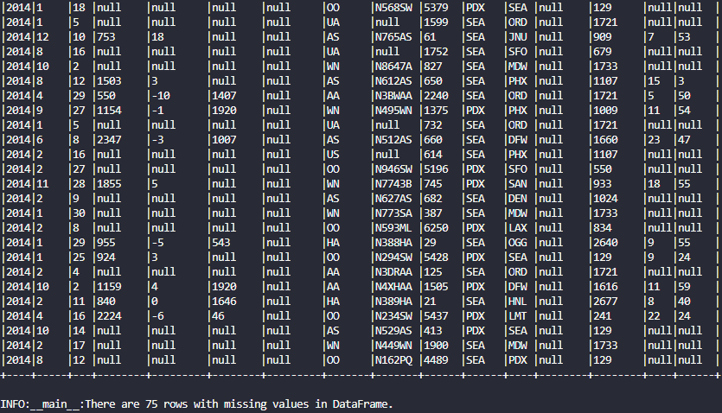

*Figure 14. Content and number of occurrences of missing data part 2.*

*Figure 15. Content and number of occurrences of the Cleaned flights DataFrame.*

**(b)**

***Script Functions Snippet***

def show_dataframe(*df*, *max_rows*=100, *show_rows*=20):

    if df.count() > max_rows:

        df.show(show_rows)

    else:

        df.show(df.count(), *truncate*=False)

def count_by(*df*, *grouped_columns*, *logger*):

    try:

        count_by_col = df.groupby(*grouped_columns).count()

        sorted_counts_df = count_by_col.orderBy("count", *ascending*=False)

        return sorted_counts_df

    except *Exception* as e:

        logger.error(f"An error occurred: {*str*(e)}")

        raise e

def percentage_by(*df*, *grouped_columns*, *logger*):

        total_flights = df.count()

        total_flights_by = df.groupby(*grouped_columns).count()

        col_percentage = total_flights_by.withColumn(

            "percentage", (total_flights_by["count"] / total_flights) * 100).orderBy("percentage", *ascending*=False)

        return col_percentage

    except *Exception* as e:

        logger.error(f"An error occurred: {*str*(e)}")

        raise e

def top_n_cat_by(*df*, *grouped_columns*, *n*, *logger*):

    try:

        top_cat = df.groupBy(*grouped_columns).count().orderBy(

            "count", *ascending*=False).limit(n)

        return top_cat

    except *Exception* as e:

        logger.error(f"An error occurred: {*str*(e)}")

        raise e

***Script Main Function Snippet***

        flight_by_year_month = count_by(clean_flights_data_df, [

            "year", "month"], logger)

        show_dataframe(flight_by_year_month)

        flight_by_day = count_by(clean_flights_data_df, ["day"], logger)

        show_dataframe(flight_by_day)

        percentage_flight_by_carrier = percentage_by(

            clean_flights_data_df, ["carrier"], logger)

        show_dataframe(percentage_flight_by_carrier)

        flights_by_origin = count_by(clean_flights_data_df, ["origin"], logger)

        show_dataframe(flights_by_origin)

        flights_by_dest = count_by(clean_flights_data_df, ["dest"], logger)

        show_dataframe(flights_by_dest)

        top_10_planes = top_n_cat_by(

            clean_flights_data_df, ["tailnum"], 10, logger)

        show_dataframe(top_10_planes)

***Output Screenshots***

*Figure 16. Sorted number of flights per year and month.*

*Figure 17. Sorted number of flights per day.*

*Figure 18. Sorted number and percentage of flights per carrier.*

*Figure 19. Sorted number of flights per origin airport.*

*Figure 20. Sorted number of flights per destination.*

*Figure 21. Sorted top 10 of flights per plane.*

**(c)**

***Script Functions Snippet***

def show_dataframe(*df*, *max_rows*=100, *show_rows*=20):

    if df.count() > max_rows:

        df.show(show_rows)

    else:

        df.show(df.count(), *truncate*=False)

def count_by(*df*, *grouped_columns*, *logger*):

    try:

        count_by_col = df.groupby(*grouped_columns).count()

        sorted_counts_df = count_by_col.orderBy("count", *ascending*=False)

        return sorted_counts_df

    except *Exception* as e:

        logger.error(f"An error occurred: {*str*(e)}")

        raise e

def analyze_average_delay(*df*, *column*, *delay_column*, *logger*):

    try:

        suffix = delay_column.split('_')[0]

        new_column_name = f"average_{suffix}_delay"

        avg_departure_delay_by_column = df.groupBy(column).agg(avg(col(delay_column)).alias(

            new_column_name)).orderBy(new_column_name, *ascending*=False)

        return avg_departure_delay_by_column

    except *Exception* as e:

        logger.error(f"An error occurred during data analysis: {*str*(e)}")

        raise e

def analyze_positive_delay(*df*, *column*, *delay_column*, *logger*):

    try:

        suffix = delay_column.split('_')[0]

        new_column_name = f"average_positive_{suffix}_delay"

        # Filter for positive delay values before computing the average.

        avg_positive_delay_by_column = df.groupBy(column).agg(avg(when(col(delay_column) > 0, col(

            delay_column))).alias(new_column_name)).orderBy(new_column_name, *ascending*=False)

        return avg_positive_delay_by_column

    except *Exception* as e:

        logger.error(f"An error occurred during data analysis: {*str*(e)}")

        raise e

def analyze_negative_delay(*df*, *column*, *delay_column*, *logger*):

    try:

        suffix = delay_column.split('_')[0]

        new_column_name = f"average_negative_{suffix}_delay"

        # Filter for negative delay values before computing the average.

        avg_negative_delay_by_column = df.groupBy(column).agg(avg(when(col(delay_column) < 0, col(

            delay_column))).alias(new_column_name)).orderBy(new_column_name, *ascending*=False)

        return avg_negative_delay_by_column

    except *Exception* as e:

        logger.error(f"An error occurred during data analysis: {*str*(e)}")

        raise e

***Script Main Function Snippet***

        flights_by_hour = count_by(clean_flights_data_df, ["hour"], logger)

        show_dataframe(flights_by_hour)

        avg_pos_dep_delay_by_carrier = analyze_positive_delay(

            clean_flights_data_df, "carrier", "dep_delay", logger)

        show_dataframe(avg_pos_dep_delay_by_carrier)

        avg_dep_delay_by_carrier = analyze_average_delay(

            clean_flights_data_df, "carrier", "dep_delay", logger)

        show_dataframe(avg_dep_delay_by_carrier)

        avg_dep_delay_by_month = analyze_average_delay(

            clean_flights_data_df, "month", "dep_delay", logger)

        show_dataframe(avg_dep_delay_by_month)

        avg_dep_delay_by_hour = analyze_average_delay(

            clean_flights_data_df, "hour", "dep_delay", logger)

        show_dataframe(avg_dep_delay_by_hour)

        avg_neg_dep_delay_by_carrier = analyze_negative_delay(

            clean_flights_data_df, "carrier", "dep_delay", logger)

        show_dataframe(avg_neg_dep_delay_by_carrier)

        avg_neg_dep_delay_by_month = analyze_negative_delay(

            clean_flights_data_df, "month", "dep_delay", logger)

        show_dataframe(avg_neg_dep_delay_by_month)

        avg_neg_dep_delay_by_hour = analyze_negative_delay(

            clean_flights_data_df, "hour", "dep_delay", logger)

        show_dataframe(avg_neg_dep_delay_by_hour)

***Output Screenshots***

*Figure 22. Sorted number of flights per hour.*

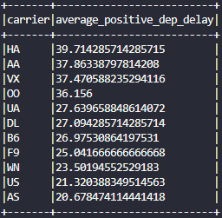

*Figure 23. Sorted average positive departure delay per carrier.*

*Figure 24. Sorted average departure delay per carrier.*

*Figure 25. Sorted average departure delay per month.*

*Figure 26. Sorted average departure delay per hour.*

*Figure 27. Sorted average negative departure delay per carrier.*

*Figure 28. Sorted average negative departure delay per month.*

*Figure 29. Sorted average negative departure delay per hour.*

**(d)**

***Script Functions Snippet***

def show_dataframe(*df*, *max_rows*=100, *show_rows*=20):

    if df.count() > max_rows:

        df.show(show_rows)

    else:

        df.show(df.count(), *truncate*=False)

def numeric_stats(*df*, *group_by_column*, *numeric_column*, *logger*):

    try:

        col_stats = df.groupBy(group_by_column).agg(

            avg(numeric_column).alias(f"average_{numeric_column}"),

            min(numeric_column).alias(f"min_{numeric_column}"),

            max(numeric_column).alias(f"max_{numeric_column}")

        ).orderBy(f"average_{numeric_column}", *ascending*=False)

        return col_stats

    except *Exception* as e:

        logger.error(f"An error occurred: {*str*(e)}")

        raise e

def compute_flight_speed(*df*, *distance*, *air_time*, *logger*):

    try:

        df_add_speed = df.withColumn(

            "flight_speed (miles per hour)", (col(distance) / (col(air_time) / 60)))

        return df_add_speed

    except *Exception* as e:

        logger.error(f"An error occurred: {*str*(e)}")

        raise e

def shortest_n_flight_from_origin(*df*, *flight_column*, *origin_column*, *origin_name*, *measurement*, *n*, *logger*):

    try:

        origin = df.filter(df[origin_column] == origin_name)

        shortest_flight = origin.select(

            flight_column, origin_column, measurement).orderBy(measurement, *ascending*=True).limit(n)

        return shortest_flight

    except *Exception* as e:

        logger.error(f"An error occurred: {*str*(e)}")

        raise e

def longest_n_flight_from_origin(*df*, *flight_column*, *origin_column*, *origin_name*, *measurement*, *n*, *logger*):

    try:

        origin = df.filter(df[origin_column] == origin_name)

        longest_flight = origin.select(

            flight_column, origin_column, measurement).orderBy(measurement, *ascending*=False).limit(n)

        return longest_flight

    except *Exception* as e:

        logger.error(f"An error occurred: {*str*(e)}")

        raise e

def average_duration(*df*, *carrier_column*, *carrier_name*, *origin_column*, *origin_name*, *measurement*, *logger*):

    try:

        carrier = df.filter(df[carrier_column] == carrier_name)

        origin = carrier.filter(df[origin_column] == origin_name)

        average_duration = origin.groupBy(df[carrier_column], df[origin_column]).agg(

            avg(measurement).alias(f"average_{measurement} (mins)"))

        return average_duration

    except *Exception* as e:

        logger.error(f"An error occurred: {*str*(e)}")

        raise e

def total_duration(*df*, *carrier_column*, *carrier_name*, *origin_column*, *origin_name*, *measurement*, *logger*):

    try:

        carrier = df.filter(df[carrier_column] == carrier_name)

        origin = carrier.filter(df[origin_column] == origin_name)

        total_duration_hours = origin.groupBy(df[carrier_column], df[origin_column]).agg(

            (sum(measurement) / 60).alias(f"total_{measurement} (hours)"))

        return total_duration_hours

    except *Exception* as e:

        logger.error(f"An error occurred: {*str*(e)}")

        raise e

***Script Main Function Snippet***

        distance_stats = numeric_stats(

            clean_flights_data_df, "carrier", "distance", logger)

        show_dataframe(distance_stats)

        transformed_flights_df = compute_flight_speed(

            clean_flights_data_df, "distance", "air_time", logger)

        show_dataframe(transformed_flights_df)

        speed_stats = numeric_stats(

            transformed_flights_df, "carrier", "flight_speed (miles per hour)", logger)

        show_dataframe(speed_stats)

        shortest_flight_distance_PDX = shortest_n_flight_from_origin(

            transformed_flights_df, "flight", "origin", "PDX", "distance", 1, logger)

        show_dataframe(shortest_flight_distance_PDX)

        longest_flight_distance_SEA = longest_n_flight_from_origin(

            transformed_flights_df, "flight", "origin", "SEA", "air_time", 1, logger)

        show_dataframe(longest_flight_distance_SEA)

        average_duration_UA_SEA = average_duration(

            transformed_flights_df, "carrier", "UA", "origin", "SEA", "air_time", logger)

        show_dataframe(average_duration_UA_SEA)

        total_duration_UA_SEA = total_duration(

            transformed_flights_df, "carrier", "UA", "origin", "SEA", "air_time", logger)

        show_dataframe(total_duration_UA_SEA)

***Output Screenshots***

*Figure 30. Average, minimum, and maximum flight distance by carrier, sorted by average distance.*

*Figure 31. New flight speed (miles per hour) calculated column.*

*Figure 32. Average, minimum, and maximum flight speed (miles per hour) by carrier, sorted by average speed.*

*Figure 33. Shortest distance flight from PDX.*

*Figure 34. Longest duration flight from SEA.*

*Figure 35. Average flight duration of carrier “UA” originiated from “SEA”.*

*Figure 37. Total flight duration of carrier “UA” originiated from “SEA”.*

**(e)**

***Script Constants Snippet***

# Constants

SCRIPTS_DIR = os.path.abspath(os.path.dirname(__file__))

DATA_DIR = os.path.join(SCRIPTS_DIR, "..", "data")

FLIGHTS_DATA_FILE_PATH = os.path.join(DATA_DIR, "flights_data_v2.csv")

PLANES_DATA_FILE_PATH = os.path.join(DATA_DIR, "planes_data_v2.csv")

LOGGING_LEVEL = logging.INFO

LOAD_DATA_ERROR_MESSAGE = "An error occurred while loading data: {}"

FILE_NOT_FOUND_MESSAGE = "The specified file does not exist: {}"

***Script Functions Snippet***

def show_dataframe(*df*, *max_rows*=100, *show_rows*=20):

    if df.count() > max_rows:

        df.show(show_rows)

    else:

        df.show(df.count(), *truncate*=False)

def load_data(*spark*, *logger*, *file_path*):

    try:

        # Load data from csv

        df = spark.read.option("inferSchema", "true").option(

            "header", "true").csv(file_path)

        return df

    except *Exception* as e:

        if "Path does not exist" in *str*(e):

            logger.error(FILE_NOT_FOUND_MESSAGE.format(file_path))

            raise *FileNotFoundError*(f"File not found: {file_path}")

        logger.error(LOAD_DATA_ERROR_MESSAGE.format(*str*(e)))

        raise e

def process_missing_data(*df*, *logger*):

    try:

        columns_to_check = df.columns

        filter_condition = None

        # Loop through the list of columns and build a filter condition to check for null values.

        for column_name in columns_to_check:

            # Create a new condition to check if the column is null

            if filter_condition is None:

                filter_condition = col(column_name).isNull()

            # For subsequent columns, update the filter condition to include a check for null values

            else:

                filter_condition = filter_condition | col(column_name).isNull()

        missing_data_df = df.filter(filter_condition)

        logger.info("Sample rows in the DataFrame with Missing Value:")

        show_dataframe(missing_data_df)

        missing_occurrence = missing_data_df.count()

        logger.info(

            f"There are {missing_occurrence} rows with missing values in DataFrame.\n")

        clean_data_df = df.filter(~filter_condition)

        return clean_data_df

    except *Exception* as e:

        logger.error(f"An error occurred: {*str*(e)}")

        raise e

def top_n_cat_by(*df*, *grouped_columns*, *n*, *logger*):

    try:

        top_cat = df.groupBy(*grouped_columns).count().orderBy(

            "count", *ascending*=False).limit(n)

        return top_cat

    except *Exception* as e:

        logger.error(f"An error occurred: {*str*(e)}")

        raise e

def bottom_n_cat_by(*df*, *grouped_columns*, *n*, *logger*):

    try:

        bottom_cat = df.groupBy(*grouped_columns).count().orderBy(

            "count", *ascending*=True).limit(n)

        return bottom_cat

    except *Exception* as e:

        logger.error(f"An error occurred: {*str*(e)}")

        raise e

def sql_top_n_cat_by(*df*, *grouped_columns*, *n*, *spark*, *logger*):

    try:

        df.createOrReplaceTempView("top_flights_planes")

        columns_str = ", ".join(grouped_columns)

        query = f"""

        SELECT {columns_str}, COUNT(*) AS count

        FROM top_flights_planes

        GROUP BY {columns_str}

        ORDER BY count DESC

        LIMIT {n}

        """

        sql_top_n_cat = spark.sql(query)

        return sql_top_n_cat

    except *Exception* as e:

        logger.error(f"An error occurred: {*str*(e)}")

        raise e

def sql_bottom_n_cat_by(*df*, *grouped_columns*, *n*, *spark*, *logger*):

    try:

        df.createOrReplaceTempView("bottom_flights_planes")

        columns_str = ", ".join(grouped_columns)

        query = f"""

        SELECT {columns_str}, COUNT(*) AS count

        FROM bottom_flights_planes

        GROUP BY {columns_str}

        ORDER BY count ASC

        LIMIT {n}

        """

        sql_bottom_n_cat = spark.sql(query)

        return sql_bottom_n_cat

    except *Exception* as e:

        logger.error(f"An error occurred: {*str*(e)}")

        raise e

***Script Main Function Snippet***

        planes_data_frame = load_data(spark, logger, PLANES_DATA_FILE_PATH)

        logger.info("Sample rows in the planes DataFrame:")

        show_dataframe(planes_data_frame)

        occurrence = planes_data_frame.count()

        logger.info(f"There are {occurrence} occurences in the DataFrame.\n")

        logger.info(planes_data_frame.schema)

        clean_planes_data_df = planes_data_frame.drop("speed")

        clean_planes_data_df = clean_planes_data_df.withColumnRenamed(

            "year", "plane_year")

        show_dataframe(clean_planes_data_df)

        flights_planes_df = transformed_flights_df.join(

            clean_planes_data_df, *on*=["tailnum"], *how*="inner")

        show_dataframe(flights_planes_df)

        occurrence = flights_planes_df.count()

        logger.info(f"There are {occurrence} occurences in the DataFrame.\n")

        clean_flights_planes_data_df = process_missing_data(

            flights_planes_df, logger)

        logger.info("Sample rows in the cleaned planes DataFrame:")

        show_dataframe(clean_flights_planes_data_df)

        clean_occurrence = clean_flights_planes_data_df.count()

        logger.info(

            f"{clean_occurrence} rows remained after removing the rows with missing values.\n")

        top_20_flights_planes = top_n_cat_by(clean_flights_planes_data_df, [

            "carrier", "model", "plane_year"], 20, logger)

        show_dataframe(top_20_flights_planes)

        bottom_20_flights_planes = bottom_n_cat_by(clean_flights_planes_data_df, [

            "carrier", "model", "plane_year"], 20, logger)

        show_dataframe(bottom_20_flights_planes)

        sql_top_20_flights_planes = sql_top_n_cat_by(clean_flights_planes_data_df, [

            "carrier", "model", "plane_year"], 20, spark, logger)

        show_dataframe(sql_top_20_flights_planes)

        sql_bottom_20_flights_planes = sql_bottom_n_cat_by(clean_flights_planes_data_df, [

            "carrier", "model", "plane_year"], 20, spark, logger)

        show_dataframe(sql_bottom_20_flights_planes)

***Output Screenshots***

*Figure 38. Content, number of occurrences and schema of planes DataFrame.*

*Figure 39. Planes DataFrame without speed column and renamed year column header.*

*Figure 40. Content and number of occurrences of joined dataset.*

*Figure 41. Content and number of occurrences of missing data part 1.*

*Figure 42. Content and number of occurrences of missing data part 2.*

*Figure 43. Content and number of occurrences of the Cleaned planes DataFrame.*

*Figure 44. Sorted top 20 carrier, model, and plane year with the most number of trips.*

*Figure 45. Sorted bottom 20 carrier, model, and plane year with the least number of trips.*

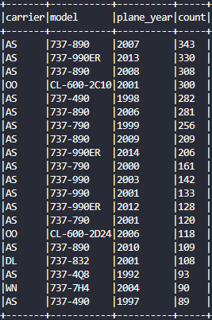

*Figure 46. Sorted top 20 carrier, model, and plane year with the most number of trips (SQL approach).*

*Figure 45. Sorted bottom 20 carrier, model, and plane year with the least number of trips (SQL approach).*

**Question 4**

(a)

(b)

(c)

(d)

(e)

(f)