Group Members:
- Erik Ekberg
- David Gamino
- Mike Millard
- Amanda Foley
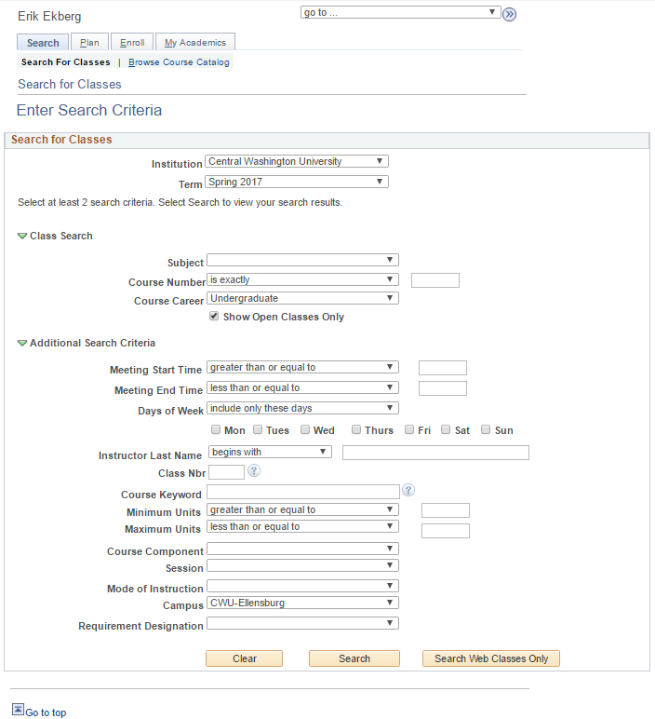
Problem Description: We will be improving the user experience for students searching for courses to fit into their schedule. Specifically, we will be improving the Class Search form found in MyCWU, or alternatively, through the Search Class Schedules button on the registrars course information page (https://www.cwu.edu/registrar/course-information). This page contains a lot of signifiers for drop down menus, however, not much affordability. It is unintuitive to describe time as greater than or equal to another time value to the typical user, since time is usually perceived in chucks and not definite comparative values. For example, we do not consider the term afternoon to include 10:47pm.
Other areas which lack affordability and meaning are the options below days of the week options. These options are helpful for discovering specific classes, however, they are not well implemented. For example, the requirement designation option is helpful for discovering general education courses with specific credit attributes (like for A skills or B skills), however, a user can not select more than one credit type to search for per query. Meaning the user must make multiple queries to view all potential courses they may be interested in.
Identify Users:
The target-user for this revision will be Central Washington University students.
A major challenge from targeting the student population is screen space. Many students use their phones to search for courses. Given the limited screen space of phones, it will be important to find a balance between functionality and practicality within our small medium.
Typical Interaction Tasks:
- Find a course that fits within a window of time. For example, if a student has a class at 1pm and 3pm, and they want to find a class to 2pm to fill the gap.
- Finding a course that fulfills a general education requirement. For example, if a student needs an A skill course to graduate, they can search specifically for A skill and be returned a list of courses with the A skill attribute.
- Finding a course within a specific subject / field of study. For example, if a computer-science student wishes to add more computer-science courses to their schedule, they can search by the computer-science prefix (CS) and be returned a list of courses with that prefix.
- A combination of any of the 3 previous examples. For example, if a student wants to find a computer-science course which starts anytime between 11am to 3pm.
Observations and Interviews:
- Psychology Graduate Student:
  - Pointed out that having none of the Mon, Tue, Wed, boxes checked is equivalent to all being selected. But selecting one box like Mon is equivalent to only Monday.
  - Days of Week input is confusing and unintuitive.
  - Easy to find courses specific to subject (e.g. Psychology).
  - Can not select multiple subjects (e.g. Psychology + Sociology).
  - Course Number options are useful, but somewhat unintuitive.
  - is exact option is nice if know exact course number.
- Psychology Graduate Student:
  - Unclear what values to input for time fields
  - Default of Show open classes only is difficult to find classes which are full, but still have an open waiting list.
  - Default of Undergraduate for Course Career make it difficult to look at layered courses or courses which are graduate level (i.e. 500+).
  - Default of Term List input to current academic quarter is annoying when searching for classes for next quarter.
- Psychology Graduate Student:
- Unclear what values to input for time fields (e.g. is 2 = 2am or 2pm?)
- If option is changed, than previous input is removed.
- Unable to select multiple requirement designations.
- Unclear what units means in Minimum Units and Maximum Units input fields.
- Course Component and Session options are not descriptive or intuitive (e.g. difference between 4-week and intensive).
- Examples buttons take a while to load / render, and are not very helpful.
Proposed Software Solution:
Our project will look at redesigning the Search for Classes page of MyCWU. Specifically, we will be looking at implementing the following:
- An easy to use datetime selector to mark what days and what times the user would like to search for classes.
- The ability to search for multiple course subjects through the dynamic addition of Subject fields.
- Remove defaults of Show open classes only and Undergraduate
- Default Term to next academic quarter if past the 3rd week of the current academic quarter.
- The ability to search for multiple requirement designations through the dynamic addition of Requirement Designation fields.
- Edit text, labels, and descriptions to be more precise in what is meant (e.g. Units versus Credits).
- Make Search web classes only a checkbox (or something else), not another search button.
Things that will not be covered in this redesign:
- Interaction with the Search for Classes database (i.e. it will not look up courses offered by CWU).
Difficulties of Foreseeable problems and solutions:
One foreseeable difficulty is placing to many options or input fields on the screen at once, especially on mobile devices. To prevent this, we will adopt a mobile first attitude in development in order to ensure features are implemented well for mobile users, and then extend the application into larger screens.

