

CP2406 Programming 3 Assignment 1

Min Khant Soe

[Company Name]

# **User Stories**

User Story 1

As far as the user is concerned, I wish to create a customization traffic simulator to edit street, vehicle, traffic light and length, breath, street width. The priority is high and the deadline is expected to be 5 days. Add street names and sign boards to create the new city maps for the training, and run the simulation.

User Story 2

I want the user to continue improving the town and use it later again to ensure that the personalized town does not go away with the changes. A medium priority and 3 days for the measurement. For the test, click the save button after changing the city to save the city by any name the user likes.

User Story 3

As for the user, I would like to reload and load into the simulation the previous established city, so that I can again simulate with other conditions, such as cars, city buses, motors, and prices. The priority shall be low, and the approximate time shall be 2 days. To test the stored town from the database, click the Open button.

User Story 4

As far as the user's rating is concerned, he can upgrade the car rate to simulate the number of cars on the lane. Priority is medium and scheduled times are three days. Click the vehicle price change button to test for faster or slower movement of all cars.

User Story 5

As far as user is concerned, I want to have a stop button, which will stop the simulator so that the moving vehicles on the roads can be stopped. The priority is high and time is estimated to be 1 day. Click the stop button for the test and see all vehicles terminated.

User Story 6

As for the user, the other vehicles, I want to prevent accidents based on the distance from ahead vehicles so that the simulator can be run without errors or problems while the simulator is in operation. Priority and projected time are five days. To monitor to see if the simulator works and to see if the software runs without a collision with the cars.

## **Developer User Stories**

Developer User story 1

I can add light and traffic for the user as a developer. This car simulator has a bus and motorcycle. It takes three days to prioritize and approximate time. To conduct this test, summarize the class of the vehicles and call for some moving methods.

Developer User Story 2

There would be no mistake because car traffic can also be stopped by developers to prevent collision with cars in front of the car. Priority is low and time is expected to be 2 days. As for the test: get away from the front of cars and call on those methods.

Developer User story 3

As a creator, the software saves all the data that customers don't lack. It takes three days to prioritize and approximate time. Save all the data as a key method file for the test and load the data to revisit the map.

Developer User story 4

As for the developer, I want a few of the data generated by the user to be loaded and executed once the program has begun. The priority is average time and 1 day is expected. The applications are based on the screen size of the user. There are two main features of the applications: urban editing and simulation modes. Setting for vehicles update pace, stop and run simulator is supported in Simulation Modes. Traffic on selected roads put on the town in editing modes. The 2D top-down grid view with lane, transport, automobiles. Spawn Vehicle randomly with the user pace. Grid is set to size 20x20 for simulation or editing mode. Forms of vehicles: car, engine, bus. Display city numbers, the amount of Avg Speed and existing city names, the traffic light, and total. There's two lanes on the route. The cars have already been determined in scale.

# **UML Diagram**

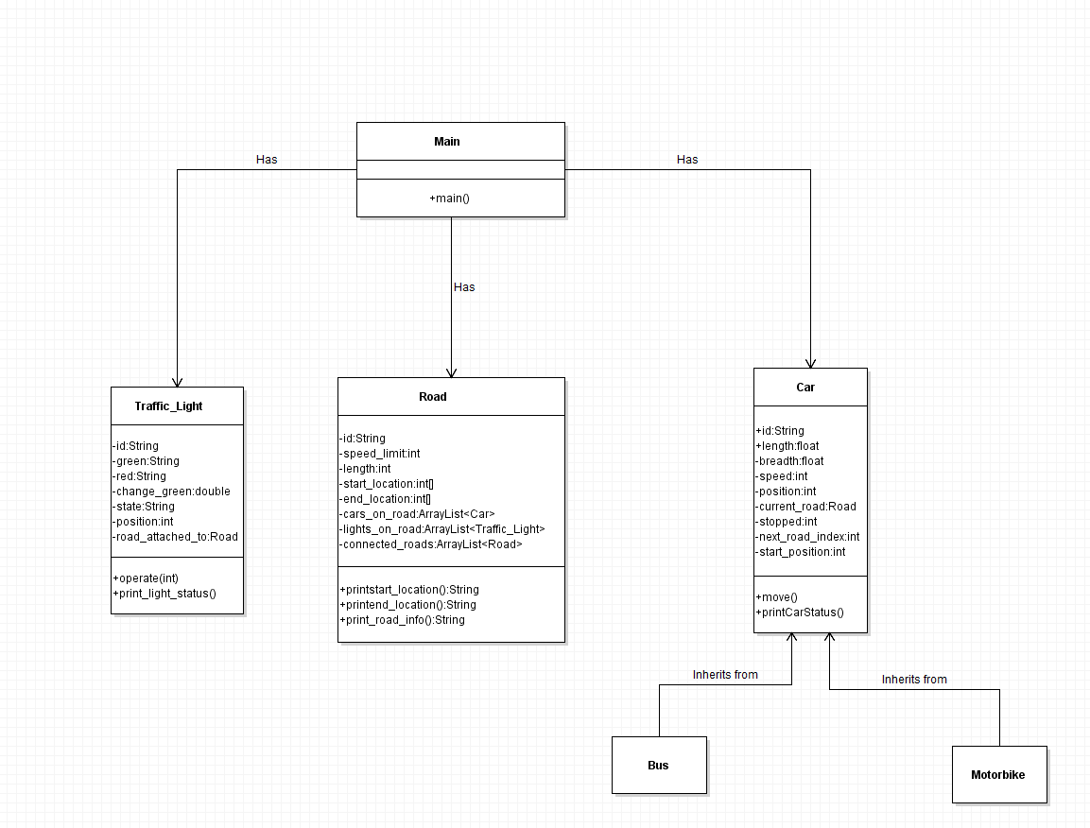

# **GitHub**

<https://github.com/1MinKhantSoe1/CP2406-Assignment-1-Traffic-Simulator-1.0-Min_Khant_Soe>

