

Min Khant Soe

[Company Name]

# **User Stories**

User Story 1

As far as the user is concerned, I wish to create a customization traffic simulator to edit street, vehicle, traffic light and length, breath, street width. The priority is high and the deadline is expected to be 5 days. Add street names and sign boards to create the new city maps for the training, and run the simulation.

User Story 2

I want the user to continue improving the town and use it later again to ensure that the personalized town does not go away with the changes. A medium priority and 3 days for the measurement. For the test, click the save button after changing the city to save the city by any name the user likes.

User Story 3

As for the user, I would like to reload and load into the simulation the previous established city, so that I can again simulate with other conditions, such as cars, city buses, motors, and prices. The priority shall be low, and the approximate time shall be 2 days. To test the stored town from the database, click the Open button.

User Story 4

As far as the user's rating is concerned, he can upgrade the car rate to simulate the number of cars on the lane. Priority is medium and scheduled times are three days. Click the vehicle price change button to test for faster or slower movement of all cars.

User Story 5

As far as user is concerned, I want to have a stop button, which will stop the simulator so that the moving vehicles on the roads can be stopped. The priority is high and time is estimated to be 1 day. Click the stop button for the test and see all vehicles terminated.

User Story 6

As for the user, the other vehicles, I want to prevent accidents based on the distance from ahead vehicles so that the simulator can be run without errors or problems while the simulator is in operation. Priority and projected time are five days. To monitor to see if the simulator works and to see if the software runs without a collision with the cars.

## **Developer User Stories**

Developer User story 1

I may add colour change as a developer to the user's traffic lights and I have removed the coords class from previous task and recreated another category named area. Only 3 vehicles are on the route, and the traffic simulators are bus, car and bike. Priority is high and 3 days are predicted for the day. Tests have public car class and call for some types of car, bus and bike transportation.

Developer User Story 2

Also as a developer, I can stop the traffic on any vehicle in order to prevent any collisions with the vehicles and no errors or difficulties will occur. To test, I want to get to the front of the vehicles and to use some methods so that each vehicle can know when to slow down or drive quickly. The priority is low, and 4 days is estimated.

Developer User story 3

I want to use the software as a developer to store all the unobtainable or incomplete data for the user. I would like to store all the details as a principal method file for testing and also to load the data while viewing the map. Priority is high and 5 days are estimated.

Developer User story 4

As a developer, I want to load up the information that is generated for the user in order to load and run all the data once the run button is pressed. To evaluate, I want to display the path where the data file is stored in the main method, so that the data file can be read and the data can also load into the traffic simulator. Priority is medium and 2 days is measured.

# **UML Diagram**

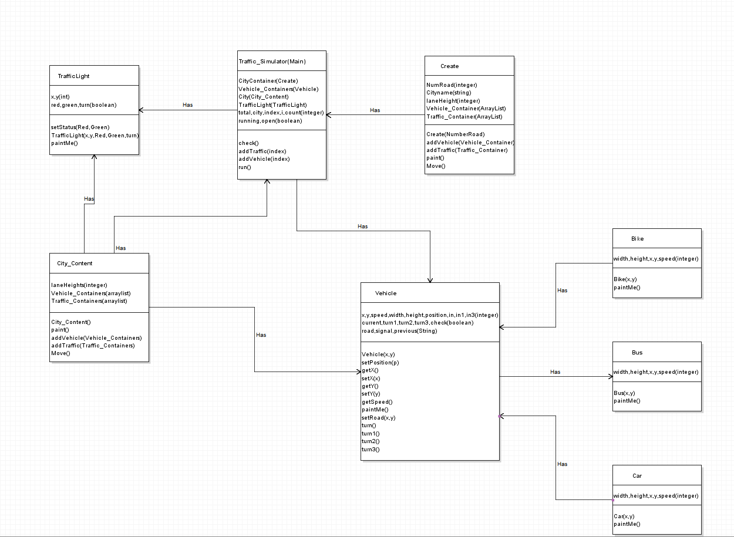

# **GitHub**