**• Team Name :** SSD_M2023_7

**• Team No. :** 7

**• Project Title :** Nutrition Counter

**• Project No. :** 8

**• Instructor/Mentor (mentioned in project details sheet) :** Prof. Charu Sharma

**• Project GitHub Repository URL:** <https://github.com/harshita8018/7_Nutrition_Counter>

**• Members Details (with Roll Numbers) :**

1. Harshita - 2023201002

2. Divyesh Patel - 2023201048

3. Hemanth Reddy - 2023201058

4. Ashish Lakhmani - 2023202008

**Objective**

* Our primary goal is to create a user-friendly tool that extracts and analyzes nutrition data from food packaging images.
* The secondary objective involves using the extracted data to inform users about whether the food is nutritious or not and give them recommendations.

**Overview**

1. Account creation and login
2. Image type selection and upload
3. Data extraction and processing
4. Displaying Results - Nutrition Content and Recommendation
5. User history is also stored

**Flow Diagram**

* FrontEnd

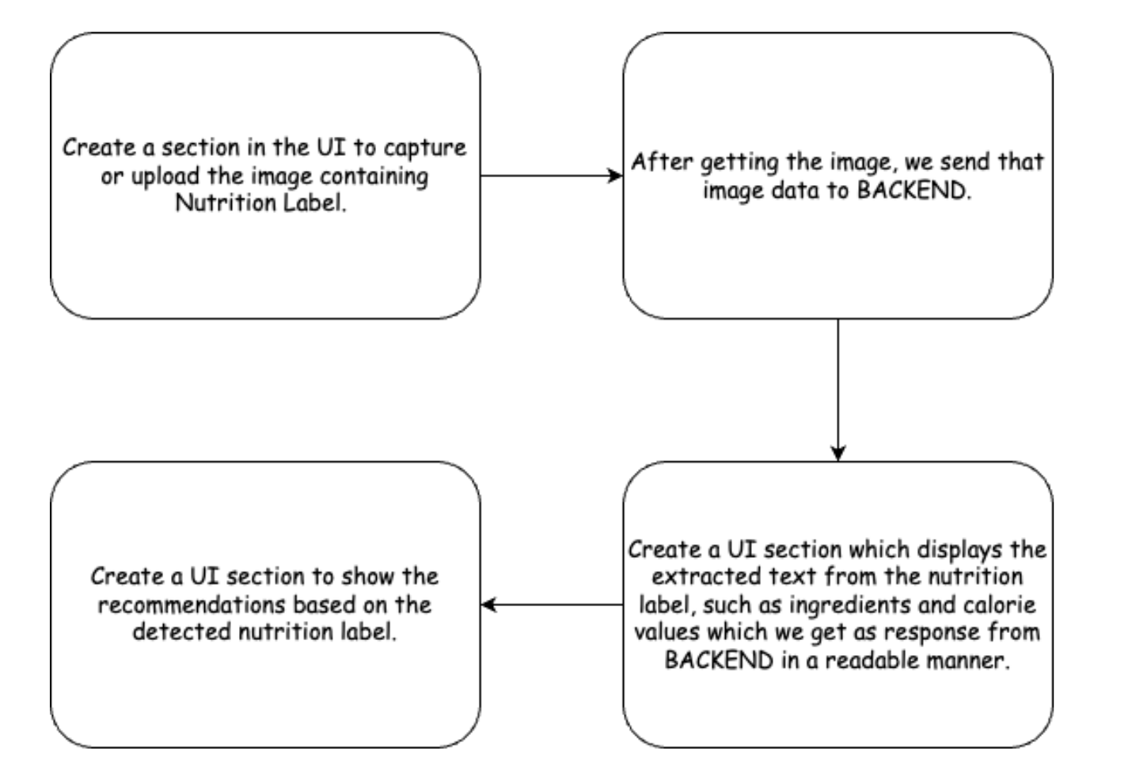

* BackEnd

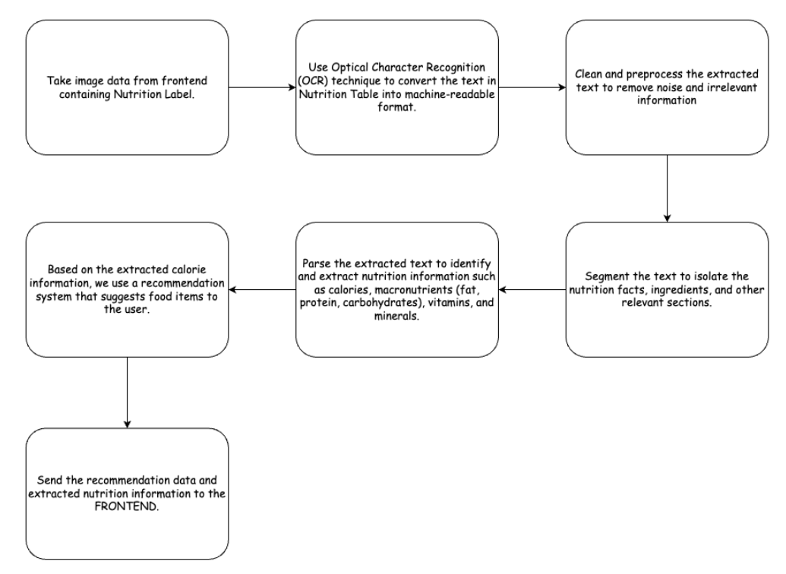

**Technology Used**

* **Model Used -** Tesseract
* **Front End -** ReactJS
* **Back End -** Python
* **DataBase -** MongoDB

**Challenges Faced**

* Model text extraction accuracy
* Image reconstruction from binary format

**Future Scope**

* User Profile Enhancements like storing their preferences, dietary restrictions and providing suggestions based on historical data
* Offering multilingual support
* Expand visualization options beyond pie charts, such as graphs, comparative analysis, or interactive visual representations for nutritional data. Provide customizable charts and graphs based on user preferences.
* Implement feedback mechanism to collect user opinion and provide better suggestions.