**WEB TECH TUTORIAL**

**ASSIGNMENT**

NAME: ANUSHA A MANAMI

USN: 1NT18IS031

6TH SEM ‘A’ SEC

ISE

1. DEMONSTRATION OF MAP AND SET FUNCTIONS

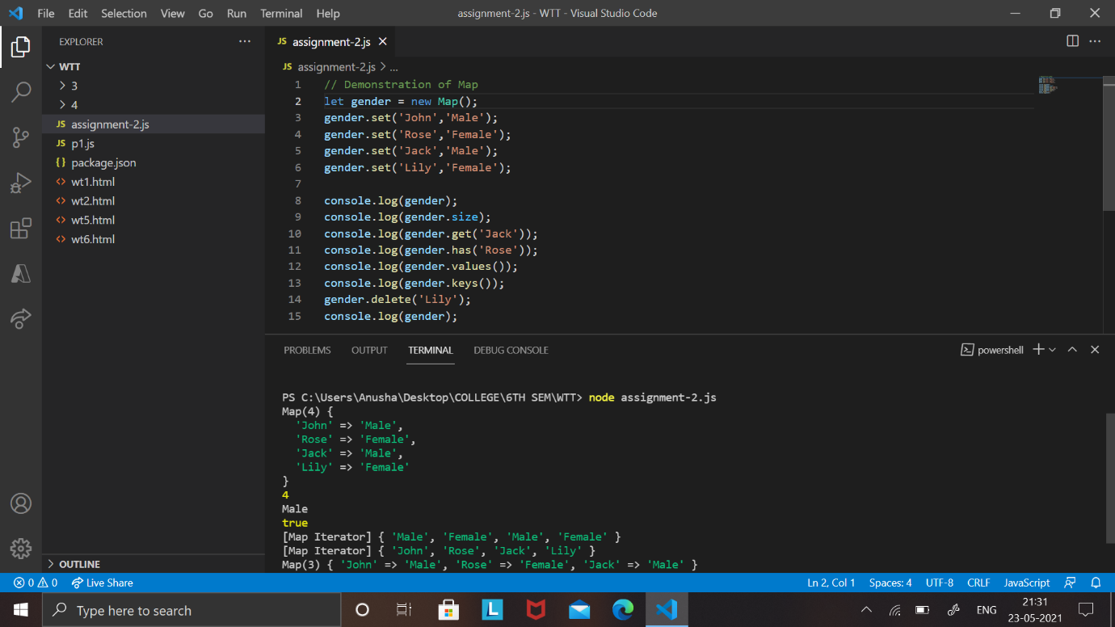

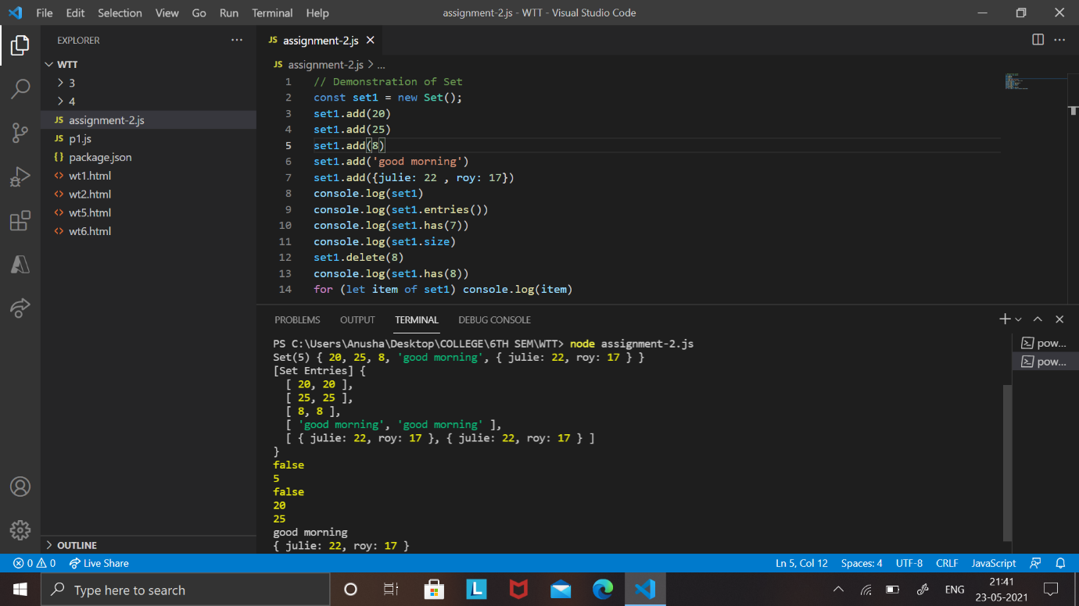

1. DEMONSTRATION OF MAP AND OBJECT

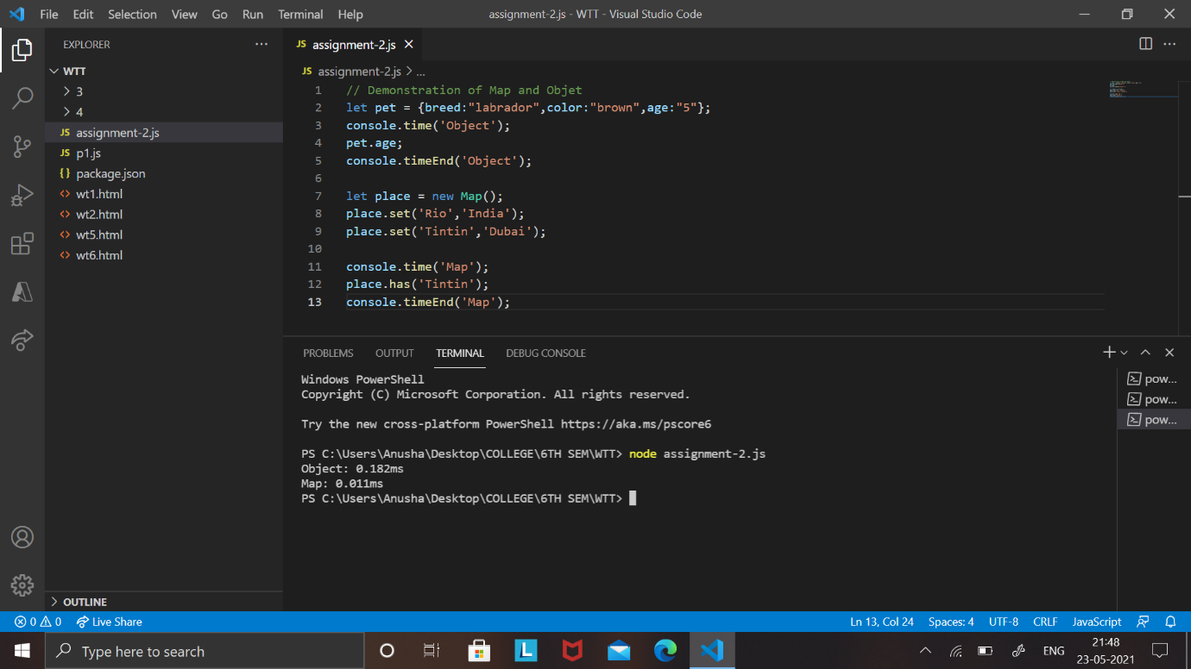

1. DEMONSTRATION OF CONVERSION OF OBJECT TO MAP AND VICE VERSA

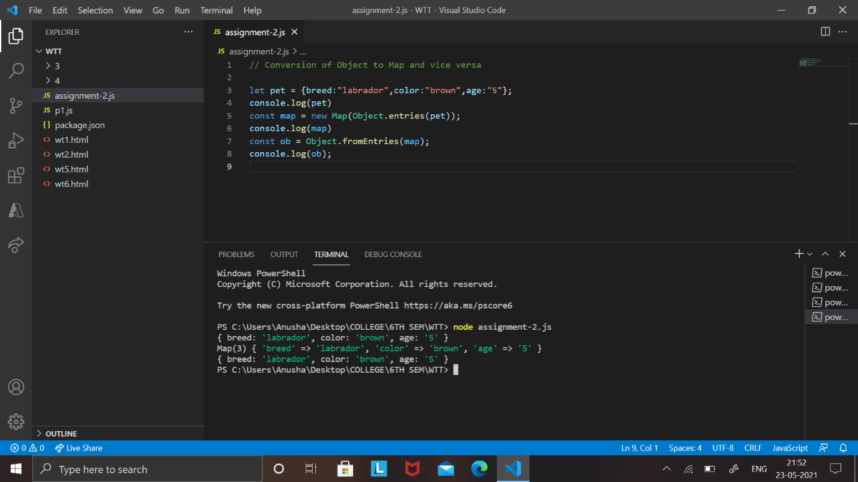

1. DEMONSTRATION OF UNION AND INTERSECTION FUNCTIONS ON SET

