**Name : Gourav Gunjan Mishra**

**USN : 1NT18IS063**

**Semester : 6th C**

1. **Create a function that takes the number of wins, draws and losses and calculates the number of points a football team has obtained so far.wins get 3 pointsdraws get 1 pointlosses get 0 pointsEx: footballPoints(3, 4, 2) ➞ 13footballPoints(5, 0, 2) ➞ 15.**

**HTML CODE:**

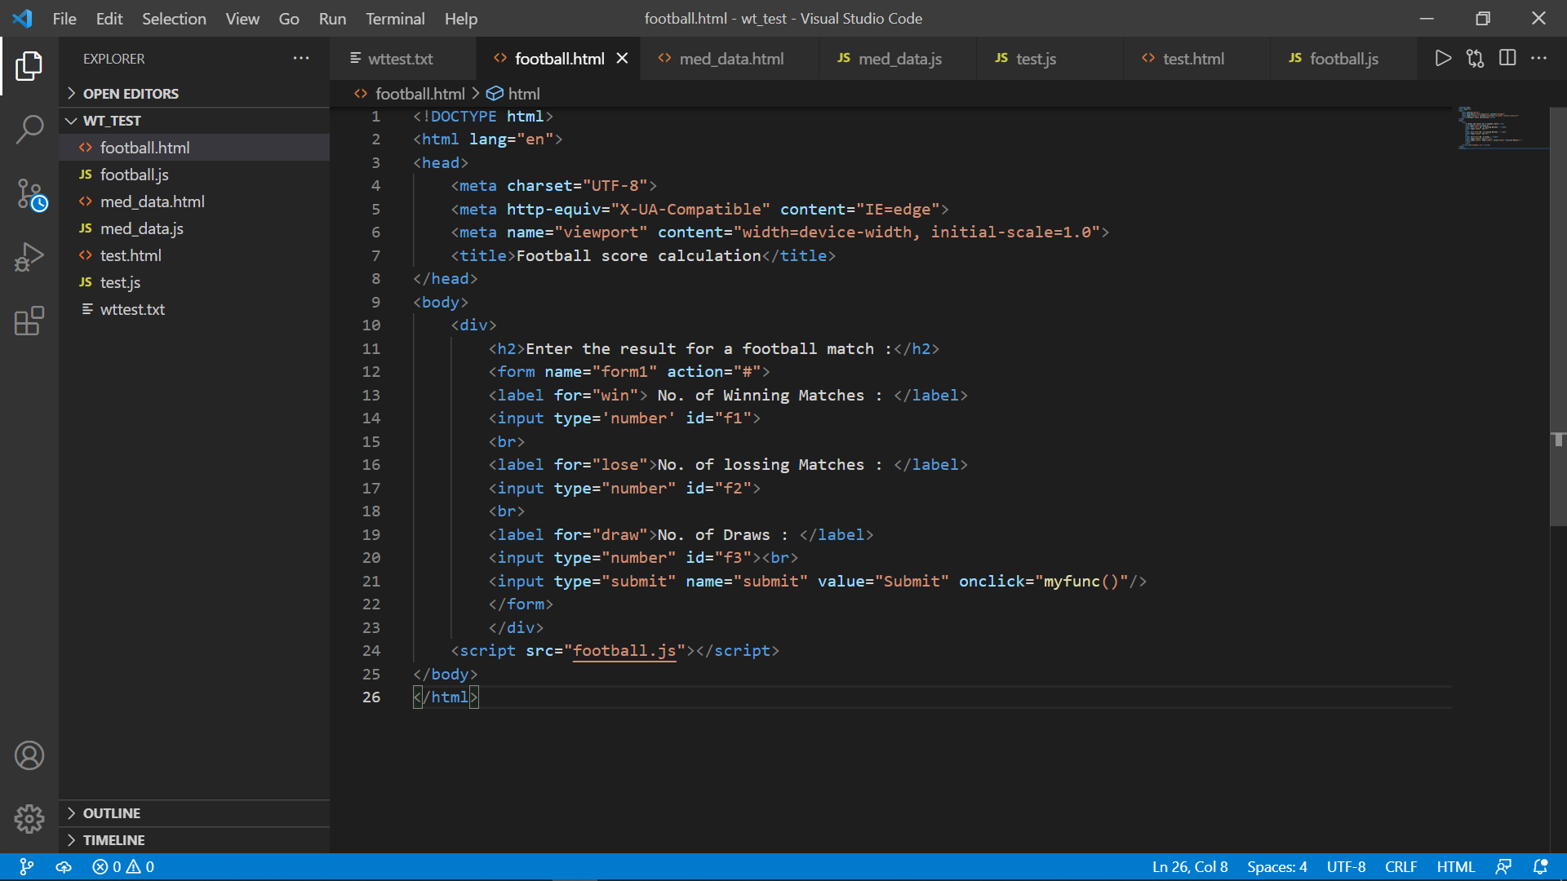

**JS CODE :**

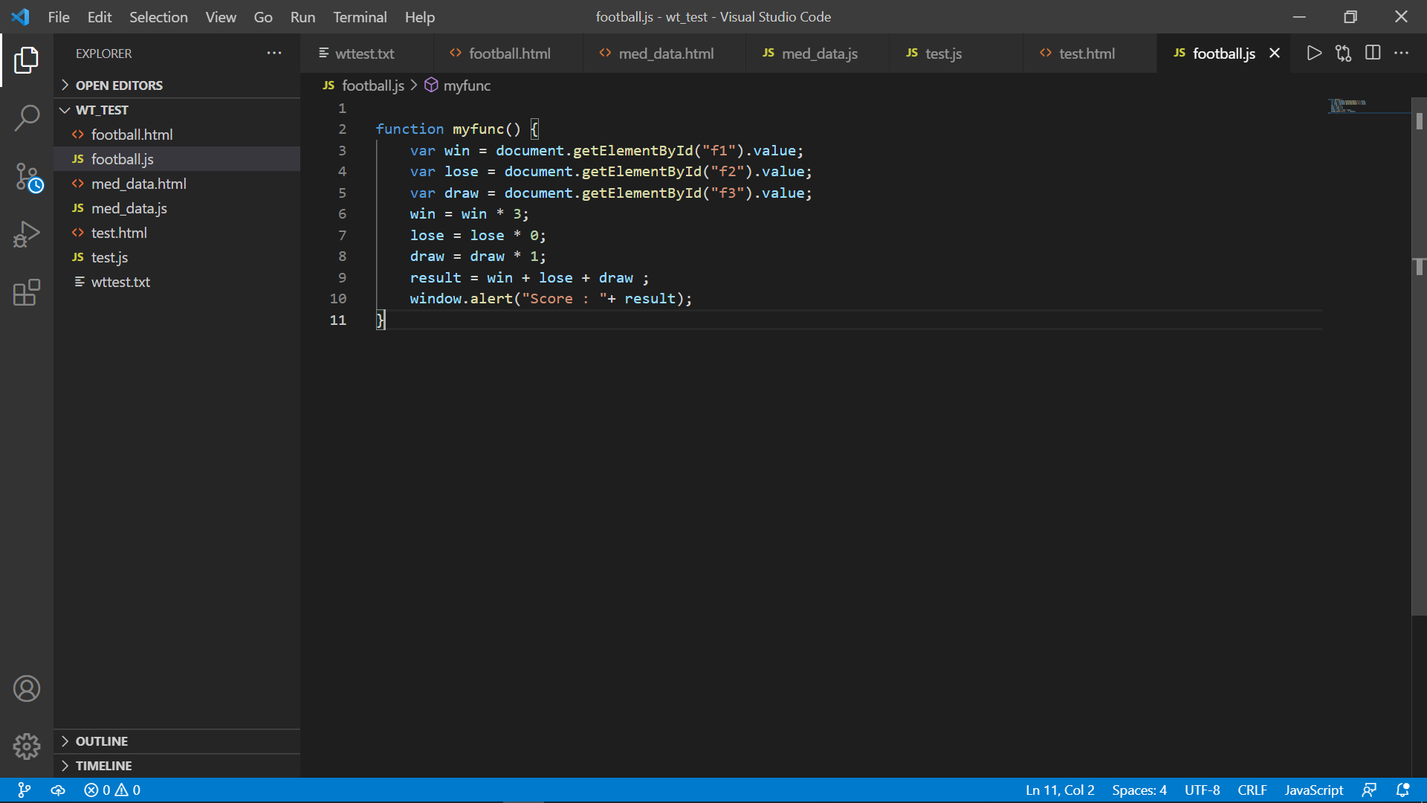

**OUTPUT :**

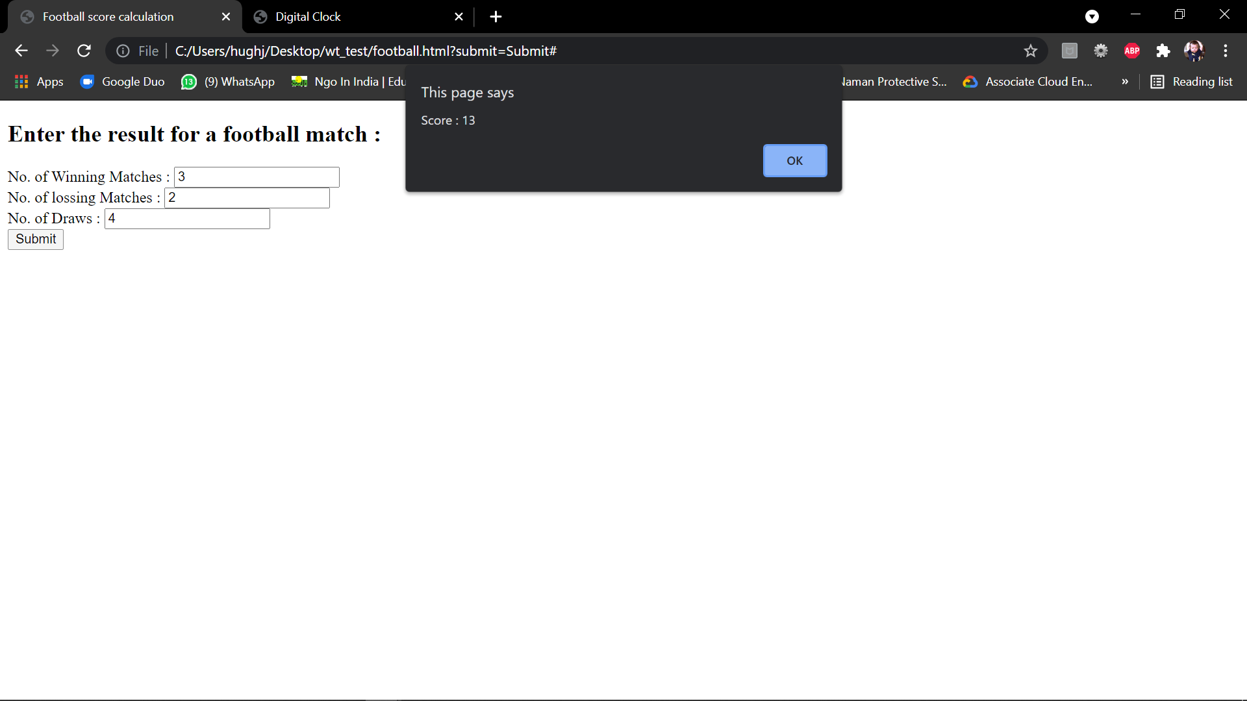

1. **Create a web interface that displays the live clock based on a event and provide functionality to change the background colour of the web page by providing options to the user also log the change of colour information.**

**HTML CODE :**

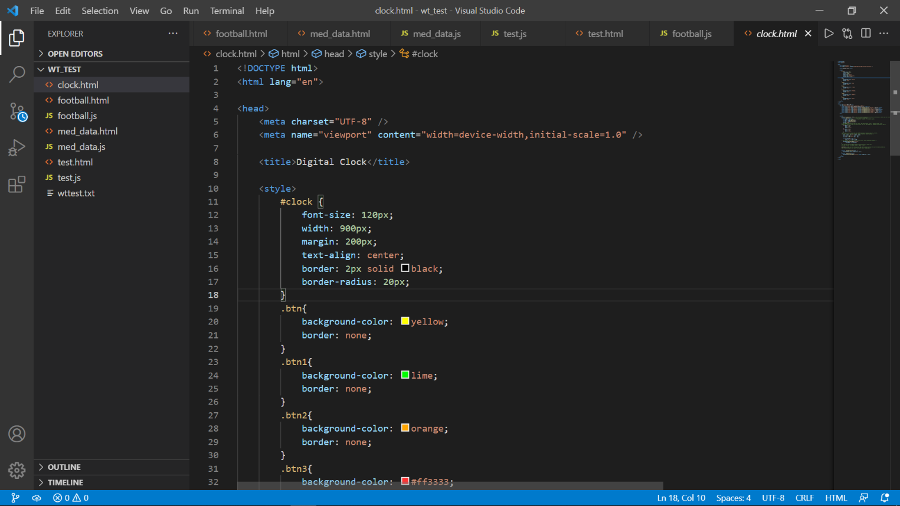

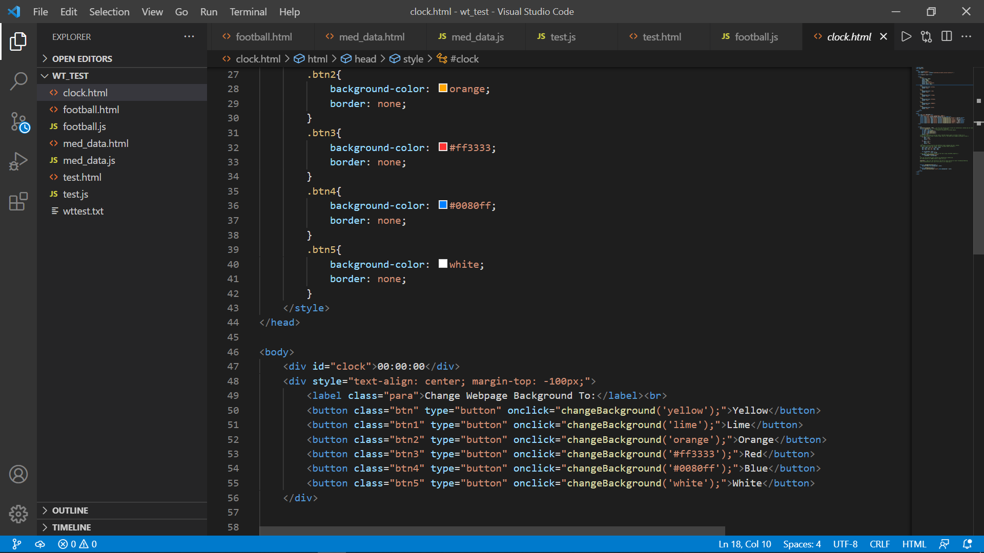

**SCRIPT CODE :**

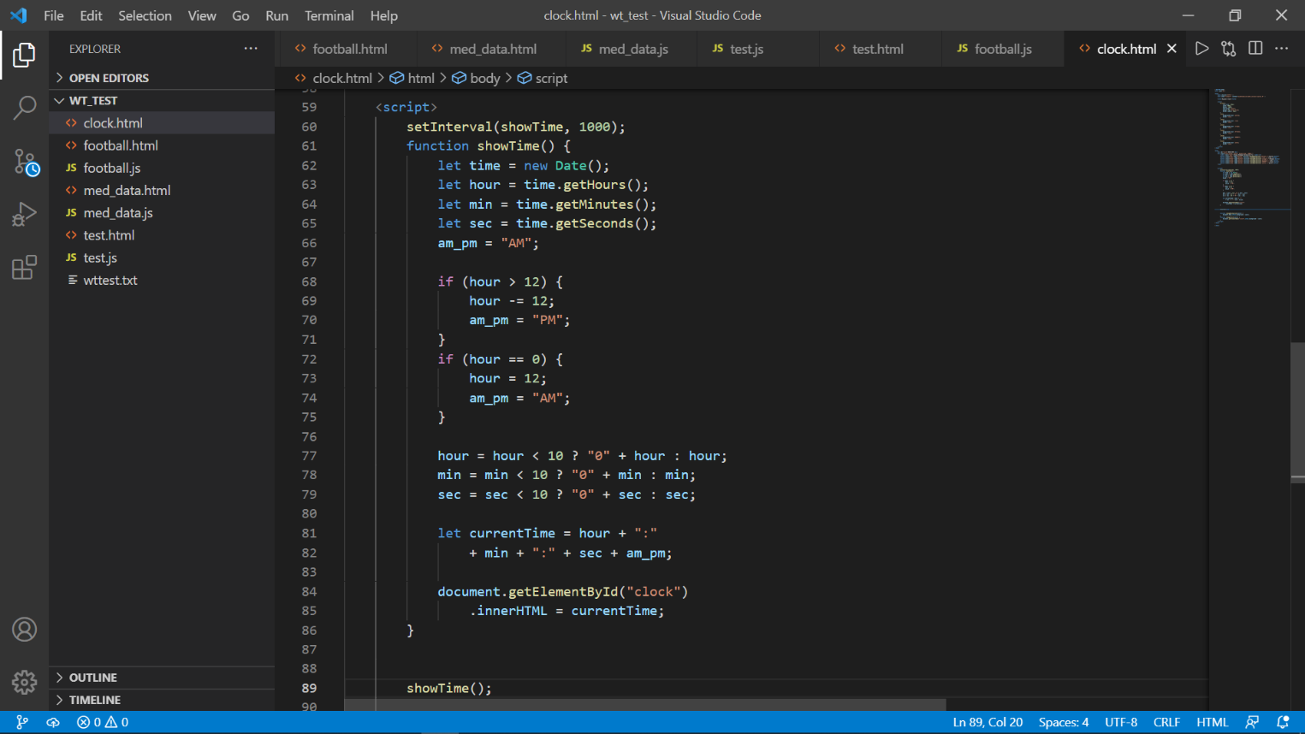

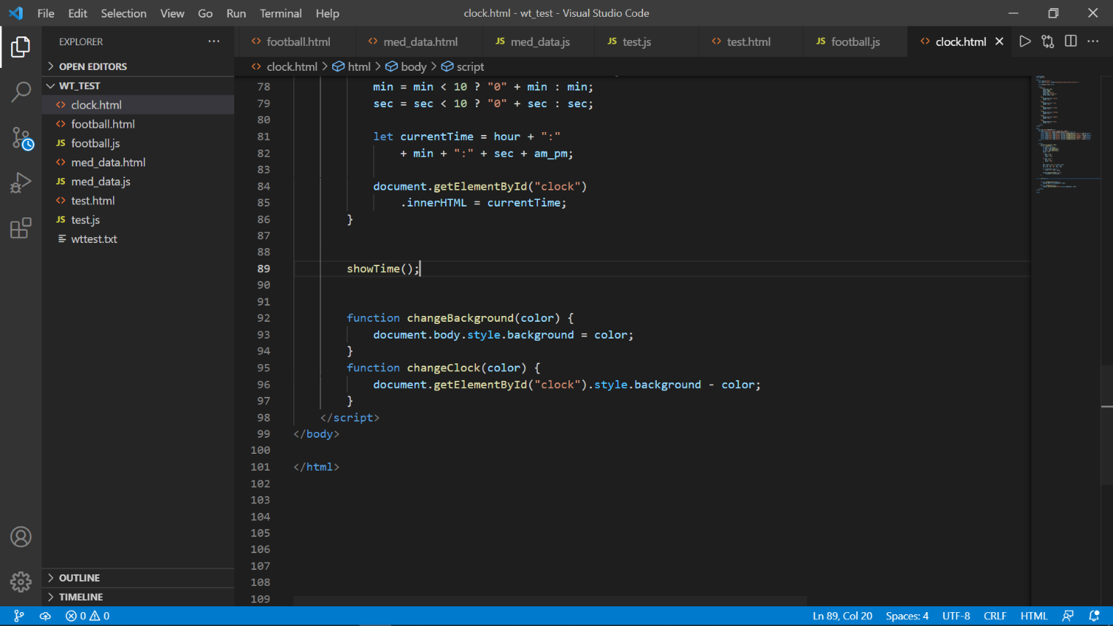

**OUTPUT :**

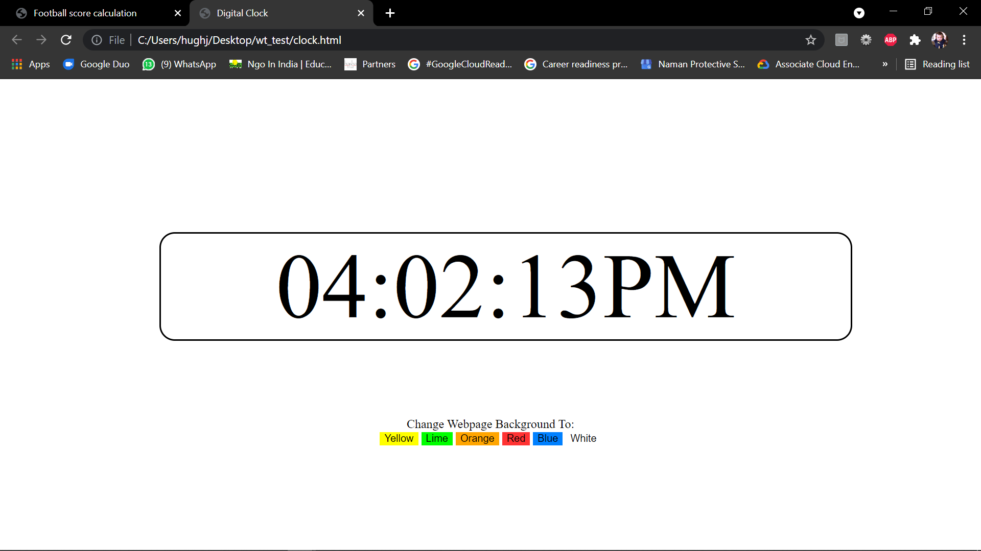

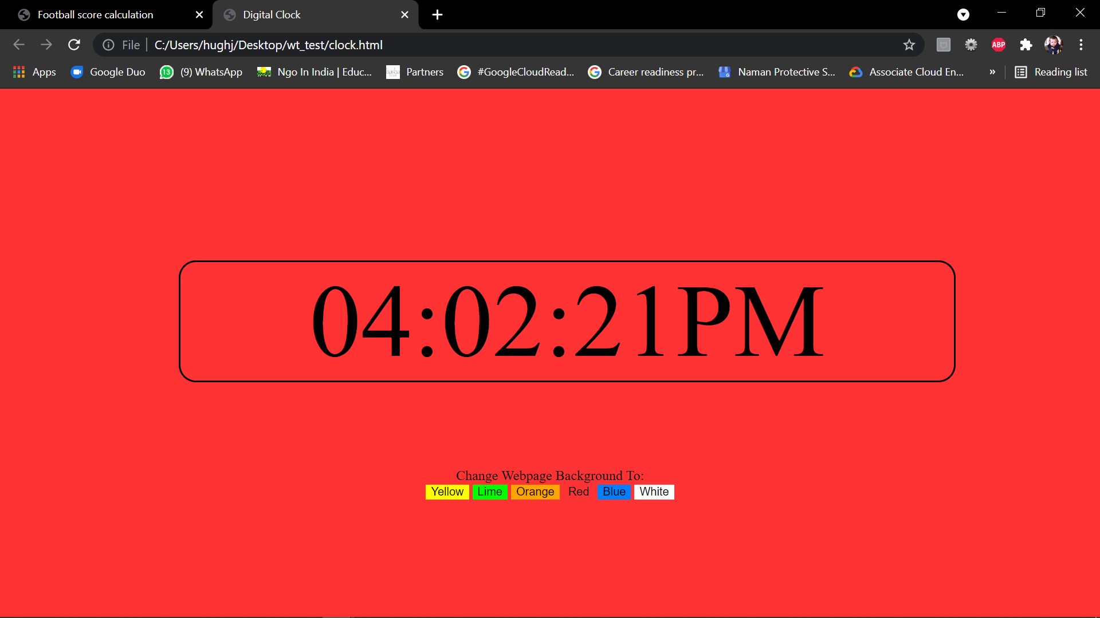

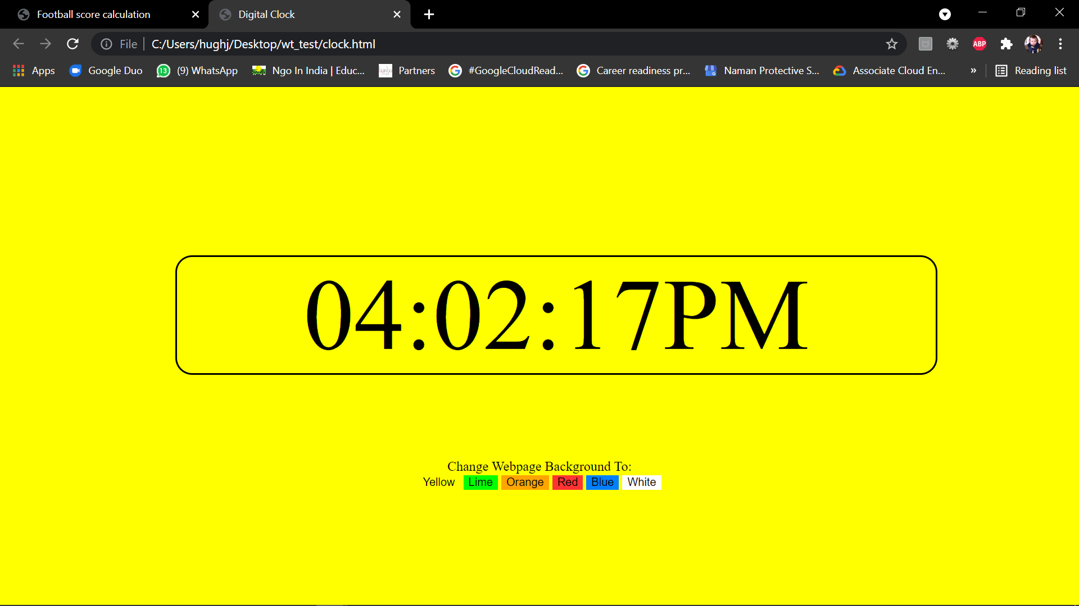

**THANK YOU**