**Session 7**

**26/05/2021**

**Problem Statement:**

**Submit a report on the HIVE setup done on your local VM with relevant snapshots and explanations.**

1. **Start the Hadoop clusters**
2. **Download the following files:**

Google Guava 27.0.1-jre

[**https://mvnrepository.com/artifact/com.google.guava/guava/27.0.1-jre**](https://mvnrepository.com/artifact/com.google.guava/guava/27.0.1-jre)

Download the binary file of hive-3.1.2

[**https://apachemirror.wuchna.com/hive/hive-3.1.2/**](https://apachemirror.wuchna.com/hive/hive-3.1.2/)

1. **Move the files into new folder** usr/local/hadoop/hive **and change the Permissions of the Hive Folder**

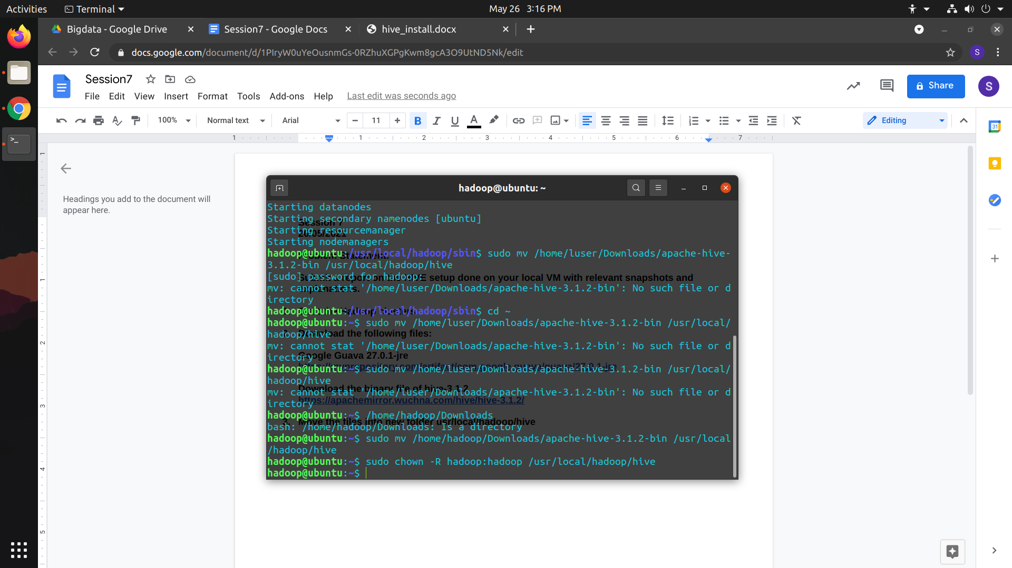

1. **Set the Path Variables:** sudo vim /etc/profile.d/hadoop_java.sh

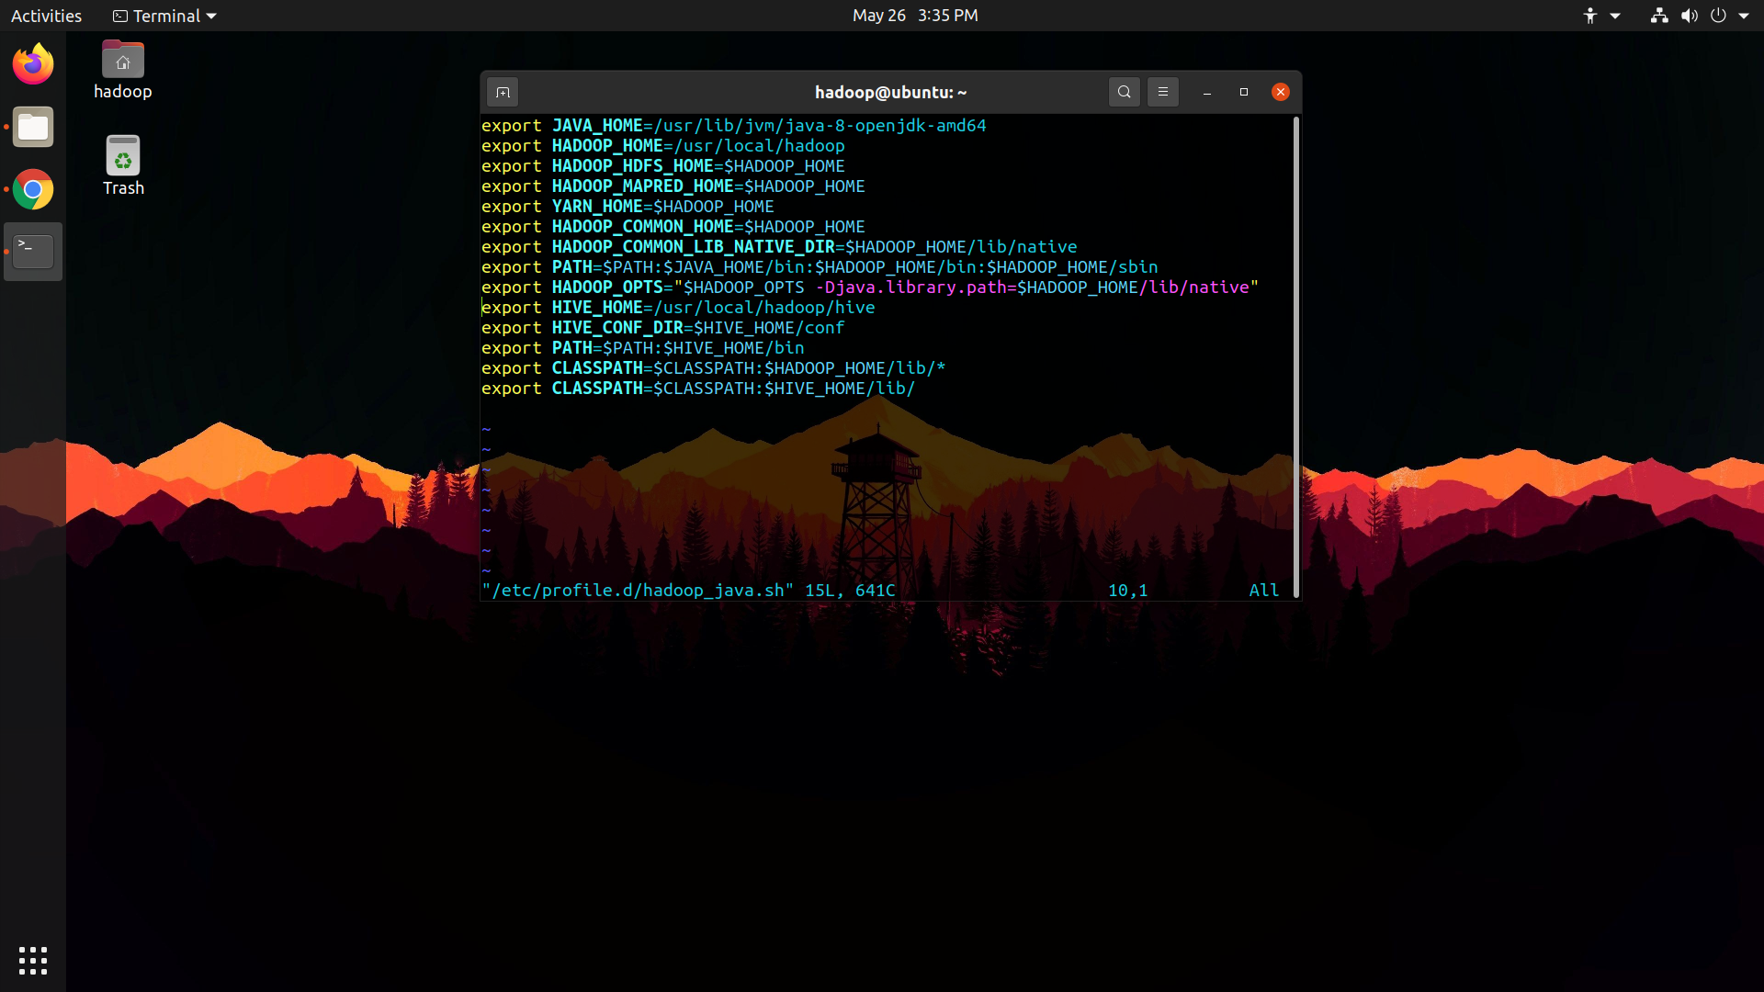

1. **Point the file to this location:**

* source /etc/profile.d/hadoop_java.sh

1. **Start your Hadoop cluster in case you have closed it:**

* cd $HADOOP_HOME/sbin && ./start-all.sh

1. **Create a Folder for all the Temporary files**

* hdfs dfs -mkdir -p /tmp
* hdfs dfs -mkdir -p /user/hive/warehouse
* hdfs dfs -chmod g+w /tmp
* hdfs dfs -chmod g+w /user/hive/warehouse

1. **Update the Guava Jar file**

* cd $HIVE_HOME/lib
* mv guava-19.0.jar guava-19.0.jar_buf
* sudo mv /home/hadoop/Downloads/guava-27.0.1-jre.jar . (. - current directory)

1. **Setup the Conf files using a predefined Template**

* cd .. && cd conf
* cp hive-env.sh.template hive-env.sh

1. **Edit the File hive-env.xml**

* vim hive-env.sh

Go to line number 49 , Add the line after this line HADOOP_HOME=/usr/local/hadoop

1. **Edit the File Hive-site.xml**

* cp hive-default.xml.template hive-site.xml
* vim hive-site.xml

Go to line number 39, in that change the value as /tmp/hive-${user.name}

// remove the additional symbol such as <, > in the description field (IMPORTANT)

Go to line number 143, change the value field as /tmp/${user.name}

Go to line number 147, change the value field as /tmp/${user.name}_resources

Go to line number 153, change the value field as change the value from 700 to 733

Go to line number 3215 and remove the special character in the description

1. **To Use SQL DB**

* schematool -dbType derby -initSchema (Observe no error)

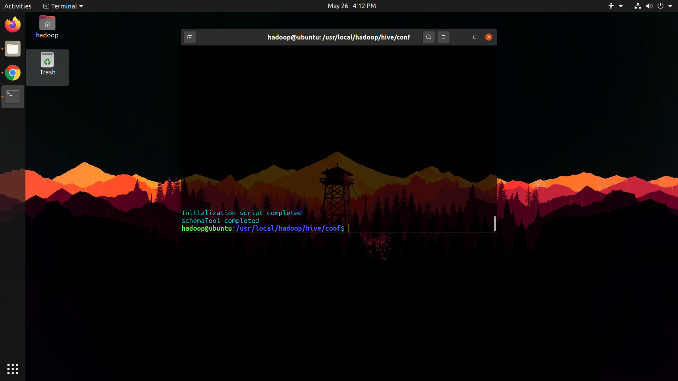

1. **Use Hive**

* hive ( to start the hive shell )

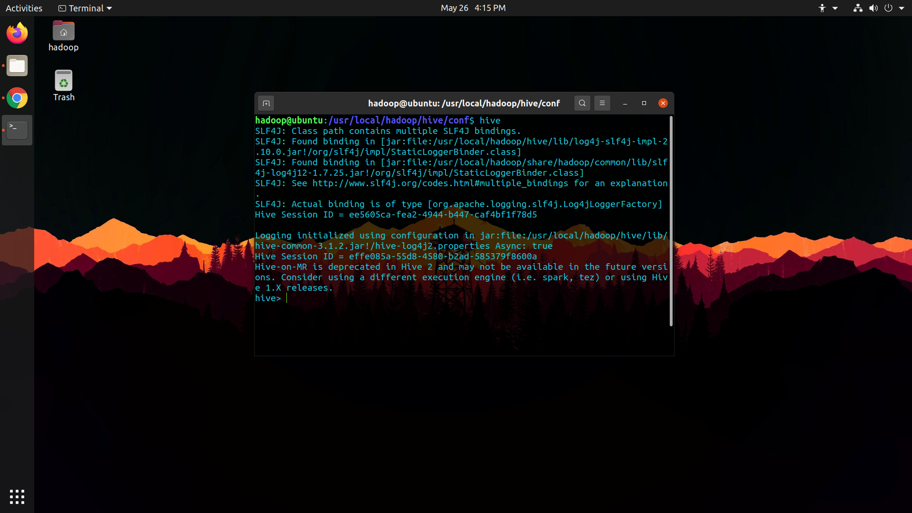

**HiveQL is up and running**

**Sriranjan S**

**1NT18IS159**