DATE:31/3/2022
USN:1NT19IS162
BD LAB

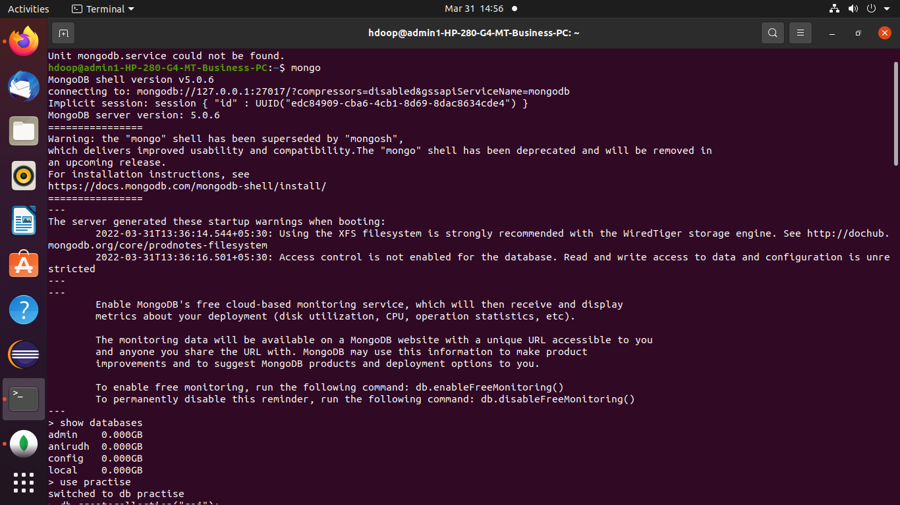
using mongo command we enter into mongo shell.

TO SHOW DATABASE
- to show how many databases are present we use the below command:
show databases

TO CREATE NEW DATABASE
we use use db_name command to either create or use database.
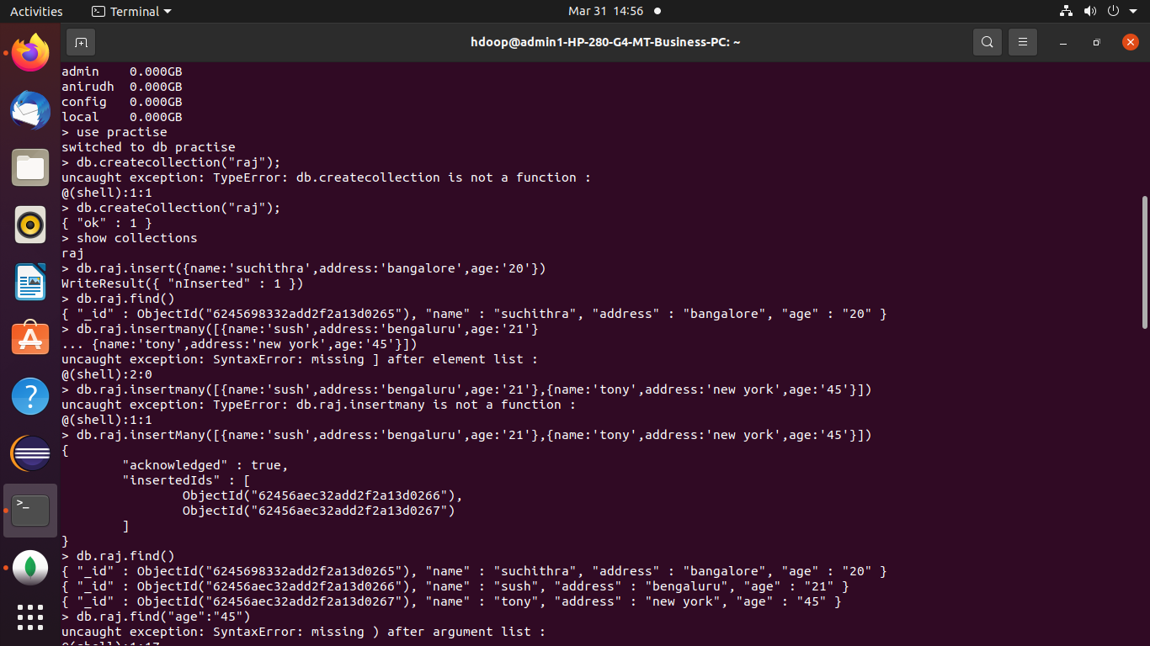
TO CREATE COLLECTION
we use db.createCollection(“raj”); to create a new collection.

TO SHOW COLLECTIONS
show collections can be used to list the collections present in database.

TO INSERT INTO COLLECTION
1.insertOne: can insert one row at a time.

db.raj.insert({name:'suchithra',address:'bangalore',age:'20'})
WriteResult({ "nInserted" : 1 })

2.insert many: can insert multiple rows at a time.
db.raj.insertMany([{name:'sush',address:'bengaluru',age:'21'},{name:'tony',address:'new york',age:'45'}])
{
"acknowledged" : true,
"insertedIds" : [
ObjectId("62456aec32add2f2a13d0266"),
ObjectId("62456aec32add2f2a13d0267")
]
}
TO DISPLAY
1.To display we use find command
db.raj.find()

t
to display a particular row
db.raj.find({“age”:”45”})

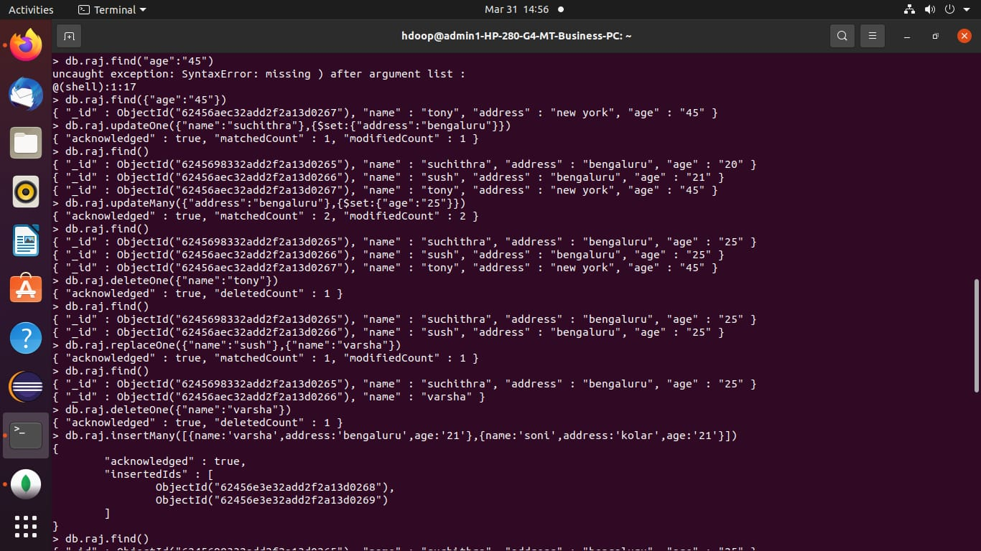
TO UPDATE:
We use db.raj.updateOne({“name”:”suchithra”},{$set:{address:’bengaluru’}})

Db.raj.updateMany({address:’bengaluru’},{$set:{age:’25’}})

TO DELETE:
Db.raj.deleteOne({name:’tony’})

Db.raj.deleteMany({address:’bengaluru’})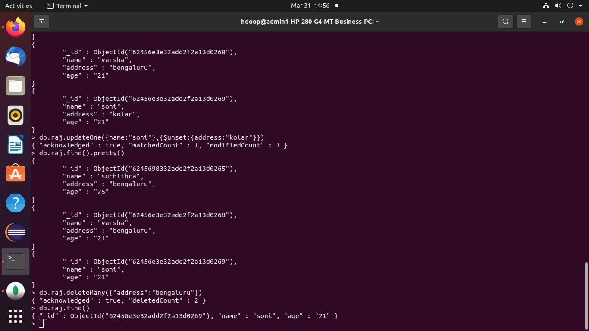

TO REPLACE:
Db.raj.replaceOne({name:’sush’},{name:’varsha’})

Update unset:
Db.raj.updateOne({name:’soni’},{$unset:{address:’kolar’}})

