**Joy of coding – Day 3**

**Question 1**

#include<stdio.h>

int main()

{

int num,rev=0,rem=0,count=0;

printf("Enter a number:\n");

scanf("%d",&num);

printf("The digits of number:\n");

while(num!=0)

{

rem=num%10;

printf("%d\t",rem);

rev=rev*10+rem;

num=num/10;

count++;

}

printf("\nNumber of digits : %d",count);

printf("\nReverse of number : %d",rev);

return 0;

}

**Output:**

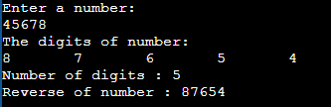

**Question 2**

#include<stdio.h>

int main()

{

int num,sum=0,rem=0,sdsum=0;

printf("Enter a number:\n");

scanf("%d",&num);

while(num!=0)

{

rem=num%10;

sum=sum+rem;

num=num/10;

}

printf("The sum of digits is %d\n",sum);

rem=0;

while(sum!=0)

{

rem=sum%10;

sdsum=sdsum+rem;

sum=sum/10;

}

printf("(Single digit sum is %d)",sdsum);

return 0;

}

**Output:**

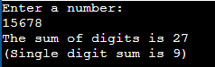 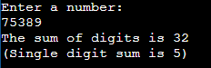

**Question 3**

#include<stdio.h>

#include<stdlib.h>

int main()

{

int num,sum=0,rem=0;

printf("Enter a number:\n");

scanf("%d",&num);

if(num==0)

{

printf("The sum is 1\n");

exit(0);

}

while(num!=0)

{

rem=num%10;

sum=sum + rem + 1;

num=num/10;

}

printf("The sum is %d\n",sum);

return 0;

}

**Output:**

**  **

**Question 4**

#include<stdio.h>

int main()

{

int num,rem=0,rev=0;

printf("Enter a number:\n");

scanf("%d",&num);

printf("Digits extracted:\n");

while(num!=0)

{

rem=num%10;

rev=rev*10+rem;

num=num/10;

}

num=rev;

rem=0;

while(num!=0)

{

rem=num%10;

num=num/10;

if(rem==0)

continue;

printf("%d ",rem);

}

return 0;

}

**Output:**

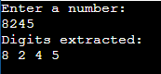 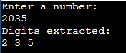 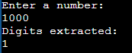

**Question 5**

#include<stdio.h>

int main()

{

int num,rem=0,pnum=0,rev=0;

printf("Enter a number:\n");

scanf("%d",&num);

while(num!=0)

{

rem=num%10;

if(rem==9)

pnum=pnum*10;

else

pnum=pnum*10 + rem + 1;

num=num/10;

}

rem=0;

while(pnum!=0)

{

rem=pnum%10;

rev=rev*10+rem;

pnum=pnum/10;

}

printf("Pin number = %d",rev);

return 0;

}

**Output:**

  