**Joy of coding – Day 4**

**Question 1**

1. int arr1[10]; No error
2. int n = 10; int arr2[n]; No error
3. int arr[ ] = { 10, 20, 30, 40 } Error: Expected ‘;’ at the end
4. int arr[6] = { 10, 20, 30, 40 } Error: Expected ‘;’ at the end
5. int arr[ ]; Error: Array size missing
6. int arr[5]; arr[3 / 2] = 2; No error
7. int arr[2] = { 10, 20, 30, 40, 50 }; Error: Excess elements in array initializer
8. int arr[2]; printf("%d ", arr[3]); printf("%d ", arr[-2]); Error: Garbage value is displayed

**Question 2**

#include<stdio.h>

int main()

{

int a[10],i;

float b[10];

char c[50];

printf("Enter Mr.Int's daily wages:\n");

for(i=0;i<6;i++)

scanf("%d",&a[i]);

printf("Enter Mr.Float's daily wages:\n");

for(i=0;i<6;i++)

scanf("%f",&b[i]);

printf("Enter Mr.Char's information:\n");

for(i=0;i<12;i++)

scanf("%c",&c[i]);

printf("Mr.Int's daily wages:\n");

for(i=0;i<6;i++)

printf("Rs.%d ",a[i]);

printf("\nMr.Float's daily wages:\n");

for(i=0;i<6;i++)

printf("Rs.%.2f ",b[i]);

printf("\nMr.Char's information:");

for(i=0;i<12;i++)

printf("%c ",c[i]);

printf("\nIn reverse order:\n");

printf("Mr.Int's daily wages:\n");

for(i=5;i>=0;i--)

printf("Rs.%d ",a[i]);

printf("\nMr.Float's daily wages:\n");

for(i=5;i>=0;i--)

printf("Rs.%.2f ",b[i]);

printf("\nMr.Char's information:\n");

for(i=11;i>=0;i--)

printf("%c ",c[i]);

return 0;

}

**Output:**

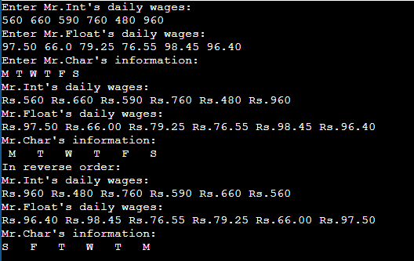

**Question 3**

#include<stdio.h>

int main()

{

int a[10],i;

float b[10],s=0,avg=0;

printf("Enter Mr.Int's daily wages:\n");

for(i=0;i<6;i++)

scanf("%d",&a[i]);

printf("Enter Mr.Float's daily wages:\n");

for(i=0;i<6;i++)

scanf("%f",&b[i]);

for(i=0;i<6;i++)

s=s+a[i];

avg=s/6;

printf("Mr.Int's weekly salary = Rs.%.3f\n",s);

printf("Mr.Int's average salary = Rs.%.3f\n",avg);

s=0;

avg=0;

for(i=0;i<6;i++)

s=s+b[i];

avg=s/6;

printf("Mr.Float's weekly salary = Rs.%.3f\n",s);

printf("Mr.Float's average salary = Rs.%.3f\n",avg);

return 0;

}

**Output:**

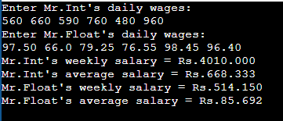

**Question 4**

#include<stdio.h>

int main()

{

int i,p;

float b[10],l;

printf("Enter daily wages:\n");

for(i=0;i<6;i++)

scanf("%f",&b[i]);

l=b[0];

for(i=1;i<6;i++)

{

if(b[i]>l)

{

l=b[i];

p=i;

}

}

switch(p+1)

{

case 1:

{

printf("Highest pay is on Monday and the pay is Rs.%.2f",l);

break;

}

case 2:

{

printf("Highest pay is on Tuesday and the pay is Rs.%.2f",l);

break;

}

case 3:

{

printf("Highest pay is on Wednesday and the pay is Rs.%.2f",l);

break;

}

case 4:

{

printf("Highest pay is on Thusday and the pay is Rs.%.2f",l);

break;

}

case 5:

{

printf("Highest pay is on Friday and the pay is Rs.%.2f",l);

break;

}

case 6:

{

printf("Highest pay is on Saturday and the pay is Rs.%.2f",l);

break;

}

default:

{

printf("Invalid input");

break;

}

}

return 0;

}

**Output:**

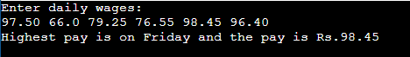

**Question 5:**

#include<stdio.h>

int main()

{

int n,a[n],num,i,count=0,attempts=0;

printf("Enter the number of chits:\n");

scanf("%d",&n);

printf("Enter the numbers on chits:\n");

for(i=0;i<n;i++)

scanf("%d",&a[i]);

printf("Enter the particular number to be picked:\n");

scanf("%d",&num);

for(i=0;i<n;i++)

{

if(num==a[i])

{

count++;

attempts=i+1;

}

}

printf("Number of duplicate chits : %d\n",count);

printf("Number of attempts : %d",attempts);

return 0;

}

**Output:**

