**Joy of coding – Day 5**

**Question 1**

#include<stdio.h>

int main()

{

int a[20],i,n,p,num;

printf("Enter number of elements of array:\n");

scanf("%d",&n);

printf("Enter elements of array:\n");

for(i=0;i<n;i++)

scanf("%d",&a[i]);

printf("Enter position where you want to insert number:\n");

scanf("%d",&p);

printf("Enter the number to be inserted:\n");

scanf("%d",&num);

for(i=n-1;i>=p;i--)

a[i+1]=a[i];

a[p]=num;

printf("The array:\n");

for(i=0;i<=n;i++)

printf("%d ",a[i]);

return 0;

}

**Output:**

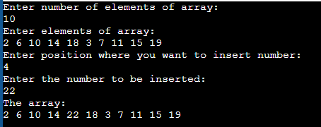

**Question 2**

#include<stdio.h>

int main()

{

int a[20],i,n,p;

printf("Enter number of elements of array:\n");

scanf("%d",&n);

printf("Enter elements of array:\n");

for(i=0;i<n;i++)

scanf("%d",&a[i]);

printf("Enter position of number you want to delete:\n");

scanf("%d",&p);

for(i=p;i<n;i++)

a[i]=a[i+1];

printf("The array:\n");

for(i=0;i<n-1;i++)

printf("%d ",a[i]);

return 0;

}

**Output:**

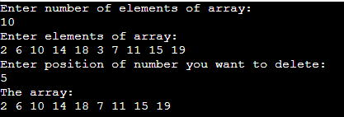

**Question 3**

#include<stdio.h>

#include<stdlib.h>

int main()

{

int a[20],i,n,j;

printf("Enter number of elements of array:\n");

scanf("%d",&n);

printf("Enter elements of array:\n");

for(i=0;i<n;i++)

scanf("%d",&a[i]);

for(i=0;i<n;i++)

{

for(j=i+1;j<n;j++)

{

if(a[i]==a[j])

{

printf("Array is not unique");

exit(0);

}

}

}

printf("Array is unique");

return 0;

}

**Output:**

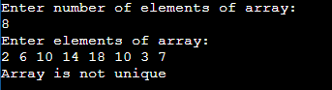

**Question 4**

#include<stdio.h>

int main()

{

int a[20],b[20],n,i,j,count;

printf("Enter number of elements of array:\n");

scanf("%d",&n);

printf("Enter elements of array:\n");

for(i=0;i<n;i++)

{

scanf("%d",&a[i]);

b[i]=-1;

}

for(i=0;i<n;i++)

{

count=1;

for(j=i+1;j<n;j++)

{

if(a[i]==a[j])

{

count++;

b[j]=0;

}

}

if(b[i]!=0)

b[i]=count;

}

for(i=0;i<n;i++)

{

if(b[i]!=0)

printf("Frequency of %d is %d\n",a[i],b[i]);

}

return 0;

}

**Output:**

