**Joy of coding – Day 6**

**Question 1**

#include<stdio.h>

int main()

{

char a,s1[50],s2[50];

printf("Different ways to read character:\n");

printf("Enter character:\n");

scanf("%c",&a); //It will read using scanf

printf("Different ways to print character:\n");

printf("%c",a); //It will print using printf

printf("\nDifferent ways to read string:\n");

printf("Enter string:\n");

scanf("%s",s1); //It will read using scanf

printf("Enter string:\n");

scanf("%s",s2); //It will read using scanf

printf("Different ways to print string:\n");

printf("%s\n",s1); //It will print using printf

puts(s2); //It will print using puts

return 0;

}

#include<stdio.h>

int main()

{

char ch;

printf("Enter character:\n");

ch=getchar(); //It will read using getchar

printf("The character:\n");

putchar(ch); //It will print using putchar

}

**Output:**

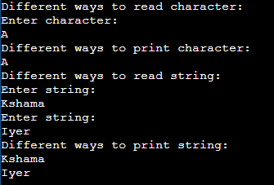

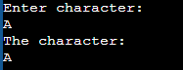

**Question 2**

#include<stdio.h>

#include<string.h>

int main()

{

char s1[]="R N S Institute of Technology";

char s2[]="Bengaluru";

char ch;

printf("Length = %d\n",strlen(s1));

strcat(s1,s2);

printf("Concatenated : %s\n",s1);

int j=0;

while(s1[j])

{

ch=s1[j];

putchar(toupper(ch));

j++;

}

return 0;

}

**Output:**

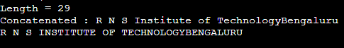

**Question 3**

#include<stdio.h>

#include<string.h>

int main()

{

char str[100],*ptr,i,l;

printf("Enter any string\n");

gets(str);

l=strlen(str);

ptr=str;

printf("%c",*(ptr+0));

for(i=1;i<l;i++)

{

if(*(ptr+i-1)==' ')

printf(" %c ",*(ptr+i));

}

return 0;

}

**Output:**



**Question 4**

#include <stdio.h>

#define OUT 0

#define IN 1

unsigned countWords(char *str)

{

int state = OUT;

unsigned wc = 0;

while (*str)

{

if (*str == ' ' || *str == '\n' || *str == '\t')

state = OUT;

else if (state == OUT)

{

state = IN;

++wc;

}

++str;

}

return wc;

}

int main(void)

{

char str[100];

gets(str);

printf("No of words : %u", countWords(str));

return 0;

}

**Output:**



**Question 5**

#include <stdio.h>

#include <string.h>

void isPalindrome(char str[])

{

int l = 0;

int h = strlen(str) - 1;

while (h > l)

{

if (str[l++] != str[h--])

{

printf("%s is not a palindrome\n", str);

return;

}

}

printf("%s is a palindrome\n", str);

}

int main()

{

char str[100];

gets(str);

isPalindrome(str);

return 0;

}

**Output:**

