Joy of coding – Day 1

Question 1
#include<stdio.h>
int main()
{
int a=10,b=100;
float c=10.5,d=100.5;
printf("++a=%d\n",++a);
printf("--b=%d\n",--b);
printf("++c=%f\n",++c);
printf("--d=%f\n",--d);
return 0;
}
Output:
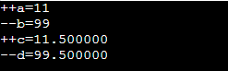

Question 2
#include<stdio.h>
int main()
{
int a=5,b=5,c=10;
printf("%d == %d is %d \n", a, b, a == b);
printf("%d == %d is %d \n", a, c, a == c);
printf("%d > %d is %d \n", a, b, a > b);
printf("%d > %d is %d \n", a, c, a > c);
printf("%d < %d is %d \n", a, b, a < b);
printf("%d < %d is %d \n", a, c, a < c);
printf("%d != %d is %d \n", a, b, a != b);
printf("%d != %d is %d \n", a, c, a != c);
printf("%d >= %d is %d \n", a, b, a >= b);
printf("%d >= %d is %d \n", a, c, a >= c);
printf("%d <= %d is %d \n", a, b, a <= b);
printf("%d <= %d is %d \n", a, c, a <= c);
return 0;
}
Output:
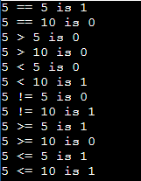

Question 3
#include<stdio.h>
int main()
{
int a=5,b=5,c=10,result;
result=(a==b)&&(c>b);
printf("(a == b) && (c > b) is %d \n",result);
result=(a==b)&&(c<b);
printf("(a == b) && (c < b) is %d \n",result);
result=(a==b)||(c<b);
printf("(a == b) || (c < b) is %d \n",result);
result=(a!=b)||(c<b);
printf("(a != b) || (c < b) is %d \n",result);
result=!(a!=b);
printf("!(a != b) is %d \n",result);
result=!(a==b);
printf("!(a == b) is %d \n",result);
return 0;
}
Output:
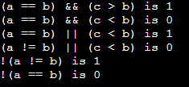
Question 4
#include<stdio.h>
int main()
{
int i;
short s;
long l;
char c;
float f;
double d;
printf("Size of int:%zu bytes\n",sizeof(i));
printf("Size of short:%zu bytes\n",sizeof(s));
printf("Size of long:%zu bytes\n",sizeof(l));
printf("Size of char:%zu bytes\n",sizeof(c));
printf("Size of float:%zu bytes\n",sizeof(f));
printf("Size of double:%zu bytes\n",sizeof(d));
return 0;
}
Output:
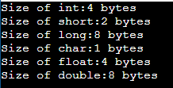

Question 5
#include<stdio.h>
int main()
{
int num=22;
printf("Left shift:\n");
printf("%d \n",num<<1);
printf("%d \n",num<<2);
printf("Right shift:\n");
printf("%d \n",num>>1);
printf("%d \n",num>>2);
return 0;
}
Output:
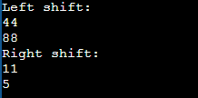
Working:
22 = 10110
22 << 1 = 101100 = 44
22 << 2 = 1011000 = 88
22 >> 1 = 1011 = 11
22 >> 2 = 101 = 5

Question 6
#include<stdio.h>
int main()
{
int a,b,c,l;
printf("Enter two numbers:\n");
scanf("%d%d",&a,&b);
l=a>b?a:b;
printf("The largest of %d and %d is %d\n",a,b,l);
printf("Enter another number:\n");
scanf("%d",&c);
l=a>b?(a>c?a:c):(b>c?b:c);
printf("The largest of %d, %d and %d is %d\n",a,b,c,l);
return 0;
}
Output:
