

Assignment

Course Title: Data Structures
Course Code: CSE207

Submitted by,
Name: Raihan Uddin Emon
Student ID: 2024-3-60-147
Section: 12
Date of Submission: 11-02-2026

Submitted to,
Puja Chakraborty,
Senior Lecturer, Department of Computer Science and Engineering, East West University
Part 1

Question 1: Write a pseudocode to insert an element at the first position of the linked list.
Pseudocode:
Algorithm 1.1: Insert element at first position (HEAD: reference to the first node, KEY: value to insert)
Step 1: Create newNode such that newNode $->$ Data $≔$ KEY and newNode $->$ next $≔$ null.
Step 2: Set newNode $->$ next $≔$ HEAD.
Step 3: Set HEAD $≔$ newNode.
Step 4: Return.

Question 2: Write a pseudocode to insert an element at k^{th} position of the linked list.
Pseudocode:
Algorithm 1.2: Insert element at k^{th} position (HEAD: reference to the first node, KEY: value to insert, K: position of the value)
Step 1: If k $<$ 1 then,
Print “Invalid position”
Go to step 12.
Step 2: Create newNode such that newNode $->$ Data $≔$ KEY and newNode $->$ next $≔$ null.
Step 3: If k $=$ 1 then,
Set newNode $->$ next $≔$ HEAD.
Set HEAD $≔$ newNode.
Go to step 12.
Step 4: Set Count $≔$ 1 and Current $≔$ HEAD.
Step 5: Repeat step 6-8 while Current $!=$ null and Count $<$ k$-$ 1.
Step 6: Set Current $≔$ Current $->$ next.
Step 7: Set Count $≔$ Count $+$ 1.
Step 8: Go to step 5.
Step 9: If Current $=$ null then,
Print “Invalid position”.
Delete newNode.
Go to step 12.
Step 10: Set newNode $->$ next $≔$ Current $->$ next.
Step 11: Set Current $->$ next $≔$ newNode.
Step 12: Return.

Question 3: Write a pseudocode to insert an element at the last position of a linked list.
Pseudocode:
Algorithm 1.3: Insert element at last position (HEAD: reference to the first node, KEY: value to insert)
Step 1: Create newNode such that newNode $->$ Data $≔$ KEY and newNode $->$ next $≔$ null.
Step 2: If HEAD $=$ null then,
Set newNode $->$ next $≔$ HEAD.
Set HEAD $≔$ newNode.
Go to step 9.
Step 3: Set Current $≔$ HEAD.
Step 4: Repeat step 5-6 while Current $->$ next $!=$ null.
Step 5: Set Current $≔$ Current $->$ next.
Step 6: Go to step 4.
Step 7: Set newNode $->$ next $≔$ Current $->$ next.
Step 8: Set Current $->$ next $≔$ newNode.
Step 9: Return.

Question 4: Write a pseudocode to insert an element to a sorted (in ascending order) linked list so that it still remains sorted.
Pseudocode:
Algorithm 1.4: Insert element into sorted linked list (HEAD: reference to the first node, KEY: value to insert)
Step 1: Create newNode such that newNode $->$ Data $≔$ KEY and newNode $->$ next $≔$ null.
Step 2: If HEAD $=$ null or KEY $<$ HEAD $->$ Data then,
Set newNode $->$ next $≔$ HEAD.
Set HEAD $≔$ newNode.
Go to step 9.
Step 3: Set Current $≔$ HEAD.
Step 4: Repeat step 5-6 while Current $->$ next $!=$ null and Current $->$ next $->$ Data $<$ KEY.
Step 5: Set Current $≔$ Current $->$ next.
Step 6: Go to step 4.
Step 7: Set newNode $->$ next $≔$ Current $->$ next.
Step 8: Set Current $->$ next $≔$ newNode.
Step 9: Return.
Question 5: Write a pseudocode to delete duplicate elements from a sorted (in ascending order) linked list.
Pseudocode:
Algorithm 1.5: Delete duplicate elements from sorted linked list (HEAD: reference to the first node)
Step 1: If HEAD = null then,
Print “The list is empty”
Go to step 7.
Step 2: Set Current $≔$ HEAD.
Step 3: Repeat step 4-6 while Current $!=$ null and Current $->$ next $!=$ null.
Step 4: If Current $->$ Data $=$ Current $->$ next $->$ Data then,
Set Temp $≔$ Current $->$ next.
Set Current $->$ next $≔$ Current $->$ next $->$ next.
Delete Temp.
Step 5: Else do,
Set Current $≔$ Current $->$ next.
Step 6: Go to step 3.
Step 7: Return.

Question 6: Write pseudocode to check whether two singly linked lists are identical.
Pseudocode:
Algorithm 1.6: Check whether two singly linked lists are identical (HEAD: reference to the first node, LinkedList X: list to compare)
Step 1: Set Current1 $≔$ this $->$ HEAD.
Step 2: Set Current2 $≔$ X.HEAD.
Step 3: Repeat step 4-7 while Current1 $!=$ null and Current2 $!=$ null.
Step 4: If Current1 $->$ Data $!=$ Current2 $->$ Data then,
Print “The lists are not identical”
Go to step 10
Step 5: Set Current1 $≔$ Current1 $->$ next.
Step 6: Set Current2 $≔$ Current2 $->$ next.
Step 7: Go to step 3.
Step 8: If Current1 $=$ null and Current2 $=$ null then,
Print "The lists are identical"
Step 9: Else do,
Print "The lists are not identical"
Step 10: Return.

Question 7: Write pseudocode to delete the entire linked list and free memory. (Destructor)
Pseudocode:
Algorithm 1.7: Delete entire linked list (HEAD: reference to the first node)
Step 1: Set Current $≔$ HEAD.
Step 2: Repeat step 3-6 while Current $!=$ null.
Step 3: Set Temp $≔$ Current.
Step 4: Set Current $≔$ Current $->$ next.
Step 5: Delete Temp.
Step 6: Go to step 2.
Step 7: Set HEAD $≔$ null.
Step 8: Print “Linked List deleted successfully”
Step 9: Return.

Question 8: Write pseudocode to merge two singly linked lists.
Pseudocode:
Algorithm 1.8: Merge two linked lists (HEAD: reference to the first node, LinkedList X: list to merge)
Step 1: If HEAD $=$ null then,
Set HEAD $≔$ X.HEAD.
Go to step 7.
Step 2: Set Current $≔$ HEAD.
Step 3: Repeat step 4-5 while Current $->$ next $!=$ null.
Step 4: Set Current $≔$ Current $->$ next.
Step 5: Go to step 3.
Step 6: Set Current $->$ next $≔$ X.HEAD.
Step 7: Return.

Question 9: Write pseudocode to check whether a singly linked list is sorted or not.
Pseudocode:
Algorithm 1.9: Check whether singly linked list is sorted (HEAD: reference to the first node)
Step 1: If HEAD $=$ null or HEAD $->$ next $=$ null then,
Print “The list is sorted”
Go to step 11.
Step 2: Set Current $≔$ HEAD.
Step 3: Set Ascending $≔$ true and Descending $≔$ true.
Step 4: Repeat step 5-8 while Current $->$ next $!=$ null.
Step 5: If Current $->$ Data $>$ Current $->$ next $->$ Data then,
Set Ascending $≔$ false.
Step 6: If Current $->$ Data $<$ Current $->$ next $->$ Data then,
Set Descending $≔$ false.
Step 7: Set Current $≔$ Current $->$ next.
Step 8: Go to step 4.
Step 9: If Ascending $=$ true or Descending $=$ true then,
Print “The list is sorted”.
Step 10: Else do,
Print “The list is not sorted”.
Step 11: Return.

Question 10: Write a pseudocode to print a singly linked list.
Pseudocode:
Algorithm 1.10: Print singly linked list (HEAD: reference to the first node)
Step 1: If HEAD $=$ null then,
Print “The list is empty”
Go to step 7.
Step 2: Set Current $≔$ HEAD.
Step 3: Repeat step 4-6 while Current $!=$ null.
Step 4: Print Current $->$ Data.
Step 5: Set Current $≔$ Current $->$ next.
Step 6: Go to step 3.
Step 7: Return.

Part 2

Follow the given instructions to build a linked list in C++
1) Design a template class Node<T> that contains the following data members: ○ data of type T ○ next, a pointer to another Node<T>
Code:

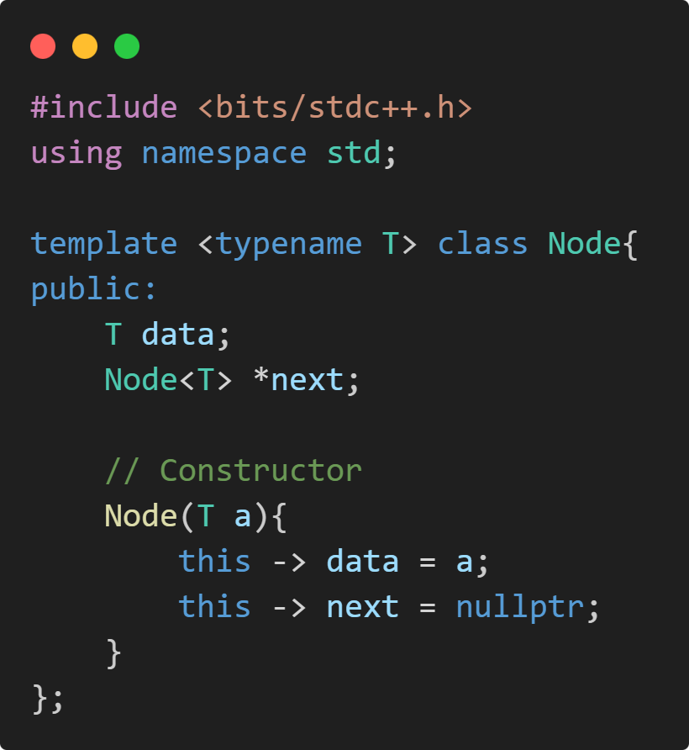
2) Design a template class LinkedList<T> to represent a singly linked list. The class should maintain a pointer named head that points to the first node of the list.
Code:

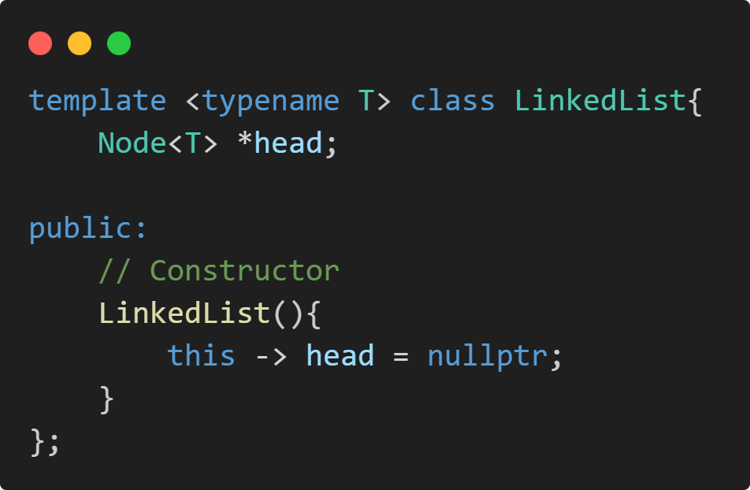

3) Implement the following member functions in the LinkedList<T> class:
○ Insert an element at the k-th position in the linked list
○ Delete a specified element from the linked list
○ Display (print) all elements of the linked list

Code:
3. a) Insert an element at the k-th position:
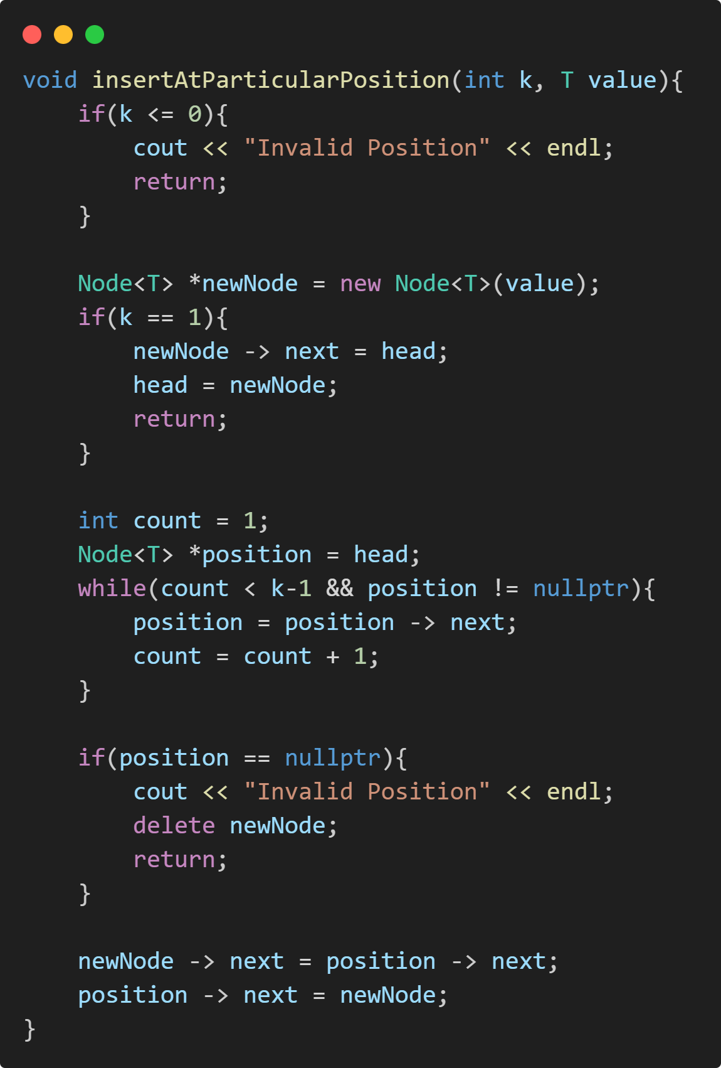
3. b) Delete a specified element:
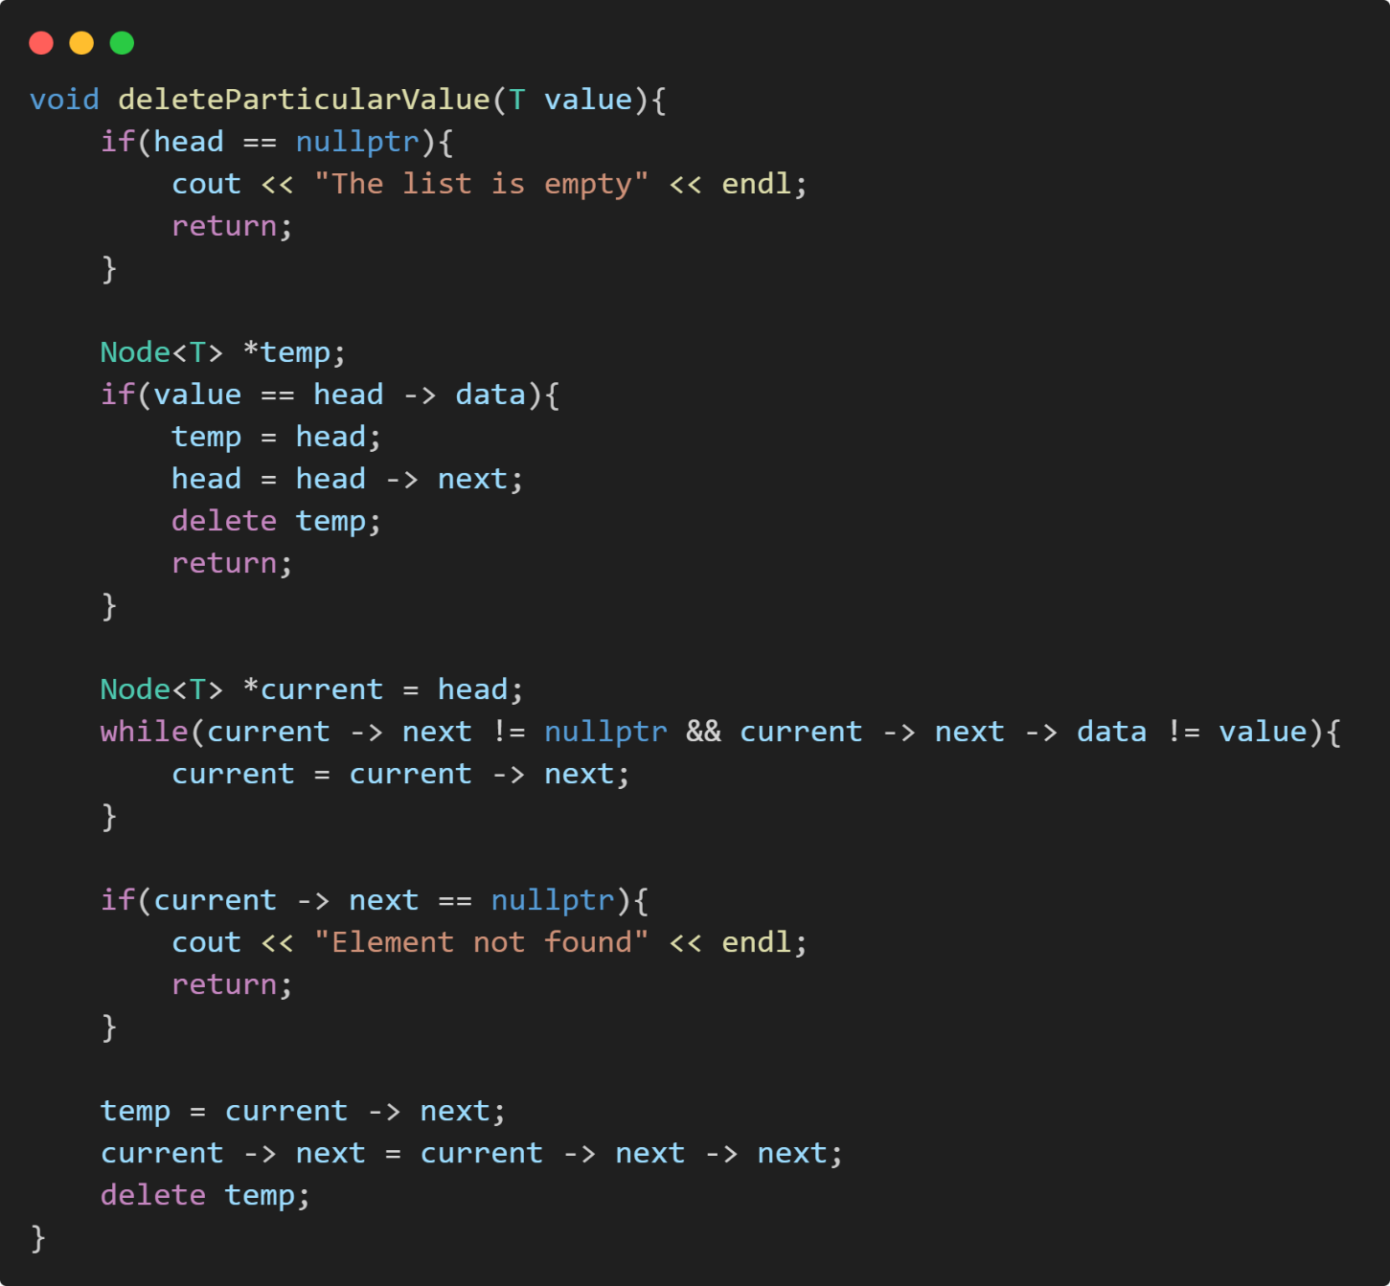

3. c) Display (print) all elements:
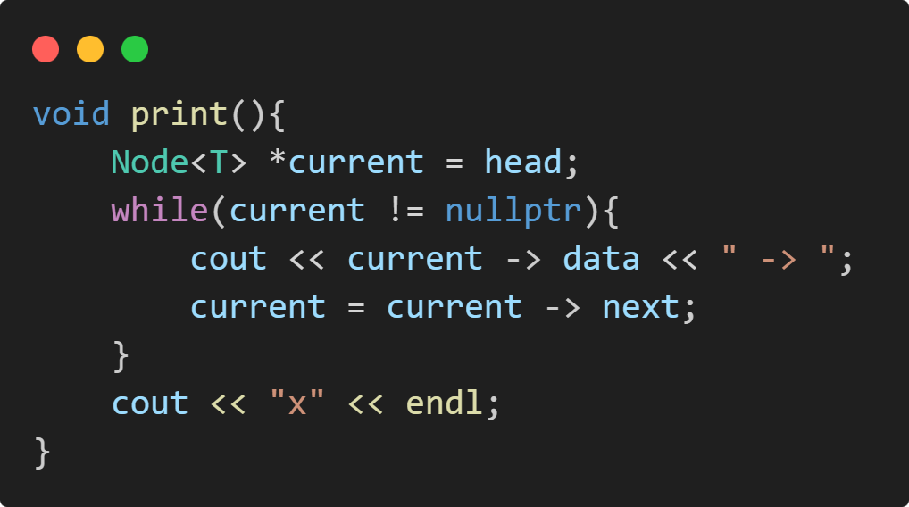
4) Implement a destructor for the LinkedList<T> class to properly deallocate all dynamically allocated memory.
Code:

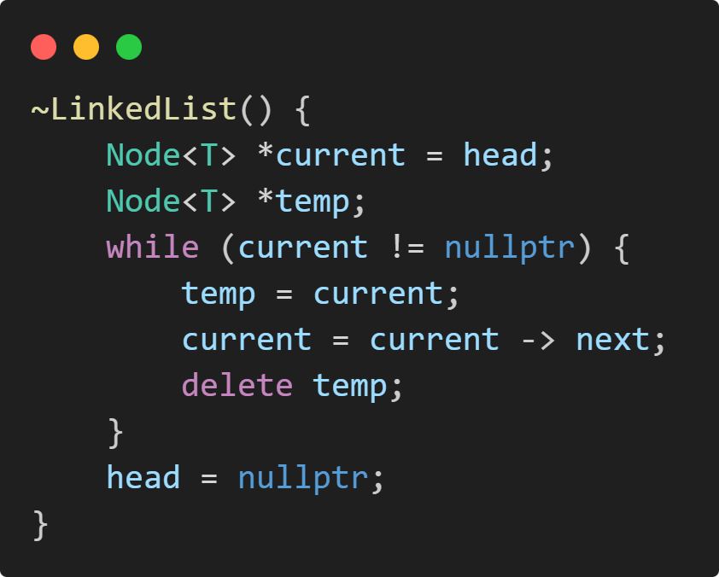

5) Use constructors wherever necessary to initialize class data members.
=> Constructors used for both Node and LinkedList template class.

6) In the main() function, create an object of the LinkedList<T> class and demonstrate the use of the implemented operations.
Code:

