TASK VIEW & CREATION
ST10091167
24 APRIL 2023

Contents
Task View 3
Task Creation 4
References 5

Task View
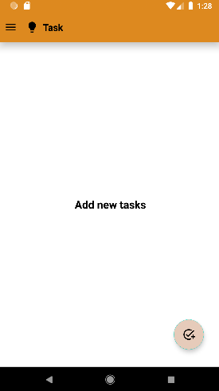
The first screen is the Task View. Tasks in the current time tracking app are considered highly mandatory because it controls most activities in the system and the business can benefit from them such as the following:
- Assigning individual employees with work
- Time tracking
- Advance recognition of accountability
- Promotes motivation.
The purpose of this screen is to view tasks created by users and display its progress of completion. There are two features displayed on the screen:
- Floating button (bottom right corner of the screen)
- Navigation drawer (top left corner of the screen)
The primary focus is the floating button. Its function is to allow a transition from the current screen to the Task Creation screen to add tasks (more will be explained on the next screen below). The secondary focus is the navigation drawer. Its function is to slide out a drawer with a variety of options (such as Home, Calendar, Inbox, etc....).

Task Creation
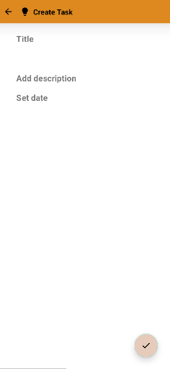
The second screen is Task Creation. This is where the creating/adding of the task takes place. The following are the keys points that will be included in the creating/adding of the task:
- Title
  - The name given to describe the task.
- Add description.
  - The given statement to give a mental image about the task.
- Set date.
  - The given period/time for the completion of the task.
There are two features displayed on the screen:
- Floating button (bottom right corner of the screen)
- Return arrow (top left corner of the screen)
Both features have a common functionality. The return arrow allows a transition from the current screen back to the Task View screen, discarding the adding/creating of the task. The floating button also allows a transition from the current screen back to Task View but by saving the adding/creating of the task for the task itself to be displayed and viewed afterwards.

References
Apploye. (2023, January 01). 15 Benefits of Time Tracking Software in 2023. Retrieved from Apploye: https://apploye.com/time-tracking-benefits/

