**CFA Institute Research Challenge**

**hosted by**

**CFA Society Spokane**

**by**



The CFA Institute Research Challenge is a global competition that tests the equity research and valuation, investment report writing, and presentation skills of university students. The following report was prepared in compliance with the Official Rules of the CFA Institute Research Challenge, is submitted by a team of university students as part of this annual educational initiative and should not be considered a professional report.

**Disclosures:**

**Ownership and material conflicts of interest**

The author(s), or a member of their household, of this report does not hold a financial interest in the securities of this company. The author(s), or a member of their household, of this report does not know of the existence of any conflicts of interest that might bias the content or publication of this report.

Compensation of the author(s) of this report is not based on investment banking revenue.

**Position as an officer or a director**

The author(s), or a member of their household, does not serve as an officer, director, or advisory board member of the subject company.

**Market making**

The author(s) does not act as a market maker in the subject company’s securities.

**Disclaimer**

The information set forth herein has been obtained or derived from sources generally available to the public and believed by the author(s) to be reliable, but the author(s) does not make any representation or warranty, express or implied, as to its accuracy or completeness. The information is not intended to be used as the basis of any investment decisions by any person or entity. This information does not constitute investment advice, nor is it an offer or a solicitation of an offer to buy or sell any security. This report should not be considered to be a recommendation by any individual affiliated with CFA Society Spokane, CFA Institute, or the CFA Institute Research Challenge with regard to this company’s stock.

|  |  |
| --- | --- |
| Valuation Date | 1-16-24 |
| Current Price | $26.25 |
| Target Price | $25.00 |
| 52-week high | $36.21 |
| 52-week low | $22.71 |
| Shares Outstanding | 27.7  (in million) |
| Market Capitalization | $719.4  (in million) |
| Beta | 1.127 |
| Adjusted | 1.085 |
| Downside | -4.76% |

|  |  |  |
| --- | --- | --- |
| 16th January, 2024 | |  |
| Radius Recycling (NASDAQ:RDUS) | |  |
| ‘Where change begins’ | |  |
|  | | Sector: Basic Materials |
|  | | Industry: Steel |
| National Association of Securities Dealers Automated Quotations (NASDAQ) | | |
|  | Recommendation: SELL | |

**Business Description**

Radius Recycling (RDUS US) is a metal recycling and steel manufacturing firm based in Portland, Oregon, and until recently was known as Schnitzer Steel Industries operating under the ticker SCHN. The company supplies ferrous scrap to export and domestic steel producers through its scrap collection, processing, and deep-water facilities. Radius also operates collection and processing facilities and manages other facilities through joint ventures (Bloomberg, L.P. Financial [Bloomberg]). They operate in the US and Canada with 54 metal recycling and 50 automotive recycling facilities. Auto recycling, under the brand name Pick-n-Pull, makes up around 20% of their business; 45% of the company’s revenue is generated from the US (CFA company presentation, Michael Bennett, 8 Nov 2023 [Bennett]).

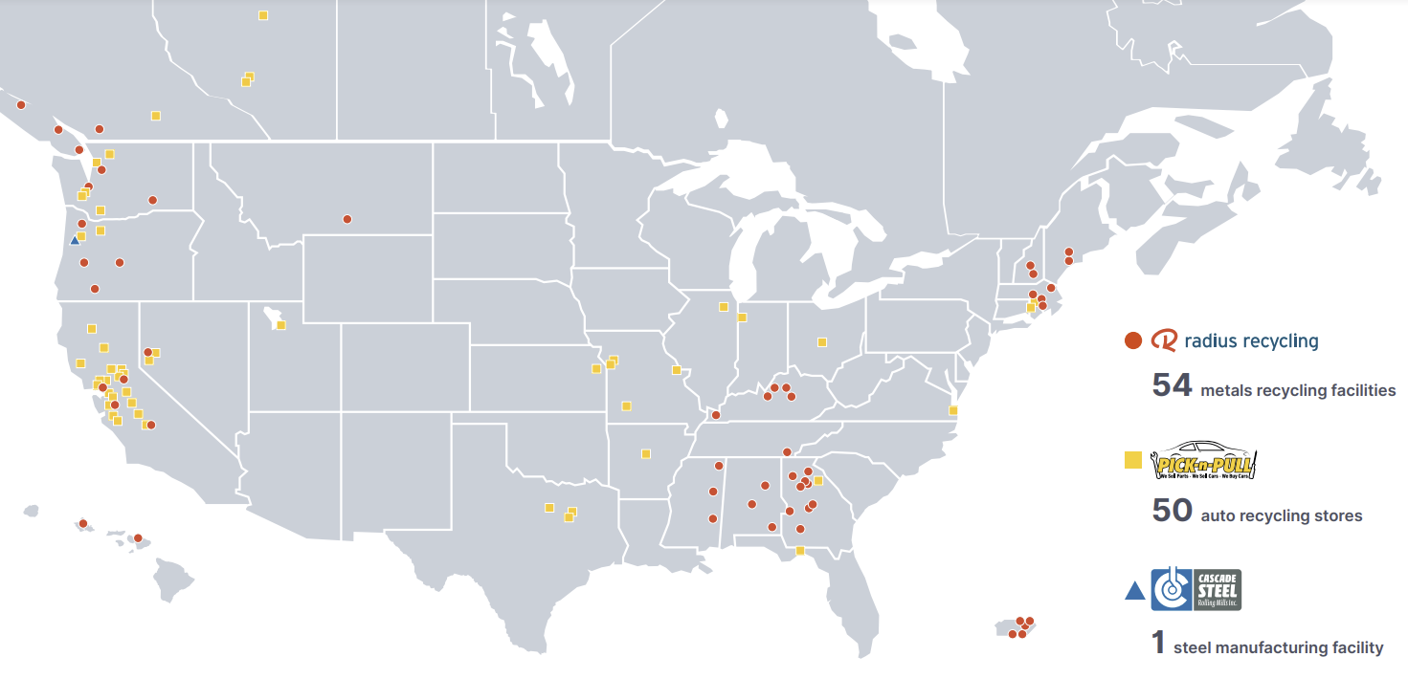The company invests in nonferrous metal extraction and separation technologies to maximize the recoverability of valuable nonferrous metal and to meet the metal purity requirements of customers (Bennett). Recycled ferrous metal is a key component used in finished steel production and is categorized into heavy melting steel (HMS), plate and structural (bonus), and shredded scrap (shred). The company also sells catalytic converters to specialty processors that extract nonferrous precious metals including platinum, palladium, and rhodium. Its nonferrous products include mixed metal joint products recovered from the shredding process, aluminum, copper, stainless steel, nickel, brass, titanium, lead, and elevated temperature alloys (Bennett). In addition to their recycling facilities, Radius operates in seven deep water port locations, six of which have large-scale shredders. Its largest port facilities are in Everett, Massachusetts; Portland, Oregon; Oakland, California; and Tacoma, Washington (Bloomberg).

**Snapshot**

We issue a sell recommendation on Radius Recycling with a target price of $25.00 per share. This would necessitate a -4.76% change in share price in 2024. This valuation was determined by issuing the following weights on 4 different valuation models: Discounted cash flows (11.14%), EBITDA multipliers (21.07%), Book Value (40.43%), and Monte Carlo probability simulations (27.36%). Details on these methods is contained in the financial analysis and valuation sections of the paper. Radius has participated in mergers and acquisitions, which are a leading driver in revenue spikes. With mergers and acquisitions slowing down in 2024, the revenue growth is expected to taper off. Additionally, profit margins have been getting squeezed from supply of scrap metal drying up from key geographic locations. Finally, during high inflation and periods of high interest rates, Radius is vulnerable to price risk being price takers in a spot market for scrap. However, Radius has opportunities to grow through their excellent focus on ESG (Environmental, Social, and Governance) and opportunities to increase their leverage into cutting edge steel recycling technologies.

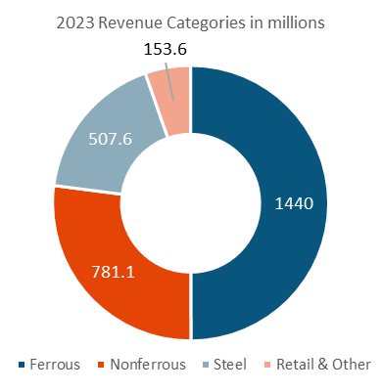

*Source: Bloomberg / Exhibit 1*

**Industry Overview & Competitive Positioning**

1. Threat of New Entrants: Low

* Barriers to Entry: The steel recycling industry has high barriers to entry, including substantial capital requirements for equipment, technology, and facilities. Compliance with environmental regulations and securing necessary permits can also deter new entrants.
* Economies of Scale: Established players likely benefit from economies of scale, making it challenging for new entrants to compete on cost. This scale advantage extends to procurement, processing, and distribution.
* Access to Supply Channels: Established relationships with suppliers of recyclable materials and access to consistent supply streams further protect against new entrants. New competitors might struggle to establish these relationships and secure a reliable supply of recyclable steel.

2. Bargaining Power of Buyers: Low

* Price Takers: In this context, buyers have limited bargaining power as they are price takers. This could be due to the standardized nature of the recycled steel market, where prices might be set based on broader market conditions rather than individual negotiations.
* Limited Alternatives: If there are few alternatives to recycled steel that meet the same cost, sustainability, and performance criteria, buyers are likely to accept prevailing prices, further reducing their bargaining power.

*Source: Bloomberg / Exhibit 2*

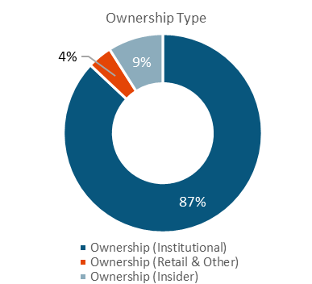

3. Bargaining Power of Suppliers: Moderate to High

* Price Makers: Suppliers of recyclable steel can exhibit significant pricing power, particularly if there are few sources of high-quality recyclable materials. The "stickiness" of prices, even when customers are willing to hold onto their recyclables, suggests a level of power with suppliers.
* Supply Constraints: The willingness of suppliers (e.g., individuals or businesses disposing of steel) to hold onto their recyclables until they get the price, they want can create supply constraints, enhancing their bargaining power.

4. Threat of Substitute Products or Services: Low

* Limited Substitutes: The threat from substitutes for recycled steel is low, particularly if recycled steel is favored for its cost-efficiency and environmental benefits. Alternatives might not offer the same balance of cost and sustainability.
* A diagram of a diagram

  Description automatically generatedMarket Preference: A growing emphasis on sustainability favors recycled materials over virgin materials, reducing the appeal of potential substitutes.

*Source: Bloomberg*

5. Intensity of Competitive Rivalry: Moderate

* Limited Number of Competitors: With only a handful of direct competitors, the competitive environment can be intense but manageable. Competitors focus on efficiency, technology, and service quality to gain an edge.
* Differentiation: Companies might differentiate based on processing technology, customer service, supply chain management, and environmental compliance to stand out.

**Investment Summary**

*Source: CFA Team / Exhibit 3t*

The global steel industry is significantly influenced by China's economic fluctuations, notably its recent GDP growth slowdown and demographic changes, impacting global steel prices and market dynamics. For Radius Recycles, with 72% of its revenue derived from Bangladesh, Turkey, and India, the economic conditions in Turkey are particularly critical (10-K, pg. 6). As Turkey faces unique challenges within its steel sector, understanding its market dynamics is essential for Radius Recycles to navigate the complex global steel industry effectively.

* A screenshot of a table

  Description automatically generated**Operational and Economic Challenges for RDUS:** RDUS is currently navigating a complex landscape marked by operational and geopolitical challenges, directly impacting its financial performance. A notable decline in the growth margin to 10%(10-K, pg 39) and an anticipated operating margin of -0.07%(Bloomberg) next year cast doubts on the company's profitability. Furthermore, despite RDUS's exports to China representing a minor percentage of its total business, the economic conditions in China, including a significant slowdown in GDP growth and demographic challenges, warrant close attention due to their broader impact on global steel prices.
* A table with numbers and a number of numbers

  Description automatically generated with medium confidence**Turkish Steel Industry Under Strain:** The Turkish steel industry, particularly long steel producers, is grappling with a multitude of challenges arising from evolving global trade dynamics. Trade barriers and competitive pressures in key markets such as the US and EU, characterized by tariffs and quotas, are significantly affecting Turkish steel exports. Additionally, Turkish exporters are at a disadvantage due to higher energy costs compared to counterparts in regions rich in oil and gas. The dependency on Russian semi-finished steel adds another layer of complexity, as European markets increasingly demand steel products free from Russian inputs. These challenges are further exacerbated by intense competition from lower-cost producers, impacting the overall export potential of Turkish steel.
* **Stagflation Impacting Turkish Domestic Construction Market:** The domestic construction sector in Turkey is facing headwinds due to an environment of stagflation. With inflation rates projected at 60% in 2023 and 40% in 2024, coupled with anticipated interest rate hikes peaking around 40% by year-end, the economic landscape is poised to suppress construction activities (Kjellberg-Motton). Although reconstruction efforts in earthquake-impacted regions provide some level of support, the overall demand within the construction sector is expected to remain subdued. This muted demand, influenced by monetary constraints, is likely to persist even in light of potential governmental projects and tender opportunities.

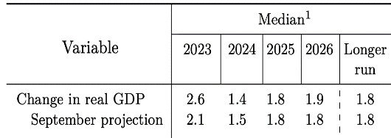

*Source: Federal Reserve / Exhibit 5*

*Source: Bloomberg / Exhibit 4*

* **Concerns Over Increased Debt Ratio:** RDUS’ decision to elevate its debt ratio from 23% to 30% raises significant concerns regarding its liquidity position and ability to meet interest obligations (Bloomberg). This strategic move, while potentially beneficial in certain contexts, necessitates a thorough assessment of the company's current and projected cash flows to ensure financial stability and the maintenance of adequate liquidity levels to meet increased financial commitments.
* **Liquidity Concerns Overview:** The current liquidity metrics of the company, characterized by a Cash Ratio of 0.01, Current Ratio of 1.74, and Quick Ratio of 0.64(Bloomberg), present significant concerns. The exceedingly low Cash Ratio suggests a precarious capacity to meet immediate financial obligations, while the Quick Ratio indicates a limited ability to cover short-term liabilities without relying on inventory sales. Although the Current Ratio appears healthy, its reliability is undermined by high inventory levels, which are not advantageous given the current economic climate and market volatility. This situation could impede the company's ability to quickly mobilize funds, potentially leading to challenges in maintaining liquidity. Strategic financial management is essential to enhance the company’s liquidity position, focusing on improving cash reserves and reducing inventory dependence to ensure stability and responsiveness to market changes.

**Total Revenue FY 2014 – FY 2024**

**Total Revenue FY 2014 – FY 2023**

**Financial Analysis and Valuation**

* The steel industry has seen high volumes of mergers and acquisitions. In December 2023, Japanese steel manufacturing firm Nippon Steel announced the acquisition of United States Steel Corporation (NYSE: X), the second largest steel producer in the United States (Nippon Steel Quarterly Report). The market, like its product, appears to be undergoing intense heat and pressure as firms seek to grow their market share and keep margins afloat during supply shortages and diminishing demand. Radius Recycling is no exception with their acquisition of Scrap Source inc. in 2022, and Columbus Recycling Acquisition Corp. in 2021. The figure to the left (exhibit 6) is a chart of total revenue (in orange) and net income, GAAP (in green). The blue bars represent the revenue generated during the years of the acquisitions. It is worth noting the higher revenue after acquisition, and subsequent tapering off after the conclusion of the deal.

*Source: Bloomberg / Exhibit 6*

*Source: Bloomberg / Exhibit 7*

* 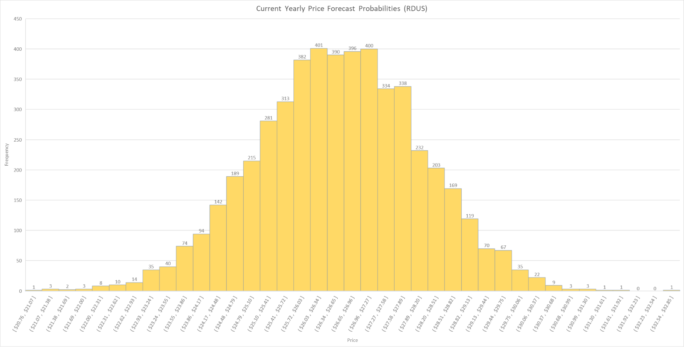Radius has a 12-month trailing price to earnings ratio of 32.45 and earnings per share of 0.85. The steel producing industry has a median price to earnings ratio of 10.41 and median earnings per share of 3.38. This presents a signal to us that shares of Radius Recycling are overvalued at $26.25 per share. Radius has a current capital structure of 64.1% from their market capitalization, 2.3% from short-term debt, and 33.6% A table with numbers and a few lines

  Description automatically generated with medium confidencefrom long-term debt. From a ratio analysis perspective, Radius has a declining trend in Return on Assets (ROA) despite increasing trends in long term debt. While debt has been rising, Radius has been using the debt to finance their recent mergers and acquisitions rather than innovative technology. In our initial meeting with Michael Bennet, Vice President of Investor Relations at Radius, Bennett stated that the firm is looking to raise their net leverage ratio to 30%, an increase of 27.23% from their current leverage of 23.58%. This rise in debt levels relative to asset levels would require the use of more long-term debt and an increase of their already skyrocketing interest expenses to service this debt (see exhibit 11). Taking on this additional debt without showing increased return on assets would lead us to believe this additional debt burden should be avoided with the prospect of an already large debt burden looming over them.

*Source: CFA Team / Exhibit 7*

*Source: Bloomberg / ExhibitSource: BloombergSource: Bloomberg / ExhibitSource: Bloomberg / ExhibitSource: Bloomberg / Exhibit*

*Source: Bloomberg / Exhibit*

* While long term debt burdens are becoming an increased challenge for Radius to service, there are also concerns with regards to short-term coverage and liquidity. As of their latest financial release, Radius had a cash ratio of 0.01, a current ratio of 1.75, and a quick ratio of 0.64. Each of these liquidity measures are significantly lower than steel producing peers with an industry median cash ratio of 0.27, current ratio of 3.25, and quick ratio of 1.24. This tells us that Radius has fewer current assets and liquid cash or cash equivalents to serve their short-term obligations. With profit margins experiencing tight compressions from inflationary pressures, it’ll prove to be challenging for Radius to sustain a profit in 2024. With their lower earnings per share among steel peers and higher price to earnings ratio, we believe the market is seeing too much value in owning shares of Radius Recycling. The market is observing the firm’s quick growth from their rapid mergers and acquisitions, but the intrinsic value of the firm will be lower than this artificially overvalued price.

**Weighted Average Costs of Capital**

*Source: CFA Team / Exhibit 8*

* A screenshot of a computer screen

  Description automatically generatedWe chose to use 4 different models and assign each various weights to calculate our fair value estimate for a share of Radius Recycling stock. The first model is a simple discounted dividend model. With a current dividend yield of 2.82%, the firm pays an annual dividend of $0.75 per share split into $0.1875 per quarter each February, May, August, and November. The firm has not raised the dividend from this amount in the past 10 years and has indicated they do not intend to change it either. With their 6.5% weighted cost of equity, we can calculate a theoretical price for Radius by dividing their annual dividend by their annual cost of equity (6.5%) to get a theoretical price per share of $11.54. This is quite low compared to the current market price of $26.25. This model presents weakness in only considering cashflows, and since Radius hasn’t indicated any increase in their perpetual dividend payments, it is reflected in the theoretical price. The weight we issued for the discounted dividend model is 11.14% of total valuation. If we gave all 4 categories of valuation the same weight, they’d each have 25% each. However, because this model severely undervalues the share price, we assigned the weight of 11.14% to capture the shortcomings of using a dividend discount model alone.
* **A table with numbers and numbers

  Description automatically generated**The second method we used for valuation is EBITDA multipliers. By calculating Radius’s enterprise value to EBITDA, we can get a theoretical value for the firm. From this theoretical firm value, we can decide the price per share. The table in exhibit 7 shows these theoretical prices per share given the enterprise value and EBITDA each year since 2016. The resultant calculations were sometimes remarkably close to the actual price that year. However, to test the accuracy of the model, we employed a Chi-Squared Test of Independence at an αlevel of 0.05 to see if the values had a relationship. Our null hypothesis is that the theoretical price per share and actual price per share are uniform. The alternative hypothesis is that they are not. The test yielded a P-Value of 0.029; in other words, we must reject our null hypothesis and conclude that the model isn’t statistically significant enough to predict the price with accuracy. Although it doesn’t make a perfect prediction, EBITDA multiples are a strong valuation method as it is normalized for differences between companies. Using EBITDA normalizes for capital structure, taxation, and fixed asset accounting. The weight we issued for the EBITDA multiple models is 21.07%. This weight was assigned as a greater share of total valuation because the EBITDA multiples, although not always accurate, represent more earnings-based Radius’s actual operations.

*Source: Bloomberg / Exhibit 10*

*Source: Bloomberg / Exhibit 9*

*Source: Bloomberg / Exhibit 10*

* A graph with orange bars

  Description automatically generatedOur third valuation tool was a simple calculation of the fair value per share based on their book value per share. This calculation involves dividing the total equity of Radius by the number of common shares outstanding. Radius has 27,700,000 shares outstanding and $911,700,000 in total equity. This would dictate a book value per share of $32.91. This is significantly higher than the market price of $26.25 but reflects a more accurate intrinsic value of the share price. As a result, we will give this model the highest weight of 40.43%.

**Interest Expenses FY 2017 – FY 2023**

* The final valuation method we used shifted gears from financial valuation methods toward statistical probabilities. Knowing about cashflows, EBITDA multiples, and book values give us an idea of the intrinsic value of the stock, but not considering price action volatility. We employed a sophisticated Monte Carlo probability simulation to visualize where the share price is likely to go in the next year. Since Radius went public in 1993, the mean share price at year’s end is $26.55. We modeled 71,000 simulations using this mean, and the historic annual price standard deviation of $17.74. This produced the probability density frontier in exhibit 8. With the mean price of $26.55, the standard deviation of the price in 2024 came out to be $1.65. Using Chebyshev’s theorem, we can conclude that from a purely statistical standpoint, the share price has a 66% chance of being within $24.90 and $28.20 (one standard deviation). Additionally, the share price should be found between $23.25 and $29.85 95% of the time (two standard deviations). However, this model has weakness by not accounting for any risk factors nor does it adjust for the financial analysis we’ve discussed above. For these reasons, we will give this a moderate weight of 27.36%.
* In conclusion, our 4 different valuation methods have been given weights that sum to be 100% of the price per share for Radius Recycling. Upon applying each weight to the predicted prices for each model, we arrive at our fair value price of $25.00 per share.

*Source: Bloomberg / Exhibit 11*

*Source: Bloomberg / Exhibit 12*

**Capital Analysis and Valuation**

RDUS has undergone significant changes in its capital structure over the past few years, particularly in 2021 and 2022. During the fiscal year of 2021, RDUS started to replace, upgrade, and add to their existing nonferrous metal recovery technologies (10-K fiscal year ended August 31, 2022 – revenue-generating activities.). RDUS also acquire eight metals recycling facilities on October 1, 2021,and two recycling facilities on April 29, 2022 (Fiscal year 10-K report ending on August 31, 2022 – Business Acquisitions)

These changes have had a substantial negative impact on the company's profitability, as reflected in its Return on Equity and Return on Assets charts (Exhibit 16). Exhibit 13's chart shows the increases in plant, property, and equipment, along with the changes in revenue over the past 12 quarters. These two charts help explain the situation with RDUS. The situation improved during Q3 of 2022, with a notable uptick in assets, revenue, and net income, especially during Q3. However, the company encountered a sharp drop in net income in Q4 2022, followed by negative income in Q1 2023.

*Source: 10-K Report / Exhibit 13*

In the 10-K report for the fiscal year ending August 31, 2022, RDUS reported about productivity improvements and cost-saving initiatives that began during the 2021 fiscal year. These improvements were designed to reduce operating expenses, improve profitability, and enhance integration and synergistic cost efficiencies within their operations. RDUS specifically mentioned actions such as idling underutilized assets, facility closures to align with market conditions, productivity initiatives for increased efficiency, and headcount reductions. For example, in fiscal 2020, RDUS stated that they implemented productivity initiatives targeting $20 million in realized benefits through reductions in annual operating expenses. These reductions primarily involved non-trade procurement spend, lower employee-related expenses, and other non-headcount measures.

The 10-K report (Fiscal year 10-K report ending on August 31, 2022 – pg 23. ) emphasized the uncertainty associated with achieving and sustaining the expected cost reductions and other benefits from these initiatives. RDUS acknowledged that these estimates and assumptions are subject to significant economic, competitive, and other uncertainties, some of which are beyond their control. The 10-K report states, “Failure to achieve or sustain the expected cost reductions and other benefits related to these productivity improvements, cost savings, and restructuring initiatives could have a material adverse effect on our results of operations and cash flows.”.

*Source: 10-K Report / Exhibit 14*

It appears that RDUS has demonstrated a recurring pattern of addressing their debt position during Q4 reporting. This pattern of debt management has persisted over the past decade, with the company typically carrying higher levels of debt from Q1 to Q3. The chart showing RDUS's contractual obligations between Q4 2019 and Q4 2023 reveal a concerning trend. Their investments during this period have significantly escalated their contractual obligations, surging by nearly 40% (Contractual Obligation Schedule chart below). Unfortunately, this substantial increase in obligations has not been matched by corresponding growth in sales. RDUS capital structure changes during the fiscal years of 2021 and 2022(2,3), resulted in significant shifts characterized by increased leases, contractual obligations, credit usage, and long-term debt. These changes are indicative of the company's ongoing struggle to attain its desired level of profitability and productivity. While RDUS possesses sufficient capital and equity to cover its liabilities, it is showing adverse effect on their operational goals.

*Source: 10-K Report / Exhibit 15*

*Source: 10-K Report / Exhibit 15*

RDUS has made several changes to their capital structure in recent quarters, and we can see the significant changes on the increase in leases, contractual obligations, credit usage, and long-term debt. RDUS is not making their desired profit and is having to take on more and more debt. This puts RDUS in a hard place, and although they have the capital and equity to cover their liabilities, they will have a hard time seeing profits. If sales do not increase, and the economy is not expected to grow during 2024, we can potentially see RDUS selling some of their properties which will affect their stock price, and shareholders. This supports our sell option for RDUS.

*Source: 10-K Report/CFA team / Exhibit 16*

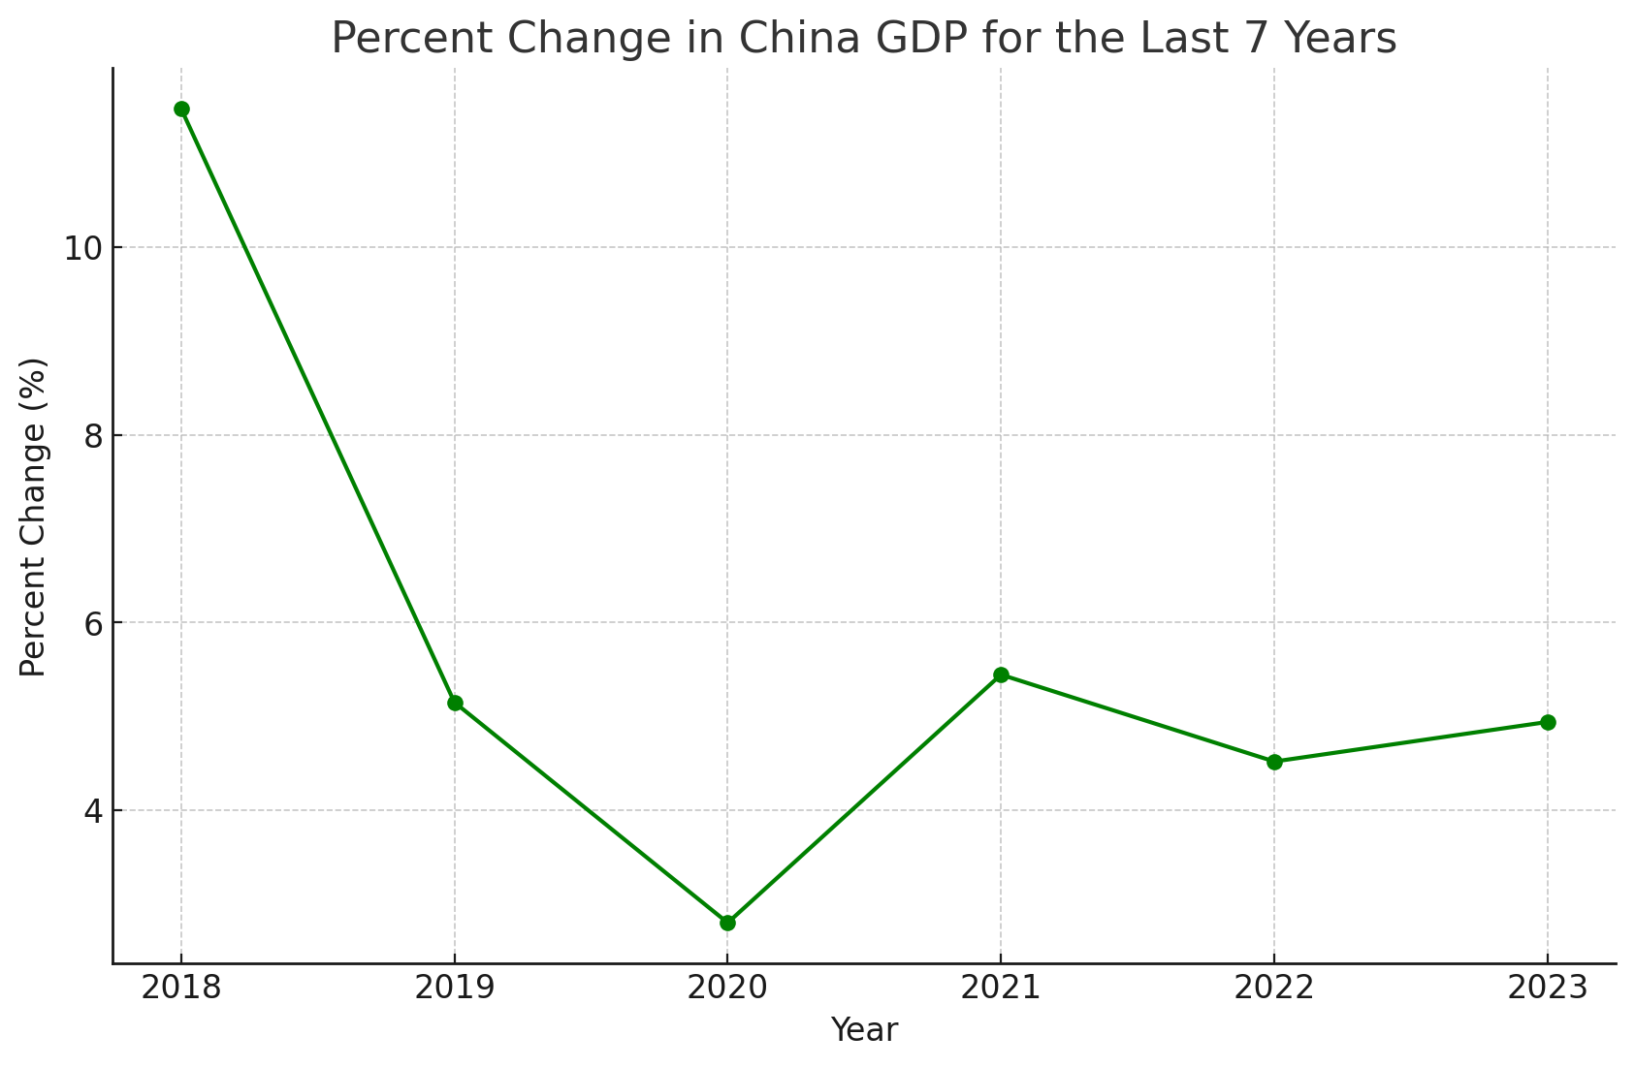

**Investment Risk**

In navigating the challenging landscape of 2024, Radius confronts a multitude of investment risks across operational, market, and political spheres. These risks, ranging from deferred tax asset concerns to the volatility of commodity prices and the intricacies of international trade policies, collectively shape the company's strategic decision-making and financial resilience.

*Source: FRED / Exhibit 17*

Operational Risk

* [IR1] Deferred Tax Assets (DTA) Concerns: As of 2023, the company holds $22.7 million in DTAs (10-K, pg. 22). If these DTAs are not realized, it could result in additional losses, especially since the company is currently experiencing net losses.
* [IR2] Supply Chain Challenges: One of the most significant factors affecting the firm’s operating margins in fiscal 2023, including the fourth quarter, has been the decreased supply of recycled scrap metal. With the U.S. economy slowing, there's a tightening in the availability of end-of-life automobiles, obsolete white goods, and scrap from reduced manufacturing and construction activities. These constrained supply conditions have led to increased purchase costs for raw materials, resulting in margin compression, as noted in the company’s Q3 2023 earnings call.

Market Risk

* A graph showing the price of a stock market

  Description automatically generated[IR3] Economic Projections and Scrap Supply: The Federal Open Market Committee's (FOMC) GDP projections for 2024 and 2025 suggest a slowdown compared to 2023. Radius has reported a deceleration in the supply of scrap materials, attributed to recessionary pressures within the U.S. economy. Additionally, the long-term potential growth rate stands at 1.8%, which is below the historical average of over 2%(FED, pg.2).

*Source: Bloomberg / Exhibit 18*

* [IR4] Expansion into EV Recycling: The company is expanding into recycling electric vehicle components, such as batteries. However, the nascent state of the electric vehicle industry poses challenges in acquiring end-of-life electric vehicles and batteries.

**Industry Cash, Current and Quick Ratios**

* [IR5] Commodity Price Volatility: Radius does not engage in hedging against steel price fluctuations, making it vulnerable to commodity price volatility. With a potential recession in 2024, there could be a substantial drop in steel demand.

Political Risk

* [IR6] Trade Policies Impact: A considerable portion of the company’s revenue comes from sales to customers outside the U.S. Tariffs, quotas, and other trade actions, as well as import restrictions, may adversely affect revenue.A screenshot of a computer screen

  Description automatically generated

*Source: Bloomberg / Exhibit 19*

**Environmental, Social, Governance**

**Key Topics and Earnings Call Trends**

For FY 2022, RDUS held a 3.52 ESG score on Bloomberg (Bloomberg). This was a weighted average of their 1.69 environmental, 2.76 social, and 7.04 governance scores. All scores were above median compared to waste management industry, and RDUS is leading the industry in governance. We expect their score to improve for FY 2023. The firm’s SSI emphasis – safety, sustainability, and integrity, based on the company’s previous initials as Schnitzer Steel Industries – continues to drive ESG improvement (Bennett). The company’s recent name change was intended to support this effort.

Environmental:

RDUS has made it their goal to increase sustainability and environmental performance in recent years. This can be difficult in an industry that deals with waste management and metals production. Notably, RDUS has reduced emissions by 27% since 2019, surpassing a 25% target. The firm now plans to bring that number to 35% by 2028 (RDUS 2023 Sustainability Report [2023 Sus Rep]). The company is well on track to comply with the IEA’s target of 50% emissions reductions in the steel industry by 2050 (International Energy Agency [IEA]). Additionally, the firm’s facilities have been run on net zero carbon emissions electricity since 2021, with 92% of energy usage coming from green power sources (74% hydro, 10% nuclear, 8% other) and the remaining 8% offset by the purchase of renewable energy credits (2023 Sus Rep). In 2022 the company launched GRN Steel™, a line of net zero carbon emissions steel products (RDUS 2022 Sustainability Report [2022 Sus Rep]); this line reduces energy use by 74% and water use by 40% against virgin steel products (2023 Sus Rep).

*Source: Bloomberg / Exhibit 20*

RDUS’ environmental score is being negatively impacted by the lack of emissions controls on three of its five metal shredders. Creation of such emissions control systems hit no significant milestones in 2023 (2023 Sus Rep). A legal agreement resolved this year required RDUS to pay fines of $500,000 for lack of emissions controls on its Portland shredder (OPB). Additionally, RDUS does not report some information about its waste management practices and ecological impact, including environmental fines and incidents (2023 Sus Rep; Bloomberg).

Statistics for 2023 also include nearly 5 million tons of ferrous metals recycled, producing and selling over 521 thousand tons of finished steel; 370 thousand tons of nonferrous metals recycled; and 660 thousand vehicles salvaged and recycled (2023 Sus Rep).

*Source: CFA Team / Exhibit 21*

Social:

RDUS is committed to maintaining a safe work environment. They do this through “policies, standards, and training programs that ensure standardized procedures” to reduce risk of injury (2023 Sus Rep). In 2023, 63% of facilities had no recordable injuries, and 90% reported no lost time injuries (LTI), although the LTI rate was greater than the previous two years combined, and the total case incident rate (TCIR) was greater than each of the previous three years (2023 Sus Rep). Mental and physical wellness programs are in place; however, only 15% of employees participate (2023 Sus Rep). The company also values volunteerism, and employees logged 1600 total hours of volunteer time off, down 27% from 2022 (2023 Sus Rep)

*Source: Bloomberg / Exhibit 22*

Employees may join unions, but employee reviews (Indeed.com) report dissatisfaction with unions’ ability to promote worker interests. While no incidents for RDUS have occurred, workers at competitor Republic Services threatened to strike in nearby Seattle in 2021 (KIRO7).

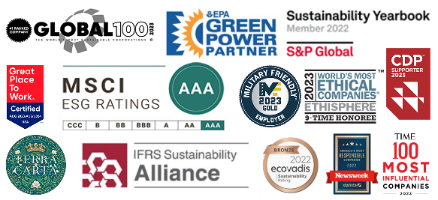

In 2023, 47% of the company’s US workforce was nonwhite, and 21% of all employees were female (2023 Sus Rep). The company has seven Employee Resource Groups (ERGs), representing its ethnically diverse, female, veteran, and LGBTQ workers; ERG participation is at 15% (2023 Sus Rep). These ERGs help employees to network and build up each other and their communities (Recycling Today).

Governance:

RDUS boasts a diverse board of directors, with four of seven members being women. Only two directors have served for more than 10 years; two others were added in the past two years (RDUS website). The board does not delegate sustainability to a committee but assumes the responsibility itself (2023 Sus Rep). Other factors positively affecting governance include executive compensation linked to ESG and company performance, high board independence (six of seven directors are independent), and a strong auditing structure (Bloomberg).

*Source: Bloomberg / Exhibit 23*

*Source: RDUS 2023 Sustainability Report / Exhibit 23*

Concerns regarding RDUS’ governance include lack of separation between board and chair, with President Lundgren exercising both roles, and certain shareholder policies that limit shareholders’ say in the election of company directors (Bloomberg).

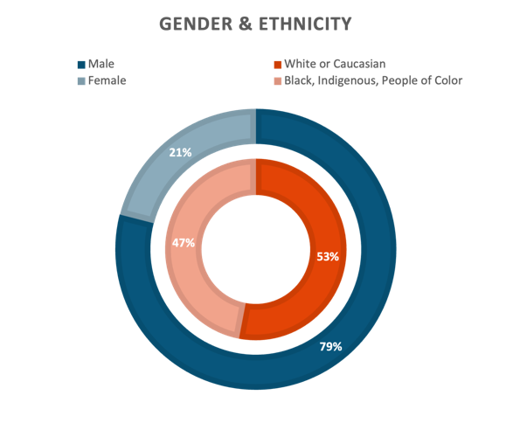

**Conclusion**

The sell recommendation for Radius Recycling (RDUS US) stems from a combination of anticipated revenue growth decline due to a slowdown in mergers and acquisitions, increasing pressure on profit margins from a diminishing scrap metal supply, and vulnerability to adverse market conditions in periods of high inflation and interest rates. Financial analyses, including EBITDA multipliers and price-to-earnings ratios, suggest an overvaluation of Radius's shares. Additionally, concerns about the company's increasing debt ratio and low liquidity metrics pose risks to its financial stability. Challenges in key markets like Turkey, coupled with competitive and industry risks in the steel recycling sector, further justify the recommendation. Consequently, a target price of $25.00 per share is estimated, representing a -4.76% change from its current price, reflecting these assorted challenges and risks.

*Source: Bloomberg / Exhibit 24*

*Source: RDUS 2023 Sustainability Report / Exhibit 24*

APPENDIX

REFERENCES

Business Wire. "Schnitzer Steel Named Most Sustainable Company in the World by Corporate Knights." 18 Jan. 2023, [www.businesswire.com/news/home/20230118005044/en/Schnitzer-Steel-Named-Most-Sustainable-Company-in-the-World-by-Corporate-Knights](http://www.businesswire.com/news/home/20230118005044/en/Schnitzer-Steel-Named-Most-Sustainable-Company-in-the-World-by-Corporate-Knights).

Ehrlich, April. "Portland Steel Company Settles with Oregon DEQ over Air Quality Violations." *OPB*, 8 Nov. 2023, [www.opb.org/article/2023/11/08/portland-steel-company-settles-oregon-deq-over-air-quality-violations/](http://www.opb.org/article/2023/11/08/portland-steel-company-settles-oregon-deq-over-air-quality-violations/).

Federal Reserve. "U.S. Federal Reserve's Economic Projections." Dec. 2023, [www.federalreserve.gov/monetarypolicy/files/fomcprojtabl20231213.pdf](http://www.federalreserve.gov/monetarypolicy/files/fomcprojtabl20231213.pdf).

Horne, Deborah. "Yard Waste Recycle Drivers at Republic Services Vote to Authorize Strike." *KIRO 7*, [www.kiro7.com/news/local/yard-waste-recycle-drivers-republic-services-vote-authorize-strike/FCKIUK4LRRFLNOJAQUEFI75FM4/](http://www.kiro7.com/news/local/yard-waste-recycle-drivers-republic-services-vote-authorize-strike/FCKIUK4LRRFLNOJAQUEFI75FM4/).

IEA. "Iron and Steel Technology Roadmap." IEA, Paris, 2020, [www.iea.org/reports/iron-and-steel-technology-roadmap](http://www.iea.org/reports/iron-and-steel-technology-roadmap). License: CC BY 4.0.

Kjellberg-Motton, Brendan. "Turkish Steel Mills Face Gloomy 2024." *Argus Media*, [www.argusmedia.com/en/news/2491502-turkish-steel-mills-face-gloomy-2024](http://www.argusmedia.com/en/news/2491502-turkish-steel-mills-face-gloomy-2024).

Mcnees, Marissa. "Opening the Career Door for Underrepresented Groups." *Recycling Today*, [www.recyclingtoday.com/article/opening-the-career-door-for-underrepresented-groups-radius-recycling/](http://www.recyclingtoday.com/article/opening-the-career-door-for-underrepresented-groups-radius-recycling/).

Nippon Steel Corporation. "Nippon Steel Quarterly Report." [www.nipponsteel.com/common/secure/en/ir/library/pdf/20231218_200.pdf](http://www.nipponsteel.com/common/secure/en/ir/library/pdf/20231218_200.pdf).

Radius Recycling. "Sustainability Report Schnitzer 2022." [www.radiusrecycling.com/documents/sustainability-report-schnitzer-2022.pdf](http://www.radiusrecycling.com/documents/sustainability-report-schnitzer-2022.pdf).

Radius Recycling. "Sustainability Report Schnitzer 2023." [www.radiusrecycling.com/assets/documents/radius-recycling-2023-sustainability-report.pdf](http://www.radiusrecycling.com/assets/documents/radius-recycling-2023-sustainability-report.pdf).

Scott, Mike. "Top Company Profile: Schnitzer Steel." *Corporate Knights*, [www.corporateknights.com/rankings/global-100-rankings/2023-global-100-rankings/top-company-profile-schnitzer-steel/](http://www.corporateknights.com/rankings/global-100-rankings/2023-global-100-rankings/top-company-profile-schnitzer-steel/).

U.S. Securities and Exchange Commission. "10-K." [www.sec.gov/ixviewer/ix.html?doc=/Archives/edgar/data/912603/000095017023055162/rdus-20230831.htm#item_1a_risk_factors](http://www.sec.gov/ixviewer/ix.html?doc=/Archives/edgar/data/912603/000095017023055162/rdus-20230831.htm#item_1a_risk_factors).

Walker, Karen. "How Radius Recycling Became the World’s Most Sustainable Company." *Forbes*, 16 Aug. 2023, [www.forbes.com/sites/karenwalker/2023/08/16/how-radius-recycling-became-the-worlds-most-sustainable-company/?sh=39a3884c575f](http://www.forbes.com/sites/karenwalker/2023/08/16/how-radius-recycling-became-the-worlds-most-sustainable-company/?sh=39a3884c575f).

Yahoo Finance. "Top 20 Steel Companies in the World." finance.yahoo.com/news/top-20-steel-companies-world-010855540.html.

Michael Bennett, VP Investor Relations, CFA company presentation - Radius Recycling – 11/08/2023

Data from Bloomberg’s ESG screen – 11/2023