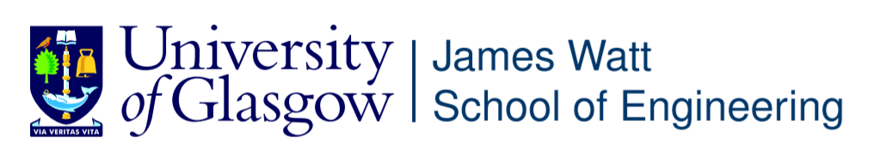

ENG4052: Digital Communication 4 (2022-23)

Lab2: Carrier Recovery using Costas Loop

**Ran Shuai (2633609R)**