# Carbon Accounting

There is a simple definition for carbon accounting: carbon accounting is a method of calculating how much greenhouse gases an organization emits (Farbstein et al., 2023). Although carbon accounting is a relatively new field, it plays a significant role in our efforts to combat global warming.

## How to do it

Figure 1

The steps of Carbon Accounting

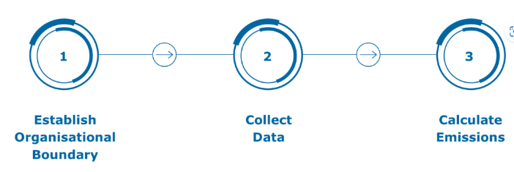

Note. Adapted from How to calculate a barbon footprint for your business, by Tarleton, 2023.

Establishing Organisational Boundary is the easiest part of these three parts. It is generally recommended to have professionals handle all steps of carbon emissions, which raises the question of whether we need to pay high commissions to these professionals.

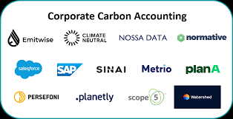

Figure 2: Carbon Accounting Corporate

These are some authoritative institutions that can help us carry out carbon emissions

## Advantages

Calculating carbon emissions can urge us to accelerate our pace towards carbon neutrality and thus improve the greenhouse effect (Mills, 2023). Now the whole world is demanding energy conservation and emission reduction. So what can we use to measure our achievements in energy conservation and emission reduction? I think a carbon emissions report is the best measure.

More and more countries are moving towards carbon neutrality in their regulations. Enterprises should be prepared for carbon accounting to avoid violating the laws of these countries, thereby avoiding unnecessary trouble. Due to the intensification of the global greenhouse effect, the European Union has formulated relevant regulations on carbon emissions and plans to achieve carbon neutrality by 2050 (Council of the European Union, 2023).

Carbon accounting has made it clear to us which energy sources emit the most greenhouse gases and urged people to vigorously develop new and sustainable clean energy sources

## Challenges

In most parts of the world, disclosing carbon emissions data is still a voluntary action (He et al., 2021). If the disclosed carbon emissions data is too high, it will bring social pressure on companies and harm their interests. Moreover, the process of measuring carbon emissions itself requires a significant amount of funds and manpower. Researchers are now very concerned about the accuracy of the carbon emissions data that is disclosed in society.

The calculation of carbon emissions is related to the proportion of operational rights (Benn & Milliband, 2009), which is a quite tedious statistical model. Therefore, many companies have difficulty implementing carbon emission calculations and choose not to perform carbon emission calculations.

Carbon accounting requires a large amount of capital and human resources to be invested. For some small or medium-sized enterprises, it may be difficult to bear these costs.

# References

Benn, H., & Milliband, E. (2009). Do I report on all parts of my organisation? In Guidance on how to measure and report your greenhouse gas emissions (pp. 8–9). essay, DEFRA.

Council of the European Union, E. C. (2023, February 7). Climate change: What the EU is doing - consilium - europa. Climate change: what the EU is doing. Retrieved March 20, 2023, from <https://www.consilium.europa.eu/en/policies/climate-change/>

Farbstein, E., Vallinder, D. A., & Buchmann, L. (2023, March 16). *Carbon Accounting, explained*. Normative. Retrieved March 20, 2023, from <https://normative.io/insight/carbon-accounting-explained/>

He, R., Luo, L., Shamsuddin, A., & Tang, Q. (2021). Corporate Carbon Accounting: A Literature Review of Carbon Accounting Research from the Kyoto Protocol to the Paris Agreement. *Accounting & Finance*, *62*(1), 261–298. <https://doi.org/10.1111/acfi.12789>

Mills, R. (2023, March 8). Clean energy 101: Carbon accounting. RMI. Retrieved March 20, 2023, from <https://rmi.org/clean-energy-101-carbon-accounting/>

Tarleton, A. (2023, March 13). How to calculate a carbon footprint for your business. EcoAct. Retrieved March 20, 2023, from <https://eco-act.com/carbon-reporting/how-to-calculate-a-carbon-footprint-for-your-business/>