

SELECT bookname,price,catid

FROM book

WHERE (catid='c2' OR catid='c3') AND price >=30 AND price <=60

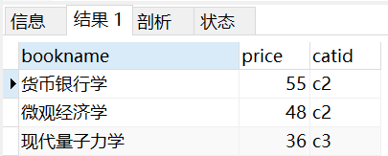



SELECT stuid,count(bookid) as num

FROM borrow

WHERE borrowdate>='2010-10-09 00:00:00'

GROUP BY stuid

HAVING count(\*)>=ALL(

SELECT count(bookid)

FROM borrow

WHERE borrowdate>='2010-10-09 00:00:00'

GROUP BY stuid

)

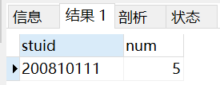



SELECT bookid,bookname,author,price,catid

FROM book

WHERE bookname like '%学'

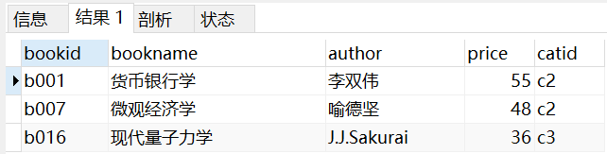



SELECT bookid,bookname,author,price,catid

FROM book NATURAL JOIN borrow

WHERE borrowdate>= ALL(

SELECT borrowdate

FROM borrow

)

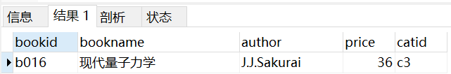



SELECT stuname,MAX(price) as highestprice,MIN(price) as lowestprice

FROM borrow NATURAL JOIN book NATURAL JOIN student

WHERE stuname like '王%'

GROUP BY stuname

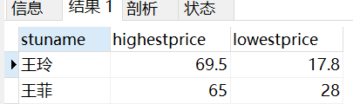

Select student.stuname,max(price) as highestprice,min(price) as lowestprice

From student,borrow,book

Where student.stuid=borrow.stuid and borrow.bookid=book.bookid and stuname like ’王%’

Group by stuname



SELECT stuid,stuname

FROM student

WHERE not exists(

SELECT stuid FROM category where catid not in(

SELECT catid

FROM book NATURAL JOIN borrow

WHERE borrow.stuid=student.stuid

)

)

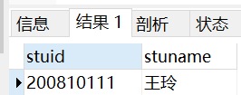

Select stuid,stuname

From student

Where

Book natural join category