**Name:** Satyam Jaiswal **UID:** 2021600028 **Batch**: B **Date:** 08/11/2023

## EXP 9: Naive Bayes Classifier

**Program:**

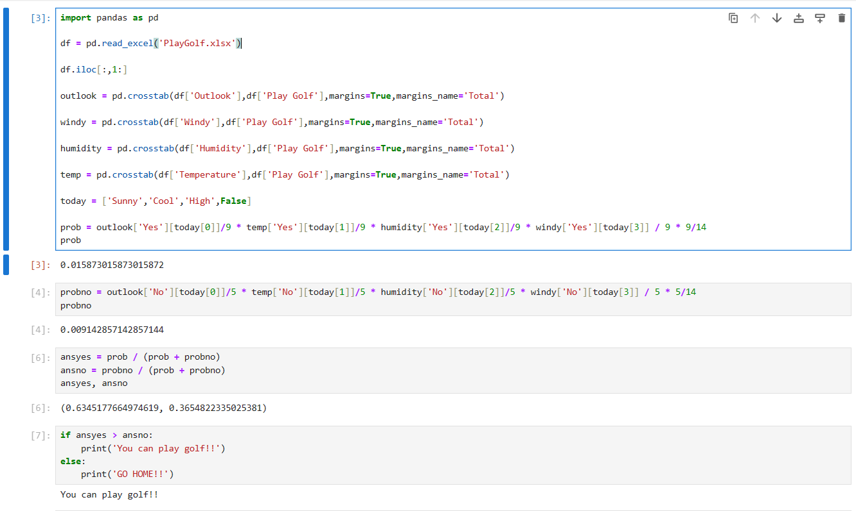

**Dataset**:

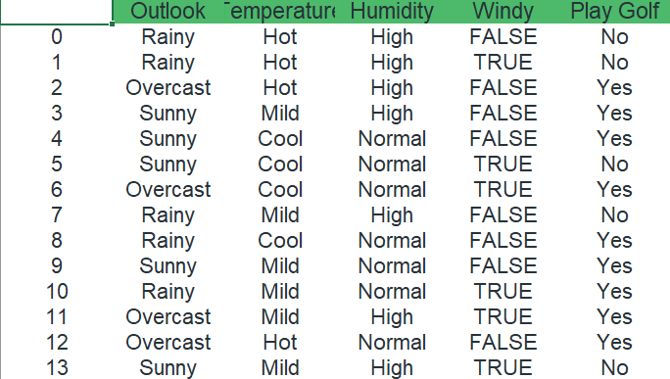

**Solved:**

