Quick Start Guide

This repository contains files for HPMS to be used in 1Integrate, it is broken up into three folders: Data, Docs, and Rules.

* Data contains “HPMSSchemaGITpopulatedgdb.zip” and “MarkupReportSchemagdb.zip”
* Docs contains this QuickStartGuide to help you get started
* Rules contains the Session-HPMS.xml file to be uploaded into 1Integrate

The xml file, which is to be uploaded into 1Integrate will produce two sessions. One session, the Rules, will perform HPMS checks on Domain, Coverage, and Cross. The other will perform HPMS checks and actions (via Action Maps) to create a spatial report layer of nonconformances.

# Retrieving the HPMS package off GitHUB:

• Clone or download the 1Integrate package from the 1Integrate-Rules-Actions-in-Transportation repository -or-

• Use GitHUB Desktop to clone repository

# Restoring rules into 1Integrate

1. Upload the xml file by clicking Tools > Upload on the top left:

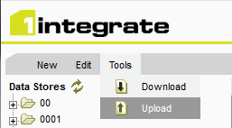

1. Drag the xml into the Upload backup file window, or browse to its location:

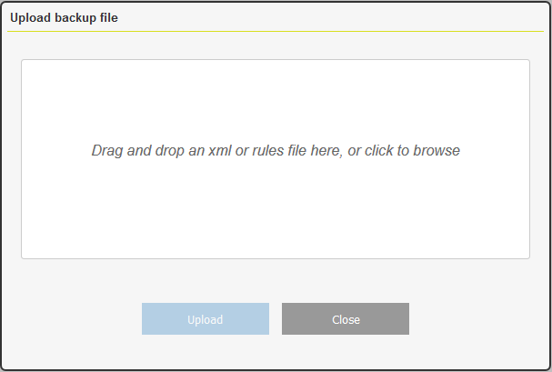

1. Click Upload
2. Click Done when upload is complete

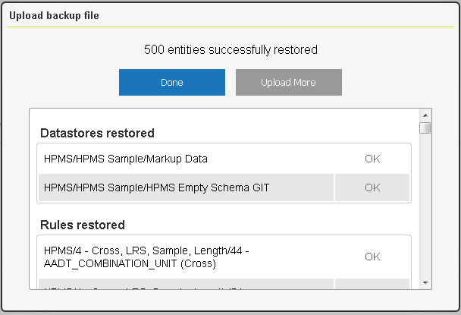

1. There are now HMPS folders with Data Sores, Rules, Actions, Action Maps, and Sessions

# Updating the Data Stores with Data

The Data Stores need to be updated by uploading the data from the Data folder. These Data Stores use FME Desktop 2018

1. Click on the Data Stores Tab and navigate to the HPMS Data Store and HPMS Empty Schema

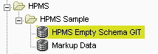

1. On the Input Details of the HPMS Empty Schema Data Store Click Upload and then navigate to the downloaded zip file.

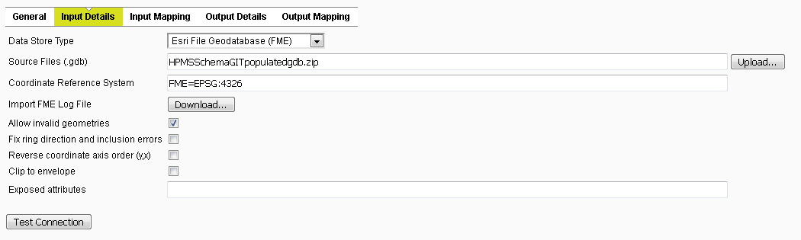

1. Click Upload

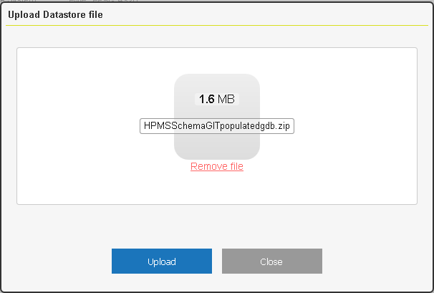

1. Click OK when data uploaded successfully
2. Click Test Connection to make sure it loaded properly
3. The Schema will need to be loaded. Click on Input Mapping > Load/refresh schema

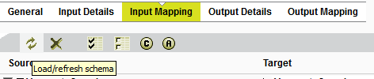

**Repeat the steps for MarkupReportSchemagdb.zip**

1. Click on the Data Stores Tab and navigate to Markup Data

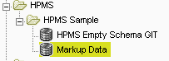

1. On the Input Details of the HPMS Empty Schema Data Store Click Upload and then navigate to the downloaded zip file.

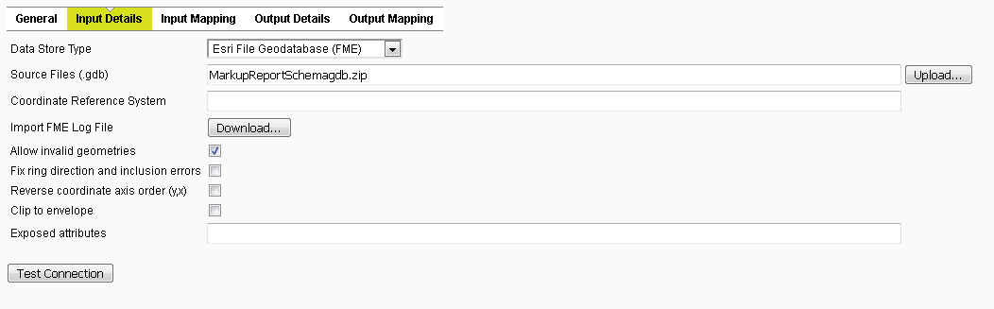

1. Click Upload

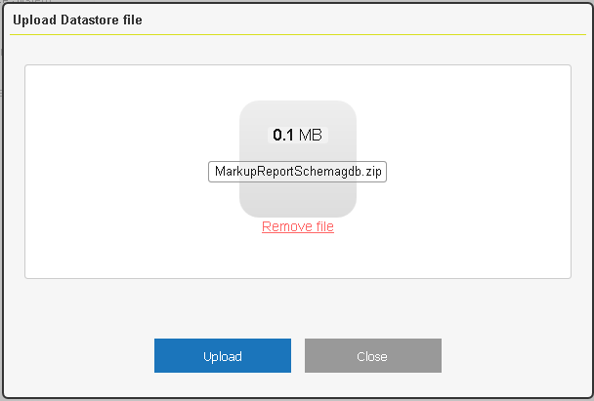

1. Click OK when data uploaded successfully
2. Click Test Connection to make sure it loaded properly
3. The Schema will need to be loaded. Click on Input Mapping > Load/refresh schema



* This is a sample process, it can be updated to include your data.

# Running the Rules

1. Click on the Sessions Tab and navigate to sessions in the HPMS folder

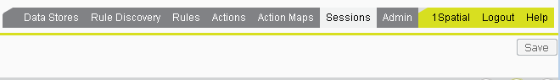

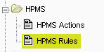

1. Click Tasks for this Session, and hit play



For additional Help please refer to <https://1spatial.com/documentation/1integrate/v2_6/Home.htm>

You may provide feedback, ask questions, and engage on the 1Spatial Highway Performance Monitoring System Forum located at: [1Spatial Customer Community](https://1spatial.force.com/success/)