How to download OpenSesame and MouseTrap

# What is OpenSesame?

OpenSesame is a program to create experiments for psychology, neuroscience, and experimental economics.

# What will we be using OpenSesame for?

Running and modifying mouse-tracking experiments in a way that does not require much coding.

To use OpenSesame for mouse-tracking you need to download BOTH OpenSesame and a plugin called MouseTrap!

# How do I download OpenSesame?

To download OpenSesame use this [link](https://osdoc.cogsci.nl/3.3/download/). Find the guide for your operating system.

## For Mac people:

When you’ve installed OpenSesame, your computer might refuse to open it. You can force the program to open by right clicking and then choose ‘open’ instead of double-clicking as you normally would. If this doesn’t cut it, you’ll have to go into the system settings and allow the program to open.

# How do I get the mouse-tracking plugin?

Open OpenSesame and copy-paste the command in the green box into the console.

*Note #1: almost never works with Mac, but don’t get discouraged there is a troubleshooting section below.*

*Note #2: You can find the console by going to “view” and then show console (or press command + D on Mac)*

!pip install [https://github.com/PascalKieslich/mousetrap-os/archive/master.zip](https://github.com/PascalKieslich/mousetrap-os/archive/master.zip" \t "_blank)

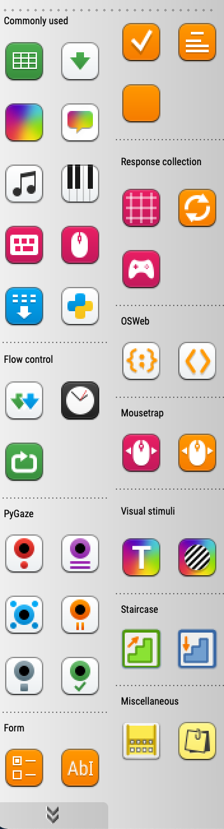If the output of the console doesn’t say anything troubling, close and reopen OpenSesame. When expanding the tools list (two arrows in the bottom left corner) you should see two MouseTrap icons in pink and orange. If they are there, you’re good to go. If not, see the trouble shooting section below.

## Quick troubleshooting for the Mac people

 If the above command didn’t work, copy-paste the following into the console in OpenSesame:

import pip.\_internal

\*And then\*

pip.\_internal.main(['install','[https://github.com/PascalKieslich/mousetrap-os/archive/master.zip']](https://github.com/PascalKieslich/mousetrap-os/archive/master.zip'%5D))

## Quick troubleshooting for Windows people

If the output of the console says something about ‘access denied’, try to close OpenSesame and then reopen it by right clicking the program and then choose ‘run as administrator’. Then type the same command in the console as before.