# 第一单元

Multiple linear regression

多变量线性回归

1. In the training set below, what is $x_{4}^{(3)}$？Please type in the number below (this is an integer such as 123, no decimal points).

$x_{4}^{(3)}$**is the 4th feather of the 3rd training example.**

这是第三个训练实例的第四个特征

1. Which of the following are potential benefits of vectorization? Please choose the best option.
2. It makes your code run faster
3. It can make your code shorter
4. It allows your code to run more easily on parallel compute hardware
5. All of the above

**D**

上述都是矢量化的好处

1. True/False? To make gradient descent converge about twice as fast, a technique that almost always works is to double the learning rate *alpha*.
2. False
3. True

**B**

将学习率加倍可能会导致学习率过大，并导致梯度下降无法找到参数 ww 和 bb 的最佳值。

# 第二单元

Gradient descent in practice

梯度下降的实践

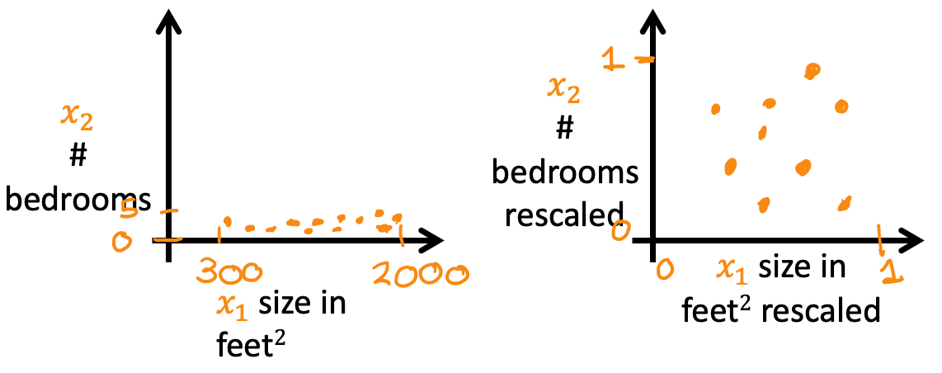

Which of the following is a valid step used during feature scaling?

1. Subtract the mean (average) from each value and then divide by the (max - min).
2. Add the mean (average) from each value and and then divide by the (max - min).

**A**

这称为均值归一化

1. Suppose a friend ran gradient descent three separate times with three choices of the learning rate $α$ and plotted the learning curves for each (cost J for each iteration).

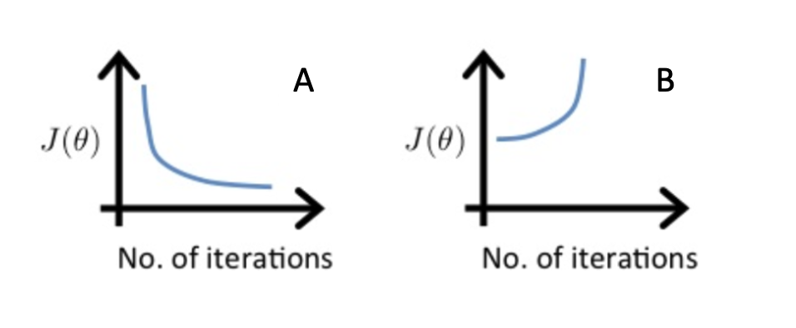

For which case, A or B, was the learning rate $α$ likely too large?

1. case B only
2. Neither Case A nor B
3. case A only
4. Both Cases A and B

**B** 随着培训的继续，成本也在增加，这可能表明学习率α太大了**。**

1. Of the circumstances below, for which one is feature scaling particularly helpful?
2. Feature scaling is helpful when all the features in the original data (before scaling is applied) range from 0 to 1.
3. Feature scaling is helpful when one feature is much larger (or smaller) than another feature.

**B**

例如，以平方英尺为单位的“房屋面积”可能高达 2,000 平方英尺，这比现代大多数房屋的“卧室数量”值在 1 到 5 之间要大得多。

1. You are helping a grocery store predict its revenue, and have data on its items sold per week, and price per item. What could be a useful engineered feature?
2. For each product, calculate the number of items sold times price per item.
3. For each product, calculate the number of items sold divided by the price per item.

**A**

此功能可以解释为每种产品产生的收入

1. True/False? With polynomial regression, the predicted values $f_{−}w,b(x)$ does not necessarily have to be a straight line (or linear) function of the input feature x.
2. True
3. False

**A**

多项式函数可以是非线性的。这可能有助于模型更好地拟合训练数据。