# 第一单元

Classification with logistic regression

利用逻辑回归进行分类

1. Which is an example of a classification task?
2. Based on a patient's blood pressure, determine how much blood pressure medication (a dosage measured in milligrams) the patient should be prescribed.
3. Based on a patient's age and blood pressure, determine how much blood pressure medication (measured in milligrams) the patient should be prescribed.
4. Based on the size of each tumor, determine if each tumor is malignant (cancerous) or not.

【答案】C

【解析】这项任务是预测两个类别中的一个，恶性的或非恶性的。

1. Recall the sigmoid function is $g(z)=\frac{1}{1+e^{-z}}$

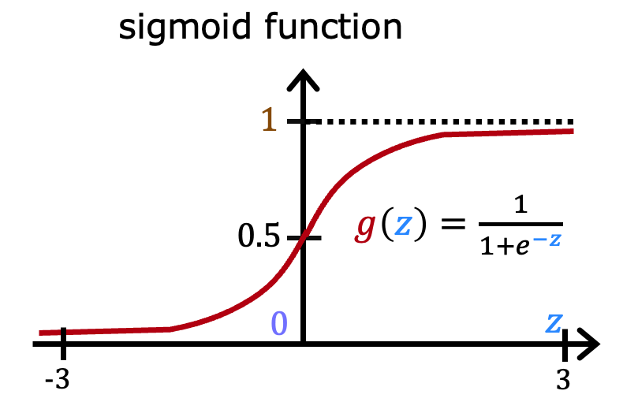

If z is a large positive number, then:

1. $g(z)$ will be near 0.5
2. $g(z)$ is near one (1)
3. $g(z)$ will be near zero (0)
4. $g(z)$ is near negative one (-1)

【答案】B

【解析】由函数特点可知g(z)接近一

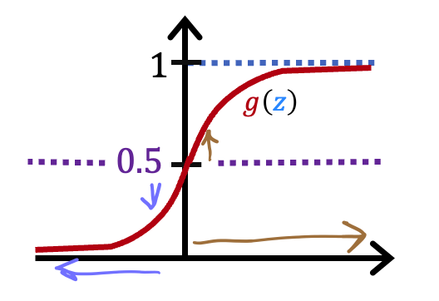

A cat photo classification model predicts 1 if it's a cat, and 0 if it's not a cat. For a particular photograph, the logistic regression model outputs $g(z)$ (a number between 0 and 1). Which of these would be a reasonable criteria to decide whether to predict if it’s a cat?

1. Predict it is a cat if $g(z)$ < 0.7
2. Predict it is a cat if $g(z)$ < 0.5
3. Predict it is a cat if $g(z)$ = 0.5
4. Predict it is a cat if $g(z)$ >= 0.5

【答案】D

【解析】g(z) 视为照片是猫的概率。当这个数字达到或超过阈值0.5时，就预测它是一只猫。

1. True/False? No matter what features you use (including if you use polynomial features), the decision boundary learned by logistic regression will be a linear decision boundary.
2. True
3. False

【答案】B

【解析】决策边界也可以是非线性的。

# 第二单元

Cost function for logistic regression

逻辑回归的代价函数

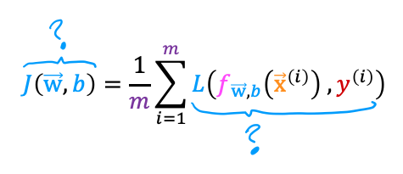

In this lecture series, "cost" and "loss" have distinct meanings. Which one applies to a single training example?

1. Loss
2. Cost
3. Both Loss and Cost
4. Neither Loss nor Cost

【答案】A

【解析】损失（Loss）是针对单个训练样本计算的。值得注意的是，这个定义并不是普遍通用的。其他地方可能会有不同的定义。

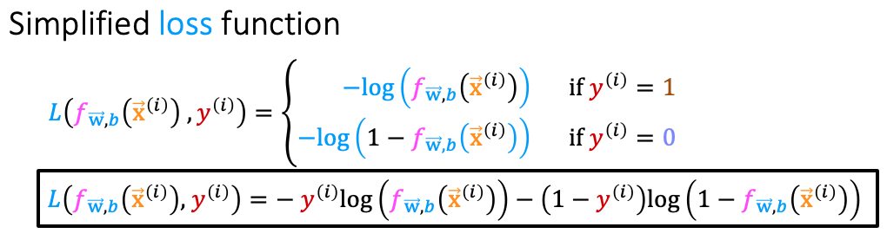

For the simplified loss function, if the label $y^{(i)}=0$，then what does this expression simplify to?

$log⁡(1-f_{\vec{w},b}(x^{(i)}))+log(1-f_{\vec{w},b}(x^{(i)}))$

$log⁡(f_{\vec{w},b}(x^{(i)})$

$-log⁡(1-f_{\vec{w},b}(x^{(i)}))$

$-\log\left(1-f_{\vec{w},b}\left(x^{\left(i\right)}\right)\right)-\log\left(1-f_{\vec{w},b}\left(x^{\left(i\right)}\right)\right)$

【答案】C

【解析】如果标签*y*(*i*)=0，那么简化的损失函数中的第一项会减少到零。

# 第三单元

Gradient descent for logistic regression

逻辑回归的梯度下降

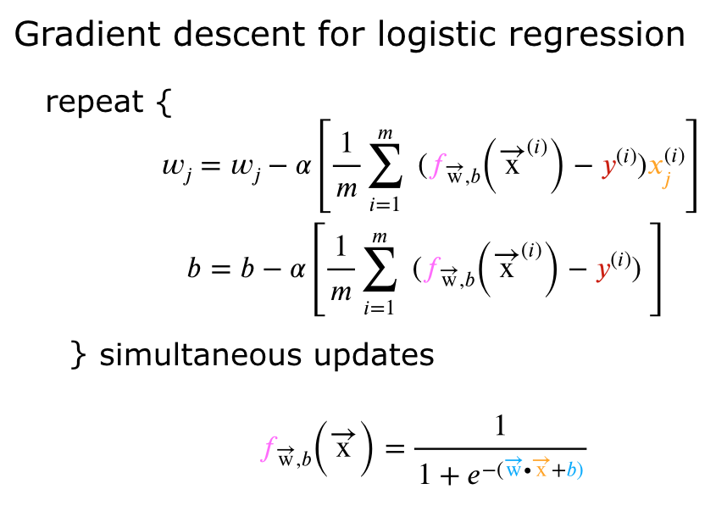

Which of the following two statements is a more accurate statement about gradient descent for logistic regression?

1. The update steps are identical to the update steps for linear regression.
2. The update steps look like the update steps for linear regression, but the definition of $f_{\vec{w},b}(x^{(i)})$ is different.

【答案】B

【解析】对于逻辑回归，𝑓𝑤⃗,𝑏(𝑥(𝑖))*fw*,*b*​(**x**(*i*)) 是sigmoid函数而不是一条直线。

# 第四单元

The problem of overfitting

过拟合问题

1. Which of the following can address overfitting?
2. Apply regularization
3. Select a subset of the more relevant features.
4. Remove a random set of training examples
5. Collect more training data

【答案】ABD

【解析】如果模型在更多的数据上进行训练，它可能对新样本有更好的泛化能力。

正则化被用来减少过拟合。移除一组随机的训练样本。

如果模型在更相关的特性上进行训练，而不是在不那么有用的特性上，它可能对新样本有更好的泛化能力。

1. You fit logistic regression with polynomial features to a dataset, and your model looks like this.

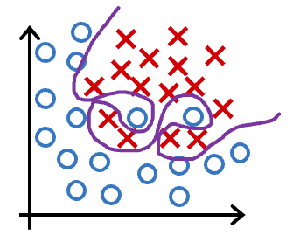

What would you conclude? (Pick one)

1. The model has high bias (underfit). Thus, adding data is likely to help
2. The model has high bias (underfit). Thus, adding data is, by itself, unlikely to help much.
3. The model has high variance (overfit). Thus, adding data is, by itself, unlikely to help much.
4. The model has high variance (overfit). Thus, adding data is likely to help

【答案】D

【解析】模型具有高方差（它对训练数据过拟合）。增加数据（更多的训练样本）可能会有帮助。

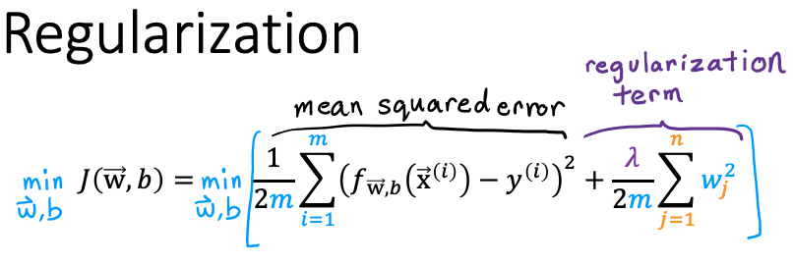  
Suppose you have a regularized linear regression model.  If you increase the regularization parameter $\begin{aligned}λ\end{aligned}$, what do you expect to happen to the parameters $w_{1},w_{2},...,w_{n}$？

1. This will reduce the size of the parameters $w_{1},w_{2},...,w_{n}$
2. This will increase the size of the parameters $w_{1},w_{2},...,w_{n}$

【答案】A

【解析】正则化通过减少参数w1, w2, ..., wn的大小来减少过拟合。