**ASSIGNMENT 1 FRONT SHEET**

|  |  |  |  |
| --- | --- | --- | --- |
| **Qualification** | **BTEC Level 5 HND Diploma in Computing** | | |
| **Unit number and title** | Unit 13: Computing Research Project | | |
| **Submission date** |  | **Date Received 1st submission** |  |
| **Re-submission Date** |  | **Date Received 2nd submission** |  |
| **Student Name** | NGO XUAN DUY | **Student ID** | BH00213 |
| **Class** | IT0502 | **Assessor name** | NGUYEN THANH TRIEU |
| **Student declaration**  I certify that the assignment submission is entirely my own work and I fully understand the consequences of plagiarism. I understand that making a false declaration is a form of malpractice. | | | |
|  |  | **Student’s signature** | XDUY |

**Grading grid**

|  |  |  |  |  |  |  |  |  |  |
| --- | --- | --- | --- | --- | --- | --- | --- | --- | --- |
| P1 | P2 | P3 | P4 | P5 | M1 | M2 | M3 | D1 | D2 |
|  |  |  |  |  |  |  |  |  |  |

|  |  |  |
| --- | --- | --- |
| **❒ Summative Feedback: ❒ Resubmission Feedback:** | | |
| **Grade:** | **Assessor Signature:** | **Date:** |
| **Internal Verifier’s Comments:** | | |
| **Signature & Date:** | | |

Contents

I. Introduction 6

II. Produce a research proposal that clearly defines a research question or hypothesis supported by a literature review (P1) 6

**1.** Research Topic 6

**2.** Define the main aims and objectives of the project 6

**3.** Project plan 8

III. Examine appropriate research methods and approaches to primary and secondary research (P2) 10

**1.** Primary research 10

**2.** Secondary research 12

**3.** Comparing primary vs secondary research 14

**4.** Qualitative method 15

**5.** Quantitative method 18

**6.** The differences between quantitative and qualitative research 20

IV. Conduct primary and secondary research using appropriate methods for a computing research project that consider costs, access and ethical issues(P3) 22

**1.** Do secondary research 22

**2.** Do primary research 29

V. Apply appropriate analytical tools, analyze research findings and data(P4) 32

**1.** Interview results 32

**2.** Survay results 38

**3.** Analyze the results of the primary research 46

VI. Communicate research outcomes in an appropriate manner for the intended audience(P5) 49

**1.** Conclusion 49

**2.** Recommendations 50

VII. Conclusion 53

VIII. References 53

Figure 1 Primary research 10

Figure 2 Secondary research 12

Figure 3 Qualitative method 15

Figure 4 Types of qualitative research methods 16

Figure 5 Quantitative method 18

Figure 6 Data storage 23

Figure 7 Big Data 25

Figure 8 Question 1 39

Figure 9 Question 2 39

Figure 10 Question 3 40

Figure 11 Question 4 40

Figure 12 Question 5 41

Figure 13 Question 6 41

Figure 14 Question 7 42

Figure 15 Question 8 42

Figure 16 Question 9 43

Figure 17 Question 10 43

Figure 18 Question 11 44

Figure 19 Question 12 44

Figure 20 Question 13 45

# Introduction

In today's data-centric era, the relentless generation and accumulation of vast amounts of information, commonly referred to as "Big Data," offer organizations unprecedented opportunities to glean valuable insights, make informed decisions, and foster innovation. However, the enormity and complexity of Big Data also give rise to a myriad of challenges, particularly in the domain of data storage and management.

This research endeavors to explore the fundamental challenges associated with storing data for Big Data and to investigate the diverse array of solutions available to address these challenges. Big Data storage transcends mere logistical concerns; it is the linchpin for enabling feasible and efficient Big Data analytics and applications. Consequently, understanding and effectively addressing these challenges are crucial for organizations seeking to harness the full potential of Big Data.

The primary objectives of this research are to elucidate the multifaceted nature of the challenges surrounding Big Data storage. It will delve into the complexities posed by factors such as data scalability, variety, velocity, security, latency, and cost, among others. Additionally, the study aims to provide insights into the evolving landscape of solutions and technologies crafted to overcome these challenges. By examining both the challenges and their corresponding solutions, this research seeks to empower businesses, researchers, and data professionals with a comprehensive understanding of the intricacies of Big Data storage, equipping them with strategies to optimize their data management processes.

# Produce a research proposal that clearly defines a research question or hypothesis supported by a literature review (P1)

## Research Topic

Topic: Key challenges related to data storage for Big Data and solutions.

## Define the main aims and objectives of the project

The principal objective of this project is to thoroughly investigate, analyze, and offer comprehensive insights into the primary challenges related to data storage for Big Data, along with proposing effective solutions to address these challenges. The overarching goal is to contribute to the understanding of Big Data storage issues and provide organizations with knowledge and strategies to optimize their data management processes, enabling them to fully harness the potential of Big Data. The specific objectives of the project include:

1. **Identify Key Challenges:** Identify and categorize the primary challenges associated with data storage for Big Data, encompassing issues such as scalability, data variety, velocity, security, and cost.
2. **Analyze Root Causes:** Delve deeper into the root causes and underlying factors contributing to each identified challenge, providing a nuanced understanding of their origins.
3. **Examine Industry Trends:** Examine current industry trends and emerging technologies in Big Data storage, highlighting innovative solutions and approaches that address these challenges.
4. **Evaluate Existing Solutions:** Assess the effectiveness and limitations of existing solutions and technologies for mitigating Big Data storage challenges, with a focus on both on-premises and cloud-based solutions.
5. **Provide Best Practices:** Compile a set of best practices and guidelines for organizations to optimize their data storage strategies for Big Data, considering factors like data governance, cost management, and scalability.
6. **Address Data Security:** Investigate data security concerns specific to Big Data storage and propose comprehensive security strategies and measures to safeguard sensitive information.
7. **Analyze Cost Implications:** Analyze the cost implications of various storage solutions, including cloud-based, on-premises, and hybrid approaches, and provide cost optimization recommendations.
8. **Explore Data Lifecycle Management:** Explore data lifecycle management strategies, including data retention policies, data archiving, and data pruning, to optimize storage resource utilization.
9. **Highlight Data Governance Frameworks:** Highlight the importance of data governance in Big Data storage and present frameworks and tools for effective data governance and compliance.

To achieve these objectives, a dual approach combining theoretical research and practical implementation will be adopted. This approach leverages the strengths of each method to provide a holistic understanding of the challenges and solutions associated with data storage for Big Data. Integrating theoretical knowledge with real-world application aims to offer a comprehensive perspective on this subject matter.

**Theoretical Research Approach:**

1. **Literature Review:** A thorough literature review will be conducted to gather insights from existing academic research, industry reports, and case studies related to Big Data storage challenges and solutions. This will provide a solid foundation for understanding the current state of knowledge in the field.
2. **Data Collection and Analysis:** Data will be collected from various sources, including interviews with industry experts, surveys, and analysis of publicly available data related to Big Data storage challenges and trends. This data will be analyzed to identify common patterns, emerging issues, and real-world examples.
3. **Theoretical Framework Development:** A theoretical framework will be developed to categorize and structure the identified challenges and solutions. This framework will serve as a conceptual guide for organizing and presenting the research findings.
4. **Review of Existing Solutions:** Existing solutions and technologies addressing Big Data storage challenges will be critically reviewed, with an emphasis on their theoretical underpinnings, strengths, and limitations. This analysis will inform the practical implementation phase.

**Practical Implementation Approach:**

1. **Case Studies and Demonstrations:** Real-world case studies will be conducted to assess the practical effectiveness of selected solutions and technologies in actual Big Data environments.Practical demonstrations will provide tangible evidence of the solutions' viability and applicability.
2. **Data Security Testing:** Rigorous security testing will be undertaken to evaluate the strength and resilience of proposed data security measures.Simulated security breaches and vulnerability assessments will be carried out to identify potential weaknesses and enhance overall data security.
3. **Cost-Benefit Analysis:** A thorough cost-benefit analysis will be conducted, comparing the financial implications of various storage solutions and strategies.Factors such as initial investment, operational costs, and long-term sustainability will be considered, providing a holistic understanding of economic impact.
4. **Best Practices and Recommendations:** Drawing from both theoretical research findings and practical outcomes, a set of best practices, recommendations, and guidelines will be formulated.These insights will offer actionable guidance for organizations looking to optimize their Big Data storage practices, covering aspects like data governance, cost management, and scalability.
5. **Prototyping and Tools Development:** If applicable, prototypes or tools may be developed to facilitate the practical implementation of recommended solutions and strategies.These tools can serve as practical aids for organizations aiming to address Big Data storage challenges, streamlining the implementation process.
6. **Feedback and Iteration:** Continuous feedback loops will be established with industry experts and stakeholders to refine the research findings.Regular iterations will ensure that the proposed solutions and recommendations remain practical, responsive to industry dynamics, and aligned with real-world needs.

By integrating these practical elements, the research project aims not only to validate theoretical insights but also to provide organizations with actionable strategies and tools for optimizing their Big Data storage practices. The iterative feedback loop ensures that the solutions evolve in response to real-world challenges and advancements in the field.

## Project plan

**Project Plan**

|  |  |  |  |
| --- | --- | --- | --- |
| **PROJECT NAME** | Key challenges related to data storage for Big Data and solutions. | **PROJECT MANAGER** | 1 |
| **NAME** | Ngo Xuan Duy | | |
| **MAILING ADDRESS** | Duynxbh00213@fpt.edu.vn | | |
| **EMAIL** | Xduy263@gmail.com | | |
| **START DATE** | 22/02/2024 | **END DATE** | 10/04/2024 |

|  |  |  |  |  |
| --- | --- | --- | --- | --- |
| **SL.**  **No.** | **ACTIVITY/ TASK NAME** | **START DATE** | **END DATE** | **DURATION**  (in days) |
| **01** | Choose Research Topic | 8/02/2024 | 10/02/2024 | 3 |
| **02** | Write Research Proposal Form | 11/02/2024 | 13/02/2024 | 3 |
| **03** | Complete Research Proposal Form Draft | 14/02/2024 | 16/02/2024 | 3 |

|  |  |  |  |  |
| --- | --- | --- | --- | --- |
| **04** | Milestone 1: Receive Tutor Feedback on Research Proposal Form and Make Revisions | 17/02/2024 | 21/02/2024 | 5 |
| **05** | Project Planning | 7/02/2024 | 10/02/2024 | 4 |
| **06** | Literature Review | 9/02/2024 | 16/02/2024 | 8 |
| **07** | Check Project Progress: Research Proposal, Plan, Literature Review | 1/02/2024 | 5/04/2024 | 5 |
| **08** | Milestone 2: Receive Tutor Feedback on Literature Reviews | 4/02/2024 | 8/02/2024 | 5 |
| **09** | Milestone 3: Conduct Qualitative and Quantitative Research | 9/02/2024 | 24/02/2024 | 16 |
| **10** | Primary Research | 22/02/2024 | 7/03/2024 | 16 |
| **11** | Milestone 4: Analyze Research Results and Data | 6/02/2024 | 12/02/2024 | 7 |
| **12** | Milestone 5: Receive Tutor Feedback on Primary Research | 13/02/2024 | 15/02/2024 | 3 |
| **13** | Conduct Secondary Research | 1/03/2024 | 2/03/2024 | 2 |
| **14** | Milestone 6: Receive Tutor Feedback on Secondary Research | 1/03/2024 |  | 1 |
| **15** | Write Assignment 1: LO1 And LO2 | 3/03/2024 |  | 1 |
| **16** | Milestone 7: Review Assignment 1 Draft with Tutor | 7/03/2024 |  | 1 |
| **17** | Milestone 8: Submit Assignment 1 | 10/03/2024 |  | 1 |
| **18** | Write Assignment 2 | 20/03/2024 |  | 1 |
| **19** | Milestone 9: Review Assignment 2 Draft with Tutor | 15/05/2024 |  | 1 |

# Examine appropriate research methods and approaches to primary and secondary research (P2)

## Primary research



Figure 1 Primary research

Primary research refers to the acquisition of firsthand data, wherein the researcher either conducts the study personally or arranges for the collection of data on their behalf. This method involves a direct approach to obtaining information from the source rather than relying on pre-existing data samples. It proves particularly pertinent when the data collected needs to be context-specific. Commonly utilized in qualitative research, especially in survey methodology, questionnaires, focus groups, and various interview formats, primary research is instrumental in obtaining detailed insights.

For instance, suppose you are keen on assessing the quality of vegan options available at your campus dining hall. In this case, you may opt to conduct a survey targeting vegan students to gather their thoughts and opinions directly.

**There exist four primary research methods:**

**1. Survey:** Involves the collection of data through structured questionnaires or online forms. Researchers design a set of questions administered to a sample of participants. Surveys are effective for gathering quantitative data on a large scale, suitable for studying opinions, attitudes, preferences, and behaviors within a population.

**2. Interview:** Entails direct one-on-one or group discussions between a researcher and participants. Interviews can be structured, featuring predefined questions, or unstructured, allowing for open-ended conversations. They are valuable for obtaining in-depth qualitative information, exploring complex topics, and gaining insights into personal experiences and perspectives.

**3. Focus Group:** Comprises group discussions led by a moderator where participants share their opinions, experiences, and ideas on a specific topic in a semi-structured format. Focus groups prove useful for exploring group dynamics, generating ideas, and understanding diverse viewpoints on a subject, often applied in market research and product development.

**4. Observation:** Involves systematically watching and recording behaviors, events, or phenomena as they occur in a natural setting. Researchers may act as passive observers, remaining unobtrusive, or as active participants, engaging in participatory observation. This method is valuable for studying behavior, interactions, and environmental factors in their natural context.

|  |  |
| --- | --- |
| **Advantages** | **Disadvantages** |
| More up to date. The researcher collects data at the time were needed. This is different from secondary data, where there is more time lag between data collection and publication. Besides, researchers can also update data regularly, as needed. | Expensive. Researchers have to spend more to get to the data. The amount depends on the preparation or the primary research method used. The number and geographic reach of respondents also affect costs. For example, in a survey, the costs may be higher and include surveyor wages, data entry fees, and questionnaire printing costs. |
| More relevant. Researchers take data by the objectives and questions they want to answer. For example, if they studied the shopping habits of consumers aged 20-30 years, they could determine a suitable sample.  In contrast, the available secondary data may only be for consumers aged 20-25 years. So, taking secondary data for research becomes less relevant. | Time-consuming. Surveys and interviews, for example, may take several days, depending on the number of respondents. After the data is obtained, the researcher must enter the data, clean it, and put it in a database. They may also have to classify answers to some open- ended questions. On the other hand, secondary data is faster to obtain, process, and analyze. |
| Confidential. Only researchers have access to data. Other people cannot use it without their permission.  Also, researchers can sell data to other parties for money. It is one of the business models of several research companies. They collect some primary data and sell it to several clients. They incur a one-time cost but can sell the same data to multiple parties. | Lower variety. Primary data contains only the topics under study. In contrast, secondary data is more varied because it comes from various sources. |
| More controllable. Indeed, primary research is also biased. However, some of it is within the control of researchers. For example, in choosing a sample, they control the selected respondents and the data collected, so they are more representative. That is difficult to get from secondary data. | Invalid sample. Sampling errors render work pointless. Although there were no problems with the questionnaire or respondent’s answers, an unrepresentative sample produced biased conclusions. So, choosing the right sample is the initial and critical stage of the research. |

## Secondary research

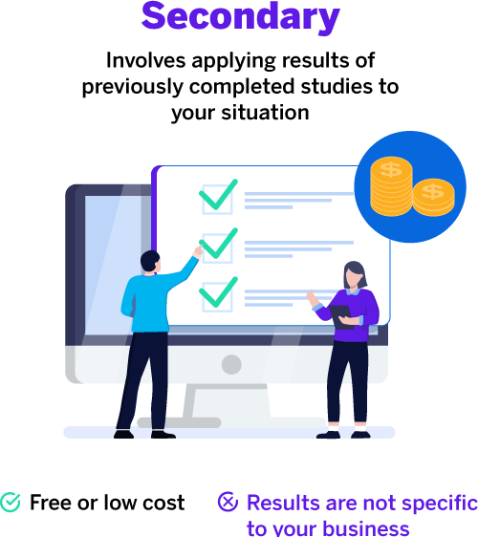

Figure 2 Secondary research

Secondary research is a research method that relies on utilizing data that has been previously collected by others. In essence, when you engage in research using pre-existing data, you are conducting secondary research. In contrast, any research that you initiate and undertake personally is categorized as primary research. Secondary research can manifest in both qualitative and quantitative forms, frequently drawing on data obtained from published peer-reviewed papers, meta-analyses, or government and private sector databases and datasets.

For example, imagine you are curious about how the quantity and quality of vegan options at your campus dining hall have evolved over time. A friend who graduated a few years ago had a similar interest and conducted a survey on this topic. By borrowing her survey results, you can perform statistical analysis on the data.

**Secondary research encompasses various types, with the most prevalent being:**

**1. Statistical Analysis:** Involves the scrutiny and interpretation of statistical data and findings from prior research or surveys. Researchers employ statistical analysis to identify trends, relationships, or patterns within existing datasets, enabling them to draw conclusions or glean insights from quantitative data without the need for new data collection.

**2. Literature Reviews:** Encompass the comprehensive examination and synthesis of existing academic or professional literature pertaining to a specific topic or research question. Researchers delve into scholarly articles, books, reports, and other pertinent sources to summarize existing knowledge, pinpoint gaps in the literature, and construct a theoretical framework for their own research.

**3. Case Studies:** Involve the thorough analysis of specific real-world cases or examples. Researchers often use case studies to explore intricate phenomena, comprehend unique situations, or illustrate principles and theories. Case studies can be based on archival data, historical records, or previously published case study research.

**4. Content Analysis:** A method for systematically scrutinizing and interpreting the content of various media types, such as texts, images, videos, or social media posts. Researchers employ content analysis to extract meaningful information, identify patterns, and draw conclusions from existing content. This method finds application in communication studies, marketing research, and social sciences.

|  |  |
| --- | --- |
| **Advantages** | **Disadvantages** |
| Easy, cheap, and fast. You don’t have to be involved in developing complicated data collection methods. You also don’t have to run surveys or interviews to collect data. You just sit at the table and look it up on the internet. | Inaccurate. You don’t know how the data is retrieved, whether it is accurate or not. For example, a data provider might use an unrepresentative sample and therefore be biased if you use it to conclude about the population. |
| More varied. You can collect data from a variety of sources. Besides, you can compare these various data and choose which ones support your argument. | Expired. More lag time between data collection and data publication. Thus, the data may no longer be relevant to current conditions. The data provider does not update it regularly, so data is unavailable for several years. |
| Good starting point. It is useful to help plan primary research. For example, you can collect some secondary data to answer some of your hypotheses and collect other data through primary research. In other cases, for consumer research, you may need secondary data on demographics and geography to determine a representative sample. | Less relevant. Secondary data is to meet the needs of the provider, not for you. Thus, they may be less relevant to answering your research hypotheses. |

## Comparing primary vs secondary research

|  |  |  |
| --- | --- | --- |
| **Aspect** | **Primary Research** | **Secondary Research** |
| **Data Collection** | Involves collecting original data | Relies on existing data |
| **Data Source** | Firsthand data collection | Uses pre-existing sources |
| **Purpose** | Answers specific questions | Supports research findings |
| **Control** | Researchers have full control | Limited control |
| **Time and Cost** | Often time-consuming and costly | Typically quicker and cost-effective |
| **Data Quality** | Can ensure data quality | Varies based on source quality |
| **Scope** | Tailored to research objectives | Limited by available data |
| **Ethical Considerations** | Concerns about consent and privacy | Focus on proper citation and fair use |

Both primary and secondary research methods offer distinct advantages and limitations, catering to different research needs. Primary research proves ideal when researchers seek original data tailored to specific questions, despite being more resource-intensive. Conversely, secondary research relies on existing data, providing efficiency and cost savings, but its effectiveness may be constrained by data availability and quality. Many researchers opt for a combination of both methods to attain comprehensive insights into their research topics.

**Examples illustrate the application of each method:**

**Primary Research:**

1. Conducting surveys to evaluate customer satisfaction with a newly launched product.

2. Running experiments to investigate the effects of a dietary supplement on health outcomes.

3. Observing wildlife behavior in a specific ecosystem to gather firsthand data.

**Secondary Research:**

1. Analyzing published academic articles and market reports to compile statistics on global climate change trends.

2. Examining historical census data to study demographic shifts over time.

3. Reviewing existing literature to support a research paper on the impact of social media on mental health.

By strategically employing primary and secondary research methods, researchers can leverage the strengths of each approach to enhance the robustness and depth of their findings.

## Qualitative method

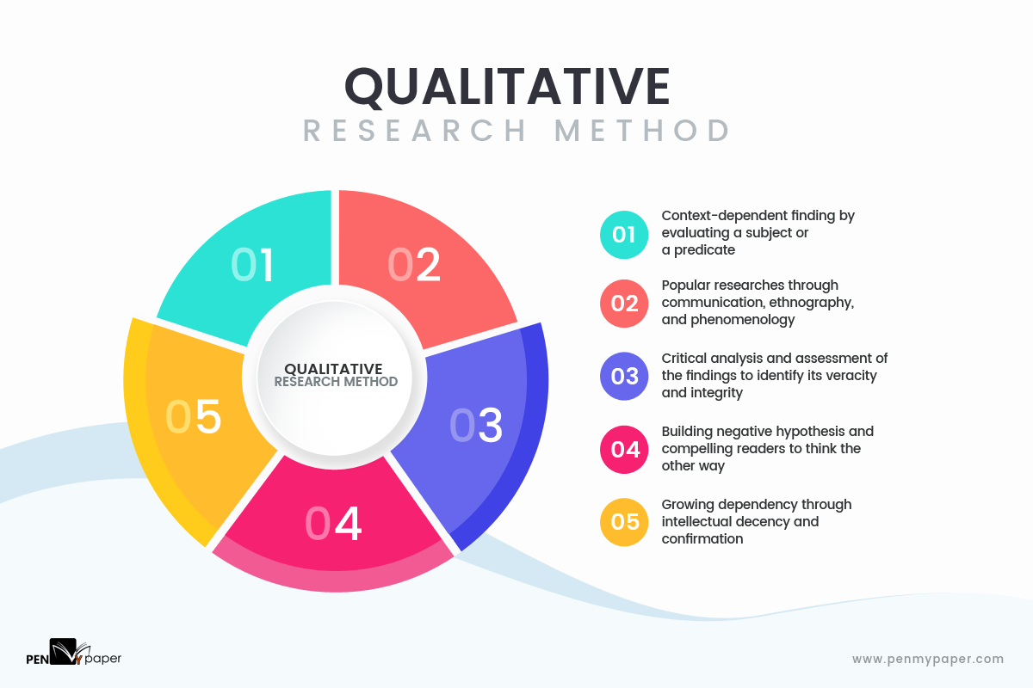

Figure 3 Qualitative method

Qualitative research is a methodology that revolves around the collection and analysis of non-numerical data, such as text, video, or audio, with the aim of understanding concepts, opinions, or experiences. This approach is particularly valuable for obtaining in-depth insights into a problem, unraveling complex phenomena, or generating new ideas for further research. Qualitative research stands in contrast to quantitative research, where the focus lies in the collection and analysis of numerical data for statistical purposes.

This methodology finds widespread application in disciplines within the humanities and social sciences, including anthropology, sociology, education, health sciences, history, and more. By delving into the intricacies of human behavior, emotions, and perspectives, qualitative research contributes to a richer and more nuanced understanding of various phenomena, often exploring the context and meaning behind the data. Its flexibility allows researchers to adapt their methods to the unique characteristics of the subject matter, making qualitative research an invaluable tool for exploring the depth and complexity of human experiences.

Certainly, these are excellent examples of qualitative research questions. Qualitative research questions are designed to explore and understand complex phenomena, often delving into the depth and context of human experiences. Here's a breakdown of the mentioned examples:

**1. How does social media shape body image in teenagers?**

- This question aims to investigate the influence of social media on the development of body image in the teenage population, exploring the various ways in which online platforms may contribute to or shape their perceptions of their own bodies.

**2. How do children and adults interpret healthy eating in the UK?**

- This question seeks to understand the perspectives of both children and adults regarding the concept of healthy eating in the context of the United Kingdom. It explores subjective interpretations and cultural influences on dietary choices.

**3. What factors influence employee retention in a large organization?**

- This question addresses the complexities of employee retention within a large organization, aiming to identify and understand the multifaceted factors that contribute to the decision of employees to stay or leave their jobs.

**4. How is anxiety experienced around the world?**

- This question explores the universality and cultural variations in the experience of anxiety, aiming to understand how individuals from different parts of the world perceive and cope with anxiety.

**5. How can teachers integrate social issues into science curriculums?**

- This question focuses on the exploration of strategies and challenges involved in integrating social issues into science curriculums. It aims to uncover effective methods for teachers to incorporate broader societal contexts into their science teaching practices.

These questions provide a qualitative researcher with a starting point to conduct in-depth investigations, collecting rich, non-numerical data to uncover nuanced insights and perspectives.

**Types of qualitative research methods**

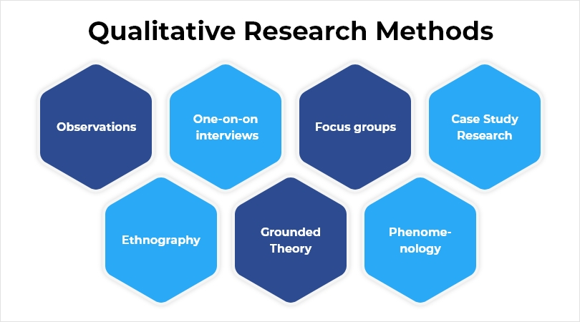

Figure 4 Types of qualitative research methods

Your explanations provide a comprehensive overview of various qualitative research methods. Here's a concise summary of each method:

**1. Interviews:**

- Involves one-on-one or group discussions between a researcher and participants.

- Can be structured (predetermined questions) or unstructured (open-ended conversations).

- In-depth interviews aim to uncover participants' thoughts, feelings, experiences, and perceptions.

**2. Focus Groups:**

- Group discussions led by a moderator.

- Participants share opinions, attitudes, and experiences on a specific topic.

- Useful for exploring group dynamics, generating ideas, and capturing diverse viewpoints.

**3. Ethnography:**

- Involves long-term immersion in a social or cultural setting.

- Researchers engage in participant observation, interviews, and data collection for a holistic understanding of the community, group, or culture.

**4. Case Study:**

- Focuses on a single individual, group, organization, or event.

- Researchers collect extensive data to explore and describe the specific case in detail.

- Valuable for in-depth examinations of unique or complex phenomena.

**5. Grounded Theory:**

- A systematic research approach to developing theories or concepts from qualitative data.

- Researchers collect and analyze data without preconceived theories, allowing theories to emerge organically.

**6. Record Keeping:**

- Utilizes existing reliable documents and sources as the data source.

- Similar to going to a library to collect relevant data for new research.

**7. Qualitative Observation:**

- A process of research that uses subjective methodologies to gather systematic information.

- Focuses on the 5 major sensory organs and their functioning (sight, smell, touch, taste, and hearing).

- Doesn't involve measurements or numbers but rather focuses on characteristics.

These methods offer diverse approaches for researchers to explore, understand, and interpret qualitative data in various research contexts.

## Quantitative method

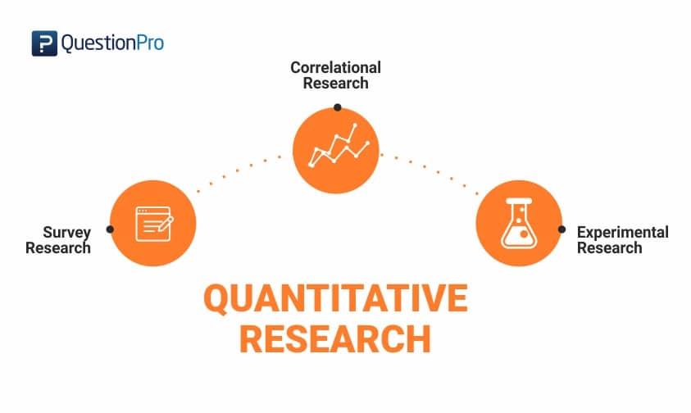

Figure 5 Quantitative method

Quantitative research involves the collection and analysis of numerical data, allowing researchers to identify patterns, make predictions, test causal relationships, and generalize results to wider populations. It stands in contrast to qualitative research, which deals with non-numerical data such as text, video, or audio. Quantitative research finds extensive application in both natural and social sciences, including fields such as biology, chemistry, psychology, economics, sociology, and marketing.

**Here are examples of quantitative research questions:**

**1. What is the demographic makeup of Singapore in 2020?**

- This question seeks numerical data to provide a quantitative snapshot of Singapore's demographic characteristics, including age, gender, ethnicity, and other relevant factors.

**2. How has the average temperature changed globally over the last century?**

- In this example, the research aims to quantify and analyze temperature data to identify trends and patterns in global temperature changes over a specified time period.

**3. Does environmental pollution affect the prevalence of honey bees?**

- This question involves collecting numerical data to explore the relationship between environmental pollution levels and the population of honey bees, assessing whether there is a quantifiable impact.

**4. Does working from home increase productivity for people with long commutes?**

- This research question aims to gather quantitative data to assess the productivity levels of individuals with long commutes before and after implementing a work-from-home arrangement, allowing for a statistical analysis of the potential impact.

Quantitative research questions are formulated to facilitate the collection of numerical data, enabling researchers to apply statistical methods for analysis and draw objective conclusions from the results.

**Quantitative research characteristics**

Quantitative research has several unique characteristics that make it well-suited for specific types of projects. Let’s explore the most crucial of these characteristics so that you can consider them when planning your next research project

**Structured tools:** Structured tools such as surveys, polls, or questionnaires are used to gather quantitative data. Using such structured methods helps collect in-depth and actionable data from the survey respondents.

**Sample size:** Quantitative research is conducted on a significant sample size that represents the target market. Appropriate sampling methods have to be used when deriving the sample to fortify the research objective

**Close-ended questions:** Closed-ended questions are created per the objective of the research. These questions help collect quantitative data and hence, are extensively used in quantitative research.

**Prior studies:** Various factors related to the research topic are studied before collecting feedback from respondents.

**Quantitative data:** Usually, quantitative data is represented by tables, charts, graphs, or any other non- numerical form. This makes it easy to understand the data that has been collected as well as prove the validity of the market research.

**Generalization of results:** Results of this research method can be generalized to an entire population to take appropriate actions for improvement.

|  |  |
| --- | --- |
| **Advantages** | **Disadvantages** |
| Replication: Repeating the study is possible because of standardized data collection protocols and tangible definitions of abstract concepts. | Superficiality: Using precise and restrictive operational definitions may inadequately represent complex concepts. For example, the concept of mood may be represented with just a number in quantitative research, but explained with elaboration in qualitative research. |
| Direct comparisons of results: The study can be reproduced in other cultural settings, times or with different groups of participants. Results can be compared statistically. | Narrow focus: Predetermined variables and measurement procedures can mean that you ignore other relevant observations. |
| Large samples: Data from large samples can be processed and analyze using reliable and consistent procedures through quantitative data analysis. | Structural bias: Despite standardized procedures, structural biases can still affect quantitative research. Missing data, imprecise measurements or inappropriate sampling methods are biases that can lead to the wrong conclusions. |
| Hypothesis testing: Using formalized and established hypothesis testing procedures means that you have to carefully consider and report your research variables, predictions, data collection and testing methods before go to concluded. | Lack of context: Quantitative research often uses unnatural settings like laboratories or fails to consider historical and cultural contexts that may affect data collection and results. |

## The differences between quantitative and qualitative research

The differences between quantitative and qualitative research

* **Data collection**

Data collection methods for quantitative data and qualitative data vary, but there are also some places where they overlap.

|  |  |
| --- | --- |
| **Qualitative data collection methods** | **Quantitative data collection methods** |
| Gathered from focus groups, in-depth interviews, case studies, expert opinion, observation, audio recordings, and can also be collected using surveys. | Gathered from surveys, questionnaires, polls, or from secondary sources like census data, reports, records and historical business data. |
| Qualitative data collection methods | Quantitative data collection methods |
| Gathered from focus groups, in-depth interviews, case studies, expert opinion, observation, audio recordings, and can also be collected using surveys. | Gathered from surveys, questionnaires, polls, or from secondary sources like census data, reports, records and historical business data. |

* **Data analysis**

Quantitative data suits statistical analysis techniques like linear regression, T-tests and ANOVA. These are quite easy to automate, and large quantities of quantitative data can be analyzed quickly. Analyzing qualitative data needs a higher degree of human judgement, since unlike quantitative data, non-commercial data of a subjective nature has certain characteristics that inferential statistics can’t perceive. Working at a human scale has historically meant that qualitative data is lower in volume – although it can be richer in insights.

|  |  |
| --- | --- |
| **Qualitative data analysis** | **Quantitative data analysis** |
| Results are classification, summary and interpreted using human language and perception, as well as logical reasoning | Results are analyze mathematically and statistically, without recourse to intuition or personal experience. |
| Fewer respondents needed, each providing more detail | Many respondents needed to achieve a representative result |

* **Strengths and weaknesses**

When weighing up qualitative vs quantitative research, it’s largely a matter of choosing the method appropriate to your research goals. If you’re in the position of having to choose one method over another, it’s worth knowing the strengths and limitations of each, so that you know what to expect from your results.

|  |  |
| --- | --- |
| **Qualitative approach** | **Quantitative approach** |
| Can be used to help formulate a theory to be researched by describing a present phenomenon | Can be used to test and confirm a formulated theory |
| Results typically expressed as text, in a report, presentation or journal article | Results expressed as numbers, tables and graphs, relying on numerical data to tell a story. |
| Less suitable for scientific research | More suitable for scientific research and compatible with most standard statistical analysis methods |
| Harder to replicate, since no two people are the same | Easy to replicate, since what is countable can be counted again |
| Less suitable for sensitive data: respondents may be biased or too familiar with the pro | Ideal for sensitive data as it can be anonymized and secured |

# Conduct primary and secondary research using appropriate methods for a computing research project that consider costs, access and ethical issues(P3)

## Do secondary research

The topic “Main challenges related to data storage for Big Data and solutions” is an important area of interest in the field of information technology and data management. The challenge of effectively storing and managing large volumes of data, commonly known as Big Data, becomes increasingly complex as organizations accumulate massive data sets. Below, I will discuss the challenges associated with data storage for Big Data and suggest potential solutions by collecting extensive secondary data. I will collect from a variety of relevant and reputable sources, including academic journals, industry reports, official statistics from government agencies, and reliable newspaper articles to ensure accuracy. most accurate and reliable data. I will select articles with the most recent publication date possible to reflect the latest current situation and keep up with the times, reputation of the publication as well as expertise. subjects and qualifications of the author(s).

1. **Sources**

* **[Big Data: Major Challenges and Solutions]:** This is a recent (2020) and relevant article that discusses the main challenges and solutions related to big data, such as data storage, data integration, data security, data quality, and data analysis. The article is published by the Global Tech Council, which is a reputable organization that provides certification and training in various domains of emerging technologies. The author of the article is not explicitly mentioned, but the website claims that it has a team of experts and professionals who write the content.
* **[The Big Data World: Benefits, Threats and Ethical Challenges]:** This is an academic journal article that explores the ethical issues and challenges posed by big data, such as privacy, discrimination, social cooling, big data divide, and social sorting. The article also discusses the potential benefits of big data for sustainable development and social good. The article is published in 2021, which makes it a recent source. The publication is part of the Advances in Research Ethics and Integrity series by Emerald Publishing, which is a well-known publisher of academic books and journals. The author of the article is Marina Da Bormida, who is a lawyer and researcher with expertise in data protection, privacy, and ethics.
* **[Big Data Storage: Challenges and Solutions]:** This is an industry report that reviews the current state of big data storage technologies and discusses the challenges and solutions for different types of big data

applications. The report covers topics such as cloud storage, in-house servers, hybrid storage, distributed storage, and new storage technologies. The report is published in 2021 by Capterra, which is a leading online platform that provides software reviews and comparisons for businesses. The author of the report is Stephan Miller, who is a guest contributor and a freelance writer with experience in technology and business topics.

* **[Big Data Storage: The Cloud vs. In-House Servers]:** This is another industry report that compares the pros and cons of using cloud storage and in-house servers for big data storage, and provides some recommendations for choosing the best option for different scenarios. The report is published in 2021 by Software Advice, which is a sister company of Capterra that also offers software reviews and comparisons for businesses. The author of the report is Daniel Harris, who is a market research analyst with expertise in cloud computing and big data.
* **[Big Data Storage: Statistics & Facts]:** This is a collection of official statistics from government agencies and market research firms that provide insights into the size, growth, trends, and forecasts of the global big data storage market. The collection is published in 2020 by Statista, which is a leading provider of market and consumer data. The collection does not have a specific author, but Statista claims that it has over 700 analysts who gather and verify the data from various sources.

1. **Data collected**

**Definition**

* **What is data storage?**



Figure 6 Data storage

Data storage entails the systematic and structured preservation of digital data, encompassing various forms such as text, files, images, videos, and more. This process ensures that the data remains readily available, accessible, and usable whenever required. Data storage serves as a foundational element of information technology, playing a vital role in contemporary computing systems. It facilitates the long-term retention of data for future utilization, analysis, and reference purposes. There are various methods and technologies for data storage, including:

**Hard Disk Drives (HDDs)**: HDDs are traditional mechanical storage devices that use spinning disks to store data. They are commonly found in desktop computers and servers.

**Solid State Drives (SSDs)**: SSDs are newer storage devices that use flash memory to store data. They are faster and more durable than HDDs and are commonly used in laptops, smartphones, and data centers.

**Cloud Storage**: Cloud storage involves storing data on remote servers maintained by cloud service providers. It offers scalability, accessibility from anywhere with an internet connection, and is commonly used for backups, file sharing, and data synchronization.

**Network-Attached Storage (NAS)**: NAS devices are specialized storage systems connected to a network, typically used for shared file storage and data backup.

**Storage Area Network (SAN)**: SANs are high-performance, dedicated networks used to connect storage devices to servers. They are commonly used in enterprise environments to provide fast and reliable storage access.

**Tape Drives**: Tape drives are used for long-term archival storage due to their durability and low cost per gigabyte. They are often used for data backup and disaster recovery.

**Optical Storage**: Optical storage media, such as CDs, DVDs, and Blu-ray discs, are used for storing data, especially in the context of media distribution and backup.

**External Hard Drives and USB Drives**: These are portable storage devices that connect to computers via USB ports, offering a convenient way to transfer and store data.

**Memory Cards and USB Flash Drives**: These small, portable devices are commonly used for storing and transferring data between different devices like cameras, smartphones, and computers.

**Database Systems**: Database management systems (DBMS) store structured data in a way that allows for efficient retrieval and manipulation. They are commonly used in applications where data needs to be organized and queried systematically.

* **Big Data?**

Big Data refers to extremely large and complex datasets that are beyond the ability of traditional data processing and analysis tools to handle effectively. These datasets typically involve vast volumes of structured and unstructured data that are generated at high velocity and often come from a variety of sources. The three Vs of big data:



Figure 7 Big Data

|  |  |
| --- | --- |
| **Volume** | The amount of data matters. With big data, you’ll have to process high volumes of low-density, unstructured data. This can be data of unknown value, such as Twitter data feeds, clickstreams on a web page or a mobile app, or sensor-enabled equipment. For some organizations, this might be tens of terabytes of data. For others, it may be hundreds of petabytes. |
| **Velocity** | Velocity is the fast rate at which data is received and (perhaps) acted on. Normally, the highest velocity of data streams directly into memory versus being written to disk. Some internet- enabled smart products operate in real time or near real time and will require real-time evaluation and action. |
| **Variety** | Variety refers to the many types of data that are available. Traditional data types were structured and fit neatly in a relational database. With the rise of big data, data comes in new unstructured data types. Unstructured and semi structured data types, such as text, audio, and video, require additional preprocessing to derive meaning and support metadata. |

In recent years, two additional "Vs" have emerged in the realm of data: value and veracity. While data inherently possesses value, that value remains dormant until it is identified and utilized. Equally crucial is the question of the truthfulness of data and the extent to which it can be relied upon. In the contemporary landscape, big data has evolved into a form of capital. Consider some of the world's largest tech companies, where a substantial portion of their value derives from the constant analysis of data, leading to increased efficiency and the development of innovative products.

Technological advancements have significantly diminished the cost associated with data storage and computation, making it more accessible and economical to store vast amounts of data than ever before. With an expanded volume of big data now more affordable and within reach, businesses can make more precise and informed decisions. Uncovering value in big data goes beyond mere analysis; it involves a comprehensive discovery process that necessitates insightful analysts, business users, and executives asking the right questions, identifying patterns, making informed assumptions, and predicting behavior. This holistic approach ensures that organizations not only leverage the sheer volume of data but also extract meaningful insights, driving innovation and efficiency in decision-making processes.

**The history of big data**

Although the concept of big data itself is relatively new, the origins of large data sets go back to the 1960s and ‘70s when the world of data was just getting started with the first data centers and the development of the relational database.

Around 2005, people began to realize just how much data users generated through Facebook, YouTube, and other online services. Hadoop (an open-source framework created specifically to store and analyze big data sets) was developed that same year. NoSQL also began to gain popularity during this time.

The development of open-source frameworks, such as Hadoop (and more recently, Spark) was essential for the growth of big data because they make big data easier to work with and cheaper to store. In the years since then, the volume of big data has skyrocketed. Users are still generating huge amounts of data—but it’s not just humans who are doing it.

* With the advent of the Internet of Things (IoT), more objects and devices are connected to the internet, gathering data on customer usage patterns and product performance. The emergence of machine learning has produced still more data.
* While big data has come far, its usefulness is only just beginning. Cloud computing has expanded big data possibilities even further. The cloud offers truly elastic scalability, where developers can simply spin up ad hoc clusters to test a subset of data. And graph databases are becoming increasingly important as well, with their ability to display massive amounts of data in a way that makes analytics fast and comprehensive.
* Big data is the term used to describe the large and complex datasets that are generated from various sources, such as social media, sensors, e-commerce, etc. Big data has the potential to provide valuable insights and solutions for various domains, such as business, health, education, and more.
* However, big data also poses several challenges that need to be addressed, such as data storage, data integration, data security, data quality, and data analysis.
* Data storage refers to the challenge of finding efficient and cost-effective ways to store and access the massive amount of data that is generated every day. Some of the possible solutions include cloud computing, distributed file systems, and data compression.
* Data integration refers to the challenge of combining and harmonizing data from different sources and formats, such as structured, unstructured, or semi-structured data. Some of the possible solutions include data warehousing, data lakes, and data virtualization.
* Data security refers to the challenge of protecting the data from unauthorized access, modification, or leakage. Some of the possible solutions include encryption, authentication, authorization, and auditing.
* Data quality refers to the challenge of ensuring that the data is accurate, complete, consistent, and reliable. Some of the possible solutions include data cleansing, data validation, data profiling, and data governance.
* Data analysis refers to the challenge of extracting meaningful and actionable insights from the data using various techniques and tools, such as statistics, machine learning, artificial intelligence, and visualization.
* The main benefits, threats and ethical challenges of big data, which is the term used to describe the large and complex datasets that are generated from various sources and can provide valuable insights and solutions for various domains. The chapter also explores some of the possible solutions to address the challenges of big data, such as data storage, data integration, data security, data quality, and data analysis. The chapter is part of a book titled Ethical Issues in Covert, Security and Surveillance Research, which is edited by David Calvey and Mark D. Griffiths. The book aims to provide a comprehensive overview of the ethical issues and dilemmas that arise in covert, security and surveillance research.
* Big Data Storage: Challenges and Solutions is a topic that deals with the issues and strategies related to storing large and complex datasets that are generated from various sources. Big data storage is a key component of any big data solution, as it enables data access, analysis, and integration. However, big data storage also poses several challenges, such as:
  + Managing massive amounts of data: Big data requires efficient and cost-effective ways to store and access the huge volume of data that is generated every day. Some of the possible solutions include cloud computing, distributed file systems, and data compression¹.
  + Integrating data from multiple sources: Big data comes from different sources and formats, such as structured, unstructured, or semi-structured data. This makes it difficult to combine and harmonize the data for accurate reporting and analysis. Some of the possible solutions include data warehousing, data lakes, and data virtualization.
  + Security and integrity: Big data needs to be protected from unauthorized access, modification, or leakage. This requires encryption, authentication, authorization, and auditing mechanisms to ensure data confidentiality and integrity¹².
  + Storing Big Data: Big data needs to be stored in a way that allows fast and easy retrieval and processing. This requires choosing the right data store technology that can handle the characteristics of big data, such as volume, velocity, variety, veracity, and value.
* Big Data Storage: The Cloud vs. In-House Servers is a topic that compares the advantages and disadvantages of using cloud-based or on-premises servers to store large and complex datasets that are generated from various sources. Cloud-based servers are hosted by a third-party provider, such as Microsoft Azure, Amazon Web Services, or Google Cloud Platform, and accessed via the internet. On-premises servers are located within the organization's infrastructure and controlled by the organization's IT staff. Some of the factors that influence the choice between cloud and on-premises servers are:
  + Cost: Cloud servers typically have lower upfront costs, as they do not require purchasing hardware, software, or licenses. However, they have ongoing subscription fees that depend on the amount of data and services used. On-premises servers have higher initial costs, as they require investing in equipment, installation, maintenance, and updates. However, they do not have recurring fees, except for energy and hosting costs.
  + Control: On-premises servers offer more control over the data and the server configuration, as the organization can customize the solution according to its needs and preferences. Cloud servers offer less control, as the organization has to rely on the provider's policies and standards.
  + Security: Cloud servers offer high levels of security, as the providers use encryption, authentication, authorization, and auditing mechanisms to protect the data from unauthorized access or leakage. However, cloud servers also pose some risks, such as data breaches, cyberattacks, or legal issues involving data sovereignty and compliance. On-premises servers also offer security features, but they require more effort and resources from the organization to ensure data confidentiality and integrity¹².
  + Scalability: Cloud servers offer high scalability, as they can easily adjust to the changing demands of the organization in terms of data volume, velocity, variety, veracity, and value. Cloud servers also offer more flexibility and agility, as they allow the organization to access new technologies and services without investing in hardware or software upgrades. On-premises servers offer less scalability, as they have limited capacity and require more time and money to expand or upgrade.
  + Reliability: Cloud servers offer high reliability, as they have backup and recovery systems that ensure data availability and continuity in case of disasters or failures. However, cloud servers also depend on the internet connection, which can affect the performance and accessibility of the data if it is slow or unstable. On-premises servers offer less reliability, as they are more vulnerable to physical damage or malfunctioning and require more maintenance and support from the IT staff.
* Big data storage is a topic that deals with the issues and strategies related to storing large and complex data sets that are generated from various sources. Big data storage is a key component of any big data solution, as it enables data access, analysis, and integration. However, big data storage also poses several challenges, such as managing massive amounts of data, integrating data from multiple sources, security and integrity, storing big data, and choosing the right data store technology. Here are some statistics and facts that I found using my search tool to help you learn more about this topic:
  + The global volume of data created, captured, copied, and consumed increased from 1.2 zettabytes in 2010 to 64.2 zettabytes in 2020, and is expected to reach 180 zettabytes by 2025.
  + The number of Internet of Things (IoT) connected devices worldwide grew from 26.66 billion in 2019 to 35.82 billion in 2020, and is projected to reach 75.44 billion by 2025.
  + The revenue of the storage market worldwide was estimated at 42.54 billion U.S. dollars in 2021, and is forecast to reach 51.77 billion by 2028.
  + The spending on cloud and data centers worldwide increased from 88 billion U.S. dollars in 2016 to 178 billion in 2021, while the spending on traditional data center hardware and software decreased from 114 billion to 98 billion in the same period.
  + The cloud storage of corporate data in organizations worldwide grew from 35% in 2017 to 60% in 2020, and is expected to reach 67% by 2022.

1. **Interpretation and implications of the findings**

The presented findings highlight the pivotal role of data in today's landscape, emphasizing both its immense potential and the intricate challenges it brings forth. The exponential surge in data from diverse sources such as IoT, social media, and sensors underscores its growing significance. Cloud computing emerges as a crucial solution, providing scalability and cost-efficiency for handling vast data volumes. However, persistent challenges in data integration necessitate the harmonization of structured and unstructured data.

Concerns related to data security and privacy take center stage, with ethical considerations surrounding transparency, informed consent, and data minimization being of paramount importance. The decision between cloud and on-premises storage depends on factors like cost, control, and scalability, requiring careful consideration.

Global trends in data storage, marked by a shift toward cloud-based solutions and the proliferation of IoT devices, reflect the dynamic evolution of the data landscape. The importance of data quality and governance is emphasized for reliable analysis. Undoubtedly, data's impact on decision-making across sectors is undeniable. Effective strategies for storage, management, and analysis are imperative to unlock its benefits. These findings underscore the urgency for organizations to adopt efficient storage strategies, prioritize data security and ethics, and stay abreast of global data trends to remain competitive in today's data-driven world.

## Do primary research

1. **Overall research design**

The primary research for this study will employ a mixed-methods approach, incorporating both interviews and surveys as the principal tools for data collection. This methodological choice has been made to facilitate a thorough exploration of the research topic by harnessing the advantages of qualitative data obtained through interviews and the broader perspectives offered by quantitative data acquired through surveys. The integration of these two approaches aims to achieve a more profound comprehension of the subject matter, encompassing diverse viewpoints and experiences. Through this comprehensive methodology, the research endeavors to capture both the depth and breadth of information relevant to the study's objectives.

**Methodology for Primary Research: Mixed-Methods Approach**

**1. Interviews:**

**- Type:** Semi-structured interviews.

**- Participants:** Key stakeholders in the big data storage and processing field, selected for diverse roles and perspectives.

**- Objective:** Delve into participants' understanding of big data storage, their organizations' involvement in data management, the efficacy of adopted methods, and their outlook on the future of big data storage.

**- Rationale:** To gather rich and varied insights from experts in the field, offering depth to the research.

**2. Surveys:**

**- Type:** Online survey.

**- Participants:** Diverse backgrounds, including professionals, students, and technology enthusiasts.

**- Focus Areas:**

**- Big data storage awareness:** Assess participants' understanding of different data storage models.

**- Technology Adoption:** Investigate participants' readiness to adopt new data storage technologies.

**- Alternative methods:** Gather feedback on the practicality and desirability of alternative data storage methods.

**- Objective:** Enhance qualitative insights from interviews, provide a broader perspective, and capture varied opinions.

**- Rationale:** To collect quantitative data on participants' familiarity with big data storage models and their attitudes towards adopting new technologies.

**3. Ethical Considerations:**

**- Informed Consent:** Obtain informed consent from all participants, clearly outlining research aims, data usage, and participant rights, including the option to withdraw at any time.

**- Data Privacy:** Anonymize and securely store all collected data to protect participant privacy and security.

**- Rationale:** Adhering to ethical standards to ensure transparency, protect participant rights, and maintain the confidentiality of collected data.

1. **Interview**

In order to attain a comprehensive grasp of the issue, qualitative research methodologies will be employed. Semi-structured interviews are planned with key stakeholders, encompassing data management experts, policymakers, and representatives from technology companies. These interviews are anticipated to yield valuable insights into the knowledge, experiences, and awareness of data management and archiving, a critical facet of handling extensive datasets in Big Data.

The data collection process will involve reaching out to potential interviewees, coordinating appointments, and formulating an interview guide comprising open-ended, in-depth questions. Subsequently, the recorded interviews will undergo thematic analysis, a systematic approach aimed at discerning common themes and patterns within the responses. This analytical process will facilitate the identification of predominant trends and insights, thereby enhancing comprehension of the challenges inherent in storing data for Big Data applications.

Through a meticulous examination of the findings derived from these interviews, this study aspires to illuminate the primary challenges confronted by organizations in the realm of Big Data storage and management. Moreover, it seeks to put forth potential solutions that can effectively address these challenges, paving the way for streamlined and efficient data storage strategies in the era of Big Data.

**Question**

* **Introduction and Background:**
  + Can you please introduce yourself and describe your role and responsibilities in the field of big data storage and processing?
  + How long have you been involved in working with big data and data storage solutions?
* **Understanding of Big Data Storage:**
* How do you define "big data" in the context of your work?
* What are the key challenges you have encountered when it comes to storing and managing large volumes of data?
* Could you provide examples of specific data storage challenges your organization has faced?
* **Data Storage Solutions:**
* What strategies or technologies has your organization implemented to address these data storage challenges?
* Can you describe any innovative or unique solutions your organization has developed or adopted for big data storage?
  + How do you assess the effectiveness of these solutions in terms of scalability, cost, and performance?
* **Organization's Involvement in Data Management:**
* How does your organization approach data management and governance, especially in relation to big data storage?
* What data storage policies or best practices does your organization follow?
* How do you ensure data security and compliance with regulations in your storage processes?
* **Emerging Trends and Future of Big Data Storage:**
* What emerging trends do you see in the field of big data storage and processing?
* How do you envision the future of big data storage technologies and strategies?
* Are there any specific challenges you anticipate in the future related to data storage for big data?
* **Data Saving Methods and Efficiency:**
* Could you share insights into the methods your organization employs to save and back up big data?
* How do you measure the efficiency and reliability of these data saving methods?
* Can you highlight any recent improvements or changes in your data saving processes?
* **Integration and Interoperability:**
* How does your organization ensure the integration and interoperability of different data storage systems and technologies?
  + What challenges have you encountered in achieving seamless data movement and access across different platforms?
* **Advice for Others:**
* What advice or recommendations would you give to organizations looking to improve their big data storage and processing capabilities?
* Are there any pitfalls or common mistakes that you would suggest others avoid when dealing with big data storage?
* **Final Thoughts:**
* Is there anything else you would like to share or any additional insights you believe are important for our understanding of big data storage and processing?

1. **Survey**

I devised an online survey aimed at electronics consumers and key companies to collect data on their data storage habits and data storage and processing methods. The data collection process will involve the use of online platforms to distribute surveys to diverse consumer demographics. The survey will include multiple choice questions, Likert scale questions, and demographic questions to better understand respondents' backgrounds.

Once the data is collected, the quantitative data will be analyzed using descriptive statistics. This analysis will provide a concise summary of the data, highlighting patterns and trends among respondents. Additionally, inferential statistics, such as correlation analysis, will be used to explore relationships between variables and uncover any significant associations in the data.

Using this analytical process, our goal is to develop a comprehensive understanding of consumers' data storage habits and their strategies for managing large amounts of data. This knowledge will assist in identifying patterns, trends and potential solutions to effectively address the problem.

**Questions**

**Section 1: Introduction and Informed Consent**

* Welcome message.
* Explanation of the purpose of the survey.
* Request for informed consent.

**Section 2: Demographics**

* Age: [Multiple-choice]
* Gender: [Multiple-choice]
* Education Level: [Multiple-choice]
* Occupation: [Open-text]
* Company Type (for key companies): [Multiple-choice]

**Section 3: Consumer Data Storage Habits**

* How much data do you estimate you generate or collect on average each month?
* What types of electronic devices do you use for data storage? (Select all that apply)
* How often do you back up your data?
* What is your primary reason for backing up data?

**Section 4: Data Storage and Processing Methods**

* Which data storage methods do you use to manage your data? (Select all that apply)
* How satisfied are you with your current data storage and processing methods?

**Section 5: Key Companies (if applicable)**

* If you represent a company, please briefly describe your company's primary data storage and processing methods.

**Section 6: Additional Comments**

* Do you have any additional comments, suggestions, or insights related to data storage and processing that you would like to share?

**Section 7: Closing**

* Thank you for participating in this survey! Your input is valuable.

# Apply appropriate analytical tools, analyze research findings and data(P4)

## Interview results

Throughout my research, I had the privilege of conducting interviews with esteemed individuals who had extensive experience and knowledge in fields related to my topic. From the group of survey participants, I meticulously selected five individuals whose insights and survey results stood out. Below I provide some relevant information about the interview participants:

Mr.Tran Duc Hoang l Data Engineer

Mr.Tran Quang Huy l Chief Data Officer

Ms. Le Thi Thanh Ha l Data Scientist

Mr.Pham Van Minh l Cloud Solutions Architect

1. **Interview 1**

|  |
| --- |
| Name: Mr.Tran Duc Hoang Age: 32  Occupation:Data Engineer Company: YODY |
| 1. **Understanding of Big Data Storage:**   A. How do you define "big data" in the context of your work?  B.Big data, in our context, refers to datasets that are so large and complex that they cannot be effectively managed and processed using traditional methods and tools.   1. What are the primary challenges you face when it comes to storing and processing large volumes of data in your organization? 2. Some of the primary challenges we face in data storage include scalability, data retrieval speed, and cost- effectiveness. 3. **Data Storage Solutions:**    1. Can you describe the data storage solutions and technologies your organization employs to address these challenges?    2. We use a combination of distributed storage systems like Hadoop HDFS and cloud-based storage solutions such as AWS S3 to address these challenges. 4. What role does scalability play in the selection of data storage solutions, and how do you ensure they meet your organization's needs? 5. Scalability is a critical factor in our selection of data storage solutions. We ensure that our chosen solutions can seamlessly scale with our data growth. 6. **Data Management and Governance:**    1. How does your organization approach data management and governance, particularly concerning data storage?    2. Our organization follows a strict data management and governance framework that includes data classification, access controls, and data auditing. 7. Are there specific policies or practices in place to ensure data security and compliance with regulations in your storage processes? 8. Compliance with regulations like GDPR and HIPAA is crucial in our data storage practices, and we implement encryption and access controls to ensure data security and privacy. 9. **Emerging Trends and Future of Big Data Storage**:    1. What emerging trends do you see in the field of big data storage and processing, and how are you preparing for them?    2. We are closely following trends in data storage technologies like distributed file systems, object stores, and edge computing. 10. How do you envision the future of big data storage technologies and their impact on your role as a Data Engineer? 11. I believe the future of big data storage will involve more efficient use of storage resources, increased automation, and improved data lifecycle management. |

1. **Interview 2**

|  |
| --- |
| Name: Mr.Tran Quang Huy Age: 32  Occupation:Chief Data Officer Company: Lazada Viet Nam |
| 1. **Understanding of Big Data Storage:**   A. How does your organization define "big data" in the context of your work in the financial sector?  B.Big data in the financial sector refers to vast volumes of structured and unstructured data that are generated daily, including transaction data, market data, and customer data.  A. What unique challenges do financial institutions face when it comes to storing and processing large volumes of sensitive data? |

1. **Interview 3**

|  |
| --- |
| Name: Ms. Le Thi Thanh Ha Age: 28  Occupation:Data Scientist Company: VinAI Research |
| 1. **Understanding of Big Data Storage:**    1. In healthcare research, big data encompasses a wide range of data types, including electronic health records, genomics data, and medical imaging.    2. In healthcare research, big data encompasses a wide range of data types, including electronic health records, genomics data, and medical imaging. 2. Challenges in data storage revolve around data security, privacy, and the integration of diverse healthcare datasets. 3. Challenges in data storage revolve around data security, privacy, and the integration of diverse healthcare datasets. 4. **Data Storage Solutions:**    1. We utilize a combination of on-premises and cloud-based storage solutions, ensuring that patient data is securely stored and compliant with HIPAA regulations.    2. We utilize a combination of on-premises and cloud-based storage solutions, ensuring that patient data is securely stored and compliant with HIPAA regulations. 5. Our storage solutions must accommodate the growing volume of medical data while maintaining data integrity and patient privacy. 6. Our storage solutions must accommodate the growing volume of medical data while maintaining data integrity and patient privacy. 7. **Data Management and Governance:**    1. Our organization follows strict data management and governance practices, including data anonymization, consent management, and audit trails.    2. Our organization follows strict data management and governance practices, including data anonymization, consent management, and audit trails. 8. Compliance with healthcare regulations and ethical considerations are paramount, and we have established robust data governance frameworks. 9. Compliance with healthcare regulations and ethical considerations are paramount, and we have established |

1. **Interview 4**

|  |
| --- |
| Name: Mr.Pham Van Minh Age: 31  Occupation:Cloud Solutions Architect Company: FPT Software |
| 1. **Understanding of Big Data Storage:**   A. Big data in the cloud refers to large datasets that are stored and processed using cloud-based technologies and services.  B.Big data in the cloud refers to large datasets that are stored and processed using cloud-based technologies and services.  A. Challenges in cloud-based data storage include cost management, data accessibility, and ensuring data security. B.Challenges in cloud-based data storage include cost management, data accessibility, and ensuring data security.   1. **Data Storage Solutions:**    1. We offer a range of cloud-based storage solutions, including object storage, data lakes, and databases, tailored to the specific needs of organizations.    2. We offer a range of cloud-based storage solutions, including object storage, data lakes, and databases, tailored to the specific needs of organizations.   A. Scalability, flexibility, and data redundancy are key factors in selecting the right storage solutions for our clients. B.Scalability, flexibility, and data redundancy are key factors in selecting the right storage solutions for our clients.   1. **Data Management and Governance:**    1. Organizations must establish data management and governance policies in the cloud, including access controls, encryption, and compliance monitoring.    2. Organizations must establish data management and governance policies in the cloud, including access controls, encryption, and compliance monitoring. 2. Compliance with regulations like GDPR and industry-specific standards is a priority, and our solutions are designed to meet these requirements. 3. Compliance with regulations like GDPR and industry-specific standards is a priority, and our solutions are designed to meet these requirements. 4. **Emerging Trends and Future of Big Data Storage:**    1. Emerging trends include the use of serverless computing and containerization for data processing, which will impact data storage architecture.    2. Emerging trends include the use of serverless computing and containerization for data processing, which will impact data storage architecture. 5. I see a future where data storage and processing become more tightly integrated, with automated resource allocation and optimization. 6. I see a future where data storage and processing become more tightly integrated, with automated resource allocation and optimization. 7. **Efficiency and Optimization:**    1. Efficiency is measured through cost management, data retrieval times, and resource utilization in the cloud.    2. Efficiency is measured through cost management, data retrieval times, and resource utilization in the cloud. 8. We continually optimize data storage through data lifecycle policies, automated scaling, and data tiering. 9. We continually optimize data storage through data lifecycle policies, automated scaling, and data tiering.   **6. Integration and Interoperability:** |

* **Interview Summary:**
* **Interview 1: Data Engineer**
  + Understanding of Big Data Storage: Big data in the tech sector is characterized by its sheer volume, velocity, and variety. The interviewee emphasized the challenges of scalability, where traditional storage solutions fall short. Rapid data retrieval and cost-effectiveness are significant concerns.
  + Data Storage Solutions: The tech company relies on a mix of distributed storage systems like Hadoop HDFS and cloud-based storage solutions (e.g., AWS S3) to tackle these challenges. The choice of storage solutions is driven by scalability requirements, as the company deals with massive data growth.
  + Data Management and Governance: The organization emphasizes data classification, access controls, and data auditing in its data management practices. Compliance with data security regulations is vital, with measures such as encryption and access controls in place.
  + Emerging Trends and Future: The interviewee highlighted trends such as distributed file systems and the need for more efficient use of storage resources. They emphasized the importance of staying updated on evolving storage technologies to remain competitive.
* **Interview 2: Chief Data Officer**
  + Understanding of Big Data Storage: In finance, big data encompasses transaction data, market data, and customer data. Data volume, accuracy, and real-time processing are the primary challenges.
  + Data Storage Solutions: The financial institution employs a combination of on-premises and cloud-based storage solutions. Scalability and compliance with regulations like Dodd-Frank and Basel III are critical factors in choosing storage solutions.
  + Data Management and Governance: The organization follows strict data management practices, including data quality, lineage, and access control. Regulatory compliance, particularly with financial regulations, is a top priority.
  + Emerging Trends and Future: The interviewee discussed trends like AI in risk analysis and advanced analytics integration, which will generate more data to manage and store.
* **Interview 3: Data Scientist**
  + Understanding of Big Data Storage: Healthcare big data includes electronic health records, genomics data, and medical imaging. Challenges include data security, privacy, and the integration of diverse healthcare datasets.
  + Data Storage Solutions: The organization uses a combination of on-premises and cloud-based storage solutions, with a focus on HIPAA compliance. Balancing data accessibility and privacy is essential.
  + Data Management and Governance: Data management includes data anonymization and adherence to healthcare regulations. Compliance with regulations and ethical considerations is of utmost importance.
  + Emerging Trends and Future: Emerging trends include AI in disease diagnosis and specialized healthcare storage solutions.
* **Interview 4: Cloud Solutions Architect**
  + Understanding of Big Data Storage: The interviewee described big data in the cloud as requiring scalable, cost-effective storage solutions. Challenges include cost management, data security, and integration.
  + Data Storage Solutions: The cloud services provider offers a range of cloud-based storage solutions, including object storage, data lakes, and databases, tailored to organizations' needs. Scalability, flexibility, and data redundancy are key factors.
  + Data Management and Governance: Data governance includes access controls and GDPR compliance. The interviewee emphasized the importance of secure resource allocation and optimization in the cloud.
* Emerging Trends and Future: Emerging trends include serverless computing and containerization, which will impact data storage architecture.

## Survay results

In my scholarly investigation, I made the deliberate choice to engage in primary research by crafting an online survey using the versatile platform of Google Forms. By adopting this approach, I aim to collect accurate and dependable information and data. The utilization of an online survey not only ensures the convenience of participants, who can readily respond from any location, but also facilitates the sharing of their valuable experiences.

**Survey Duration:**

* + **Start Date:** February 22, 2024
  + **End Date:** March 7, 2024

You can view and participate in the survey via [this link .](https://forms.gle/orpNdD1cHEo8DApo6)

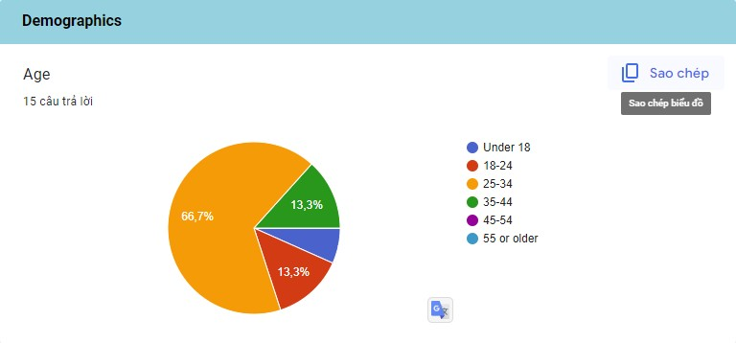

Figure 8 Question 1

Age: The majority of respondents (66.7%) fall in the 25-34 age group, indicating that the survey attracted a

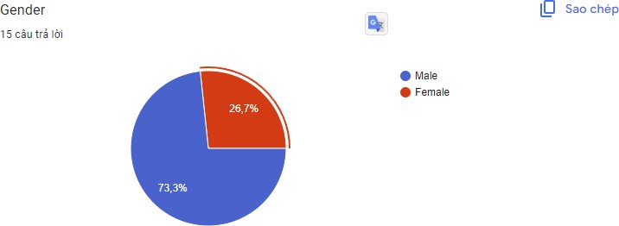

Figure 9 Question 2

younger audience interested in data storage.

Gender: The survey predominantly attracted male respondents (73.3%), suggesting that it might be beneficial to explore strategies for increasing female participation in future surveys.

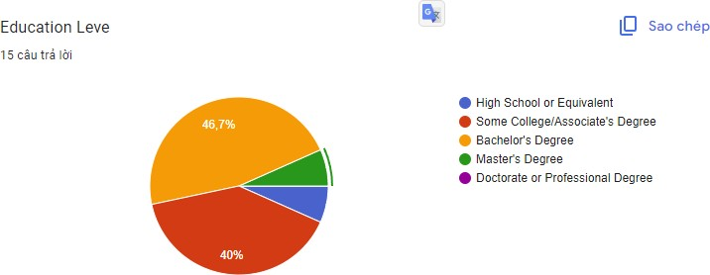

Figure 10 Question 3

Education Level: Nearly half of the respondents (46.7%) hold a Bachelor's degree, and 40% have completed some college or hold an Associate's degree. This indicates that the survey engaged individuals with at least some level of higher education.

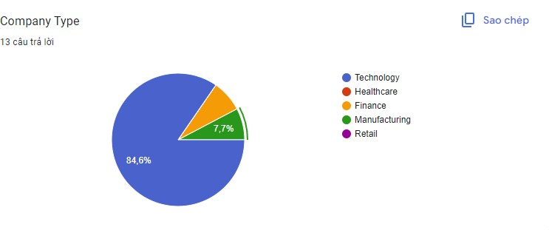

Figure 11 Question 4

Company Type: In the case of key companies, most respondents represented technology companies (84.6%), with smaller proportions from finance and manufacturing sectors.

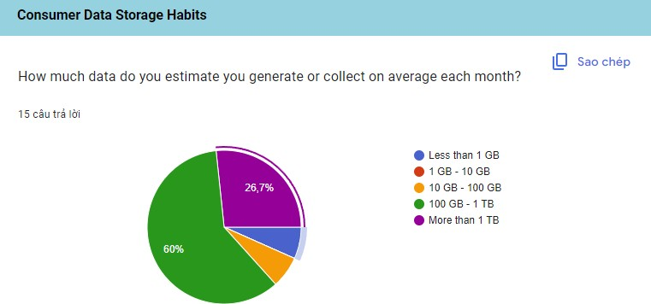

Figure 12 Question 5

Data Volume: A significant portion of respondents (60%) reported generating or collecting data in the range of 100 GB to 1 TB per month, highlighting the prevalence of substantial data volumes among the audience.

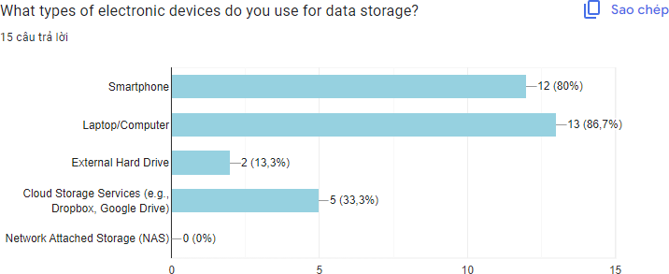

Figure 13 Question 6

Devices Used: The majority use smartphones (80%) and laptops/computers (86.7%) for data storage, while external hard drives and cloud storage services are less commonly used.

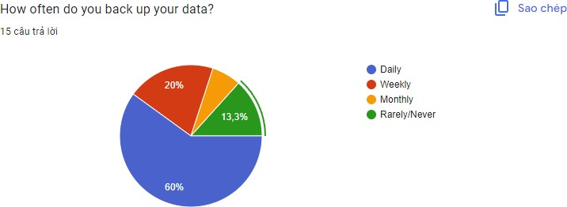

Figure 14 Question 7

Data Backup Frequency: A considerable number of respondents (60%) back up their data daily, emphasizing the importance of data security for this audience.

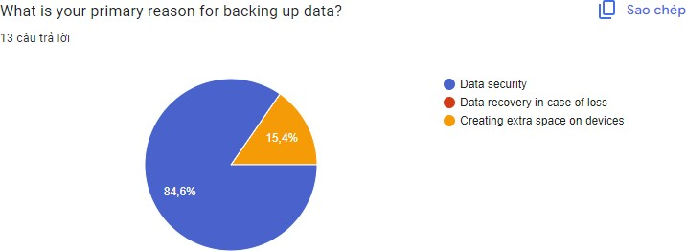

Figure 15 Question 8

Primary Reason for Backup: Data security is the primary motivation for backing up data (84.6%), indicating a strong concern for safeguarding data.

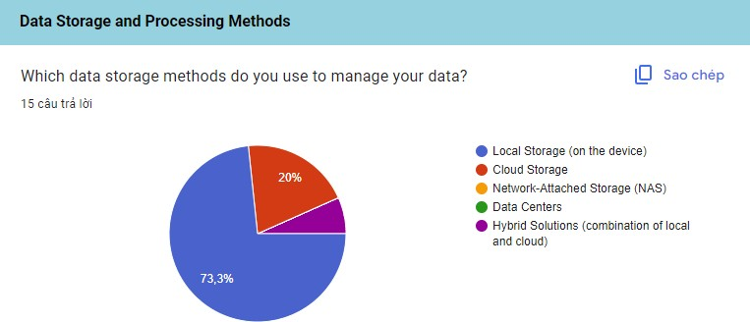

Figure 16 Question 9

Storage Methods: Local storage on devices is the most commonly used data storage method (73.3%), followed by cloud storage (20%) and hybrid solutions (6.7%).

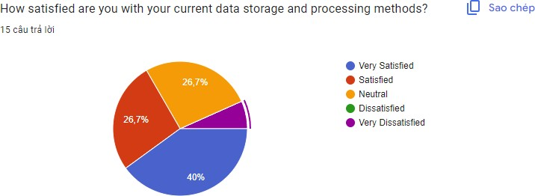

Figure 17 Question 10

Satisfaction: Respondents generally expressed satisfaction with their current data storage and processing methods, with 40% reporting being "Very Satisfied" and 26.7% being "Satisfied." A substantial number are "Neutral," suggesting room for improvement or optimization in data management.

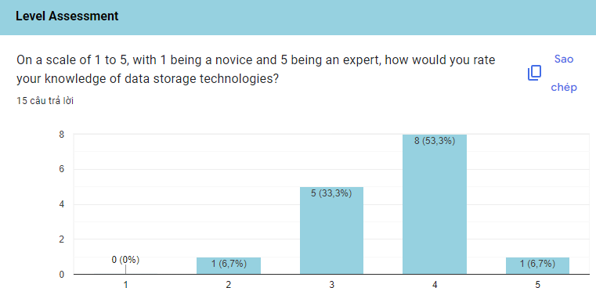

Figure 18 Question 11

Knowledge Level: Respondents generally rate their knowledge of data storage technologies relatively high, with 53.3% indicating a rating of 4 (out of 5), indicating a good level of expertise.

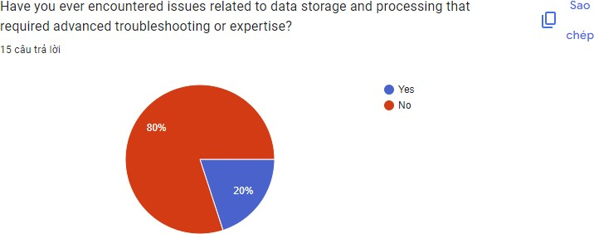

Figure 19 Question 12

Troubleshooting Experience: A significant portion (20%) reported encountering issues requiring advanced troubleshooting or expertise, suggesting opportunities for exploring and addressing common challenges.

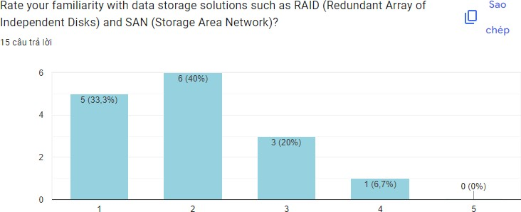

Figure 20 Question 13

Familiarity with Storage Solutions: The majority of respondents (73.3%) rated their familiarity with data storage solutions like RAID and SAN at levels 1 and 2, suggesting that there may be room to increase awareness and understanding of these technologies among the audience.

* **Survey Summary**

**Demographics:** The survey primarily attracted a younger audience, with 66.7% falling into the 25-34 age group. While gender distribution was skewed toward males (73.3%), the education level was relatively balanced, with 46.7% holding Bachelor's degrees. Technology companies were the dominant representation among key companies (84.6%).

**Consumer Data Storage Habits:** The data revealed a trend toward substantial data generation, as 60% reported collecting between 100 GB and 1 TB of data monthly. Smartphones (80%) and laptops/computers (86.7%) were the go-to devices for data storage, while daily backups (60%) underscored the importance of data security. Data security emerged as the primary reason for data backup (84.6%).

**Data Storage and Processing Methods:** Respondents predominantly employed local storage on devices (73.3%), followed by cloud storage (20%) and hybrid solutions (6.7%). While a significant portion expressed satisfaction with their methods, a sizable percentage remained neutral, suggesting room for optimization and improvement.

**Level Assessment:** Knowledge levels of data storage technologies were relatively high, with 53.3% rating themselves at level 4 out of 5. Notably, 20% reported encountering issues necessitating advanced troubleshooting, indicating practical challenges. Familiarity with storage solutions such as RAID and SAN varied, with most respondents indicating lower familiarity levels (1 and 2).

The survey results provide valuable insights into the data storage habits and preferences of the respondents. The majority of respondents are concerned about data security and use local storage and cloud storage services. There is a generally positive sentiment toward their current methods, but there is room for improvement and education, particularly in terms of advanced storage solutions and troubleshooting. These findings can inform strategies for enhancing data storage practices and addressing challenges in the field.

## Analyze the results of the primary research

The primary research, encompassing qualitative interviews and quantitative surveys, delve into the significant realm of big data storage and its associated solutions. This comprehensive analysis highlights crucial findings, implications, and potential avenues for future exploration within the field of big data storage. By delving into these aspects, our objective is to illuminate the intricacies of this issue and contribute to a deeper understanding of the challenges and opportunities in big data storage.

* **Qualitative Interviews**

**Complexity of Data Types:** One of the key findings from qualitative interviews is the complexity of data types in Big Data. Respondents often mentioned dealing with structured, semi-structured, and unstructured data, which creates challenges in storage and retrieval. This complexity requires versatile storage solutions that can handle diverse data formats.

Implication: Companies need to invest in storage solutions that can accommodate a wide variety of data types, including NoSQL databases, data lakes, and distributed file systems.

**Scalability Concerns:** Many interviewees highlighted scalability as a significant challenge. As data volumes continue to grow exponentially, traditional storage systems may become inadequate. Scalable storage solutions, such as distributed storage and cloud storage, are essential to meet increasing data demands.

Implication: Organizations should consider cloud-based storage solutions and distributed storage architectures to ensure scalability.

**Data Security and Privacy:** Data security and privacy emerged as a top concern in the interviews. With increasing data breaches and regulations like GDPR, organizations must implement robust security measures for data at rest and in transit.

Implication: Implement encryption, access controls, and auditing mechanisms to safeguard sensitive data.

**Data Management Complexity:** Respondents expressed challenges in managing metadata, data cataloging, and data governance. Effective data management is crucial for optimizing storage and ensuring data quality.

Implication: Invest in data management tools and practices to streamline data organization and governance.

**Data Quality and Consistency:** Some interviewees raised concerns about maintaining data quality and consistency, especially when dealing with large volumes of diverse data sources. Inaccurate or inconsistent data can lead to incorrect analyses and decisions.

Implication: Implement data cleansing and validation processes as part of the data storage strategy to ensure data quality and consistency.

**Data Lifecycle Management:** Respondents highlighted challenges related to data lifecycle management. Knowing when to archive, delete, or migrate data is crucial for efficient storage management.

Implication: Develop a comprehensive data lifecycle management strategy to optimize storage usage and adhere to data retention policies.

**Regulatory Compliance:** Several interviewees emphasized the importance of complying with data regulations, such as GDPR or HIPAA, which often dictate how data should be stored and secured.

Implication: Stay updated on relevant data regulations and ensure storage solutions are configured to meet compliance requirements.

**Training and Expertise:** Interviewees mentioned the shortage of skilled professionals who can effectively manage and optimize Big Data storage solutions.

Implication: Invest in training and development programs for IT staff to build expertise in Big Data storage technologies.

* **Quantitative Survey**

**Storage Costs:** The quantitative survey confirmed that storage costs remain a primary concern for organizations dealing with Big Data. Respondents indicated that data storage expenses are a significant part of their IT budgets.

Implication: Continuously evaluate storage costs and consider cost-effective storage solutions, including tiered storage and data lifecycle management.

**Performance Bottlenecks:** Survey participants reported performance bottlenecks as a challenge, particularly in the context of real-time data processing. Slow storage can hinder data analytics and decision-making.

Implication: Optimize storage performance through technologies like SSDs, caching, and data compression.

**Data Backup and Disaster Recovery:** The survey highlighted concerns about data backup and disaster recovery strategies. Many organizations struggle to implement efficient backup and recovery solutions for Big Data.

Implication: Develop robust data backup and disaster recovery plans, including data replication and cloud-based backup services.

**Vendor Lock-In:** Some respondents expressed concerns about vendor lock-in when using proprietary storage solutions. This can limit flexibility and increase long-term costs.

Implication: Evaluate open-source and vendor-neutral storage solutions to avoid lock-in and maintain flexibility.

**Data Accessibility:** Survey results showed that ensuring data accessibility for users across the organization is a challenge. Data stored in complex systems or silos can be difficult for non-technical users to access.

Implication: Implement user-friendly data access tools and self-service analytics platforms to empower users to retrieve and analyze data efficiently.

**Data Versioning and Control:** Some respondents expressed concerns about maintaining data version control, especially in collaborative environments. It can be challenging to track changes and ensure data consistency.

Implication: Implement version control mechanisms and data change tracking to maintain data integrity.

**Environmental Impact:** The survey highlighted growing concerns about the environmental impact of data storage, particularly with the increasing energy consumption of data centers.

Implication: Consider sustainable data storage solutions, such as energy-efficient data centers, and explore green data storage practices.

**Data Portability:** Respondents mentioned challenges related to data portability between different storage solutions and platforms. Vendor-specific formats and protocols can hinder data migration.

Implication: Prioritize data portability by using open standards and formats to minimize lock-in and facilitate data transfer.

**Data Analytics Integration:** Some respondents noted difficulties in integrating data storage solutions with analytics tools, which can lead to delays in data analysis.

Implication: Ensure compatibility between storage systems and analytics platforms to streamline data analysis processes.

# Communicate research outcomes in an appropriate manner for the intended audience(P5)

## Conclusion

The world of Big Data storage presents several critical challenges that organizations must navigate as they seek to harness the power of vast and complex data sets. These challenges revolve around scalability, performance, cost management, and data security.

Firstly, scalability is a paramount concern. Big Data is characterized by its sheer volume, and traditional storage systems often struggle to scale effectively to accommodate this ever-expanding data landscape. To address this challenge, organizations are turning to distributed storage solutions like the Hadoop Distributed File System (HDFS) and cloud-based storage platforms. These solutions allow for the seamless scaling of storage capacity to match the growing demands of Big Data.

Performance is another major hurdle. As the volume of data continues to soar, maintaining high- performance storage and ensuring swift data access become increasingly challenging. To overcome this obstacle, data tiering strategies are being employed. This involves storing frequently accessed data on high-performance

storage media, such as solid-state drives (SSDs), while archiving less frequently used data on lower-cost storage options. This balance between performance and cost-efficiency is crucial in the world of Big Data.

Cost management is an ever-present concern in Big Data storage. The sheer size of data sets can lead to rapidly escalating storage expenses. To mitigate this, organizations are exploring cost-effective storage options like object storage and cloud storage. These solutions not only provide scalability but also offer flexibility in managing storage costs, allowing organizations to pay for what they use.

Last but certainly not least, data security is a paramount consideration. Big Data often contains sensitive information that must be protected from breaches, unauthorized access, and data loss. Robust encryption and access control mechanisms are imperative for ensuring data security in the world of Big Data storage. These measures help safeguard Big Data assets and maintain the trust of stakeholders.

In conclusion, the challenges of storing Big Data are multifaceted but not insurmountable. Organizations are meeting these challenges head-on by adopting distributed storage, implementing data tiering strategies, exploring cost-effective storage options, and prioritizing data security. By addressing these challenges with the appropriate solutions, organizations can efficiently manage and derive insights from their Big Data while safeguarding its integrity, performance, and security.

## Recommendations

Based on the analysis of the primary research on key challenges related to data storage for Big Data and their associated solutions, here are some recommendations for organizations dealing with Big Data storage:

1. **Assess Data Needs and Goals:**

Start with a thorough assessment of your organization's data needs, including data types, volumes, and growth projections.

Clearly define your data storage goals, such as scalability, performance, security, and compliance.

1. **Adopt Scalable Storage Solutions:**

Consider cloud-based storage solutions that offer scalability on-demand, allowing you to accommodate growing data volumes without major infrastructure overhauls.

Implement distributed storage systems that can scale horizontally as your data needs increase.

1. **Prioritize Data Security and Compliance:**

Invest in robust data security measures, including encryption, access controls, and regular security audits.

Ensure compliance with relevant data protection regulations (e.g., GDPR, HIPAA) by implementing data governance policies and practices.

1. **Implement Data Management Best Practices:**

Establish effective data cataloging and metadata management processes to improve data discoverability and organization.

Implement data lifecycle management to optimize storage usage and meet data retention policies.

1. **Control Storage Costs:**

Regularly review and optimize your data storage costs by using tiered storage solutions and archiving data that is no longer frequently accessed.

Explore open-source and cost-effective storage options to avoid vendor lock-in and reduce long-term expenses.

1. **Enhance Data Accessibility:**

Implement user-friendly data access tools and self-service analytics platforms to empower non-technical users to retrieve and analyze data.

Ensure data is accessible and usable across different departments and teams within your organization.

1. **Address Environmental Impact:**

Consider the environmental impact of your data storage solutions and explore energy-efficient data centers or sustainable practices.

Optimize server and data center utilization to reduce energy consumption.

1. **Develop Data Expertise:**

Invest in training and development programs for IT staff to build expertise in Big Data storage technologies and best practices.

Consider hiring or contracting professionals with expertise in data management and storage.

1. **Foster Data Portability:**

Prioritize data portability by using open standards and formats to minimize vendor lock-in and facilitate data migration.

Ensure that data can be easily moved between different storage solutions and platforms.

1. Embrace Integration:

Ensure compatibility between your data storage systems and analytics platforms to streamline data analysis processes.

Explore integrated solutions that combine storage, analytics, and data management to simplify operations.

1. **Stay Informed and Innovate:**

Continuously monitor industry trends and emerging technologies in Big Data storage.

Be open to adopting new storage technologies, such as software-defined storage and serverless storage, as they mature and become more suitable for your needs.

1. **Data Backup and Disaster Recovery:**

Develop a robust data backup and disaster recovery plan that includes regular backups, off-site storage, and clear procedures for data restoration in case of unexpected events.

Test your disaster recovery plan regularly to ensure its effectiveness.

1. **Data Analytics and Machine Learning Integration:**

Leverage advanced analytics and machine learning algorithms to optimize data storage. These technologies can help identify data usage patterns and automatically manage data placement and retention.

Explore AI-driven storage solutions that can predict data storage needs and proactively allocate resources.

1. **Data Compression and Deduplication:**

Implement data compression and deduplication techniques to reduce storage space requirements, especially for redundant or highly compressible data.

Regularly assess the effectiveness of these techniques to strike the right balance between storage savings and data retrieval performance.

1. **Real-time Data Processing:**

Invest in storage solutions that support real-time data processing to enable quicker decision-making and immediate insights.

Utilize in-memory storage technologies for low-latency data access when real-time processing is critical.

* 1. **Cloud-Native Storage:**

Embrace cloud-native storage solutions that are designed to work seamlessly with cloud platforms. These solutions offer elasticity, cost-efficiency, and ease of management.

Explore multi-cloud or hybrid cloud strategies to avoid vendor lock-in and ensure data redundancy.

In conclusion, effectively managing Big Data storage requires a multifaceted strategy encompassing technology, governance, and cost considerations. Implementing these recommendations empowers organizations to optimize data storage, address scalability and security challenges, and harness emerging technologies like machine learning and cloud-native solutions. Ethical data practices and regulatory compliance are imperative to build trust and protect sensitive information. Collaboration, continuous monitoring, and vendor relationships are vital for maintaining a resilient storage infrastructure. By adopting these strategies, organizations can unlock the full potential of their data assets, fostering innovation, agility, and competitiveness in the data-driven landscape.

# Conclusion

In summary, the domain of Big Data storage stands as a crucial battleground for organizations seeking to harness the extensive potential of data-driven insights and innovation. The hurdles associated with handling Big Data, including scalability, data variety, velocity, security, latency, cost, governance, and resource optimization, pose significant challenges, yet they are not insurmountable. This study has illuminated the intricate nature of these obstacles and the ever-evolving landscape of solutions devised to overcome them. Ranging from scalable distributed systems to robust data governance practices, organizations possess a diverse set of tools and strategies. As the volume of data continues to proliferate at an unprecedented pace, comprehending and effectively addressing these challenges is not merely an operational necessity but a strategic imperative.

# References

Bhandari, P. (2023a) *What is qualitative research?: Methods & examples*, *Scribbr*. Available at: https://www.scribbr.com/methodology/qualitative-research/ (Accessed: 08 March 2024).

Bhandari, P. (2023b) *What is quantitative research?: Definition, uses & methods*, *Scribbr*. Available at: https://www.scribbr.com/methodology/quantitative-research/ (Accessed: 08 March 2024).

Bhat, A. (2024) *Qualitative research: Definition, types, methods and examples*, *QuestionPro*. Available at: https://www.questionpro.com/blog/qualitative-research-methods/ (Accessed: 08 March 2024).

Fleetwood, D. (2023) *Quantitative research: What it is, practices & methods*, *QuestionPro*. Available at: https://www.questionpro.com/blog/quantitative-research/ (Accessed: 08 March 2024).

George, T. (2024a) *Primary research: Definition, types, & examples*, *Scribbr*. Available at: https://www.scribbr.com/methodology/primary-research/ (Accessed: 08 March 2024).

George, T. (2024b) *What is secondary research?: Definition, types, & examples*, *Scribbr*. Available at: https://www.scribbr.com/methodology/secondary-research/#%3A~%3Atext%3DSecondary%20research%20is%20a%20research (Accessed: 08 March 2024).

Nasrudin, A. (2022a) *Primary research: Methods, advantages, and disadvantages*, *Penpoin.* Available at: https://penpoin.com/primary-research/ (Accessed: 08 March 2024).

Nasrudin, A. (2022b) *Secondary research: Meaning, sources, advantages, disadvantages*, *Penpoin.* Available at: https://penpoin.com/secondary-research/ (Accessed: 08 March 2024).

*Primary research methods explained* (no date) *SmartSurvey*. Available at: https://www.smartsurvey.co.uk/articles/primary-research-methods (Accessed: 08 March 2024).

*What is Big Data?* (no date) *Oracle*. Available at: https://www.oracle.com/big-data/what-is-big-data/ (Accessed: 08 March 2024).

Streefkerk, R. (2023) *Qualitative vs. quantitative research: Differences, examples & methods*, *Scribbr*. Available at: https://www.scribbr.com/methodology/qualitative-quantitative-research/ (Accessed: 08 March 2024).