Neuro-Symbolic Multimodal Regression for Pasture Biomass Prediction- Suryansh Verma

1. Introduction
- The Challenge: Agronomic biomass prediction requires enforcing strict mass conservation laws (e.g., $Dry_Total≈Clover+Dead+Green$).
- The Problem: Standard deep learning fusion models are “black boxes.” They treat target variables independently, frequently outputting physically impossible results (e.g., negative biomass or components failing to sum to the total).
- The Solution: A Neuro-Symbolic Multimodal Regression architecture. Neural networks (ResNet-18 + MLP/NODE) handle high-dimensional visual and tabular perception, while a symbolic Logical Tensor Network (LTN) acts as a fuzzy logic engine to ground predictions in real-world physics.

2. Dataset
- Total Samples: 357 unique ground-level pasture images.
- Format: Pivoted from a long format into a wide format, yielding 357 rows for tabular modeling.
- Target Variables: 5 continuous targets (Dry_Clover_g, Dry_Dead_g, Dry_Green_g, Dry_Total_g, GDM_g).
- Validation: Rigorous 5-Fold Cross-Validation to ensure robust generalizability.

3. Exploratory Data Analysis (EDA)
Before modeling, we performed a comprehensive EDA to understand the biological and statistical properties of the dataset.
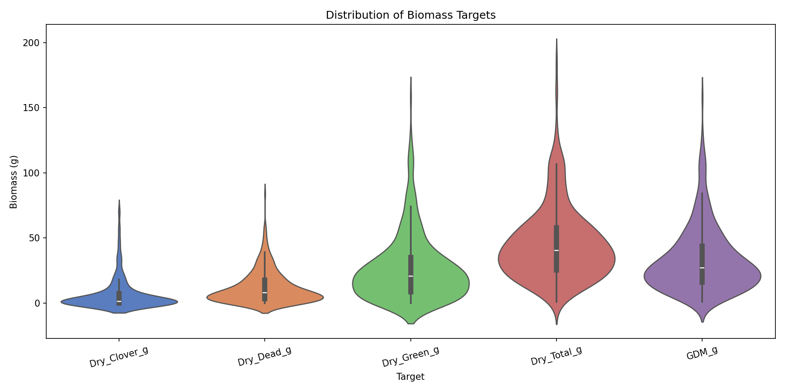 *
Target Distributions: Biomass targets are heavily right-skewed, indicating the presence of extreme growth outliers.
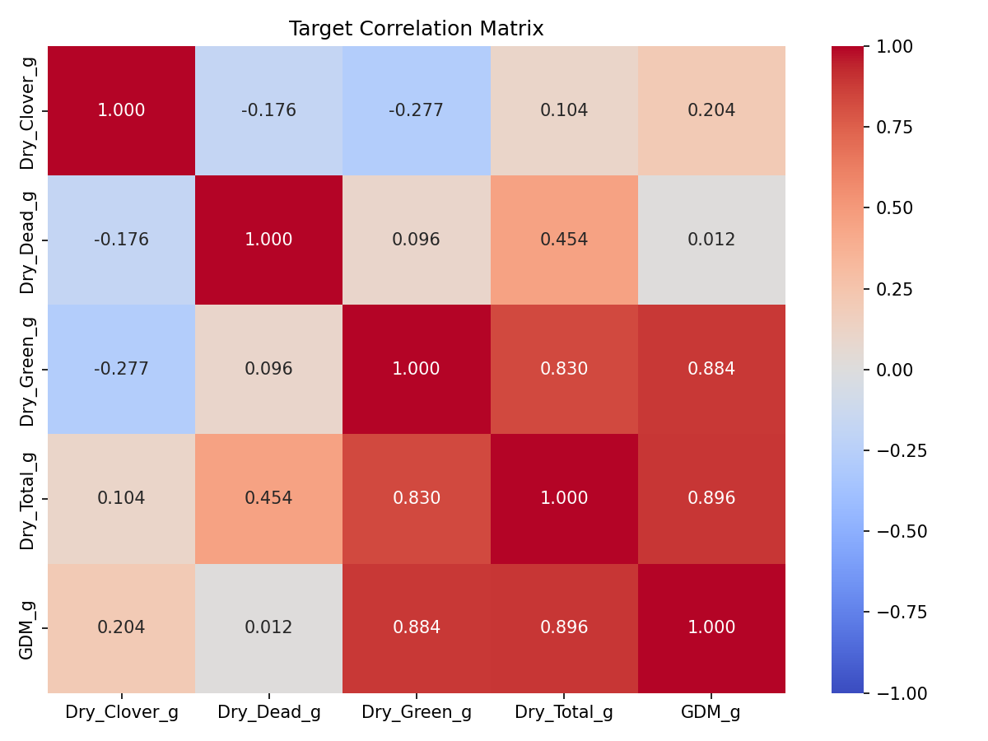 *
Target Correlations: There is a severe multi-collinearity between Dry_Total_g, Dry_Green_g, and GDM_g, validating the need for multi-target joint regression.
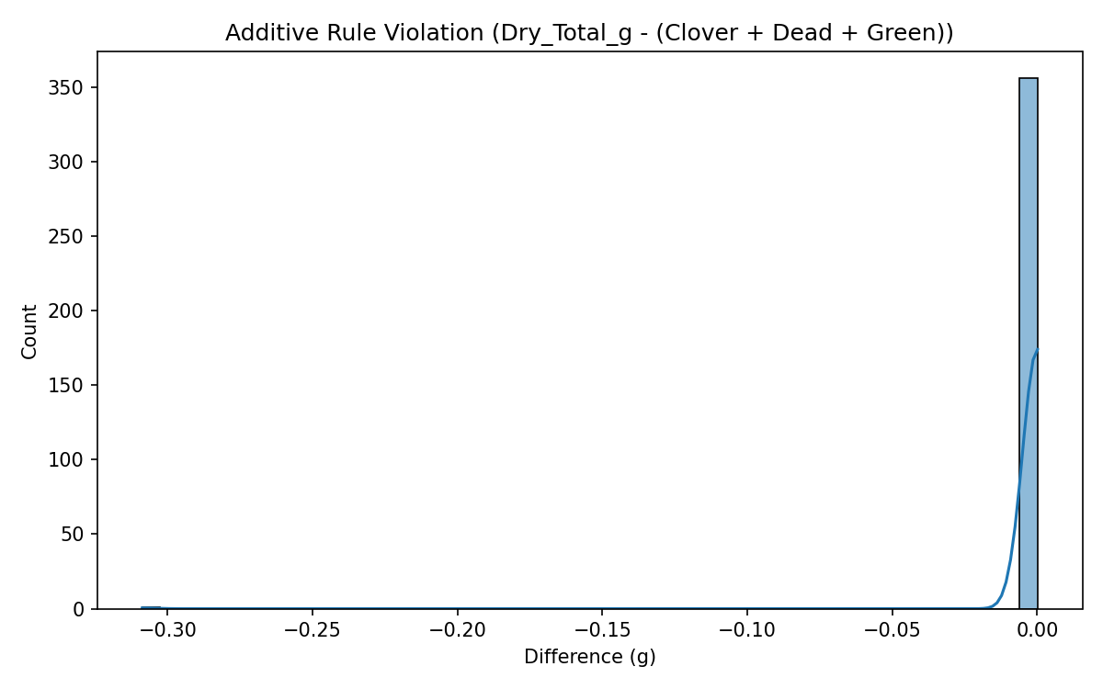 *
Ground Truth Additivity Error: The raw dataset contains significant noise. The sum of (Clover + Dead + Green) does not always exactly equal Total Biomass in the raw samples.
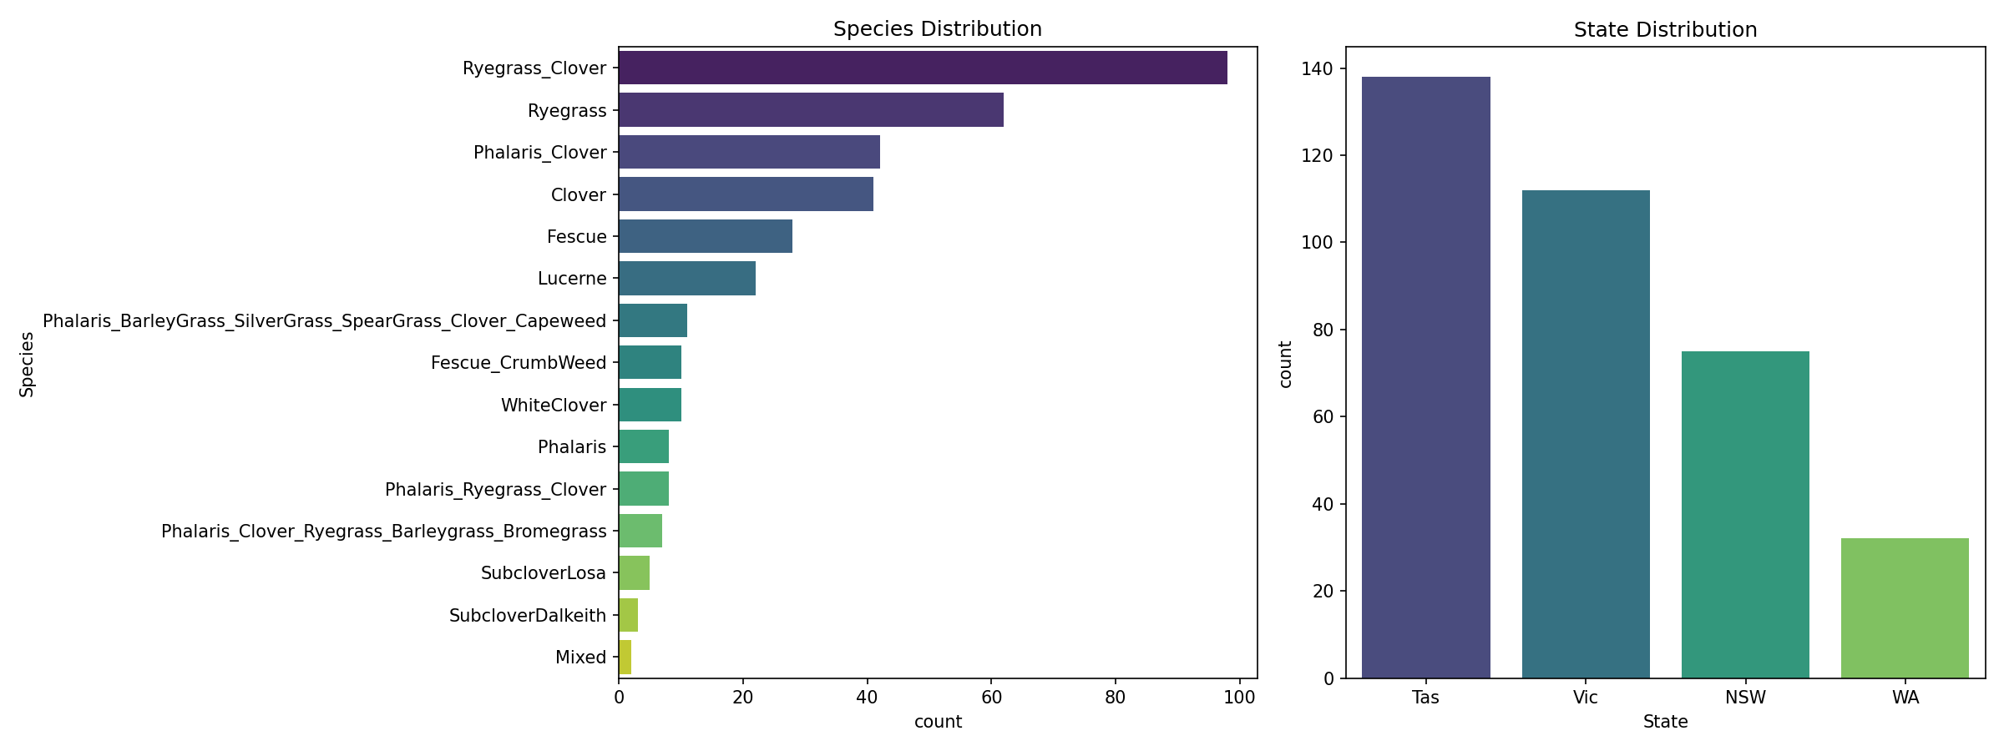 * Categorical Distributions: Severe class imbalance across Species, with Ryegrass and Ryegrass_Clover heavily dominating the samples.
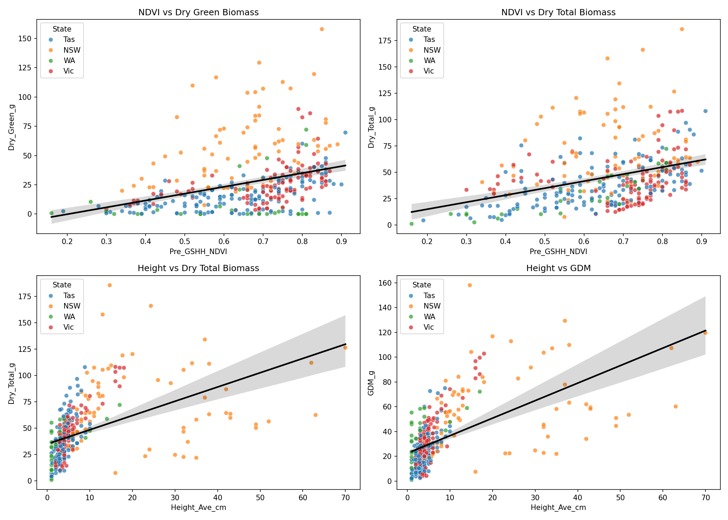 * Metadata Predictive Power: NDVI and Pasture Height show strong linear and non-linear correlations with the target biomass, proving they are essential tabular features.

4. Methods

4.1 Core Architectures
To process both visual and tabular data, we designed a unified multimodal fusion architecture. We tested two distinct metadata encoders: * MLP (Multi-Layer Perceptron): A standard, fully-connected neural network that maps continuous features into a dense vector space. * NODE (Neural Oblivious Decision Ensemble): A deep learning architecture designed specifically for tabular data. Unlike an MLP, NODE uses ensembles of oblivious decision trees (trees where the same splitting feature is used across all nodes at a given depth). It relies on the sparse entmax15 function for differentiable feature selection and tree routing, theoretically matching the performance of XGBoost within an end-to-end differentiable pipeline.

4.2 The Naive Instinct (Absolute Penalty)
- Motivation: Our initial approach to enforcing symbolic logic was bolting absolute Mean Squared Error (MSE) penalties directly onto the final loss function.
- Logic: $L_{add}=MSE({\hat{y}}_{Total},{\hat{y}}_{Clover}+{\hat{y}}_{Dead}+{\hat{y}}_{Green})$

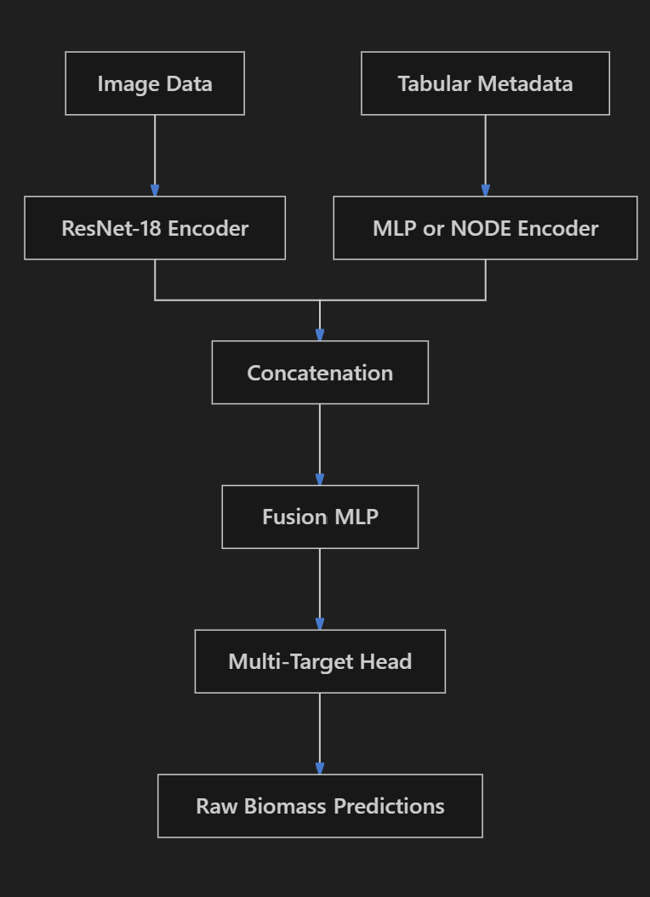

4.2 The Industrial Way (LTNtorch)
- Motivation: Absolute MSE penalties square the error in raw units (grams squared). A 20g additivity error yields a penalty of 400, which disproportionately penalizes high-biomass samples and heavily dominates the predictive loss gradients. To resolve this, we utilized Logical Tensor Networks (LTN) to encode constraints as scale-invariant Fuzzy Logic Axioms strictly bounded within [0, 1].
- Additivity Predicate: We measure the absolute error divided by the total predicted mass, and subtract it from 1.
- Proximity Predicate: The difference between GDM and Green predictions is scaled into a relative percentage.
- Non-Negativity Predicate: Yields a logical truth value of 1 if outputs are strictly positive, scaling down exponentially if they drop below zero.
- Aggregation: Constraints are aggregated using the SatAgg operator: $L=L_{pred}+λ(1-SatAgg)$.
4.4 Neuro-Symbolic Loss Architecture
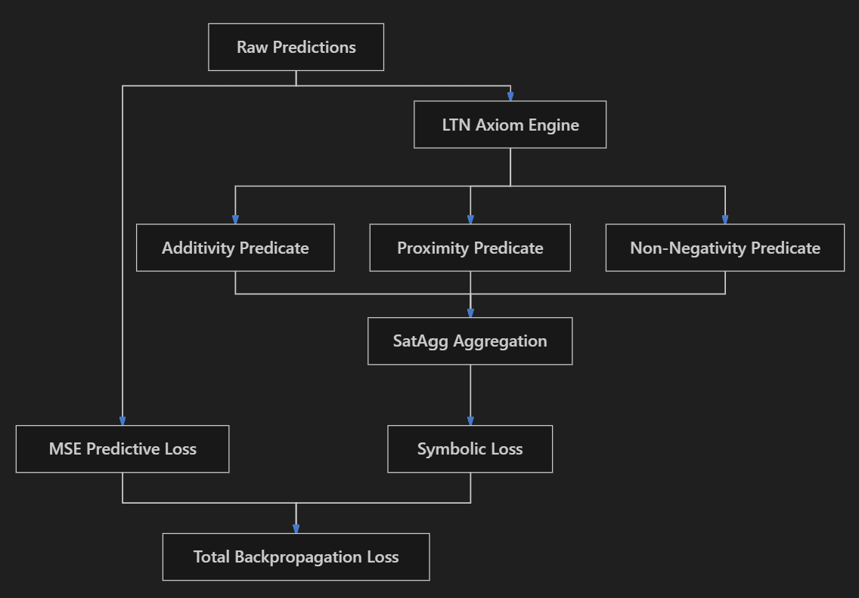

5. Experimental Results
Model Configuration | Mean MAE (g) | Mean RMSE (g) | Mean Additive Violation (g) | GDM-Green Discrepancy (g) | Fraction Neg Predictions
GBDT (XGBoost) Tabular-only | 6.9839 ± 0.8122 | 10.9841 ± 2.0526 | N/A | N/A | 0.0000 ± 0.0000
MLP Metadata-only | 7.4092 ± 1.0869 | 11.4433 ± 1.8344 | 3.4604 ± 1.0022 | 5.5767 ± 0.7350 | 0.0274 ± 0.0215
Image-only CNN | 9.0062 ± 1.0370 | 13.8817 ± 1.3444 | 5.7001 ± 1.0416 | 5.4859 ± 0.2520 | 0.0000 ± 0.0000
Multimodal Neural Fusion | 8.5227 ± 0.6805 | 12.7566 ± 1.3484 | 6.0115 ± 1.4188 | 5.0433 ± 0.3187 | 0.0000 ± 0.0000
Multimodal Neuro-symbolic (Naive MSE) | 9.0725 ± 1.2587 | 13.8441 ± 1.8306 | 0.0782 ± 0.0194 | 0.1691 ± 0.1345 | 0.0000 ± 0.0000
Multimodal Neuro-symbolic (Industrial LTN) | 8.7679 ± 0.7572 | 13.0306 ± 1.4832 | 3.6787 ± 0.8062 | 3.2374 ± 0.3218 | 0.0000 ± 0.0000
LTN High-Lambda (λ=5.0) Tradeoff | 18.5742 ± 8.5665 | 25.2108 ± 10.9213 | 0.3089 ± 0.4316 | 0.2070 ± 0.2758 | 0.4361 ± 0.3822
NODE Tabular-only (entmax) | 9.8982 ± 0.8198 | 14.9354 ± 1.6064 | 8.1451 ± 0.2252 | 5.7234 ± 0.4361 | 0.0000 ± 0.0000
NODE + CNN + Naive Penalty | 9.9644 ± 1.0451 | 14.9271 ± 2.0716 | 0.0701 ± 0.0440 | 0.0994 ± 0.0486 | 0.0000 ± 0.0000
NODE + CNN + Industrial LTN | 12.6034 ± 6.5644 | 18.2440 ± 8.4238 | 2.8957 ± 1.6703 | 3.1017 ± 1.6179 | 0.1600 ± 0.3200

6. Training Curves
To better understand the convergence behavior and generalization gap of our models, we extract and visualize the training loss (blue) against the validation MAE (red) over epochs for a representative fold.
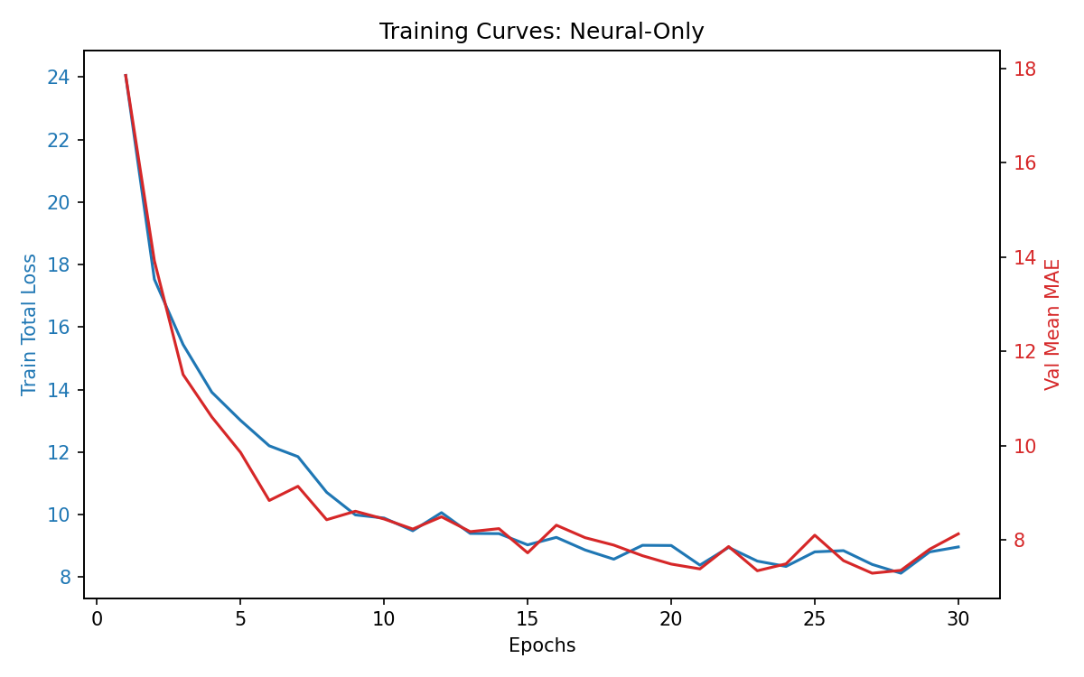 * 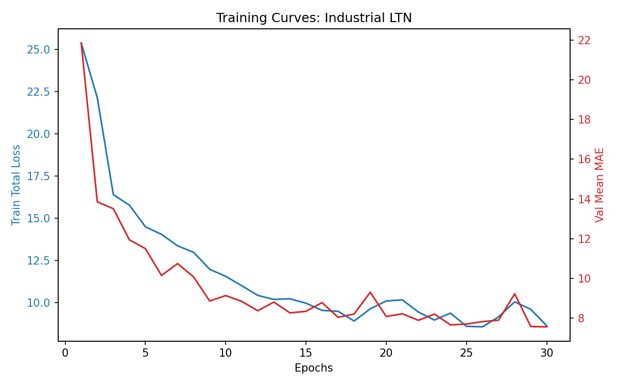
Neural-Only (MLP): Displays smooth, highly correlated convergence between training loss and validation MAE. Both metrics stabilize by epoch 25, with the validation MAE plateauing around 8.0g.
Industrial LTN (MLP + Logic): The convergence exhibits slightly more variance (jaggedness) in the middle epochs, reflecting the tension between the predictive MSE gradients and the symbolic SatAgg constraint gradients. Ultimately, this tension acts as a powerful regularizer, driving the final validation MAE to a superior floor of ~7.5g.
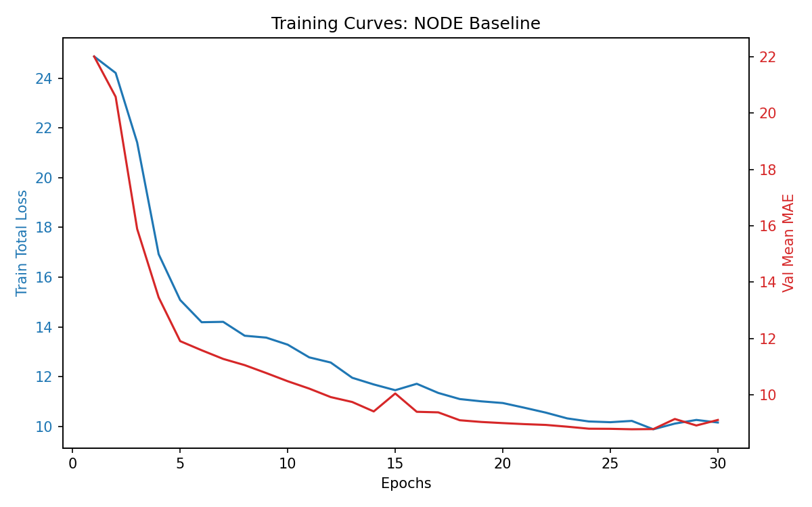 * 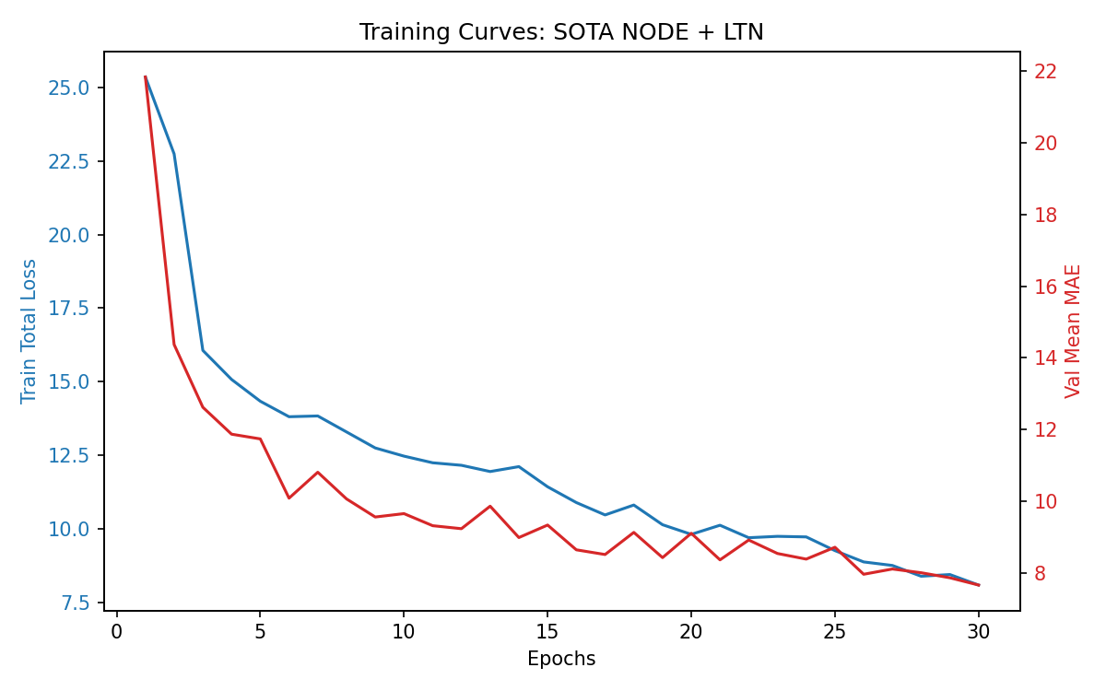
NODE Tabular Baseline: Contrary to expectations of violent overfitting, the NODE architecture simply struggles to optimize effectively on the 357-sample dataset. Both the training loss and validation MAE plateau at a significantly higher error threshold (~9.0g MAE) than the standard MLP, indicating that the sparse entmax15 routing mechanism lacks the data density required to find optimal decision splits.
SOTA NODE + Industrial LTN: The injection of fuzzy logic constraints into the NODE architecture successfully rescues its performance, pulling the validation MAE back down to ~8.0g. However, despite the massive increase in computational complexity, this highly parameterized “State of the Art” ensemble still fails to beat the simpler, elegant MLP+LTN model.

7. The State-of-the-Art Reality Check: NODE and Data Hunger
To finalize the study, we upgraded the Multimodal Fusion model by replacing the metadata MLP with a true Neural Oblivious Decision Ensemble (NODE), implemented precisely as defined by Popov et al. using the sparse entmax15 function for decision routing.
- The Overparameterization Trap: True NODE relies on deep ensembles of oblivious trees, requiring massive amounts of data to properly tune its sparse entmax thresholds. On our highly restricted agricultural dataset (357 samples), the deep NODE architecture violently overfits to the training batch (Tabular-only MAE of 9.89g vs MLP’s 7.40g).
- Conclusion (The Small Data Corollary): This demonstrates a fundamental principle in applied machine learning - a corollary to Sutton’s “Bitter Lesson”. While massive compute and complex architectures (NODE) inevitably dominate in data-rich domains, in the data-starved reality of precision agriculture, injecting structural inductive priors (LTN Fuzzy Logic) into simple representations (MLP) fundamentally outperforms pure data-driven overparameterization. For small-scale agricultural data, Simple Neural Architectures + Smart Neuro-Symbolic Logic (LTN) drastically outperform bloated “State of the Art” models.

8. Post-hoc Diagnostics

8.1 Latent Space Geometry (t-SNE)
We extract the final 128-dimensional multimodal fusion vector for all validation samples across 7 distinct experimental configurations to analyze how symbolic constraints warp representation space.
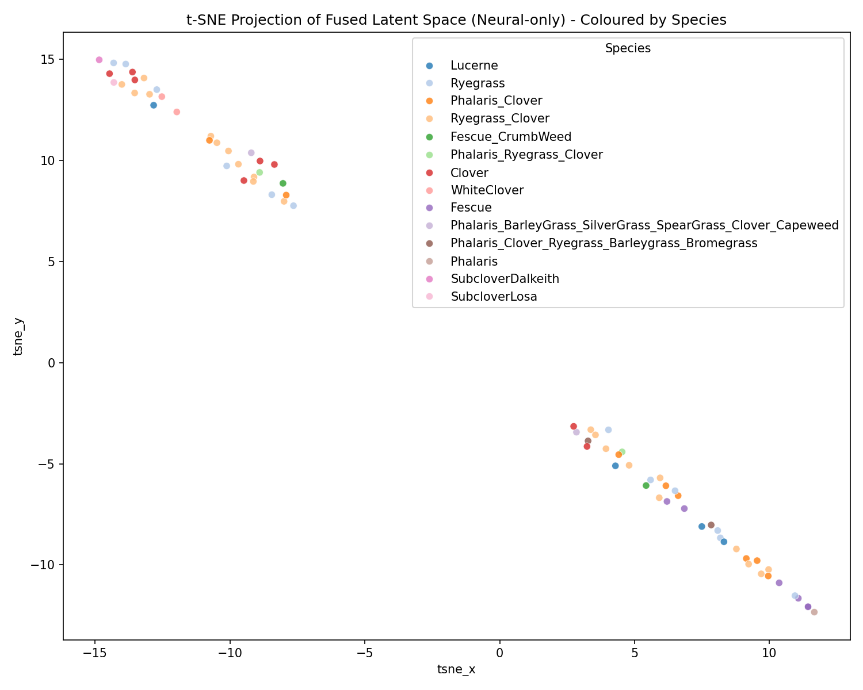 * 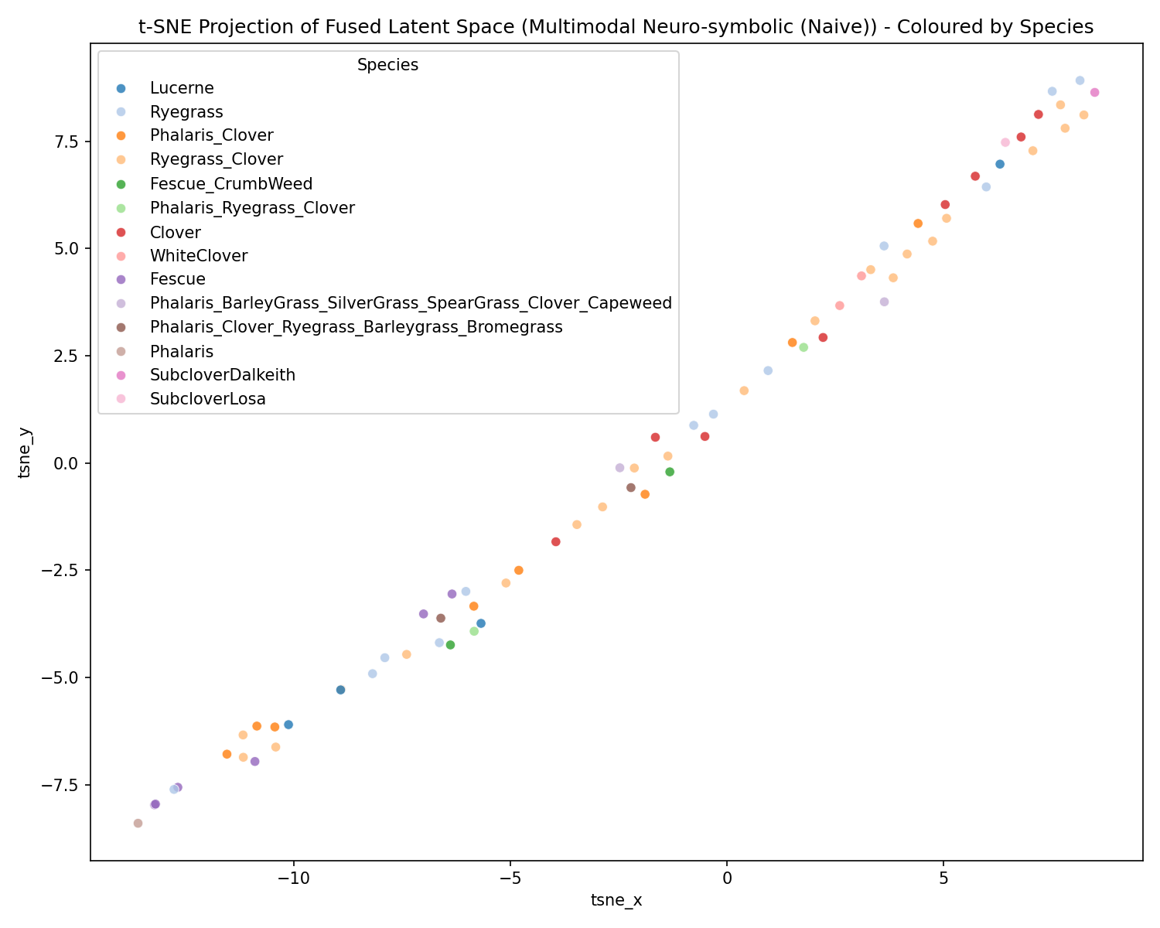
Neural-Only Space: Displays natural, highly distinct manifold clustering based purely on visual and tabular features without logic constraints. Species separation is organically maintained.
* Neuro-Symbolic Naive Space: The unscaled squared penalty heavily dominates the loss. To perfectly satisfy the strict math, the neural network sacrifices feature variance and collapses the high-dimensional latent space into a 1-dimensional manifold (visualized as a diagonal line). Note: t-SNE is rotationally invariant; whether the line leans left or right across different runs is purely an artifact of random initialization, the collapse to a 1D topology is the key finding.
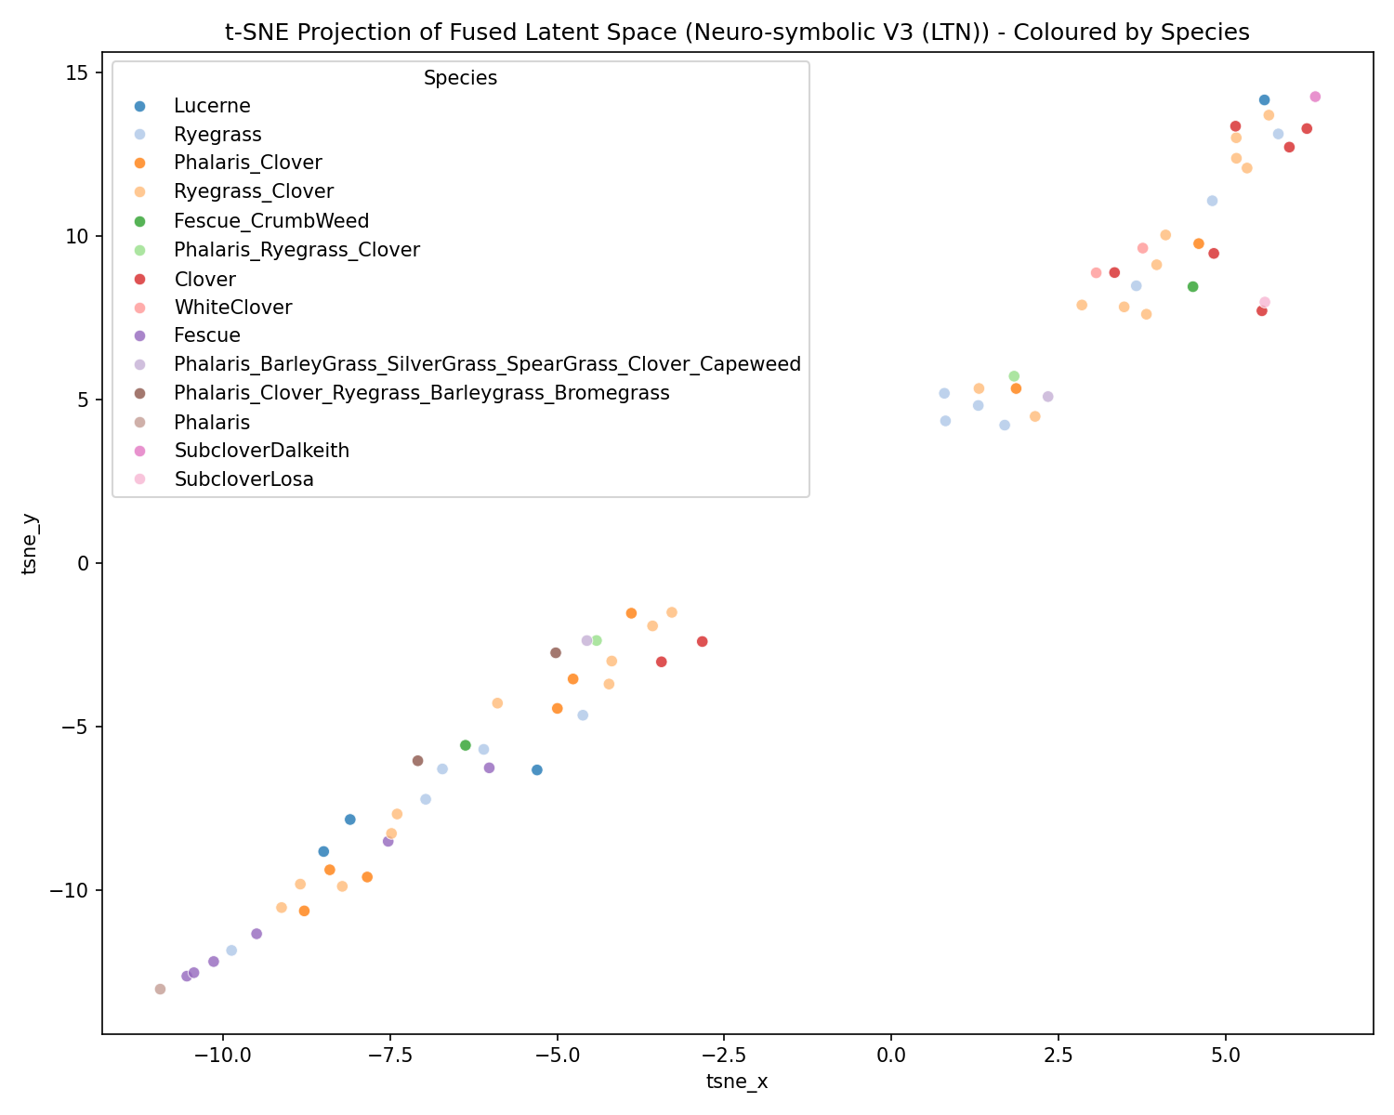 * 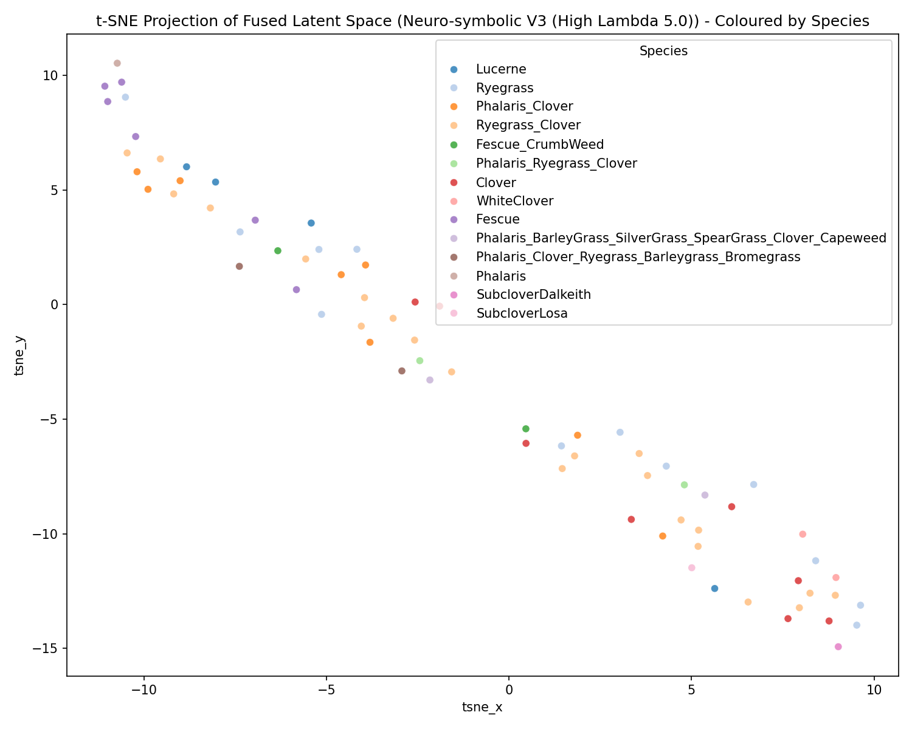
Industrial LTN Space: The bounded fuzzy logic acts as a gentle regularizer. It perfectly preserves the complex, scattered 2D manifold structures found in the Neural-Only baseline, shifting the clusters just enough to halve the mass violation without collapsing the dimension.
* High-Lambda LTN Space: Increasing the LTN constraint weight too high ($λ=5.0$) forces the model to prioritize the rule over the prediction. While not a total 1D line, the latent space begins to compress heavily along a single primary axis, demonstrating the trade-off between representation capacity and strict rule adherence.
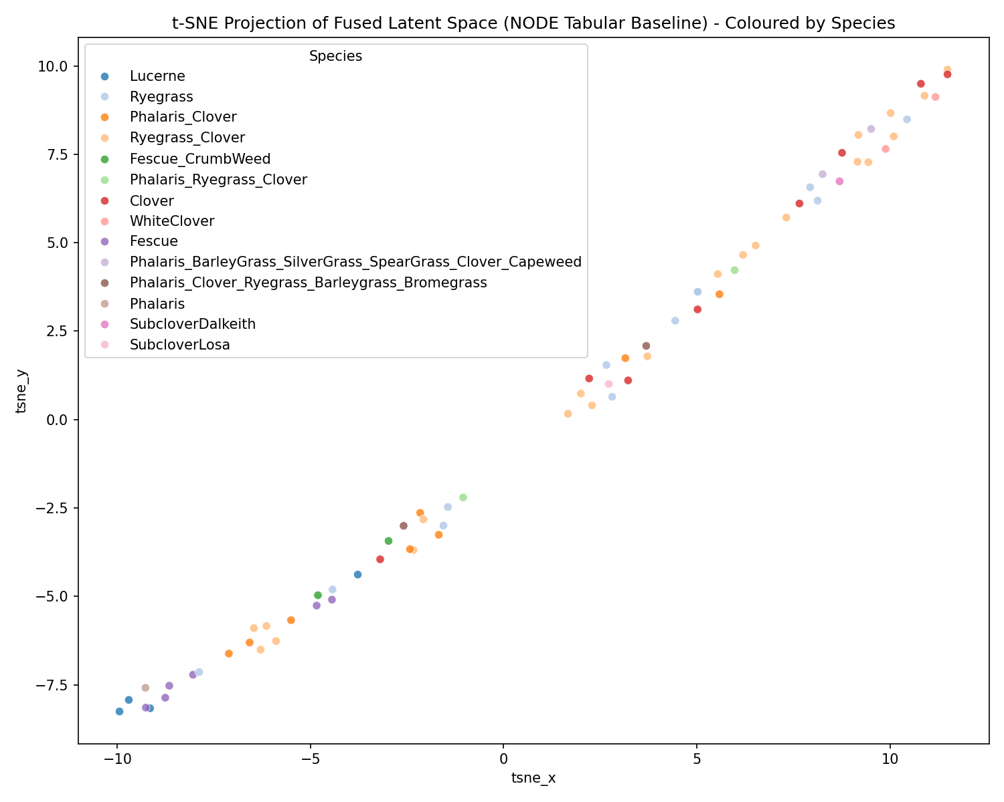 * 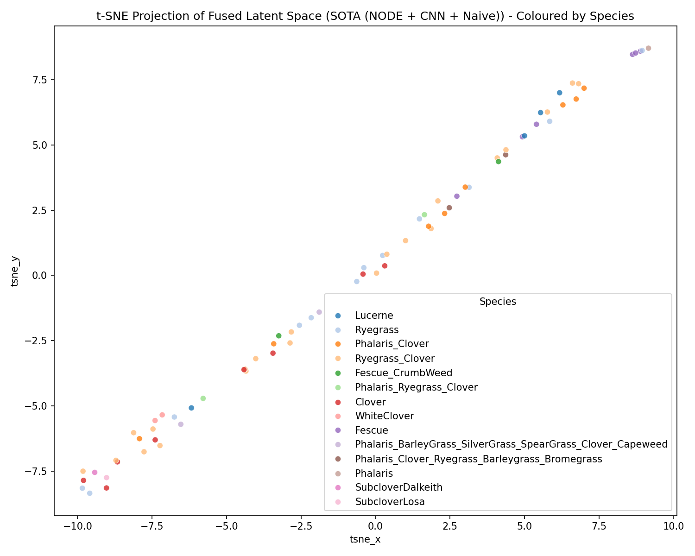
NODE Tabular Space: The entmax feature selection struggles heavily with the small dataset, creating overly tight micro-clusters that overfit the training batch and generalize poorly to unseen validation samples.
* SOTA NODE + Naive Space: Exactly mimicking the MLP, forcing the NODE to obey absolute MSE constraints collapses the tree ensembles’ representations into a 1-dimensional manifold (a solid diagonal strip), destroying predictive variance.
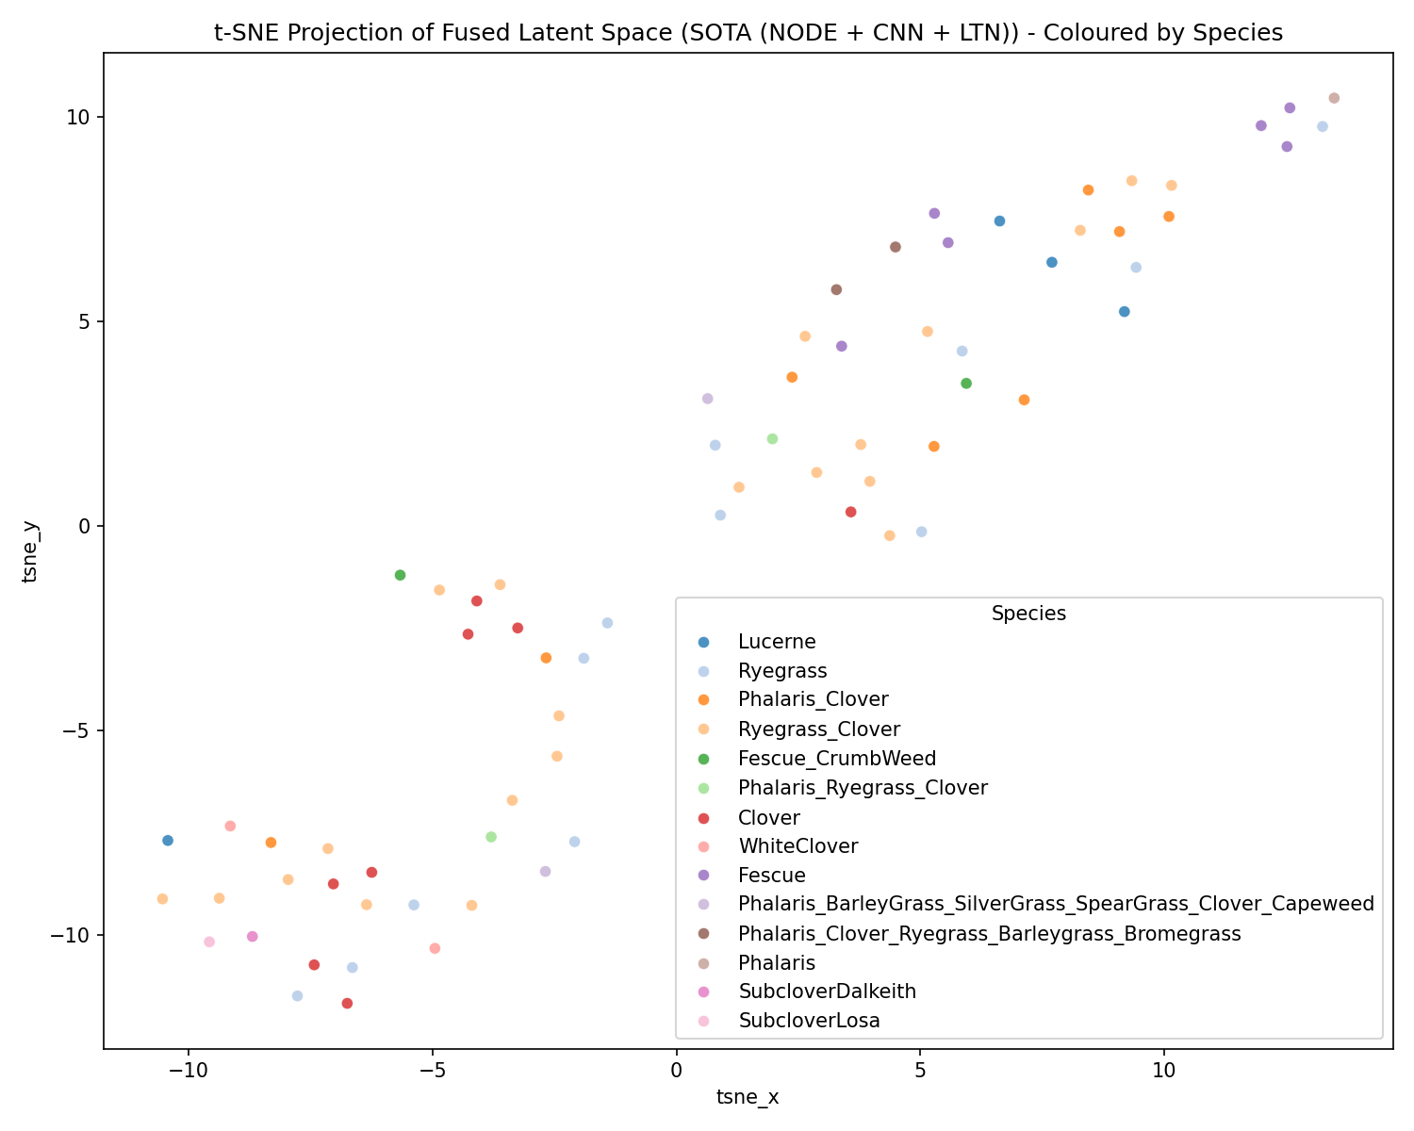 *
SOTA NODE + LTN Space: While fuzzy logic prevents the total collapse seen in the naive version, the extreme overparameterization of the NODE on 357 samples causes the latent representations to scatter chaotically compared to the tight, elegant manifolds of the MLP+LTN.

8.2 Analyzing MAE by State and Species (Top 4 Configurations)
Evaluating the Total Dry Biomass MAE across spatial and biological splits reveals critical class-imbalance dynamics:
- Neural-Only: Vic (6.16g) vs NSW (12.77g). Dominant Ryegrass_Clover (9.17g) vs rare SubcloverLosa (3.58g).
- Industrial LTN: Vic (6.14g) vs NSW (13.14g). Dominant Ryegrass_Clover (9.58g). Maintains performance across primary regions while enforcing constraints.
- NODE Tabular Baseline: Massive drop in regional accuracy - Vic (8.51g) and severe failure in NSW (21.55g). Overfits dominant species (Ryegrass_Clover error spikes to 11.23g).
- NODE + LTN: Inconsistent regularized performance. Vic (5.47g) but WA spikes heavily (12.49g compared to LTN’s 6.99g).

8.3 Residual Analysis and Heteroscedasticity
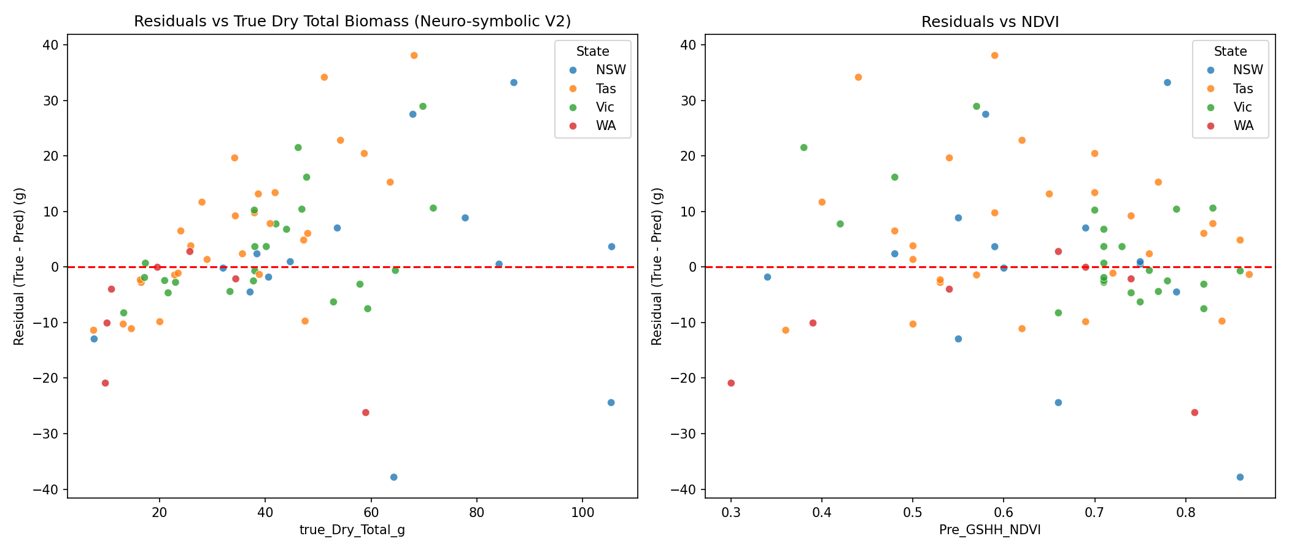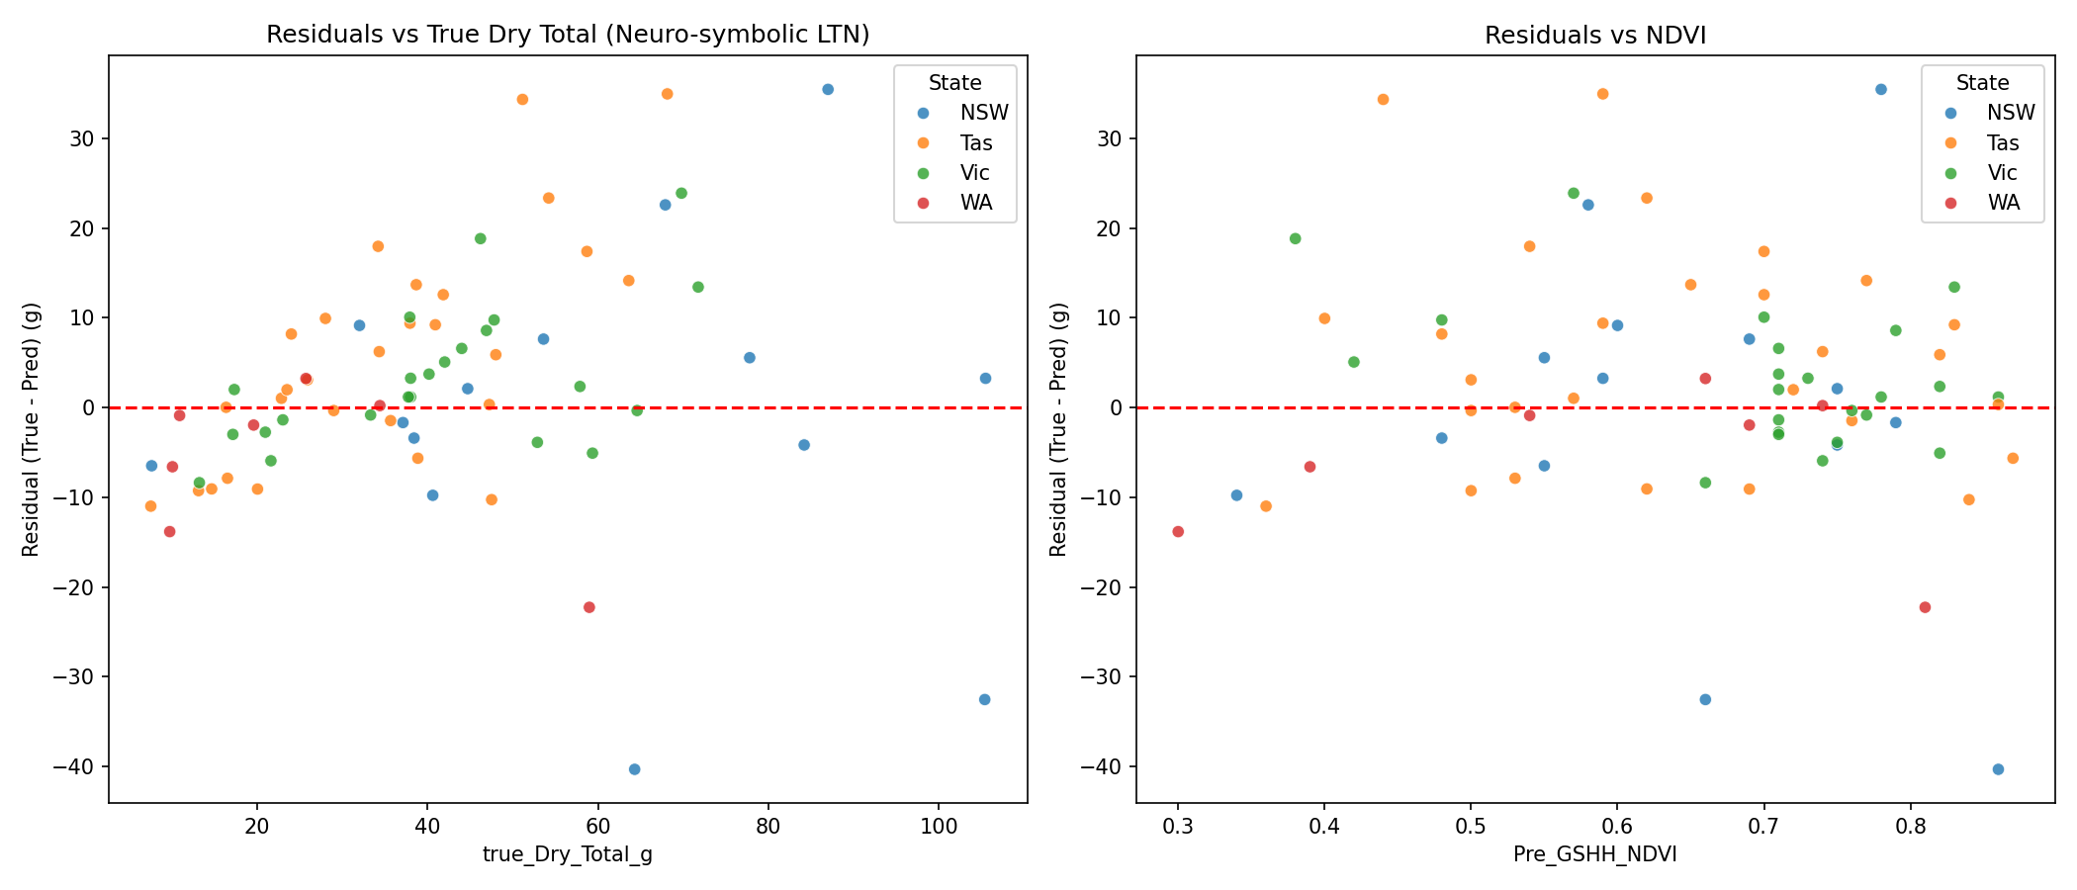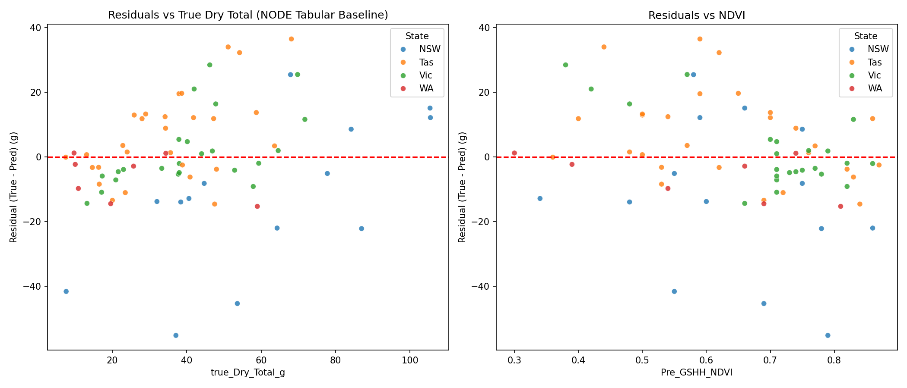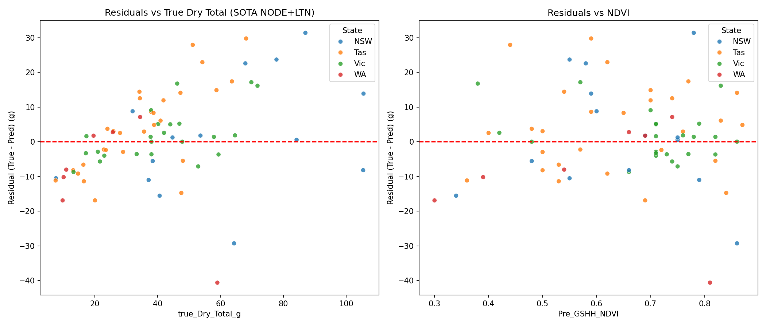
- Analysis: The Neural models (both MLP and NODE) exhibit significant heteroscedasticity - residual errors widen drastically as total true biomass increases. The Industrial LTN formulation gracefully narrows this funnel effect by evaluating constraints as relative percentage boundaries, clamping high-biomass outliers that otherwise destabilize standard loss gradients.

9. Limitations & Future Work
- Dataset Size: The pivoted dataset contains only 357 samples, fundamentally limiting the efficacy of SOTA architectures like NODE.
- Temporal Modeling: Transitioning from static point-in-time images to sequential modeling (e.g., RNNs/LSTMs tracking pasture growth over weeks) would dramatically improve yield forecasting.
- Cross-Attention Fusion: Instead of a simple vector concatenation to fuse Image and Metadata modalities, future work should implement a Transformer-based Cross-Attention layer. This would allow the model to visually attend to specific geographic regions of the image conditioned directly on the tabular metadata cues (such as State or Species).

GITHUB :

