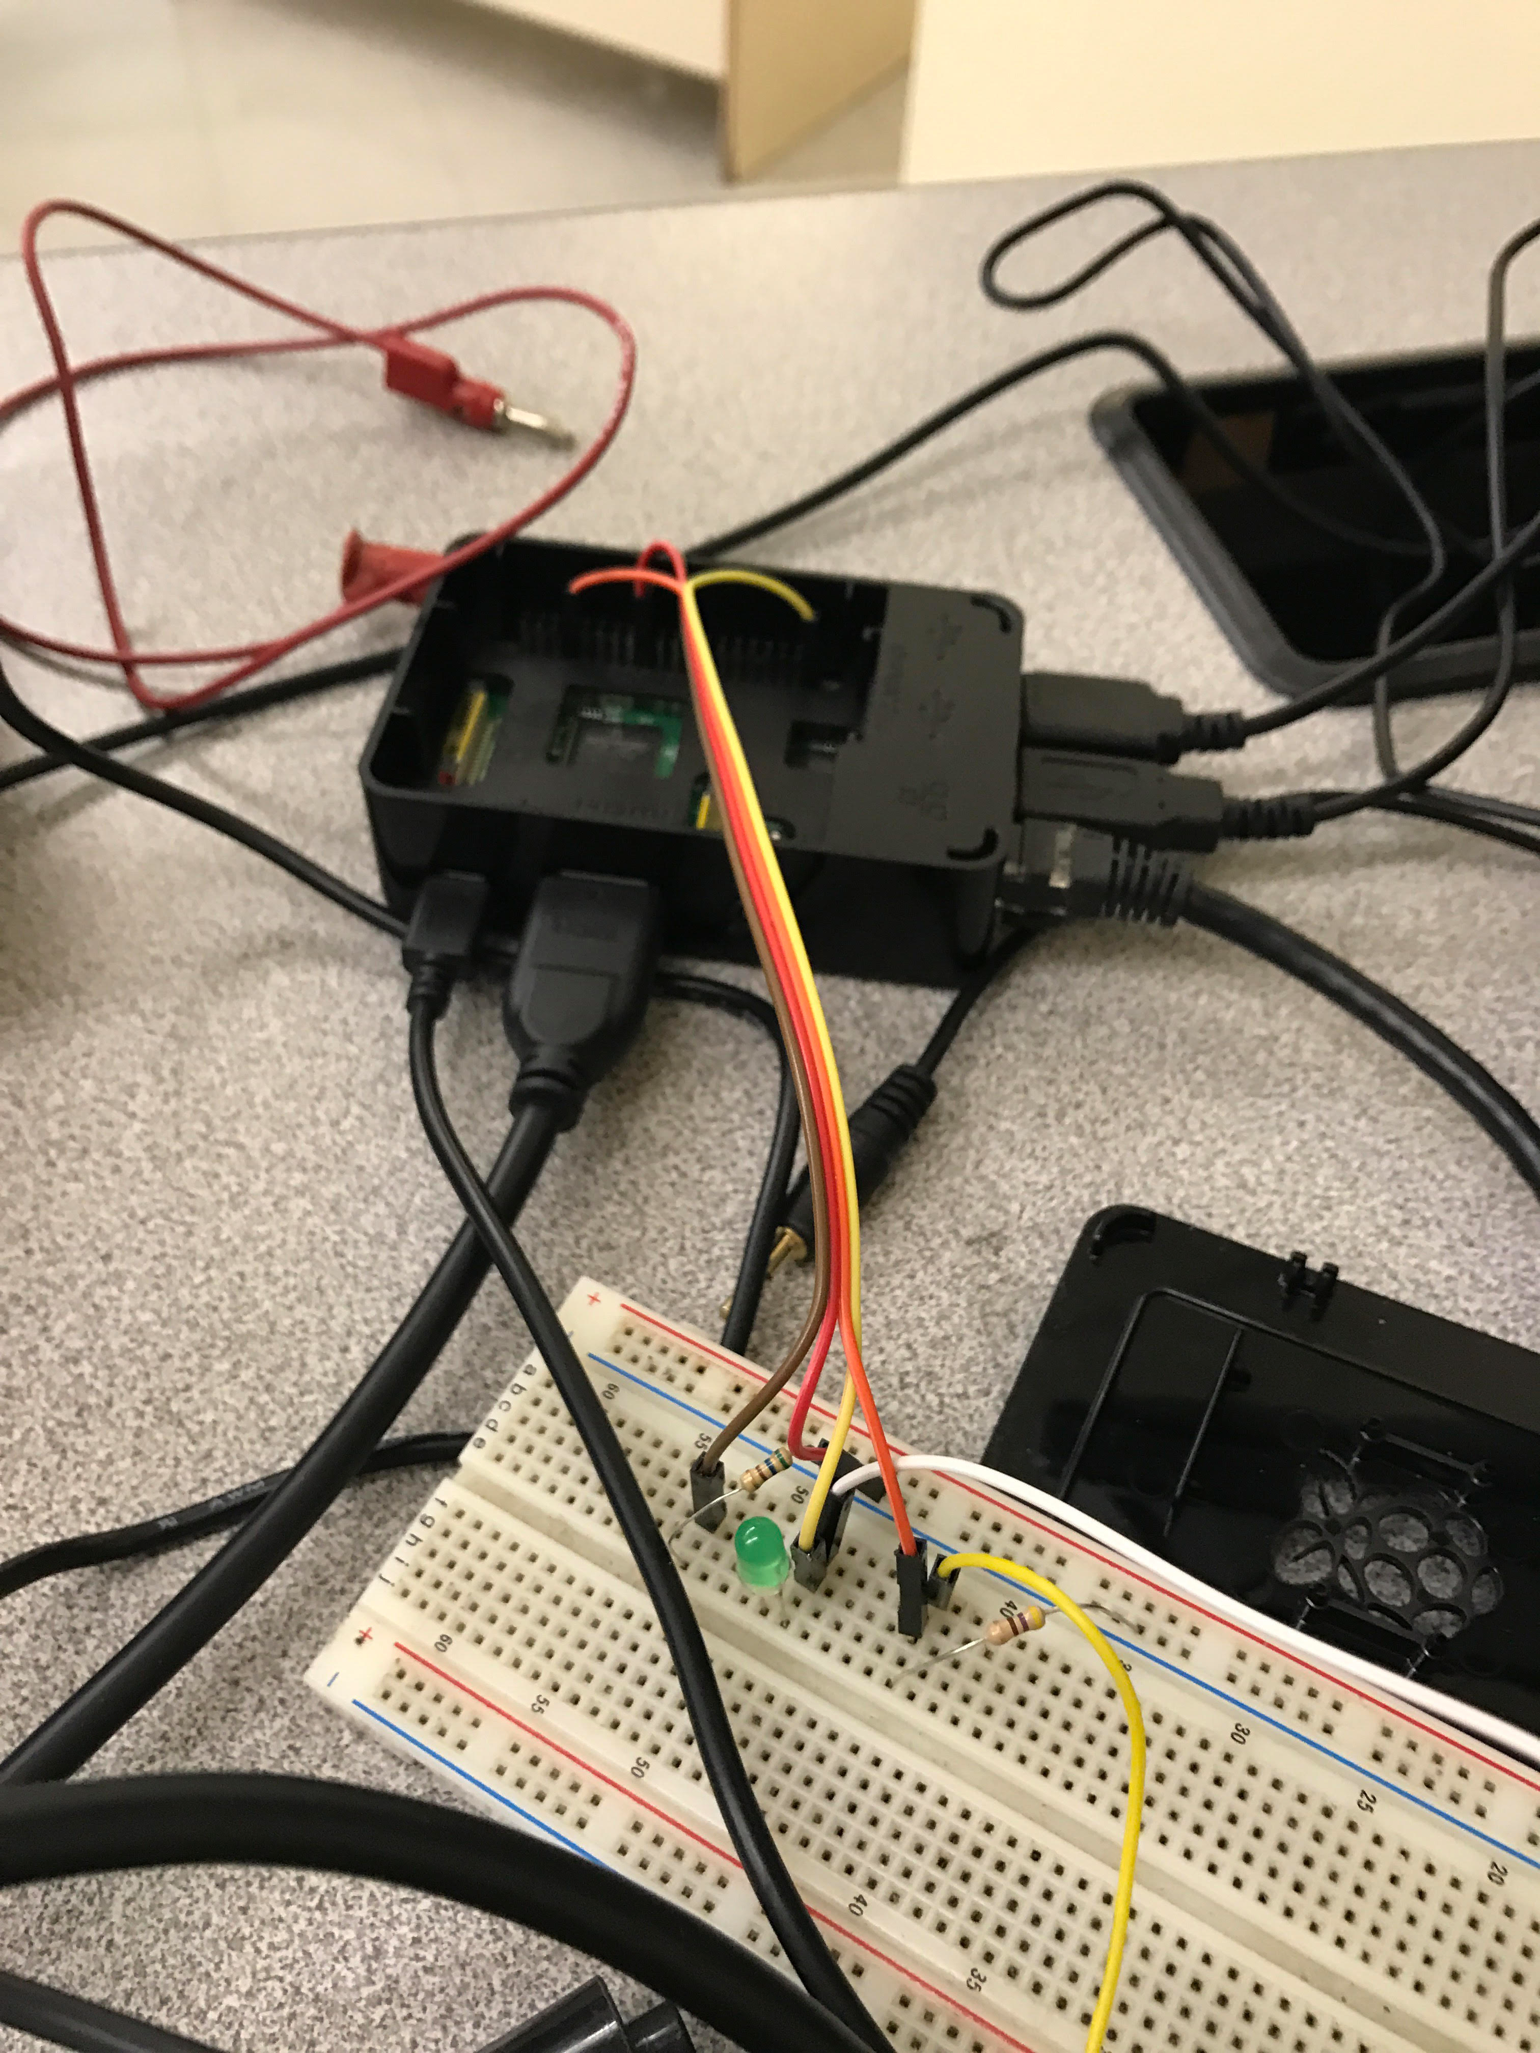
#!/usr/bin/python
import os
import time
import sqlite3 as mydb
import sys
""" Log Current Time, Temperature in Celsius and Fahrenheit
To an Sqlite3 database """
def readTemp():
tempfile = open("/sys/bus/w1/devices/28-051692206bff/w1_slave")
tempfile_text = tempfile.read()
currentTime=time.strftime('%x %X %Z')
tempfile.close()
tempC=float(tempfile_text.split("\n")[1].split("t=")[1])/1000
tempF=tempC*9.0/5.0+32.0
print [currentTime, tempC, tempF]
return [currentTime, tempC, tempF]
def logTemp():
con = mydb.connect('temperature.db')
with con:
try:
[t,C,F]=readTemp()
print "Current temperature is: %s F" %F
cur = con.cursor()
cur.execute('CREATE TABLE IF NOT EXISTS TempData(Time TEXT, Cel REAL, Far REAL)')
#sql = "insert into TempData values(?,?,?)"
print "Still works"
cur.execute('insert into TempData values(?,?,?)', (t,C,F))
print "Temperature logged"
except:
print "Error!!"

con = mydb.connect('temperature.db')
with con:
cur = con.cursor()
cur.execute("DROP TABLE IF EXISTS TempData")

#loop for 10 min
for x in range(20):
logTemp() #log temp
time.sleep(30) #wait 30 seconds

#create csv file
f = open("data.csv","w")

con = mydb.connect('temperature.db')
with con:
cur = con.cursor()
cur.execute('SELECT * FROM TempData')
rows = cur.fetchall()
for row in rows:
f.write(','.join([str(x) for x in row]))
f.write('\n')
#[f.write(','.join(row)) for row in rows]
f.close()

