 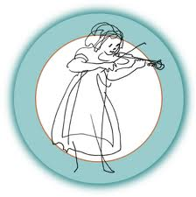 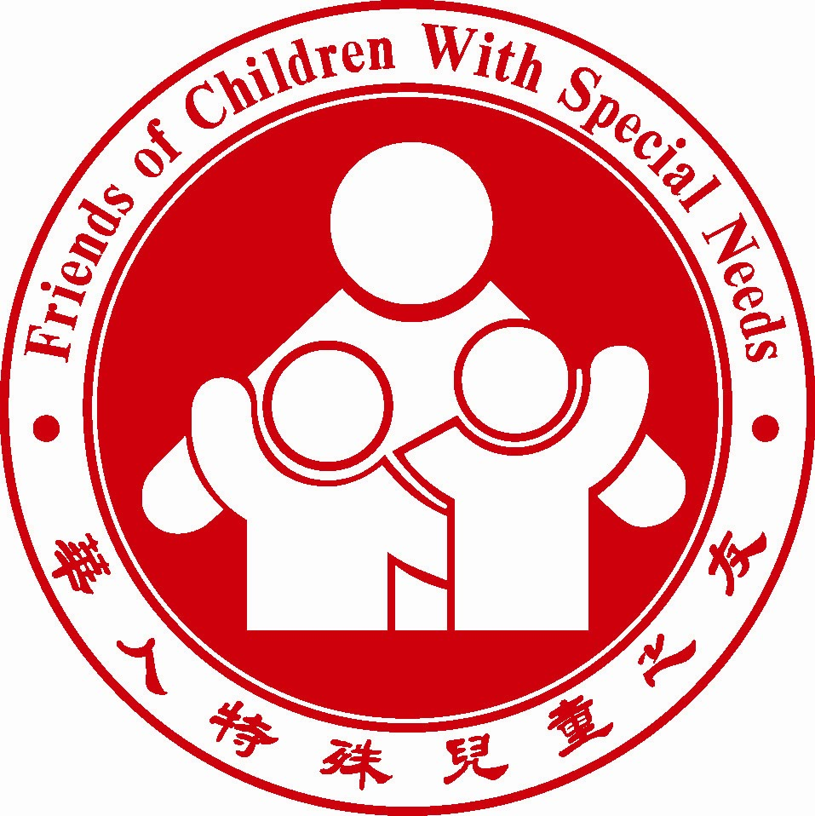

***FCSN Private Chinese Lessons***

2015 fall session registration Form

**What:** 1:1 Chinese lesson for one hour or 30 minutes

**Who:** Children and adults with special needs who are interested

**Where:** FCSN SB Center 3675 Payne Ave. San Jose, CA95117

**When*: Chinese class – Saturday from 2:00-4:00PM with Victor***

***On* 9/12, 9/19, 9/26, 10/3, 10/10, 10/17, 10/24, 10/31, 11/7, 11/14, 11/21 *total 11 classes***

***Chinese class – Saturday from 1:30PM – 3:00PM with Lucy***

***On* 9/12, 9/19, 9/26, 10/3, 10/10, 10/17, 10/24, 10/31, 11/7, 11/14, 11/21 *total 11 classes***

***Chinese Class – Saturday from 1:00PM – 3:00 PM with Jerry***

***On*  10/10, 10/17, 10/24, 10/31, 11/7, 11/14, 11/21 *total 7 classes***

**Contact: Candy Chen** at candychen2000@yahoo.com for availability

**Cost: 1 hr 11 classes $110, 30 minutes 11 classes $55, 1 hr 7 classes $70 Extra donation is welcome.**

**Additional $25 registration fee for non-FCSN members.**

***Joining FCSN membership is as easy as filling out an application form and paying a one-time / life-time membership fee of $50 for your entire family.***

**Students need to bring their own learning materials.**

Please make check payable to “FCSN” Note “private Chinese Saturday" in the memo.

Please bring the check and the registration form on the first day of the class.

**Parent or guardian is required to stay with the student during the lesson. FCSN reserves the right to remove me/him/her from the program**

**and terminate my/his/her admission for safety reasons.**

Student’s name (Last, First): ___________________________________________

Sex: M / F Age: ____ Date of Birth: _____________ Diagnosis:___________

Mother’s (guardian): __________________ Father’s:______________________

Home #: ____________ Cell #: _______________ Work #:________________

E-mail: __________________________________

Emergency Contact: ____________ Relationship to Student: _____________Phone #:___________

The emergency contact must be a person other than parents.

Please mark X at the time slot that you are coming for the class (please e mail candychen2000@yahoo.com first to make sure the time slot is still available.)

Class Name: ___ Chinese ___________

Day: ___ Saturday afternoon___________________

Time slot: from _______________ to ________________

Instructor’s name: ________________________________

Yes ___ No ___ I give my permission to *Friends of Children with Special Needs (FCSN)* staff to film, photo, or tape my family for the purpose of promoting the objectives of this music program.

By registering with the Private music Program, the parent(s)/guardian(s) release FCSN and all its volunteers from any and all liabilities resulting from participation in all activities. The parent(s)/guardian(s) also agree to and accept all terms stated in this registration below.

**Participant Liability Waiver and Hold Harmless Agreement**

Please read this form carefully and be aware that by registering for and participating in this program(s) or by registering your minor child/ward for participation in this program(s), you will be waiving your rights and/or the rights of your minor child/ward to all claims for injuries you or your minor child/ward might sustain arising out of this program(s) and you will be required to indemnify, hold harmless, and defend Friends of Children with Special Needs (FCSN) for any claims arising out of participation in said program(s).

**Risk of Injury**

If my or my child's behavior is injurious to self or to others, FCSN reserves the right to remove me/him/her from the program

and terminate my/his/her admission for safety reasons.

As a participant in the program, or as a parent or legal guardian of a participant under 18 years of age, I recognize and acknowledge that there are certain risks of physical injury, and I agree to assume the full risk of injuries, including death,

damages, or loss which I and/or my minor child/ward may sustain as a result of participating in any and all activities

associated with this program.”

**Waiver of Injury Claims** “

I agree to waive and relinquish any and all claims I and/or my minor child/ward may have arising out of, connected with, or in any way associated with the activities of the program.”

**Release from Liability** “

I do hereby fully release and discharge Friends of Children with Special Needs (FCSN) and its officers, agents, and employees from any and all claims from injuries, including death, damage or loss which I or my minor child/ward may have or which may occur on account of participation in the program.”

**Indemnity and Defense** “

I further agree to indemnify, hold harmless and defend Friends of Children with Special Needs (FCSN) and its officers, agents, and employees from any and all claims from injuries, including death, damages and losses sustained by me or my minor child/ward and arising out of, connected with, or in any way associated with the activities of the program.”

In the event of any emergency, I authorize Friends of Children with Special Needs (FCSN) to secure from any licensed hospital, physician, and/or medical personnel any treatment deemed reasonable and necessary for me or my minor child/ward’s immediate care and agree that I will be responsible for payment of any and all medical services rendered.

I have read and fully understand and agree to the above Participants Liability Waiver and Hold Harmless Agreement.

Adult Student or Parent Signature: ______________________ Date: __________