VISVESVARAYA TECHNOLOGICAL UNIVERSITY
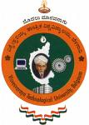
BELAGAVI-590018

Report on
INDUSTRY INTERNSHIP (BCI803)
“Android App Development Using GenAI”
Submitted in the partial fulfillment of the requirement for the Internship Program
Bachelor of Engineering
In
CSE (ARTIFICIAL INTELLIGENCE & MACHINE LEARNING)

Submitted by
CHETHAN S
1VA22CI019
Industry Internship at
MindMatrix
1, 27th Main Rd, near Union Bank, PWD Quarters, 1st Sector, HSR Layout, Bengaluru, Karnataka 560102

Internal Guide | External Guide
Name: Dr. Vikramathithan A C | Name: Mr.Tirumal Mutalikdesai
Designation: Professor | Designation: Program Coordinator
Dept. & College name: CSE ( AI & ML), SVIT | Company name: MindMatrix
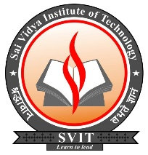

DEPARTMENT OF CSE (ARTIFICIAL INTELLIGENCE & MACHINE LEARNING)
SAI VIDYA INSTITUTE OF TECHNOLOGY
(Approved by AICTE, New Delhi, Affiliated to VTU, Belagavi | Recognized by Govt. of Karnataka)
Accredited by NBA, New Delhi (CSE, ISE, ECE), NAAC ‘A’ Grade
RAJANUKUNTE, BENGALURU – 560 119
2025-26
SAI VIDYA INSTITUTE OF TECHNOLOGY
(Approved by AICTE, New Delhi, Affiliated to VTU, Belagavi | Recognized by Govt. of Karnataka)
Accredited by NBA, New Delhi (CSE, ISE, ECE), NAAC ‘A’ Grade
RAJANUKUNTE, BENGALURU – 560 119
2025-26
DEPARTMENT OF CSE (ARTIFICIAL INTELLIGENCE & MACHINE LEARNING)
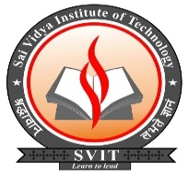

CERTIFICATE
Certified that the Internship work entitled “Android App Development Using GenAI” carried out by, CHETHAN S (1VA22CI019), bonafide students of SAI VIDYA INSTITUTE OF TECHNOLOGY, BENGALURU, in partial fulfillment for the award of Bachelor of Engineering in CSE (ARTIFICIAL INTELLIGENCE & MACHINE LEARNING) of VISVESVARAYA TECHNOLOGICAL UNIVERSITY, Belagavi during the year 2025-26. It is certified that all corrections/suggestions indicated for Internal Assessment have been incorporated in the report deposited in the departmental library. The Industry/Research Internship (BINT803B) report has been approved as it satisfies the academic requirements in respect of internship work prescribed for the said Degree.

……………………………… ……………………………………….
Dr. Vikramathithan A C Mrs Shilpa Patil
Professor Assistant Professor
Dept. of CSE(AI&ML) Dept. of CSE(AI&ML)

………………………… ----------------------------- …………………………………
Mrs. Deepa Pattan Dr. T G Manjunath Dr. Manjunath T N
SPOC – Internship Professor & HOD Principal
Dept. of CSE(AI&ML)
Examiners Name: Signature with Date

- ---------------------------- --------------------------------

- ---------------------------- ---------------------------------

ACKNOWLEDGEMENT

The completion of Industry Internship brings with and sense of satisfaction, but it is never completed without thanking the persons who are all responsible for its successful completion. First and foremost, I wish to express my deep sincere feelings of gratitude to my Institution, Sai Vidya Institute of Technology, for providing me an opportunity to do my education.
I would like to thank the Management and Prof. M R Holla, Director, Sai Vidya Institute of Technology for providing the facilities.

I extend my deep sense of sincere gratitude to Dr. Manjunath T N, Principal, Sai Vidya Institute of Technology, Bengaluru, for having permitted to carry out the Internship work on “Android App Development Using GenAI” successfully.

I express my heartfelt sincere gratitude to Dr. T G Manjunath, Professor and Head, Department of CSE (Artificial Intelligence & Machine Learning), Sai Vidya Institute of Technology, Bengaluru, for her valuable suggestions and support.

I express my sincere gratitude to my Dr. Vikramathithan A C, Professor, Department of CSE (Artificial Intelligence & Machine Learning), Sai Vidya Institute of Technology, Bengaluru, for his constant support.

I am thankful to “MindMatrix” for providing me an opportunity to be an internee.

I express my sincere gratitude to my Mr. Tirumal Mutalikdesai, Program Coordinator , MindMatrix, Bengaluru, Karnataka, for his constant support.

I express my sincere gratitude to Mrs Shilpa Patil, Assistant Professor, Sai Vidya Institute of Technology, Rajanukunte, Bangalore for her constant support.

I express my sincere gratitude to Mrs. Deepa Pattan, Internship SPOC, for her constant support.

Finally, I would like to thank all the Teaching, Technical faculty and supporting staff members of Department of CSE (Artificial Intelligence & Machine Learning),, Sai Vidya Institute of Technology, Bengaluru, for their support.

CHETHAN S 1VA22CI019

TABLE OF CONTENTS
Headings | PAGE NO
Table of Contents | 1-2
Acknowledgement | 3-3
List of Tables / List of Figures (if any) | 4-4
Offer Letter | 5-5
Contact Information | 6-6
Introduction | 7-7
Internship Objectives | 8-10
Learning Activities / Experiences | 10-14
Overview of the work carried out & Learning Outcomes | 14-17
Project Developed / Result Discussion (If any) | 17-20
Importance and Applications | 20-21
Conclusion/ Summary | 21-21
References/ Bibliography | 21-23
Appendix : Daily attendance Dairy  Internship Completion Certificate | 23-40

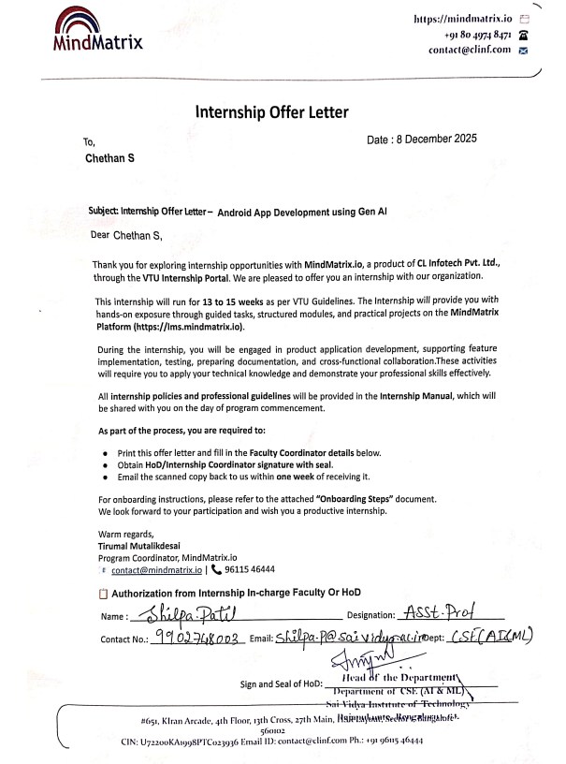
INTERNSHIP OFFER LETTER

PART I (Contact Information)
(THIS WILL BE PREPARED IN CONSULTATION WITH THE FACULTY MENTOR)
An internship is a unique learning experience that integrates studies with practical work. This agreement is written by the student in consultation with the faculty Mentor and Industrial supervisor. It shall serve to clarify the educational purpose of the internship and to ensure an understanding of the total learning experience among the principal parties involved.

Student Name: _________________________________________________________________
Student USN__________________ Semester____________ Year: ________________________ Branch _______________________________________________________________________ College Name________________________________________________________________ Phone: __________________________Email: ________________________________________

Industrial Supervisor
Name: ____________________________________Designation__________________________
Company/Organization:__________________________________________________________ Internship Address_______________________________________________________________ City, State, Pin:________________________________________________________________ Phone: __________________________Email: ________________________________________

Name and Signature of the Guide

RAITHA-VARTA
AI-POWERED FLASH-CARD FARMING ADVISOR

1.1 INTRODUCTION

The internship provided practical exposure to Android application development and smart agriculture technologies through the development of the Raitha Varta – Smart Farming Assistance Application. The internship mainly focused on learning how mobile applications can be used to solve real-world agricultural problems faced by farmers in rural areas.
During the internship, knowledge was gained about frontend and backend development using XML, Kotlin, Android Studio, and Firebase. The internship helped in understanding the complete software development lifecycle including planning, UI design, coding, database integration, testing, and debugging.
The project was developed to help farmers access crop guidance, farming tips, irrigation awareness, and smart farming information through a simple mobile application. The internship also provided practical experience in cloud database integration, user interface design, and multi-language support for rural users.
Overall, the internship improved technical knowledge, problem-solving ability, and practical understanding of mobile app development and smart farming solutions.
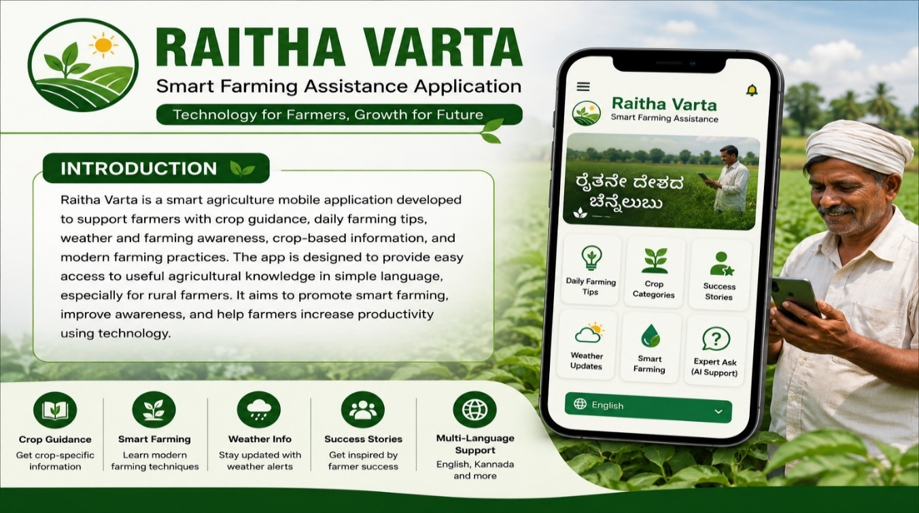
Fig 1.1 Raitha vartha smart farming assistance application
1.2 OBJECTIVES:
1.2.1 Knowledge and Understanding
The internship aimed to provide a strong understanding of Android application development using Android Studio. Through practical implementation, knowledge was gained about creating mobile applications, managing project structures, handling activities, and understanding the Android development lifecycle.
The internship also focused on learning frontend development using XML layouts and Android UI components. Knowledge was acquired about designing user-friendly interfaces using RecyclerView, CardView, Buttons, TextView, ImageView, and ScrollView. Understanding responsive layouts and mobile-friendly designs was an important part of the learning process.
Another major objective was to understand backend integration using Firebase Firestore and Realtime Database. The internship provided practical exposure to connecting mobile applications with cloud databases for storing and retrieving information dynamically.
Knowledge about cloud storage and real-time synchronization was also gained during the internship. Understanding how data is updated and synchronized between the application and the database helped in learning modern cloud-based application development techniques.
The internship helped in understanding how smart farming applications can support farmers through technology. Knowledge was gained about providing crop guidance, farming tips, irrigation awareness, and agricultural information through mobile applications.
Another important learning objective was understanding mobile application architecture and data flow. This included learning how frontend components interact with backend services and how information is processed and displayed to users efficiently.
The internship also provided understanding about database management and data handling techniques. Knowledge was gained regarding organizing crop details, farming tips, images, and user information within the Firebase database.
Understanding multi-language implementation in Android applications was another objective of the internship. Knowledge was acquired about using string resources to support regional languages like Kannada, helping rural farmers access the application easily.
The internship also focused on understanding agricultural datasets and their management. Information related to crop categories, farming practices, disease prevention methods, and irrigation techniques was collected and organized for application usage.
Knowledge about AI-based farming support systems and crop disease detection concepts was also explored. Although implemented as a prototype, the internship introduced concepts related to AI integration, image processing, and smart agriculture solutions.
Another important objective was understanding debugging, testing, and application performance optimization. The internship provided experience in identifying coding errors, fixing bugs, and improving the responsiveness and stability of the application.
Finally, the internship helped in understanding how mobile applications can improve digital agriculture awareness among farmers. It demonstrated how technology can bridge the communication gap between agricultural experts and rural farmers by providing simple and accessible information.
1.2.2 Skills
The internship helped in developing Android application coding skills using Kotlin and XML. Practical coding experience improved understanding of mobile application logic, activity management, and user interaction handling.
UI/UX design skills were improved through designing application layouts, navigation systems, and user-friendly interfaces suitable for rural users. The internship enhanced the ability to create visually attractive and easy-to-use mobile screens.
Practical experience in Firebase integration was gained during the internship. Skills were developed in connecting applications to Firebase Firestore and Realtime Database, storing information, retrieving data, and handling cloud synchronization.
Database handling and cloud synchronization skills were improved through managing crop details, farming tips, images, and user-related information within the Firebase backend environment.
The internship also enhanced debugging and problem-solving abilities. Various issues related to Firebase integration, UI responsiveness, image loading, and navigation errors were identified and resolved during development.
Communication and project documentation skills were improved while preparing project reports, documentation, feature descriptions, and internship presentations. Technical concepts were learned and explained in a structured manner.
Teamwork and task management abilities were also developed during the internship. Collaboration, planning development tasks, and completing assigned modules within deadlines improved professional working habits.
The internship enhanced analytical thinking and technical understanding by encouraging practical implementation of smart farming concepts and mobile application features.
Experience in implementing multi-language support was gained through the use of Android string resources and localization techniques. This improved accessibility and usability for regional language users. Application testing and maintenance skills were also improved through testing the app on multiple devices, identifying performance issues, and optimizing the application for better user experience.
Time management and project planning abilities were developed while balancing frontend development, backend integration, debugging, testing, and documentation activities within the internship duration.
Overall, the internship helped in building both technical and professional skills required for real-world Android application development and smart agriculture technology solutions.

1.3 LEARNING ACTIVITIES
The internship activities mainly focused on the design, development, testing, and implementation of the Raitha Varta – Smart Farming Assistance Application. These activities provided practical exposure to real-world Android application development and smart agriculture technologies. The internship activities were planned in a way that helped in achieving both technical learning objectives and professional skill development.
One of the major learning activities during the internship was frontend development. This included creating XML layouts, designing user-friendly interfaces, implementing buttons, card views, image views, text views, scroll views, and navigation systems. These activities improved understanding of mobile application usability, responsive design, and UI/UX principles. Practical implementation helped in learning how to create applications that are simple and accessible for rural users.
Another important learning activity was backend development using Firebase Firestore and Realtime Database. The application was connected to Firebase for storing and retrieving farming tips, crop details, images, and success stories. Through these activities, understanding was gained about cloud database management, real-time synchronization, data retrieval methods, and backend integration techniques.
The internship also involved collecting and organizing agricultural datasets from online resources, farming references, and government agriculture websites. Research activities were conducted to gather information about crop categories, irrigation techniques, organic farming methods, disease prevention tips, and smart farming practices. These activities improved research skills, data collection abilities, and information management techniques.
Daily coding activities formed a major part of the internship learning process. Writing Kotlin code for implementing application logic, navigation handling, database interaction, and UI functionality helped in improving programming confidence and practical coding experience. These activities also enhanced logical thinking and application development skills.
Testing and debugging activities were regularly performed throughout the development process. Errors related to UI responsiveness, Firebase connectivity, image loading, and navigation were identified and resolved. These activities improved debugging skills, analytical thinking, and problem-solving abilities. The internship provided practical understanding of how testing improves application quality and user experience.
The internship also included implementing multi-language support using Android string resources. Kannada and English language support was planned to help rural farmers use the application more easily. These activities improved understanding of localization techniques, language resource management, and accessibility implementation in Android applications.
Another important learning activity involved creating smart farming awareness modules within the application. Daily farming tips, water-saving methods, soil care practices, irrigation suggestions, and crop-specific guidance were added into the application. These activities helped in understanding how digital technology can support modern agriculture and improve farming awareness.
Documentation and report writing activities were also carried out during the internship. Preparing project reports, module explanations, feature descriptions, and technical documentation improved communication skills and professional documentation practices. It also helped in organizing project information in a structured format.
Project discussions and mentor interactions played an important role in the learning process. Regular discussions helped in clarifying technical concepts, improving project ideas, understanding software development practices, and identifying better implementation methods. Feedback received during project reviews helped in improving the overall quality of the application.
The internship also involved learning about future enhancement possibilities such as AI-based crop disease detection, weather integration, market price prediction, and expert farming support systems. Although some features were implemented as prototypes, these activities introduced advanced concepts related to artificial intelligence and smart agriculture technologies.
Time management and project planning activities were another important part of the internship. Tasks such as frontend development, backend integration, testing, debugging, and documentation were completed according to planned schedules and deadlines. This improved professional discipline and work management abilities.
Overall, the internship activities provided valuable practical exposure to Android development, cloud-based backend integration, smart farming applications, and software project management. The activities helped in strengthening both technical knowledge and professional skills required for future career growth in software development and digital agriculture solutions.
1.4 JOB DESCRIPTION
During the internship, the primary role was working as an Android Application Developer for the Raitha Varta – Smart Farming Assistance Application project. The internship involved both frontend and backend development activities, along with application testing, database management, and feature implementation. The work focused on creating a user-friendly mobile application that helps farmers access important agricultural information through smartphones.
One of the major responsibilities during the internship was designing and developing the frontend interface of the application using XML layouts and Kotlin programming language in Android Studio. The interface was designed to be simple, interactive, and easy to use for rural farmers with basic digital knowledge. Different layouts and navigation systems were created to improve usability and user experience.
Several Android UI components such as RecyclerView, CardView, Buttons, ImageView, TextView, ScrollView, and LinearLayout were implemented during development. These components were used to create farming tip cards, crop category pages, success story sections, and smart farming guidance screens. The goal was to ensure smooth navigation and attractive presentation of information inside the application.
Another important responsibility involved backend integration using Firebase Firestore and Realtime Database. Firebase services were connected with the application to store and retrieve crop information, farming tips, images, success stories, and other agriculture-related content. Cloud database management and real-time synchronization were important parts of the backend work carried out during the internship.
The internship also included managing agricultural datasets and organizing farming-related information. Data such as crop names, irrigation methods, soil care techniques, disease prevention methods, and organic farming tips were collected, structured, and uploaded into the Firebase database. Proper data organization was necessary to ensure efficient information retrieval inside the application.
Another responsibility during the internship was implementing daily farming tip modules and crop-specific information sections. These modules were designed to provide useful and simple agricultural guidance to farmers. The application displayed information in a card-based format along with images and short descriptions to improve readability and understanding.
Testing and debugging formed an important part of the internship responsibilities. The application was tested on different Android devices and emulators to ensure proper functionality, responsive design, and smooth performance. Issues related to screen compatibility, navigation errors, image loading, and Firebase connectivity were identified and resolved during the testing phase.
The internship also involved fixing application bugs and improving overall app performance. Debugging activities included handling crashes, improving UI responsiveness, reducing loading delays, and ensuring proper synchronization between frontend and backend services. These tasks helped in improving the reliability and stability of the application.
Implementation of multi-language support was another important responsibility during the internship. Regional language accessibility was planned to help farmers use the application comfortably in their preferred language. Android string resources were used for managing English and Kannada language support inside the application.
The internship also included planning and researching future enhancement features for the application. Concepts such as AI-based crop disease detection, expert assistance systems, weather updates, irrigation alerts, and market price prediction were explored during project discussions. Prototype-level UI planning for some advanced features was also carried out.
Project documentation and report preparation were additional responsibilities handled during the internship. Documentation included preparing feature descriptions, technical explanations, workflow diagrams, and internship reports. This helped in maintaining proper project records and improving technical communication skills.
The internship required following project deadlines and completing assigned modules according to the development schedule. Frontend development, backend integration, testing, debugging, and documentation activities were completed within the planned internship timeline. Time management and task planning were important aspects of the work process.
The overall contribution to the organization involved developing a smart farming support system that can improve farming awareness and provide useful agricultural guidance to rural farmers. The Raitha Varta application aimed to promote digital agriculture and encourage farmers to adopt smart farming techniques through accessible mobile technology.
Through this internship role, practical experience was gained in Android application development, Firebase integration, cloud database management, UI/UX design, testing, debugging, and smart agriculture technology implementation. The internship helped in building technical knowledge, professional skills, and confidence required for real-world software development projects.

1.5 OVERVIEW OF THE WORK CARRIED OUT SO FAR & LEARNING OUTCOME
During the internship, several important activities were completed as part of the development of the Raitha Varta – Smart Farming Assistance Application. The work carried out during the internship provided practical exposure to Android application development, backend integration, database management, and smart farming technologies. The internship activities helped in improving both technical knowledge and professional skills related to real-world software development.
One of the major tasks completed during the internship was the successful development of the frontend interface of the application. XML layouts and Android UI components were used to design attractive and user-friendly mobile screens. Different sections such as the home screen, crop categories page, farming tips section, and success stories page were created. UI components including RecyclerView, CardView, Buttons, TextView, ImageView, and ScrollView were implemented to improve usability and navigation. This work improved understanding of mobile UI development, layout management, and responsive application design principles.
Another major achievement during the internship was the integration of Firebase Firestore and Realtime Database with the application. Firebase services were connected successfully for storing and retrieving farming tips, crop details, success stories, and image resources. Through this work, practical understanding was gained about cloud database management, backend connectivity, real-time synchronization, and data handling techniques. Knowledge about storing dynamic content in cloud environments was also improved.
The crop categories module and daily farming tips section were implemented successfully during the internship. Different crop categories such as paddy, coconut, tomato, and areca nut were organized and displayed inside the application. Daily farming tips were presented in card-based formats along with images and short descriptions. This work helped in understanding data organization methods, content management, and information display techniques within Android applications.
Research and data collection activities were also carried out as part of the internship work. Agricultural datasets and farming-related information were collected from online farming resources, agricultural references, and government agriculture websites. Information regarding irrigation methods, organic farming, crop management, soil care, and disease prevention techniques was gathered and organized. These activities improved research abilities, data analysis skills, and awareness about smart farming practices.
Implementation of multi-language support was another important activity completed during the internship. English and Kannada language support was planned using Android string resources to improve accessibility for rural users. This activity improved understanding of localization techniques and demonstrated how regional language support can make applications more user-friendly for farmers.
Testing and debugging activities were performed regularly during the development process. The application was tested on multiple devices and Android emulators to ensure smooth performance and proper functionality. Errors related to Firebase connectivity, UI responsiveness, navigation flow, and image loading were identified and fixed. These activities enhanced debugging skills, analytical thinking, and problem-solving abilities.
Several advanced concepts and future enhancement modules were also explored during the internship. Features such as AI-based crop disease detection, expert assistance systems, weather updates, irrigation alerts, and smart farming recommendations were discussed and planned for future implementation. This provided understanding about the future scope of smart agriculture technologies and AI integration in farming applications.
Throughout the internship, practical experience was gained in coding, backend integration, UI design, cloud database handling, testing, and project documentation. Daily development activities improved confidence in Android application development and strengthened technical understanding.
1.5.1 TOPICS LEARNED DURING THE INTERNSHIP
The internship provided learning opportunities in several important technical areas, including:
- Android Studio development
- XML UI design
- Kotlin programming
- Firebase integration
- Firestore database handling
- RecyclerView implementation
- Multi-language support
- Cloud synchronization
- Smart farming applications
- Mobile app testing and debugging
- User interface design principles
- Backend data management
- Localization techniques
- Real-time database connectivity
- Mobile application architecture
Learning Outcome
The internship resulted in significant improvement in both technical and professional skills. Practical knowledge was gained about developing Android applications from frontend to backend integration. The internship improved understanding of Firebase cloud services, mobile UI design, database management, and application testing techniques.
The project also created awareness about how mobile technology can support farmers and improve digital agriculture practices. Understanding was gained about smart farming concepts, agriculture-related data management, and the importance of user-friendly mobile applications for rural communities.
The internship enhanced problem-solving ability, coding confidence, communication skills, project documentation practices, and time management skills. Exposure to real-world software development activities helped in understanding industry-level project workflows and technical implementation methods.
Overall, the work carried out during the internship successfully achieved the intended learning objectives and provided valuable practical experience in Android application development and smart agriculture technology solutions.

1.6 PROJECT DEVELOPED / RESULT DISCUSSION
The project developed during the internship was Raitha Varta – Smart Farming Assistance Application, a mobile application created to support farmers by providing useful agricultural information through smartphones. The project was designed with the objective of improving farming awareness, promoting smart agriculture practices, and helping rural farmers access crop-related guidance easily in their regional language.
The application was mainly focused on solving common agricultural problems faced by farmers such as lack of crop guidance, low awareness about modern farming techniques, difficulty in accessing expert agricultural information, and language barriers. The project aimed to provide a simple, user-friendly, and technology-based solution that could help farmers improve their farming practices and agricultural knowledge.
The Raitha Varta application was developed using Android Studio with XML and Kotlin for frontend development, while Firebase Firestore and Realtime Database were used for backend and cloud data management. The application architecture was designed to support easy navigation, real-time data access, and smooth interaction between frontend and backend services.
One of the major features implemented in the application was the Daily Farming Tips module. This section provided farmers with simple and useful farming guidance in the form of short tips displayed using card-based layouts along with images and descriptions. Tips related to irrigation methods, soil care, organic farming, crop protection, and water-saving techniques were included. This feature helped in improving farming awareness and encouraging better agricultural practices.
Another important module developed in the application was the Crop Categories section. Different crop categories such as paddy, coconut, tomato, areca nut, and other crops were organized systematically. Farmers could select specific crop categories and view related farming information, crop care methods, and agricultural guidance. This feature improved the accessibility and organization of crop-related information.
The Success Stories feature was also implemented to motivate farmers by sharing examples of successful farming practices and modern agricultural techniques. This section aimed to encourage farmers to adopt smart farming methods by learning from real-life examples and experiences.
The application also included Multi-Language Support, which was planned to support regional users more effectively. English and Kannada language options were implemented using Android string resources. This feature was important because many rural farmers are more comfortable using applications in their local language. Multi-language support improved the accessibility and usability of the application.
Another major component of the project was the integration of Firebase cloud services. Firebase Firestore and Realtime Database were used to store and retrieve farming tips, crop details, images, and other agricultural data dynamically. Cloud database integration improved data management efficiency and allowed real-time synchronization between the application and backend services.
The frontend interface of the application was successfully developed using XML layouts and Kotlin programming language. Different Android UI components such as RecyclerView, CardView, Buttons, ImageView, TextView, and ScrollView were implemented to create an attractive and user-friendly interface. The UI design focused on simplicity so that rural users with limited digital knowledge could use the application easily.
During the project development process, several testing and debugging activities were performed to ensure smooth application performance. The application was tested on Android emulators and different mobile devices to identify and fix issues related to navigation, Firebase connectivity, UI responsiveness, and image loading. These testing activities helped improve the stability and usability of the application.
The project successfully demonstrated how mobile technology can support digital agriculture and improve farming awareness among rural users. It showed that Android applications integrated with cloud services can be effectively used for providing agricultural information, crop guidance, and smart farming support.
The application achieved its primary objective of providing simple, understandable, and accessible agricultural guidance to farmers through mobile devices. The project also created awareness about smart farming practices, irrigation management, and modern agriculture techniques among users.
In addition to the implemented features, several future enhancement modules were discussed during the project development process. Advanced features such as AI-based crop disease detection, weather integration, irrigation alerts, government scheme notifications, market price prediction, and expert farming assistance systems were planned for future implementation.
The AI-based crop disease detection module was planned as a future enhancement where farmers could upload crop images and receive disease identification and farming suggestions using artificial intelligence models. Weather integration was also planned to provide real-time climate updates and farming recommendations based on weather conditions.
Overall, the Raitha Varta project was successfully developed as a smart farming assistance application that combines Android development, Firebase cloud services, and digital agriculture concepts. The project provided valuable practical experience in frontend development, backend integration, database management, testing, debugging, and smart farming technology implementation. It also highlighted the importance of mobile technology in improving agricultural awareness and supporting rural farming communities.
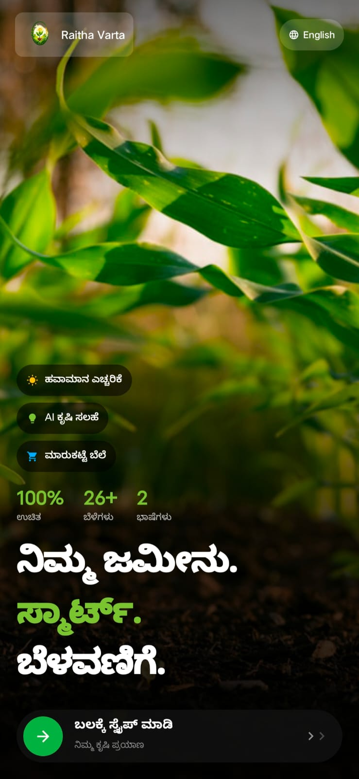 | 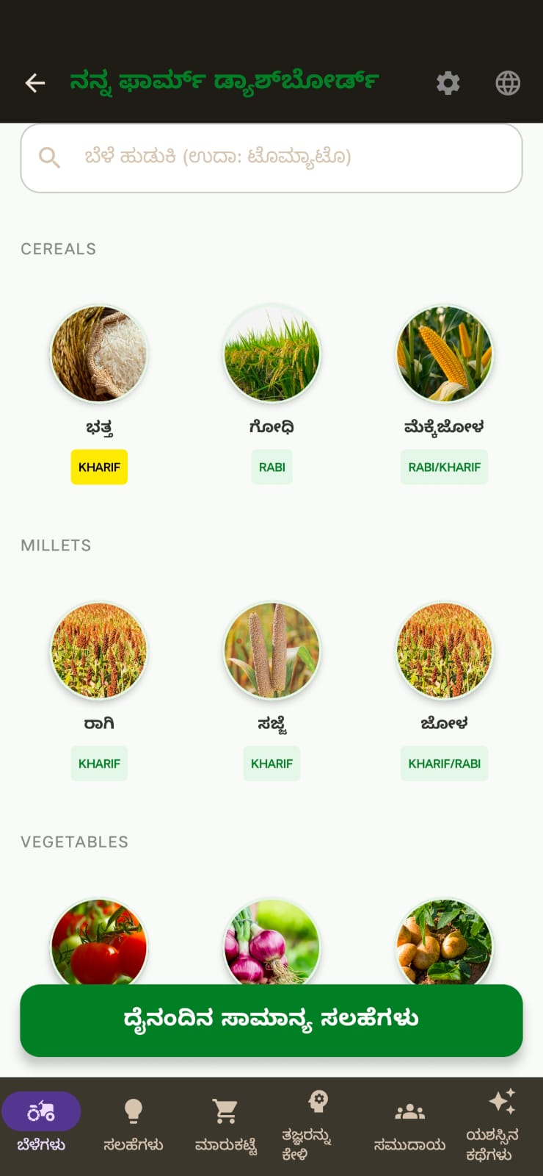
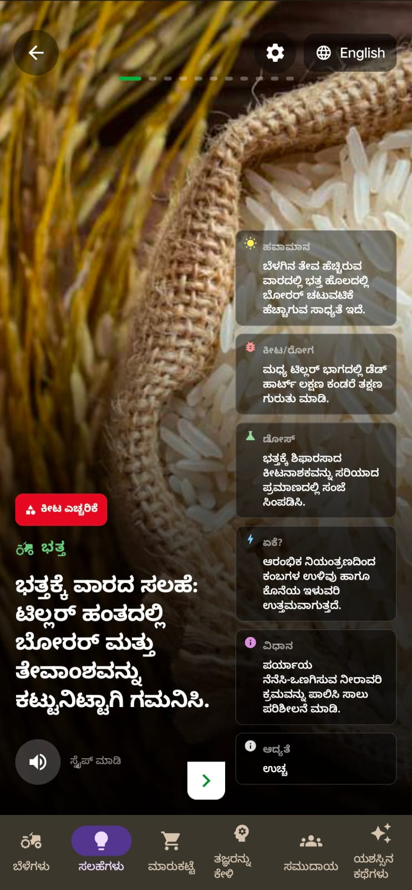 | 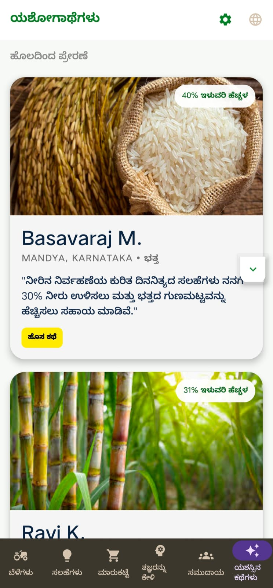

1.7 IMPORTANCE AND APPLICATIONS
Raitha Varta is important because it helps farmers access agricultural information easily using smartphones.
The application supports digital agriculture and encourages farmers to adopt modern farming techniques.
The project helps in improving farming awareness, irrigation management, soil care practices, and crop productivity.
Multi-language support makes the application accessible for rural farmers who are more comfortable using regional languages.
The application can also reduce the communication gap between agricultural experts and farmers.
The project promotes smart farming practices such as water-saving techniques, organic farming awareness, and crop management.
Future applications may include AI-based crop disease detection, weather forecasting, market price prediction, and government scheme notifications.
The project demonstrates the practical use of Android development and cloud technologies in agriculture-based solutions

1.8 CONCLUSION
The internship provided valuable practical experience in Android application development and smart agriculture technologies. Through the development of the Raitha Varta application, knowledge was gained about frontend development, backend integration, Firebase database management, and mobile application design.
The internship improved technical skills, problem-solving abilities, and understanding of real-world software development processes. It also created awareness about how technology can support farmers and improve agricultural productivity.
Overall, the internship was successful in achieving the learning objectives and provided industry-oriented experience in mobile application development and smart farming solutions.

1.9 REFERENCES

- Firebase Documentation. Firebase is a cloud-based platform developed by Google that provides backend services such as real-time database, authentication, and cloud storage for mobile and web applications. The Raitha Varta application used Firebase for storing farming tips, crop details, and user-related information securely in the cloud. The documentation was referred to for implementing database integration and backend connectivity in the Android application.
- Android Developers Official Website. The official Android developer documentation provided guidance for designing and developing the Raitha Varta mobile application using Android Studio and Kotlin. It was used for understanding layouts, activities, fragments, navigation components, RecyclerView, and material design principles for building user-friendly Android applications.
- Kotlin Programming Language Documentation. Kotlin is the modern programming language officially supported for Android application development. The documentation helped in understanding syntax, object-oriented programming concepts, functions, classes, and Android-specific implementations used in the Raitha Varta application development process.
- Android Studio Official Website. Android Studio is the integrated development environment used for creating and testing the Raitha Varta project. The platform provided tools for UI design, emulator testing, debugging, Gradle build management, and APK generation. The official documentation and tutorials were referred to during application development.
- Material Design Guidelines. Material Design guidelines developed by Google were used to design an attractive and user-friendly interface for the Raitha Varta application. These guidelines helped in selecting colors, typography, buttons, layouts, cards, and navigation styles to improve the overall user experience.
- Glide Image Loading Library. Glide is an open-source image loading library used in Android applications for efficient image handling and caching. It was referred to for displaying crop images and agricultural content smoothly in the Raitha Varta application without affecting performance.
- Room Database Documentation. Room Database is a local database library provided by Android Jetpack for offline data storage. The documentation was referred to for understanding database entities, DAO interfaces, queries, and local data persistence features that can support offline accessibility in farming applications.
- Agriculture Information Portal – Government of India. The agriculture portal of the Government of India provided information related to crop management, irrigation practices, soil health, and farming schemes. These resources were studied to understand agricultural concepts and prepare useful content for farmers in the Raitha Varta application.
- Food and Agriculture Organization (FAO). The Food and Agriculture Organization is an international organization working towards sustainable agriculture and food security. Agricultural articles, smart farming concepts, and crop advisory information from FAO resources were referred to while understanding modern farming practices and farmer support systems.
- GeeksforGeeks Android Development Tutorials. GeeksforGeeks tutorials were referred to for learning Android application development concepts including RecyclerView, Firebase integration, intents, adapters, layouts, and activity lifecycle management. These tutorials helped in solving implementation issues during the project development phase.
1.10 APPENDIX
Day 1
Today the internship program was introduced along with the objectives and expected outcomes. The development environment was prepared by installing Android Studio and configuring the Kotlin programming language. An overview of Android application architecture and mobile application lifecycle was discussed. Basic understanding about XML layouts, Gradle files, and emulator setup was gained. The learning outcome of the day was understanding the fundamentals of Android app development and software installation procedures.
Day 2
The session focused on learning the basics of Kotlin programming language. Concepts such as variables, data types, operators, loops, and conditional statements were practiced using sample programs. Small exercises were performed inside Android Studio to understand syntax and error handling. The coding standards and debugging methods were also introduced. The learning outcome was the ability to write simple Kotlin programs independently.
Day 3
Today practical work was carried out on Android project structure and activity lifecycle. Different folders such as manifests, Java/Kotlin, drawable, and layout resources were explored. A simple application with TextView and Button components was developed. Event handling using button click listeners was practiced. The learning outcome was understanding Android project organization and basic UI interaction.
Day 4
The internship activities included designing user interfaces using XML layouts. LinearLayout, ConstraintLayout, and RelativeLayout were studied and implemented in sample applications. Different UI elements like EditText, Button, and ImageView were added to the project. Layout alignment and responsive design concepts were discussed. The learning outcome was creating attractive Android application interfaces.
Day 5
Today the focus was on understanding intents and navigation between activities. Explicit and implicit intents were implemented in Android Studio projects. A simple login and navigation screen was created for practice purposes. Data passing between activities using intents was demonstrated. The learning outcome was understanding application flow and activity communication.
Day 6
A workshop session on Google Skills Boost platform was attended for improving technical skills. The account was created and introductory cloud learning modules were completed. Different Android and cloud computing courses available in the platform were explored. Notes were prepared regarding Google developer tools and certifications. The learning outcome was awareness about online skill enhancement platforms.
Day 7
Today practice was done on Toast messages, Snackbar notifications, and Logcat debugging. Different debugging methods were used to identify and resolve errors in Kotlin code. The importance of debugging during application development was explained. Small exercises were completed to display notifications based on user actions. The learning outcome was improved debugging and troubleshooting skills.
Day 8
The internship work included creating forms using EditText, RadioButton, and CheckBox components. User input validation techniques were implemented in Kotlin code. Error messages and input restrictions were added for better user experience. Form handling methods and validation logic were discussed in detail. The learning outcome was understanding user input management in Android applications.
Day 9
Today RecyclerView and Adapter concepts were introduced for displaying lists of data efficiently. A sample application displaying student details in list format was created. Adapter classes and ViewHolder patterns were implemented in Kotlin. Scrollable user interface design was also practiced. The learning outcome was understanding dynamic list handling in Android applications.
Day 10
A code lab activity was completed on Android UI design and Material Design components. Buttons, cards, and floating action buttons were implemented in a sample project. Different themes and color palettes were applied to improve interface appearance. Material Design guidelines were studied during the practical session. The learning outcome was designing modern Android application interfaces.
Day 11
The internship session focused on Firebase introduction and backend connectivity concepts. Firebase account setup and project creation were demonstrated practically. Firebase Authentication and Realtime Database features were explored. A sample Android project was connected with Firebase successfully. The learning outcome was understanding cloud backend integration basics.
Day 12
Today database operations such as insert, update, delete, and retrieve were practiced using Firebase Realtime Database. User details entered in the application were stored in cloud storage. Data synchronization and real-time updates were observed during testing. Error handling methods for database operations were also discussed. The learning outcome was understanding cloud database management.
Day 13
A workshop related to mobile application UI/UX design was attended. The importance of user-friendly interfaces and accessibility features was explained. Examples of successful mobile applications were analyzed for design inspiration. Wireframing and screen planning methods were introduced. The learning outcome was improving application design thinking and user experience knowledge.
Day 14
Today image handling techniques in Android applications were practiced. ImageView components and drawable resources were used for displaying images. Basic image loading libraries such as Glide were introduced. Crop and profile images were integrated into sample applications. The learning outcome was understanding multimedia integration in Android apps.
Day 15
The internship work focused on Shared Preferences for local data storage. User login information and application settings were stored locally in the device. Different methods for saving and retrieving data were practiced in Kotlin. Security considerations while storing local data were also discussed. The learning outcome was understanding lightweight local storage techniques.
Day 16
Today practical exercises were completed on menus and navigation drawers. Option menus, popup menus, and context menus were implemented in Android Studio projects. Navigation drawer layouts were designed for easy application navigation. User interaction improvements were tested in the application. The learning outcome was understanding advanced navigation components.
Day 17
A Google Skills Boost course related to cloud fundamentals was completed today. Topics such as cloud computing, virtual machines, and cloud services were explored. Notes were prepared regarding cloud deployment concepts and storage systems. The practical activities improved understanding of modern cloud technologies. The learning outcome was gaining foundational cloud computing knowledge.
Day 18
Today fragments and fragment lifecycle concepts were studied in Android development. Multiple fragments were integrated into a single activity application. Fragment communication methods and dynamic UI updates were implemented practically. Different navigation techniques between fragments were explored. The learning outcome was understanding modular application design.
Day 19
The internship activities included implementing splash screens and application logos. Custom themes and startup screens were designed using XML and Kotlin. Branding elements for Android applications were discussed during the session. Logo placement and responsive layouts were tested on emulators. The learning outcome was understanding application branding and startup design.
Day 20
Today notification systems and alert dialogs were implemented in Android applications. Notification channels and popup alert messages were configured. User interaction with notifications was tested practically. Real-time alerts for application events were demonstrated. The learning outcome was understanding user communication methods in Android apps.
Day 21
Today API integration concepts were introduced using REST APIs. JSON data parsing techniques were practiced using Kotlin libraries. Sample weather and news APIs were tested inside Android Studio projects. Data fetched from APIs was displayed dynamically in RecyclerView. The learning outcome was understanding server communication and API usage.
Day 22
The internship session focused on Retrofit library implementation for API handling. Retrofit dependencies were added into Gradle files and configured successfully. GET and POST request methods were practiced with sample applications. Error handling and response management techniques were explored. The learning outcome was understanding networking operations in Android applications.
Day 23
Today GitHub version control concepts were introduced during the practical session. A GitHub account was created and repositories were managed for Android projects. Push, pull, commit, and branch operations were demonstrated. Collaborative project development concepts were also discussed. The learning outcome was understanding source code management.
Day 24
The activities included attending a Salesforce Trailhead learning session. Accounts were created in Salesforce Trailhead platform and beginner modules were completed. CRM basics, cloud applications, and learning badges were explored. Hands-on exercises were performed to gain credits and achievements. The learning outcome was understanding online certification platforms and cloud CRM concepts.
Day 25
Today practical exercises were carried out on Room Database implementation. Database entities, DAO interfaces, and database classes were created using Kotlin. Offline data storage and retrieval were tested successfully. CRUD operations were implemented in Android applications. The learning outcome was understanding local database management.
Day 26
The internship work focused on implementing search functionality in Android applications. SearchView and filtering mechanisms were added into RecyclerView projects. User-friendly search operations were tested with sample datasets. Performance optimization methods were also discussed. The learning outcome was improving application usability and data handling.
Day 27
A code lab on Firebase Authentication was completed today. Email and password authentication methods were implemented practically. User registration and login validation screens were tested. Password reset and authentication security concepts were explained. The learning outcome was understanding secure user authentication systems.
Day 28
Today the session focused on implementing animations in Android applications. Fade, zoom, slide, and rotate animations were practiced using XML animation resources. Splash screen transition effects were also added into sample projects. User experience enhancement methods were discussed during the session. The learning outcome was understanding Android animation techniques.
Day 29
The internship activities included testing Android applications using emulators and physical devices. Compatibility issues related to different screen sizes were identified and resolved. Performance testing and memory usage analysis were carried out. Error logs were monitored for application optimization. The learning outcome was understanding mobile application testing methods.
Day 30
Today a workshop on soft skills and communication development was attended. Presentation skills, teamwork, and professional communication techniques were discussed. Group activities were conducted to improve confidence and interaction. Documentation writing methods for project reports were introduced. The learning outcome was improving professional and communication skills.
Day 31
Today the basics of Firebase Cloud Storage were studied and implemented in sample applications. Image and document upload operations were tested successfully. File retrieval and download features were practiced inside Android Studio. Cloud storage security rules were also explored. The learning outcome was understanding file storage integration in Android applications.
Day 32
The internship work focused on implementing dark mode and theme customization. Light and dark themes were added into Android projects using Material Design principles. Theme switching functionality was tested on different devices. User preference management was integrated using Shared Preferences. The learning outcome was understanding UI customization techniques.
Day 33
Today practical exercises were completed on location services and GPS functionality. Google Maps integration and location permissions were implemented in Android applications. Current location fetching and map marker placement were tested. Navigation-related concepts were discussed during the session. The learning outcome was understanding location-based services.
Day 34
A Google Skills Boost module related to cybersecurity fundamentals was completed today. Concepts such as secure passwords, authentication, encryption, and online safety were explored. Practical activities related to cyber awareness were completed successfully. Notes regarding mobile application security were prepared. The learning outcome was gaining awareness about cybersecurity practices.
Day 35
Today JSON parsing and dynamic data loading techniques were revised with practical exercises. Nested JSON objects and arrays were handled using Kotlin data classes. API response structures were analyzed carefully. RecyclerView integration with API data was improved. The learning outcome was strengthening backend data handling knowledge.
Day 36
The internship activities included creating profile management screens in Android applications. User profile editing and image updating functionalities were implemented. Firebase database integration was used to store profile details. Validation techniques for profile updates were practiced. The learning outcome was understanding user account management.
Day 37
Today APK generation and application build configuration were practiced. Debug and release APK creation methods were explored inside Android Studio. Gradle dependencies and build variants were discussed in detail. APK testing was performed on mobile devices. The learning outcome was understanding application packaging and deployment.
Day 38
The session focused on integrating bottom navigation bars in Android applications. Multiple fragments were linked using navigation menus. Smooth transitions between screens were tested successfully. User-friendly navigation structures were implemented practically. The learning outcome was understanding advanced application navigation.
Day 39
Today practical work was carried out on card-based UI design for applications. Material Cards and RecyclerView card layouts were implemented. Attractive UI arrangements and spacing techniques were practiced. Different card elevation and styling properties were explored. The learning outcome was improving UI designing skills.
Day 40
A workshop related to emerging technologies and AI tools was attended today. Concepts of artificial intelligence, machine learning, and automation were introduced. Different AI-powered tools used in software development were explored. Discussion sessions were conducted regarding future technologies. The learning outcome was understanding current technology trends.
Day 41
Today the internship work focused on implementing progress bars and loading indicators. Background processing concepts were discussed during application execution. User-friendly loading screens were integrated into API projects. Different styles of progress indicators were tested. The learning outcome was understanding asynchronous task handling.
Day 42
The session included learning about Android permissions and security management. Runtime permissions for camera, storage, and location were implemented. Permission request dialogs and user authorization methods were practiced. Application privacy and security guidelines were discussed. The learning outcome was understanding Android security practices.
Day 43
Today Firebase Firestore database concepts were introduced. Collections, documents, and cloud synchronization methods were implemented practically. Firestore queries and filtering operations were tested. Differences between Firestore and Realtime Database were explained. The learning outcome was understanding modern cloud database solutions.
Day 44
The internship activities included creating multilingual application support. English and Kannada language resources were added into Android applications. Language switching methods and localization techniques were tested. User accessibility improvements were discussed during the session. The learning outcome was understanding multilingual application development.
Day 45
Today Salesforce Trailhead modules related to cloud applications were completed. Hands-on practical exercises were performed to gain badges and points. CRM workflows and customer data handling concepts were explored. Reports and dashboards available in Salesforce were studied. The learning outcome was understanding enterprise cloud platforms.
Day 46
Today practical exercises were completed on image sliders and ViewPager2 implementation. Swipe navigation between images and cards was integrated into Android applications. Auto-scrolling features and indicators were tested successfully. Smooth transition animations were also applied. The learning outcome was understanding interactive UI components.
Day 47
The internship session focused on integrating video and multimedia content in applications. VideoView and media player components were implemented practically. Multimedia permissions and playback controls were tested. Educational video integration concepts were explored. The learning outcome was understanding media handling in Android applications.
Day 48
Today debugging and performance optimization activities were carried out. Memory leaks and unnecessary resource usage were identified using Android profiling tools. Application startup performance was improved through optimization methods. Error handling techniques were revised with examples. The learning outcome was improving application performance management.
Day 49
The internship activities included designing the home screen for the Raitha Varta project. Daily farming tips and crop cards were added into the interface. Color combinations and icons suitable for agricultural applications were selected. User-friendly layouts were tested on different devices. The learning outcome was understanding real-time project UI development.
Day 50
Today backend connectivity for the Raitha Varta application was implemented using Firebase. Crop tips and farming information were stored in the database. Real-time synchronization between application and cloud database was tested. CRUD operations for agricultural data were successfully performed. The learning outcome was understanding backend integration in live projects.
Day 51
Today practical work focused on implementing crop category sections in the project. Different crop details and images were organized into separate categories. RecyclerView and adapters were used for displaying data efficiently. User navigation between categories was improved. The learning outcome was understanding structured data presentation.
Day 52
A code lab related to cloud-based Android applications was completed today. Firebase hosting and backend services were explored in detail. Authentication and storage features were integrated practically. Documentation regarding cloud application deployment was prepared. The learning outcome was strengthening cloud development knowledge.
Day 53
Today practical exercises were completed on search and filtering operations in the Raitha Varta project. Users were able to search crop information dynamically. Filter options based on categories were added successfully. RecyclerView filtering logic was optimized for better performance. The learning outcome was improving user interaction and application usability.
Day 54
The internship work focused on implementing notification features for farming alerts. Timely agricultural reminders and crop notifications were integrated into the project. Notification channels and alert management were configured properly. Real-time notification testing was completed successfully. The learning outcome was understanding notification-based communication systems.
Day 55
Today a workshop on project documentation and report writing was attended. The structure of internship reports and project documentation was explained clearly. Formatting techniques using Times New Roman font and paragraph alignment were discussed. Technical writing standards were introduced during the session. The learning outcome was improving documentation skills.
Day 56
Today practical work focused on integrating success stories and educational content in the application. Card layouts were used for displaying farmer achievements and agricultural awareness information. Image integration and scrolling features were tested successfully. User engagement techniques were discussed during the implementation process. The learning outcome was understanding content management in Android applications.
Day 57
The internship activities included implementing profile settings and logout functionality. Firebase authentication session management was practiced. User account data retrieval and update operations were tested. Security improvements for user sessions were also explored. The learning outcome was understanding session handling and user management.
Day 58
Today practical exercises were completed on responsive UI design for multiple screen sizes. Layout optimization for tablets and smartphones was carried out. ConstraintLayout guidelines and responsive spacing methods were implemented. Emulator testing on different resolutions was performed. The learning outcome was improving responsive application design knowledge.
Day 59
A Google Skills Boost workshop related to AI and cloud technologies was attended today. Hands-on labs were completed for gaining credits and badges. Cloud deployment and storage concepts were revised practically. Notes regarding future technology opportunities were prepared. The learning outcome was understanding industry-relevant technologies.
Day 60
Today debugging sessions were conducted for the Raitha Varta application. Runtime crashes and UI issues were identified and corrected. Firebase data loading performance was optimized successfully. Application stability testing was performed using multiple devices. The learning outcome was improving troubleshooting and debugging skills.
Day 61
Today practical exercises focused on integrating splash screens and logo animations into the final project. Startup transition effects were improved using animation resources. Branding concepts suitable for agricultural applications were applied. Logo visibility and loading performance were tested. The learning outcome was understanding professional application presentation.
Day 62
The internship work included implementing offline support using Room Database. Frequently accessed crop information was stored locally for offline usage. Synchronization methods between local and cloud databases were discussed. User accessibility during internet issues was improved. The learning outcome was understanding hybrid storage systems.
Day 63
Today practical work was carried out on integrating feedback forms into the application. Users were able to send suggestions and issue reports directly. Firebase database was used to store feedback details securely. Form validation and submission handling were tested successfully. The learning outcome was understanding user feedback systems.
Day 64
A Salesforce Trailhead practical session was completed today. CRM workflows, reports, and dashboards were explored through guided modules. Achievement badges and learning credits were earned successfully. Cloud-based customer management concepts were revised. The learning outcome was improving enterprise platform awareness.
Day 65
Today the session focused on implementing image upload features in Android applications. Farmers were able to upload crop images for awareness purposes. Firebase Cloud Storage integration was tested practically. Image compression and optimization methods were also explored. The learning outcome was understanding media upload systems.
Day 66
The internship activities included preparing diagrams and flowcharts for the project documentation. Use case diagrams, application flow diagrams, and architecture designs were prepared. Proper labeling and technical representation standards were followed. Documentation formatting techniques were revised. The learning outcome was improving software documentation skills.
Day 67
Today practical exercises were carried out on Firebase security rules. Database read and write permissions were configured carefully. User authentication restrictions and secure data handling were implemented. Different testing scenarios were performed for security verification. The learning outcome was understanding secure backend configuration.
Day 68
Today code optimization and cleanup activities were completed for the project. Unused resources and redundant code were removed from the application. Naming conventions and coding standards were improved. Project folder organization was also updated. The learning outcome was understanding clean coding practices.
Day 69
The internship session focused on APK testing and compatibility verification. Application installation was tested on multiple Android devices. Runtime errors and UI alignment issues were corrected. Performance and responsiveness were analyzed during testing. The learning outcome was understanding final-stage application testing.
Day 70
Today a workshop related to entrepreneurship and startup opportunities was attended. Discussions were conducted regarding mobile application startups and freelancing opportunities. Real-world examples of successful startups were analyzed. Career opportunities in Android development were explored. The learning outcome was understanding entrepreneurship concepts in technology.
Day 71
Today practical work focused on improving application navigation and menu design. User-friendly transitions and smoother navigation flows were added. Toolbar customization and icon placement were optimized. Different navigation patterns were tested for better usability. The learning outcome was improving application accessibility.
Day 72
The internship activities included integrating agricultural awareness articles into the project. Educational content related to soil health, irrigation, and crop protection was added. RecyclerView and card layouts were used for displaying articles. User readability and interface design were improved. The learning outcome was understanding educational content integration.
Day 73
Today practical exercises were carried out on Firebase Realtime Database synchronization. Live data updates and real-time notifications were tested successfully. Data consistency and synchronization speed were monitored carefully. Backend optimization methods were discussed. The learning outcome was understanding real-time cloud data operations.
Day 74
A Google Skills Boost code lab on cloud databases and analytics was completed today. Practical activities related to cloud storage and monitoring were performed. Learning badges and credits were achieved successfully. Documentation regarding cloud analytics was prepared. The learning outcome was improving practical cloud computing knowledge.
Day 75
Today the internship work focused on implementing farmer help and support sections in the application. Contact details and awareness resources were added for user assistance. Simple and accessible layouts were designed for support screens. User interaction testing was completed successfully. The learning outcome was understanding support system implementation.
Day 76
Today practical work was carried out on improving RecyclerView performance and smooth scrolling. Image loading optimization techniques were applied using Glide. Large datasets were tested efficiently without lag. Adapter management and view recycling concepts were revised. The learning outcome was understanding performance optimization.
Day 77
The internship session focused on project report preparation and formatting. Introduction, objectives, methodology, and result discussion sections were drafted. Proper paragraph alignment, font settings, and spacing techniques were applied. Technical report writing standards were followed carefully. The learning outcome was improving technical documentation skills.
Day 78
Today practical exercises were completed on implementing admin panel functionalities in the project. Crop tips and content management features were integrated. Firebase database update operations were tested through admin controls. Role-based access concepts were introduced. The learning outcome was understanding basic admin management systems.
Day 79
Today debugging and user testing activities were conducted for the Raitha Varta project. User feedback was collected regarding navigation and interface design. Minor bugs related to layouts and database operations were corrected. Application performance was verified after updates. The learning outcome was understanding user-centered testing approaches.
Day 80
A workshop on interview preparation and resume building was attended today. Technical interview questions related to Android development were discussed. Resume writing techniques and project presentation methods were explained. Mock interview activities were conducted among interns. The learning outcome was improving career preparation skills.
Day 81
Today practical work focused on final UI enhancements for the project. Icons, fonts, colors, and spacing were optimized for better user experience. Material Design standards were followed during interface improvement. Application responsiveness was verified on multiple devices. The learning outcome was understanding professional UI refinement.
Day 82
The internship activities included revising Kotlin programming concepts and Android fundamentals. Important coding patterns and application lifecycle methods were practiced again. Error handling and exception management techniques were improved. Small coding exercises were solved independently. The learning outcome was strengthening programming confidence.
Day 83
Today project screenshots and implementation evidence were collected for the final report. Different application modules were documented properly. Image captions and descriptions were added for better presentation. Folder organization for report submission was completed. The learning outcome was understanding project documentation standards.
Day 84
Today practical testing was completed for Firebase authentication and database synchronization. User registration, login, logout, and password reset features were verified successfully. Backend performance and response time were analyzed carefully. Security validation testing was also carried out. The learning outcome was understanding complete backend verification.
Day 85
The internship session focused on presentation preparation for the final project review. PowerPoint slides containing objectives, modules, and results were created. Presentation delivery techniques and confidence-building exercises were conducted. Project demonstration flow was finalized successfully. The learning outcome was improving presentation and communication abilities.
Day 86
Today final modifications were made to the Raitha Varta application. Minor UI corrections, alignment changes, and performance optimizations were completed. Database cleanup and testing operations were carried out successfully. User experience improvements were verified before project submission. The learning outcome was understanding final deployment preparation.
Day 87
The internship activities included preparing references and bibliography for the project report. Documentation sources related to Android Studio, Firebase, Kotlin, and Google developer platforms were collected. Proper formatting styles for references were applied. Online learning resources and workshops attended during internship were documented. The learning outcome was understanding academic referencing methods.
Day 88
Today the final project demonstration was conducted before mentors and supervisors. Application modules and backend functionalities were explained clearly. Questions related to implementation and technology stack were answered confidently. Feedback and suggestions for future improvements were received. The learning outcome was improving technical explanation and confidence.
Day 89
Today the internship review meeting was conducted to discuss overall performance and achievements. Skills gained during the internship such as Kotlin programming, Firebase integration, UI design, and cloud learning were summarized. Achievements from Google Skills Boost and Salesforce Trailhead were highlighted. Future learning opportunities in Android development were discussed. The learning outcome was understanding professional growth and self-evaluation.
Day 90
The final day of the internship included project submission and report verification activities. All project files, APKs, documentation, and presentations were organized and submitted successfully. Internship experiences and technical knowledge gained during the 90 days were reflected upon. Appreciation was expressed to mentors and team members for guidance and support. The learning outcome was gaining practical exposure to Android application development and professional work culture.

