1. **Develop a system using UML for Passport Management System; it should verify the passport details of the applicant by the central computer. The details regarding the passport will be provided to the central computer and the computer will verify the details of the applicant and provide approval to the office. Then the passport will issue from the office to the applicant.**

**CLASS DIAGRAM**

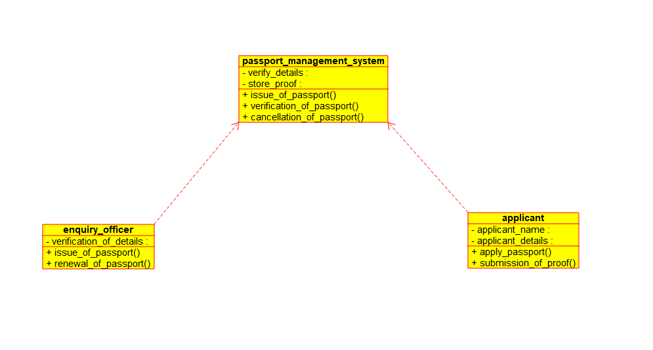

1. **Develop a system using UML for implementing the Book Bank process. It should verify the details of the student by the central computer. The details regarding the student will be provided to the central computer through the administrator in the book bank and the computer will verify the details of the student and provide approval to the office. Then the books that are needed by the student will issue from the office to him.**

**USE CASE DIAGRAM**

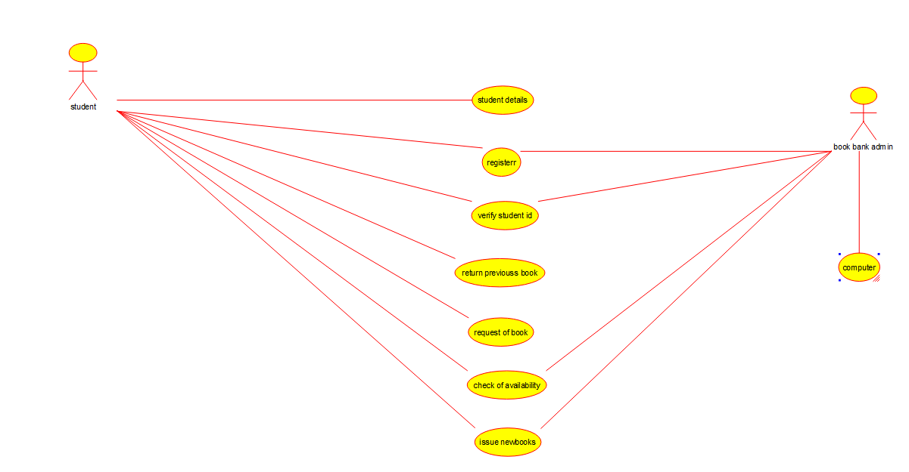

1. **Develop a system using UML for implementing the Exam Registration Portal. It should verify the details of the candidate by the central computer. The details regarding the candidate will be provided to the central computer through the administrator and the computer will verify the details of the candidate and provide approval. Then the hall ticket will be issued from the office to the candidate.**

**ACTIVITY DIAGRAM**

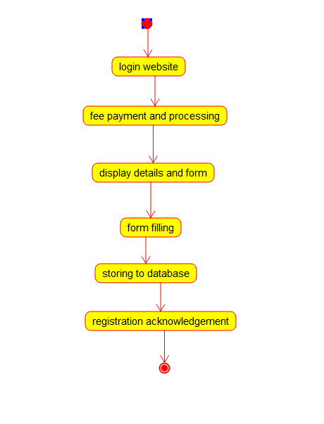

1. **Develop a system using UML for implementing Stock Maintenance System. In this system, the customer can place orders and purchase items with the aid of the stock dealer and central stock system. These orders are verified and the items are delivered to the customer. Then the stock details are to be updated accordingly.**

**CLASS DIAGRAM**

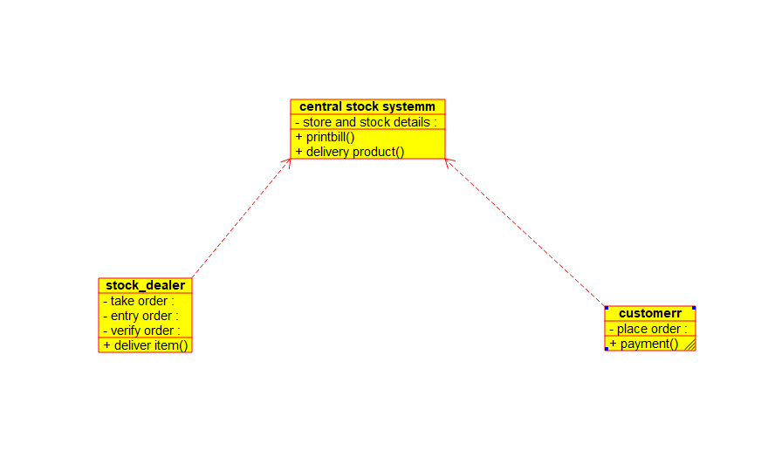

1. **Develop a system using UML for implementing Online Course Reservation System. This system is organized by the central management system. The student first browses and selects the desired course of their choice. The university then checks the availability of the seat if it is available the student is enrolled for the course.**

**STATE DIAGRAM**

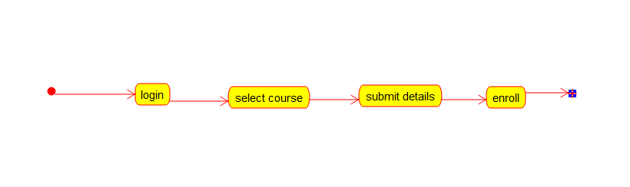

1. **Develop a system using UML for implementing E-Ticketing System. This is to be used by the passenger for reserving the tickets for their travel. This E-ticketing is organized by the central system. The information is provided by the railway reservation system.**

**COMPONENT DIAGRAM**

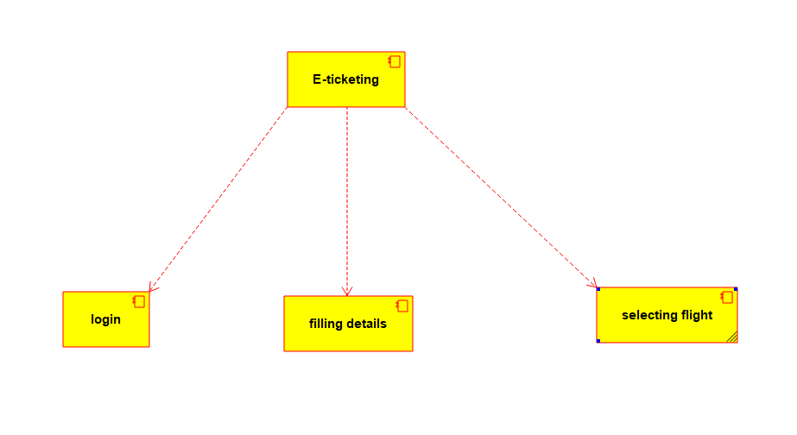

1. **Develop a system using UML for implementing Credit Card Processing System. In this system, the cardholder can purchase items and pays the bill with the aid of a credit card. The cashier should accept the card and proceed with the transaction using the central system. The bill is to be verified and the items are delivered to the cardholder based on it.**

**DEPLOYMENT DIAGRAM**

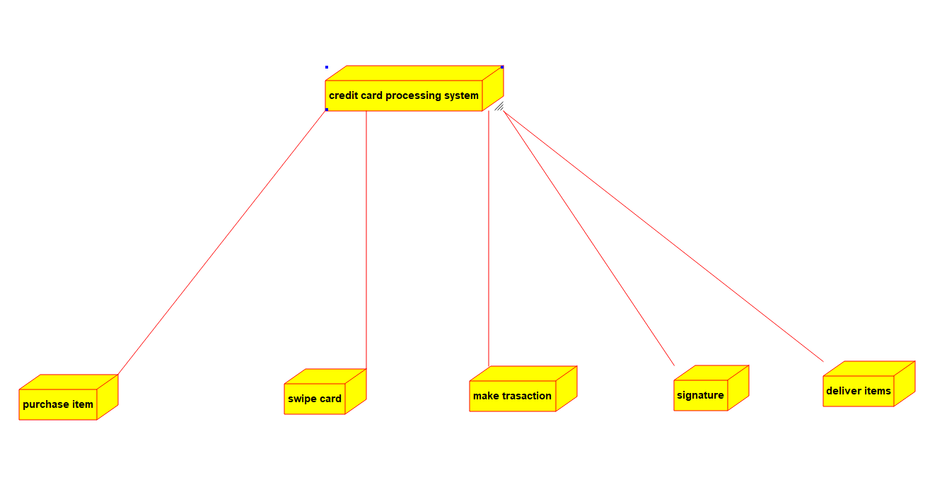

1. **Develop a system using UML for Software Personnel Management System. It should be used to process the details of a person who works in a software company. The details are to be stored in the central management system for cross-checking the person’s details.**

**DEPLOYEMNT DIAGRAM**

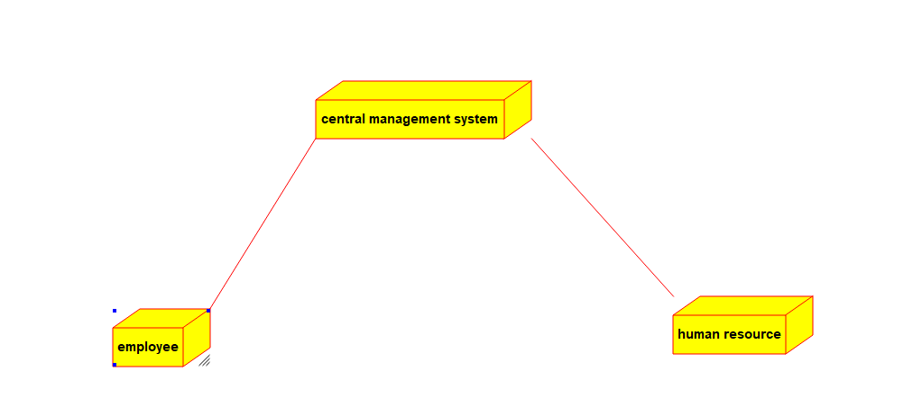

1. **Develop a system using UML for E-Book Management System. It should be designed to manage the books that were read through the internet. That should consist of the details of the e-book that were read by the user online. It will be controlled by the central system. This system should act as a backup of all details together.**

**ACTIVITY DIAGRAM**

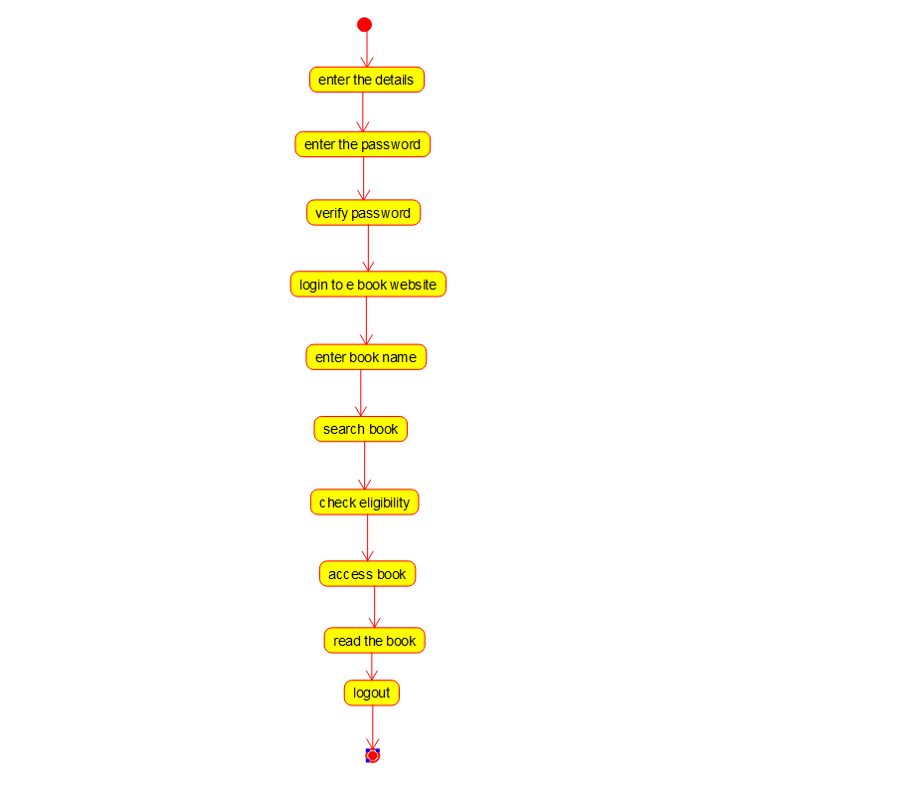

1. **Develop a system using UML for Recruitment System, to recruit the applicant for a particular job in the company. It was controlled by the central management** **system to manage the details of the particular applicant who has to be recruited by a company.**

**COMPONENT DIAGRAM**

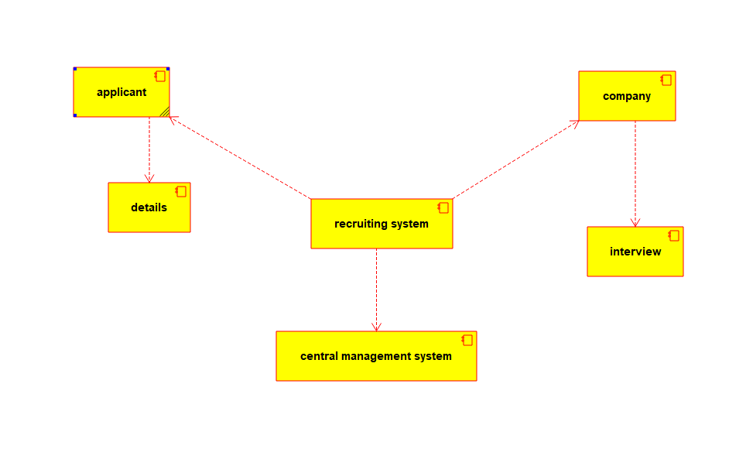

1. **Develop a system using UML for Conference Management System. It should manage the details of the process that will be taking place at the conference. It should work along with the organizer, who arranges the program and central management system, which consists of all the details of the member and the role he/she, who is going to participate in the presentation.**

**ACTIVITY DIAGRAM**

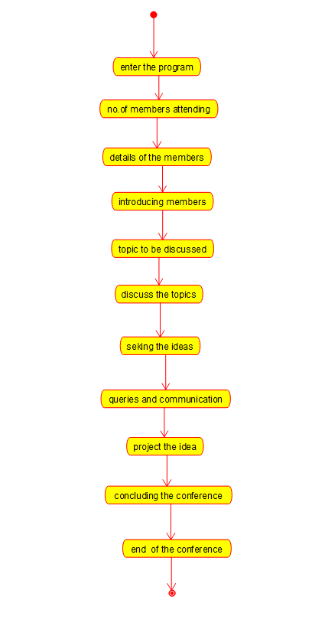

1. **Develop a system using UML for Foreign Trading System, to maintain the details about the trading system that exists between the two countries. These details are to be held by the trading management system. The supplier and the customer will interact with the system.**

**SEQUENCE DIAGRAM**

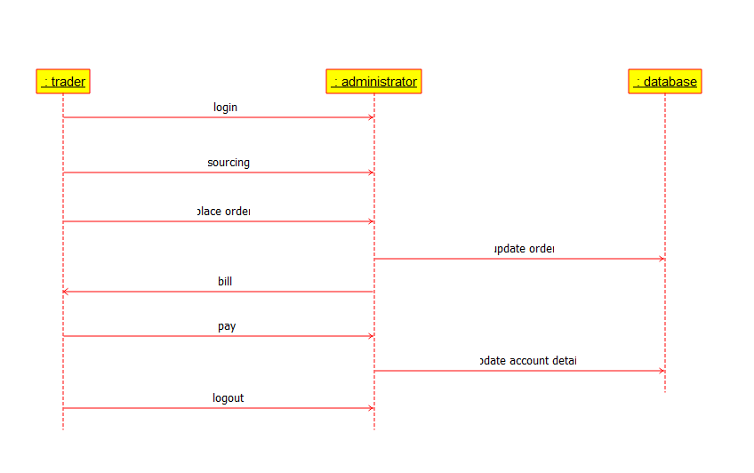

**13. Develop a system using UML for BPO Management System. The system should hold the details of the customer and all approaches to it. It is managed by the central system.**

**USE CASE DIAGRAM**

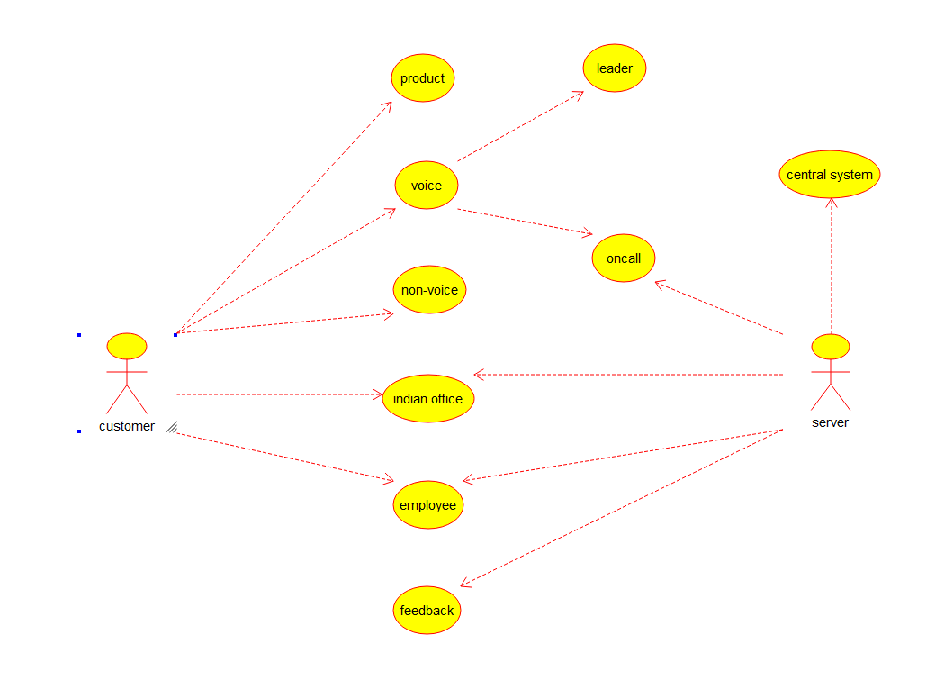

**14.Develop a system using UML for E-Commerce Registration System, to add customers. Then a catalog should be produced for the customer to add items to the cart. The return system should be included, to allow customers to return items within a specific time.**

**ACTIVITY DIAGRAM**

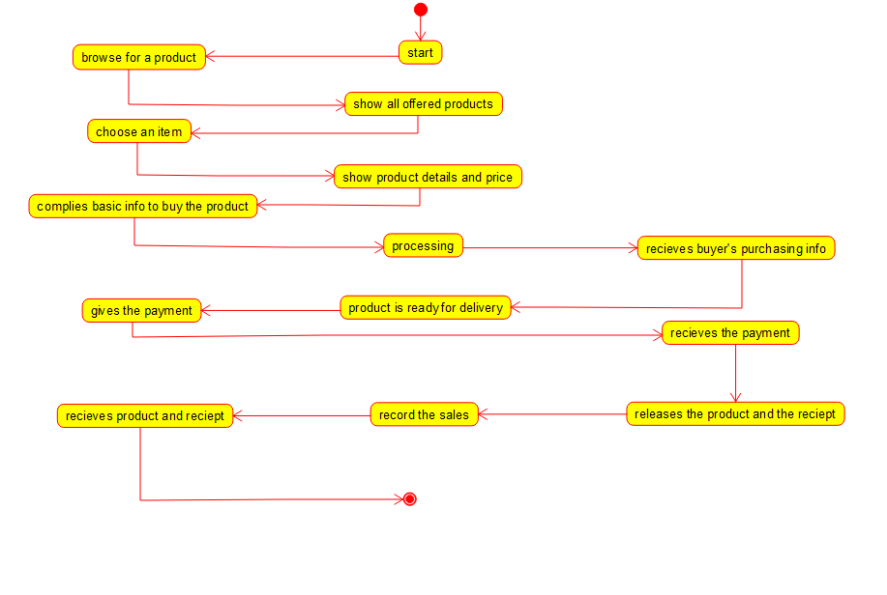

**15.Develop a system using UML for Blood Bank Registration System. The system should have the list of donors and the hospitals can check for the donor's availability and get their appointment. The donor and the hospital can interact with the central system.**

**COMPONENT DIAGRAM**

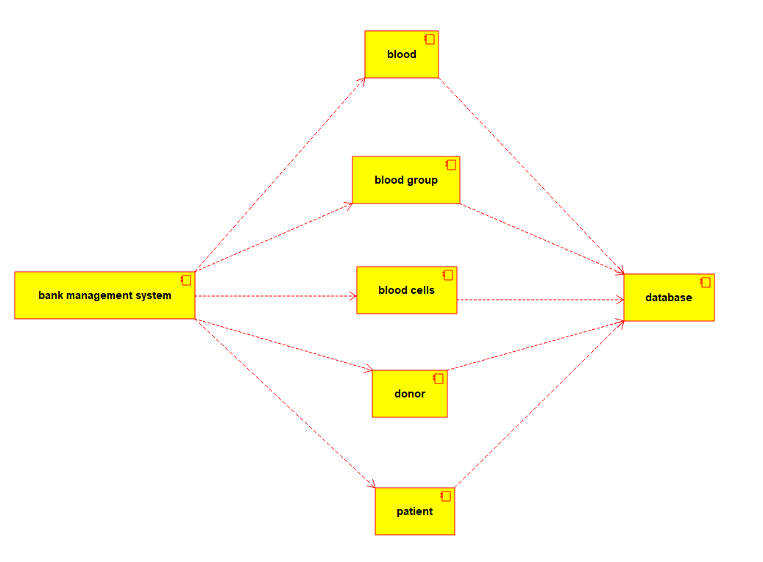

**16. Develop a system using UML for Online Internship Registration System. It should verify the details of the candidate by the central computer. The details regarding the candidate will be provided to the central computer through the administrator and the computer will verify the details of the Candidate and provide approval. Then the internship letter will be issued from the company to the candidate.**

**USE CASE DIAGRAM**

**17. Develop a system using UML for Vehicle Registration Number Registering System. The owner should apply with the documents and pay the fee, once the documents had been accepted and the vehicle is verified. Then the document for registration is issued by the system.**

**STATE DIAGRAM**

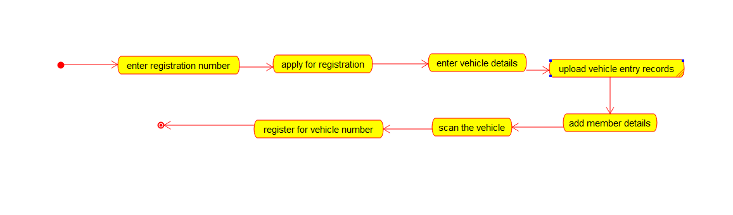

**18. Develop a system using UML for Food Order System. In this system, the customer can place orders and purchase items with the aid of the dealer and central food system. These orders are verified and the items are delivered to the customer.**

**ACTIVITY DIAGRAM**

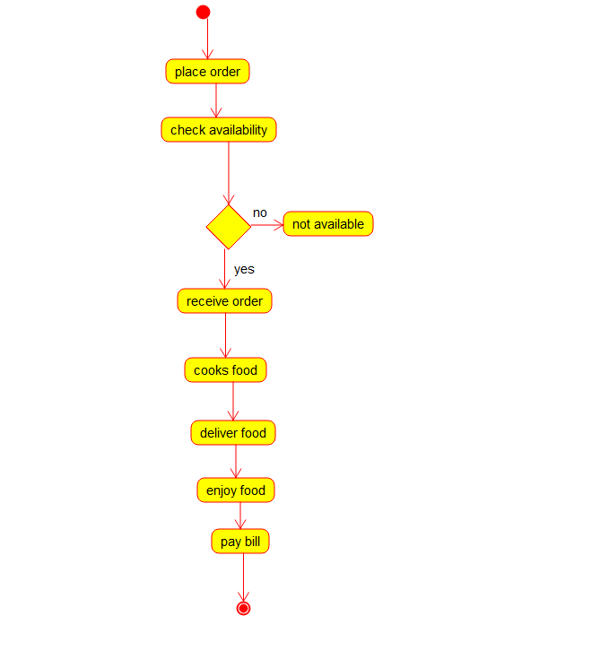

**19. Develop a system using UML for Home Services System. HACS is a system controlled by a remote system such as a mobile phone and coordinates home appliances. The document furnishes the detailed design with all the UML diagrams. It encompasses CRC cards, Use Case Diagrams, Sequence Diagrams, and Class Diagrams for home appliance control systems (HACS).**

**COMPONENT DIAGRAM**

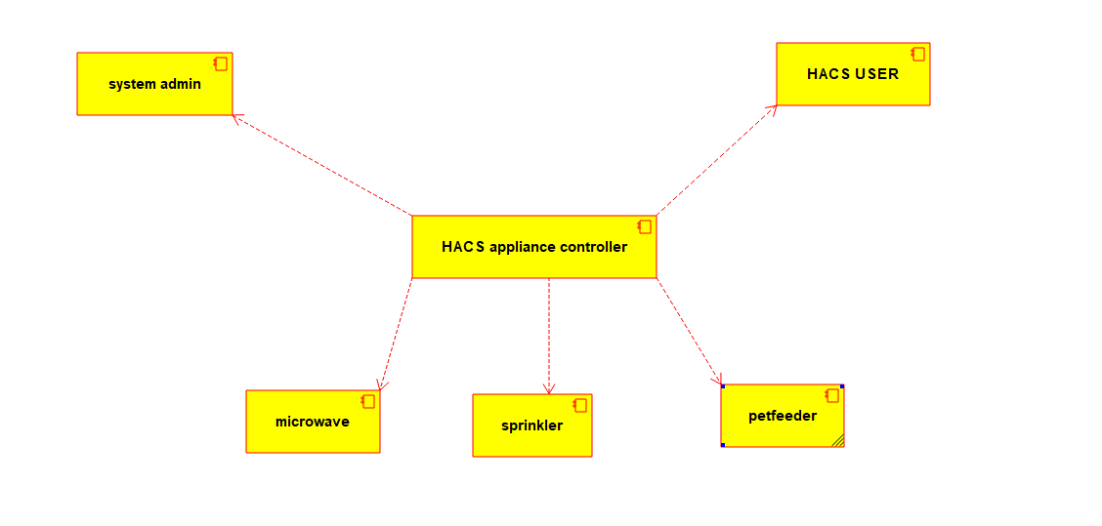

**20. Develop a system using UML for Library Management System. It should verify the details of the reader by the central computer. The details regarding the reader will be provided to the central computer through the administrator in the library and the computer will verify the details of the reader and provide approval to the office. Then the books that are needed by the reader will issue from the library to him.**

**STATE DIAGRAM**

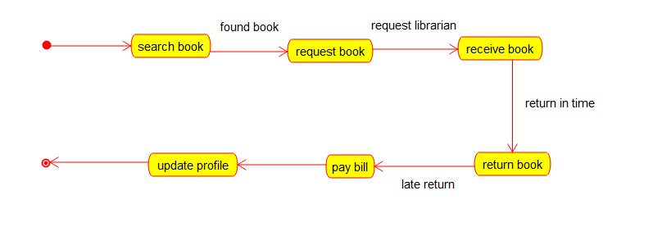

**21. Develop a system using UML for Hospital Management System. The central system should manage patients’ and doctors’ appointments and case details. Also, include medical prescriptions and consultation fee details.**

**USE CASE DIAGRAM**

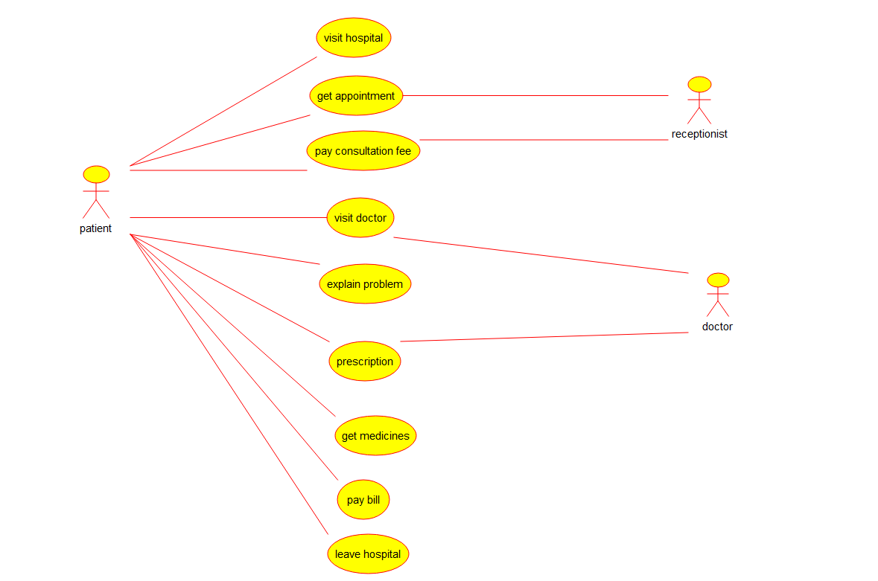

**22. Develop a system using UML for Online Insurance Processing System. The admin can create a category and sub-category, under which a new policy can be added. The user can view and buy the required policies. The system is managed by the Insurance Management System.**

**COMPONENT DIAGRAM**

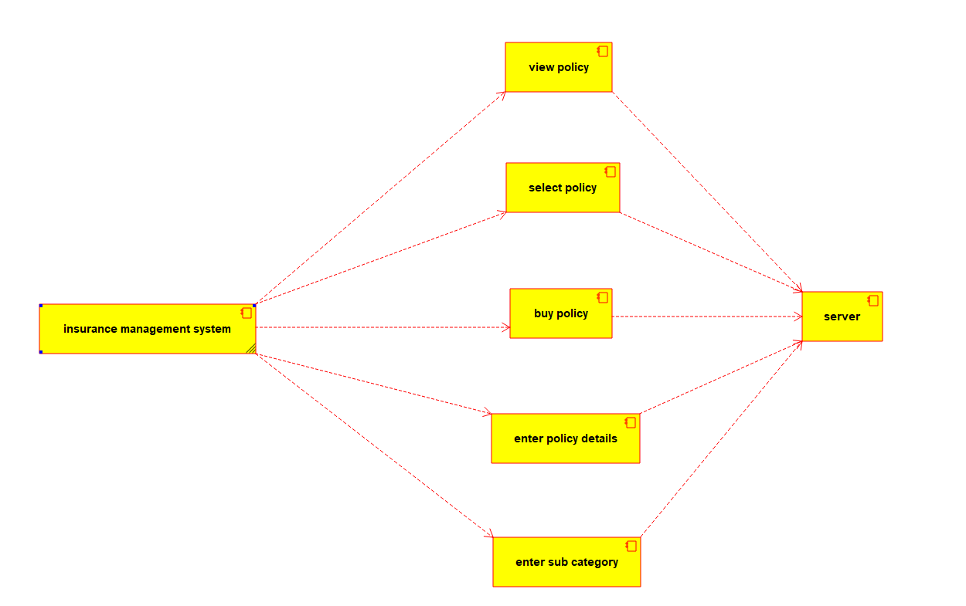

**23. Develop a system using UML for Online Shopping System. This system should represent the shopping system as well as its primary users, and roles. The logs of the transactions should be carried out for the shopping. The cart should be maintained before the purchase transaction.**

**STATE DIAGRAM**

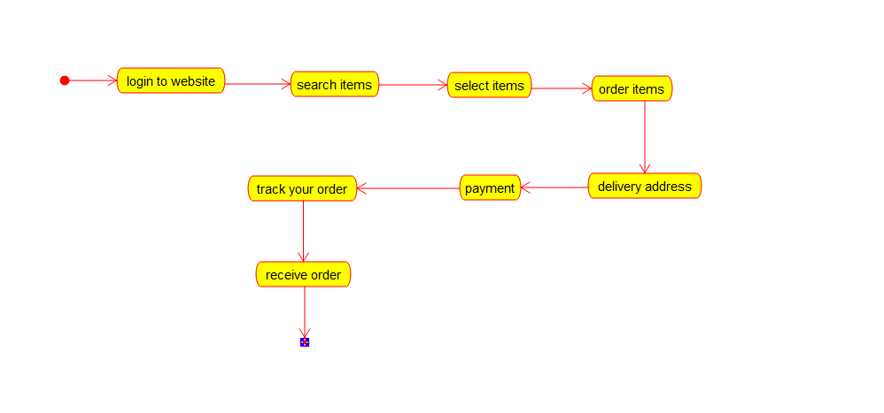

**24. Develop a system using UML for Online Stock Market System. This System facilitates its users the trade (i.e. buying and selling) stocks online. It allows clients to keep track of and execute their transactions of the different stocks in their portfolios. The central system should keep track of all the users, who interact with the system.**

**ACTIVITY DIAGRAM**

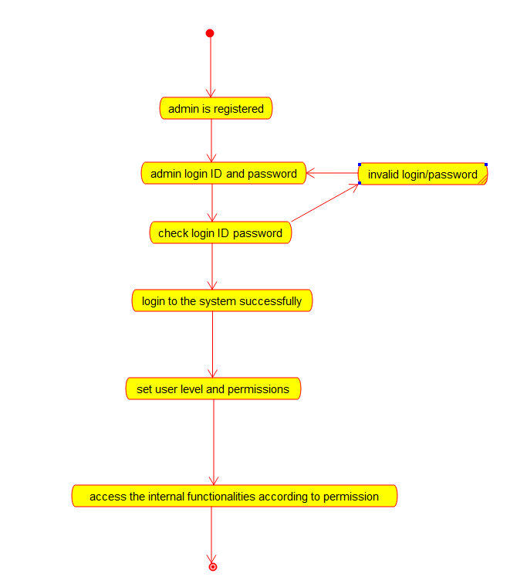

**25. Develop a system using UML for Online Voting System. Registration of the new citizen and update can be done in the system. The process of initiating the polling. The voting was done from the citizen’s end and the result publishing should be maintained by the admin.**

**CLASS DIAGRAM**

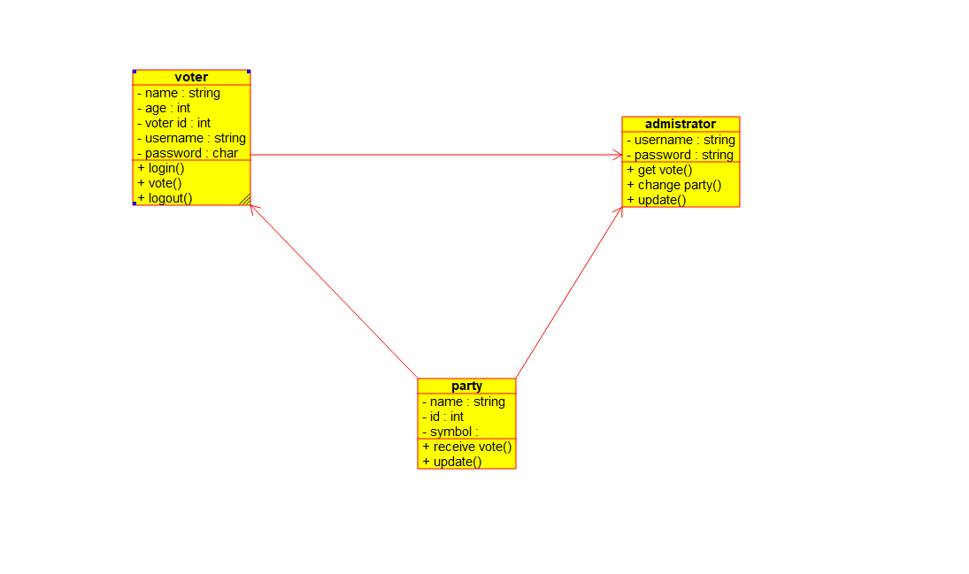

**26. Develop a system using UML for Jewellery Shop Management System. The admin can add new customer detail and update the existing customer’s detail. Whenever a customer made a purchase, it should reflect in the bill details as well as in the customer details. Also, the system should update the stock remained the shop.**

**USE CASE DIAGRAM**

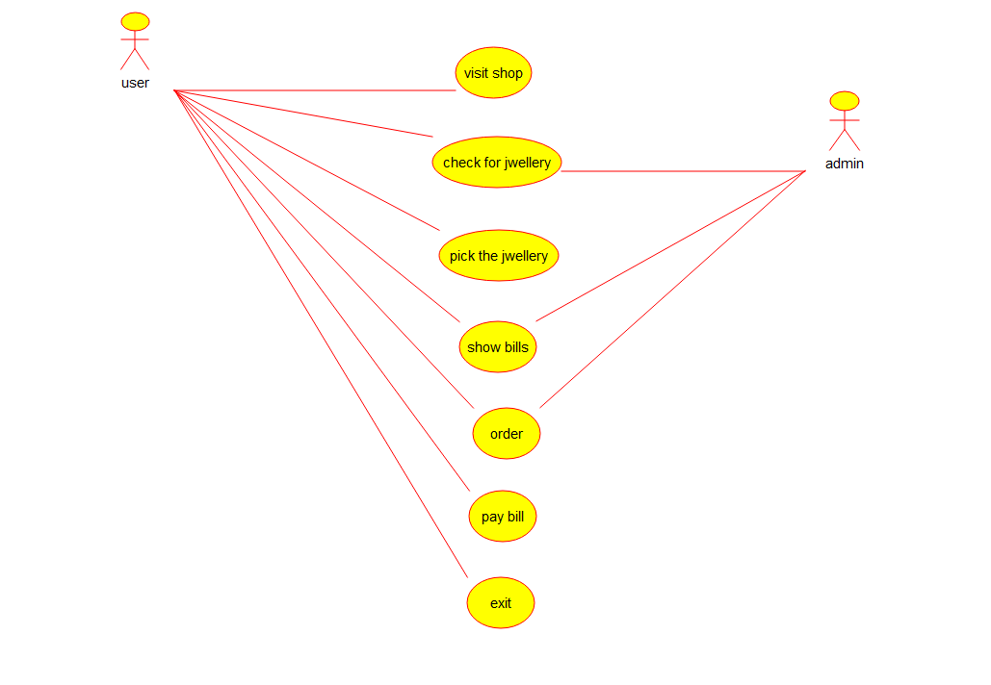

**27. Develop a system using UML for Supermarket Management System. The system should maintain the stock detail, employee detail, and customer details. The system should intimate the product with low stock and nearing the expiry date. The loyalty feature of the customers should be maintained. The offers to the customers should be based on their loyalty features.**

**ACTIVITY DIAGRAM**

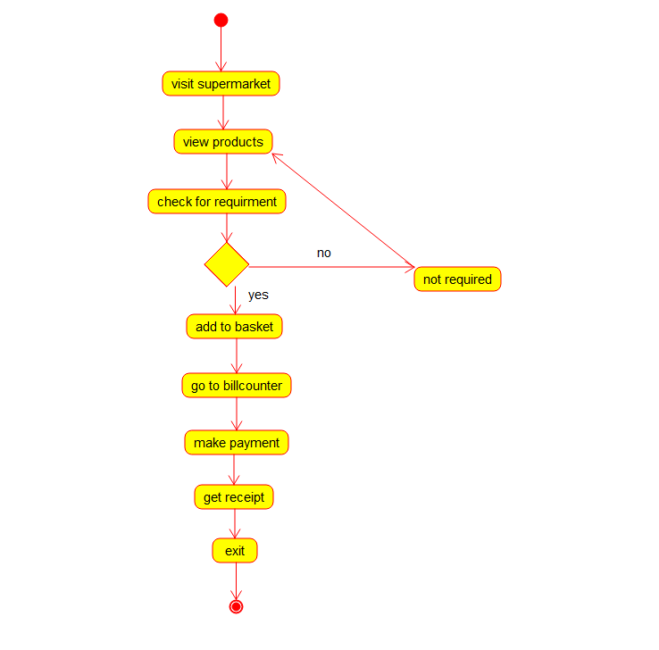

**28. Develop a system using UML for Airplane Reservation System. The customer can search for flights for a given data and source/destination airport and reserve the required seats, the system should handle the payment. The customer can view flight schedules and cancel their reservation(s) if needed. Admin can add new aircraft, flights, and flight schedules. Admin can cancel any prescheduled flight and a notification should be sent to all stakeholders.**

**SEQUENCE DIAGRAM**

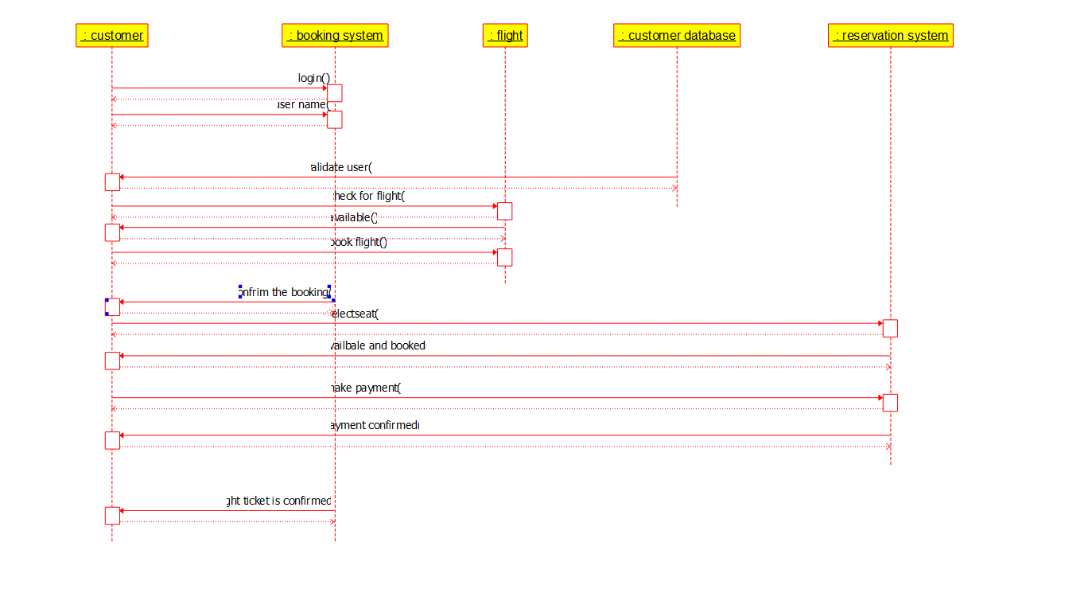

**29. Develop a system using UML for the Bus ticket Reservation System. The customer can create a login and the details are stored by the system. The customer can view the bus and seat availability from source to destination on a given date and time. The customer can book tickets and view the status of the bus. The customer can cancel the ticket and a refund will be decided based on the time remaining before the departure of the bus.**

**STATE DIAGRAM**

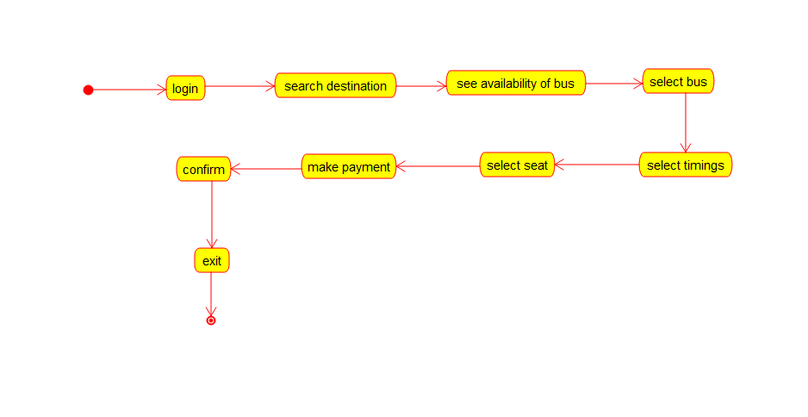

**30. Develop a system using UML for the Train ticket Reservation System. The customer can create a login and the details are stored by the system. The customer can view the train and seat availability from source to destination on a given date and time. The customer can book tickets and view the status of the train. The customer can cancel the ticket and a refund will be decided based on the time remaining before the departure of the bus.**

**COMPONENT DIAGRAM**

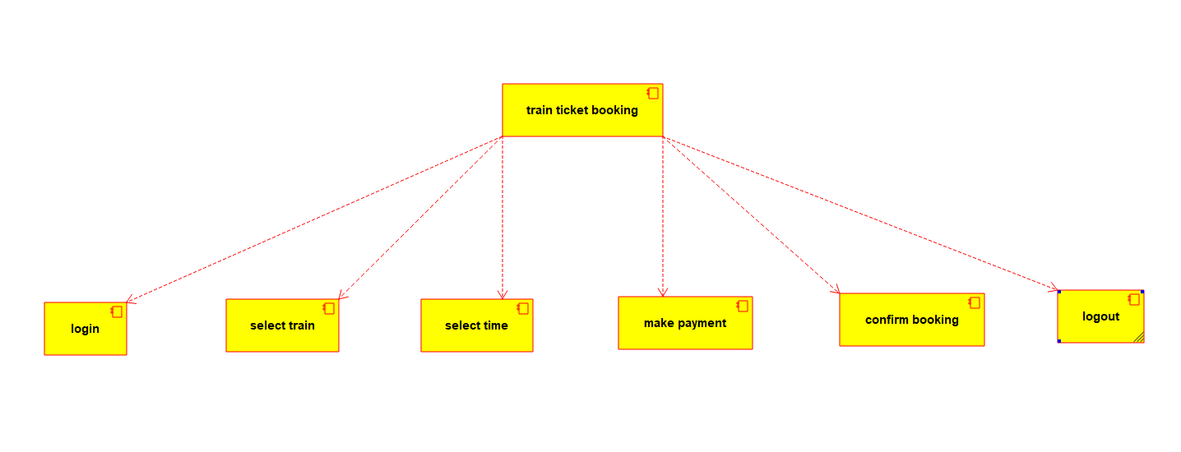

**31. Develop a system using UML for Agriculture Loan Management System. The admin should add new customers and view his/her records. The admin should check the defaulters. The customer can see his/her account detail and apply for a new loan by providing the required documents. The admin should verify the document submitted and approve the loan after verifying the payback potential of the customer.**

**DEPLOYMENT DIAGRAM**

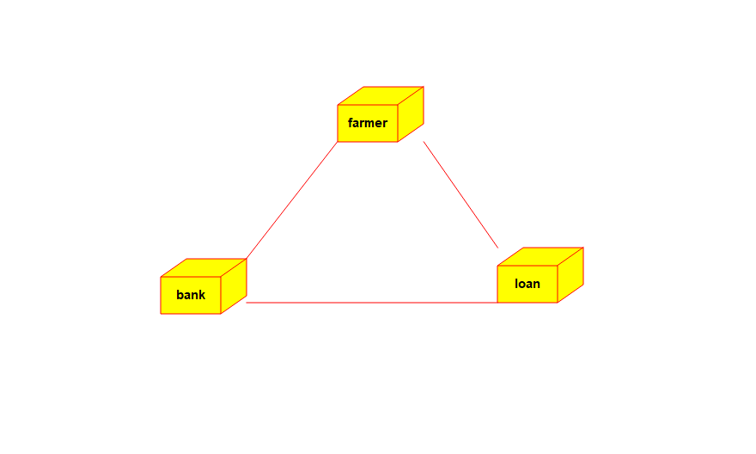

**32. Develop a system using UML for Jewel Loan Management System. The admin should add new customers and view the customers' records. The admin should check the defaulters. The customer can see his/her account detail and apply for a new loan by providing the required ornaments. The admin should verify the purity of the ornaments submitted and approve the loan after verifying the payback potential of the customer.**

**DEPLOYMENT DIAGRAM**

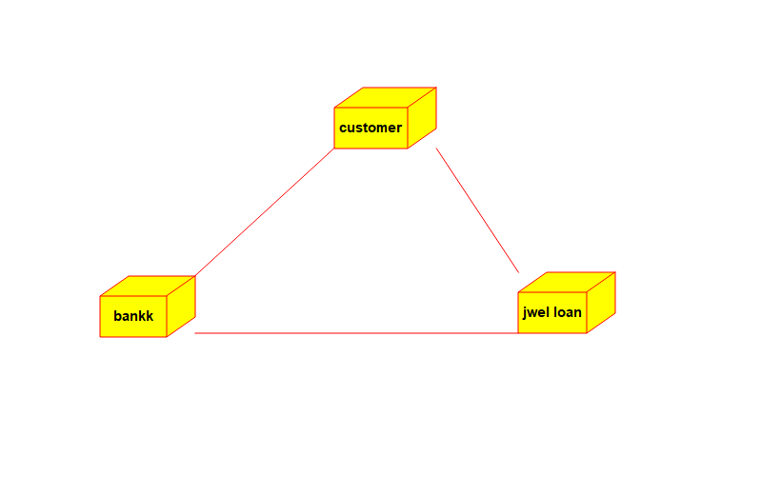

**33. Develop a system using UML for Personal Loan Management System. The admin should add new customers and view the customer's records. The admin should check the defaulters. The customer can see his/her account detail and apply for a new loan by providing the required documents, and payslip. The admin should verify the document submitted and approve the loan after verifying the payback potential of the customer.**

**USE CASE DIAGRAM**

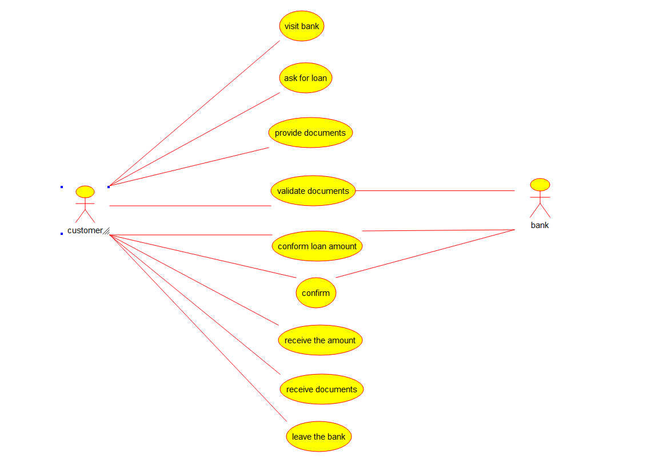

**34. Develop a system using UML for Home Loan Management System. The admin should add new customers and view the customer's records. The admin should check the defaulters. The customer can see his/her account detail and apply for a new loan by providing the required documents. The admin should verify the document submitted and approve the loan after verifying the payback potential of the customer.**

**ACTIVITY DIAGRAM**

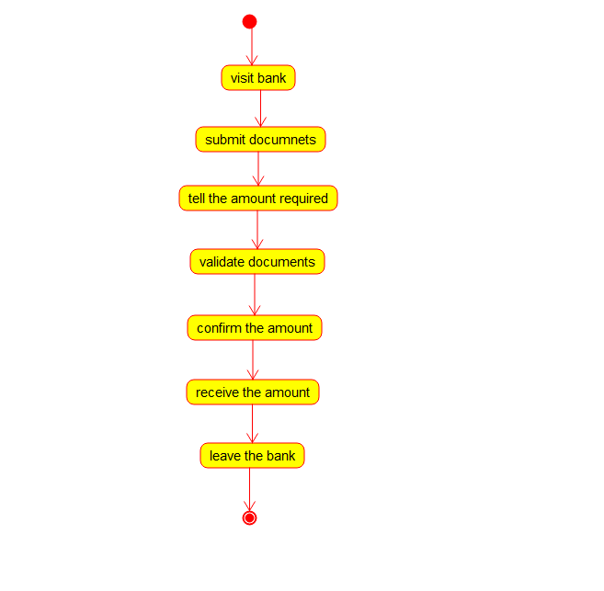

**35. Develop a system using UML for Land Registration System. The system should maintain the database of the land detail and the owner of those lands. The system also maintains the citizen’s details having the lands in their name. Whenever the land is registered, the land owner's detail should be updated the same as the citizen's detail too. The amount transacted for the registration and the tax paid for it is also to be updated.**

**STATE DIAGRAM**

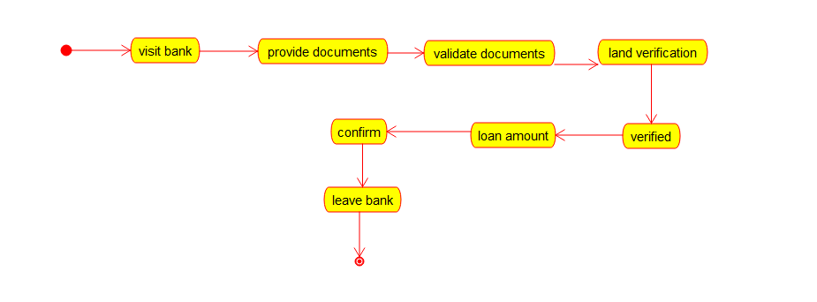

**36. Develop a system using UML for Car/Bike Vehicle Booking System. The system should support the renting of different automobiles by the customer. Each vehicle should have a unique access detail. The system should be able to send a notification whenever the reservation is approaching the pickup date, as well as when the vehicle is nearing the due date. The system should maintain a vehicle log to track all events related to the vehicles.**

**CLASS DIAGRAM**

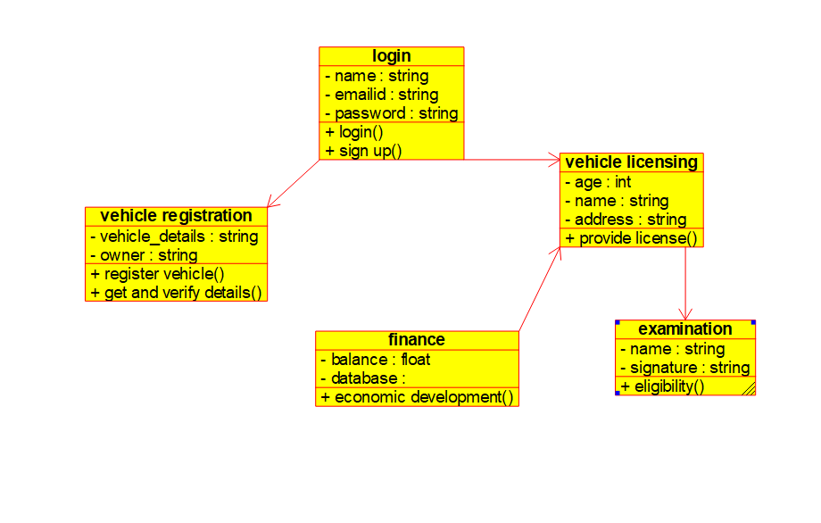

**37. Develop a system using UML for Doctor Appointment System. The central system should manage doctors’ availability and appointments for the given date. The patient can book the doctor’s appointment based on the doctor’s availability. When the booking is confirmed, it should be updated with the patient and doctor.**

**SEQUENCE DIAGRAM**

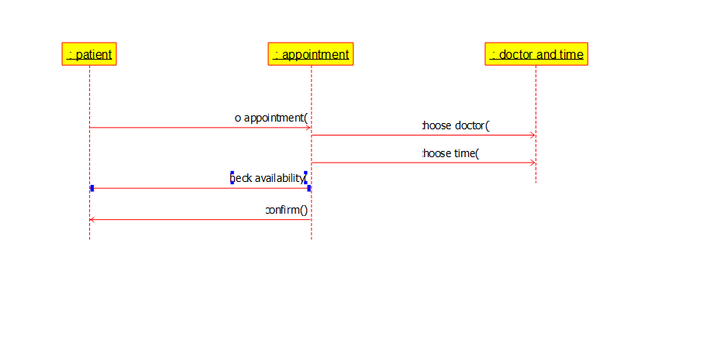

**38. Develop a system using UML for Salon/Beauty Parlour Reservation System. The central system should manage beauticians’ availability and appointments for the given date. The customer can book the beautician appointment based on availability. When the booking is confirmed, it should be updated for the patient and beautician.**

**COMPONENT DIAGRAM**

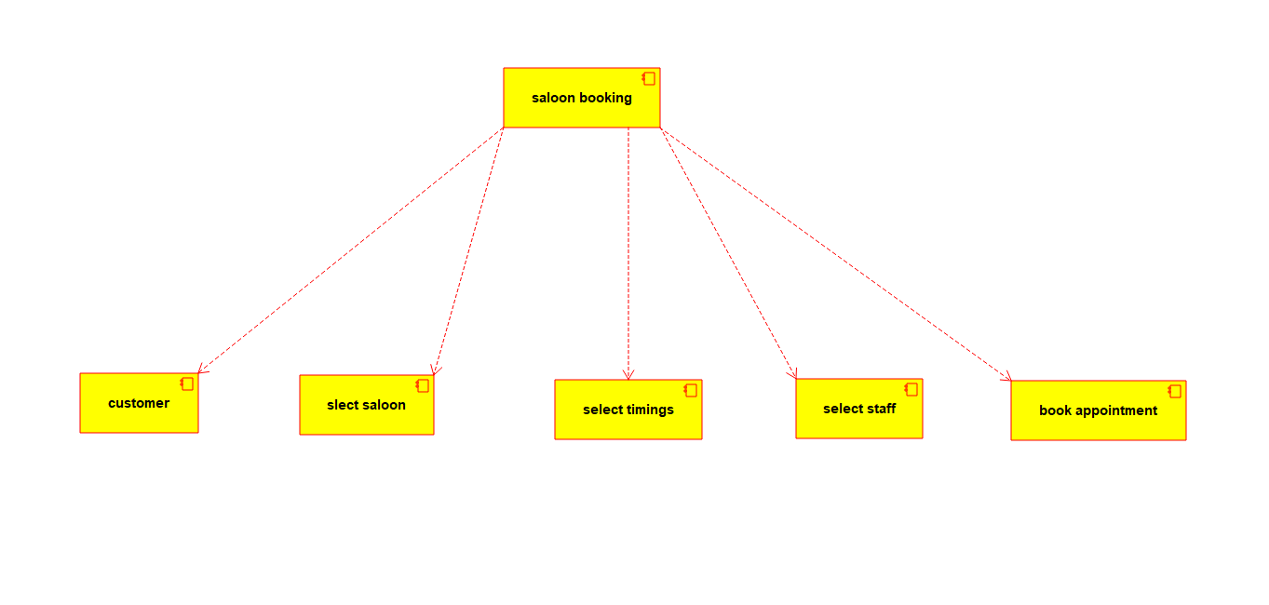

**39. Develop a system using UML for Gardener Booking System. The central system should manage the list of gardeners and their availability and appointments for the given date. The customer can book the gardener’s appointment based on availability. When the booking is confirmed, it should be updated for the gardener and beautician.**

**STATE DIAGRAM**

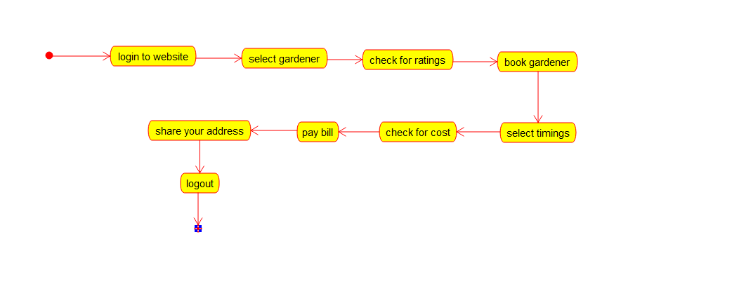

**40. Develop a system using UML for HOME Tax Collection System. The system should generate a home tax for all the homes in the stipulated area it covers and the same should be sent to the owner of the home. The owners should be allowed to pay the tax online or offline. When the deadline for the bill is nearer, a reminder message should be sent to the owner. When the deadline is crossed, it should be intimated to the owner and the admin to take corresponding actions.**

**DEPLOYEMENT DIAGRAM**

