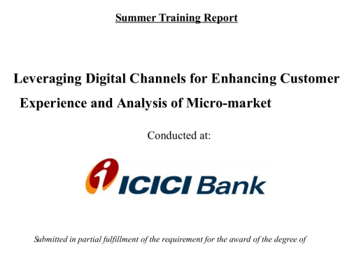 **Bachelor of Commerce**

**(Session 2023-2024)**

**Submitted By: Roll No.**

**Ajay Kumar 211720003**

**B.com 5th sem**



**MRSPTU, BATHINDA**